Recall Cases Summary – Australia (Last Update Date: July 30, 2020)
Date | Product | Categories | Hazard | Photo
Dec 3,2019 | Bunk Bed | Furniture | Injury Hazard | 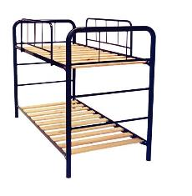
Dec 3, 2019 | DiningSet | Furniture | Injury Hazard | 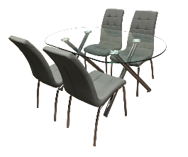
Dec 6,2019 | Kid Rattle | Toys and Childcare articles | Choking Hazard & Suffocation Hazard | 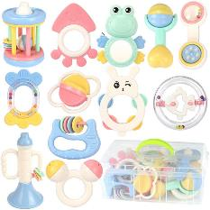
Dec 6, 2019 | Lotion | Cosmetics | Health Risk Hazard | 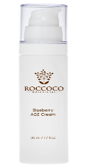
Dec 10, 2019 | Baby Sandals | Footwear | Choking Hazard & Suffocation Hazard | 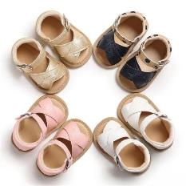
Dec 11, 2019 | Snorkel | Sporting Goods/ Equipment | Drowning Hazard | 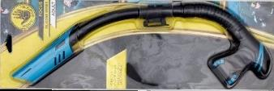
Dec 11, 2019 | Set of 3 plastic toy cars | Toys and Childcare articles | Choking Hazard & Suffocation Hazard | 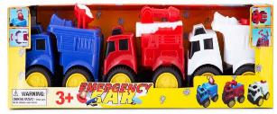
Dec 13, 2019 | Hair conditioner | Cosmetics | Injury Hazard | 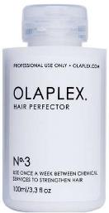
Dec 13, 2019 | Motorcycle helmet | Personal Protective Equipment | Injury Hazard | 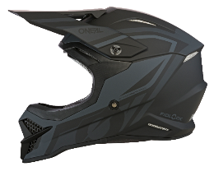
Dec 19, 2019 | Plastic blocks | Toys and Childcare articles | Choking Hazard | 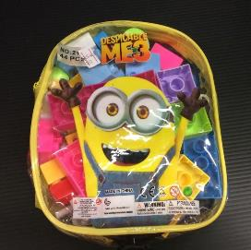
Dec 19, 2019 | Bicyclerack | Sporting Goods/ Equipment | Injury Hazard | 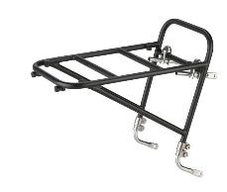
Dec 23, 2019 | Baby Stroller& Tricycle | Toys and Childcare articles | Injury Hazard & Fall Hazard | 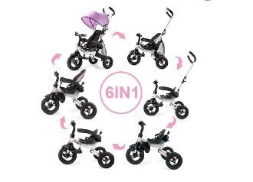
Dec 23, 2019 | LED Light Kit | Lighting Equipment | Electric Shock Hazard | 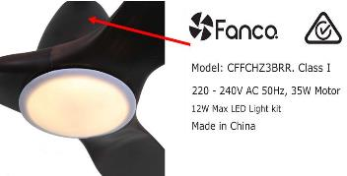
Jan 7, 2020 | Flat Pedal | Sporting Goods/ Equipment | Fall Hazard & Injury Hazard | 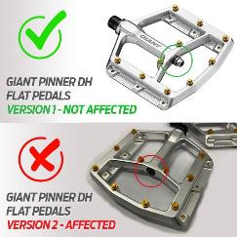
Jan 10, 2020 | Electric Massage Gun | Computer / Audio / Video / Other Electronics & Accessories | Fire Hazard & Electric shock Hazard | 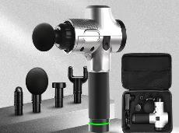
Jan 10, 2020 | Power Bank | Computer / Audio / Video / Other Electronics & Accessories | Fire Hazard & Electric shock Hazard | 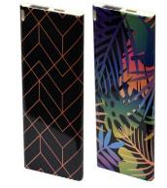
Jan 10, 2020 | Toy Train | Toys and Childcare articles | Choking Hazard & Suffocation Hazard | 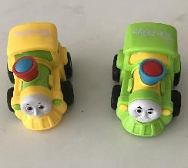
Jan 14, 2020 | Stroller | Toys and Childcare articles | Entrapment Hazard & Injury Hazard | 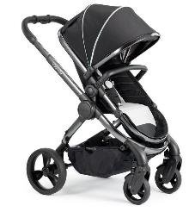
Jan 15, 2020 | AC Adapter | Computer / Audio / Video / Other Electronics & Accessories | Fire Hazard | 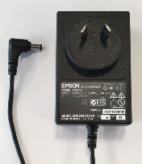
Jan 17, 2020 | LED bulbs | Lighting Equipment | Electric shock Hazard & Fire Hazard | 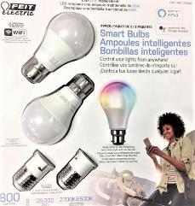
Jan 17, 2020 | Shaped Teethers | Toys and Childcare articles | Choking Hazard & Suffocation Hazard | 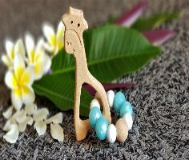
Jan 22, 2020 | Rattles | Toys and Childcare articles | Choking Hazard & Suffocation Hazard | 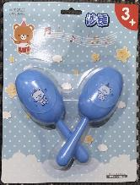
Jan 26, 2020 | Toy Dog | Toys and Childcare articles | Choking Hazard | 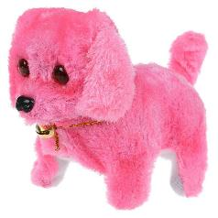
Jan 26, 2020 | Inflatable Pool Toys | Toys and Childcare articles | Drowning Hazard | 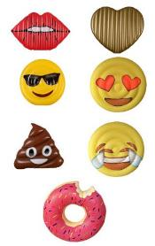
Feb 2, 2020 | Travel mug | Food Contact Material | Health Risk Hazard | 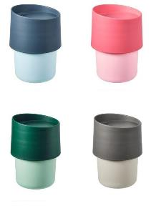
Feb 4, 2020 | Bath Toys | Toys and Childcare articles | Choking Hazard & Suffocation Hazard | 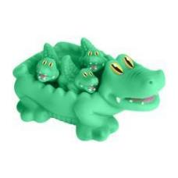
Feb 5, 2020 | Inflatable Paddling Pool for kids | Toys and Childcare articles | Drowning Hazard | 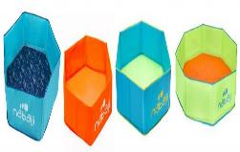
Feb 5, 2020 | Sunglasses | Eyewear | Damage to Eyesight Hazard | 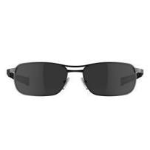
Feb 11, 2020 | Inflatable Development Mat for child | Toys and Childcare articles | Suffocation Hazard | 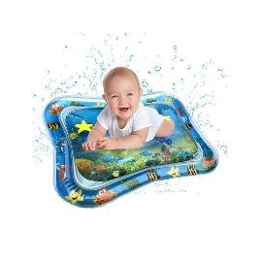
Feb 12, 2020 | Bike Child Seat | Toys and Childcare articles | Injury Hazard | 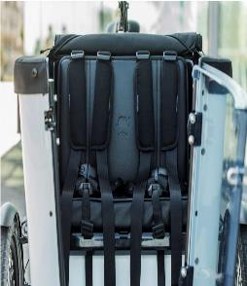
Feb 12, 2020 | Keychain | Tools | Burn Hazard & Choking Hazard | 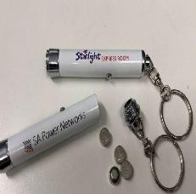
Feb 12, 2020 | Toy Excavator and Tank | Toys and Childcare articles | Choking Hazard & Suffocation Hazard | 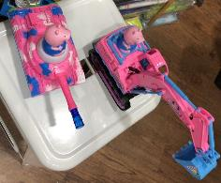
Feb 12, 2020 | Arresting machine toy | Toys and Childcare articles | Choking Hazard & Suffocation Hazard | 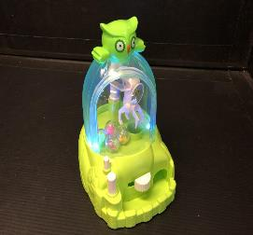
Feb 13, 2020 | Toy plane | Toys and Childcare articles | Choking Hazard & Suffocation Hazard | 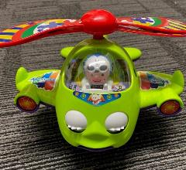
Feb 16, 2020 | Bath Duck Sets and Wind-Up Butterfly | Toys and Childcare articles | Choking Hazard & Suffocation Hazard | 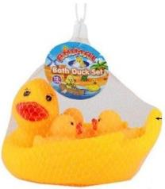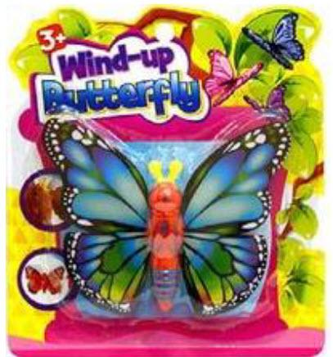
Feb 16, 2020 | Dart Gun | Toys and Childcare articles | Damage to eyesight Hazard | 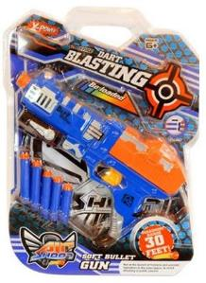
Feb 16, 2020 | Light Hanging Kit | Computer / Audio / Video / Other Electronics & Accessories | Fall Hazard & Injury Hazard | 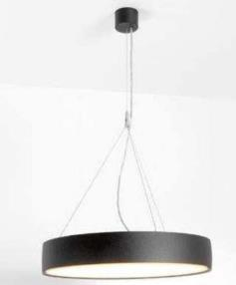
Feb 16, 2020 | Kids' Bicycles | Toys and Childcare articles | Injury Hazard | 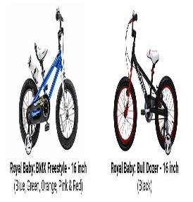
Feb 16, 2020 | Baby bath seats | Toys and Childcare articles | Drowning Hazard | 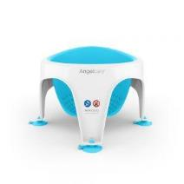
Feb 18, 2020 | Facial cleansing brush | Electronics & Accessories | Electric Shock Hazard | 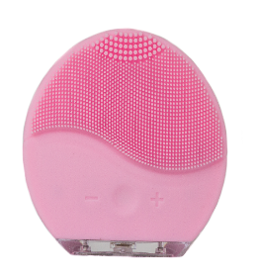
Feb 20, 2020 | Pullback biplane toy | Toys and Childcare articles | Choking Hazard & Suffocation Hazard | 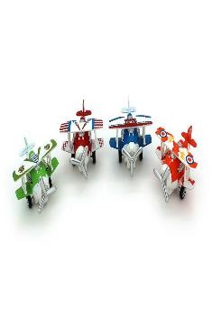
Feb 20, 2020 | Kayak | Sporting Goods/ Equipment | Injury Hazard & Drowning Hazard | 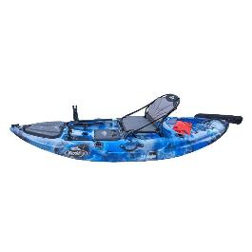
Feb 20, 2020 | Two Piece Sleepwear | Fabric / Textile / Garment / Home Textile | Fire Hazard | 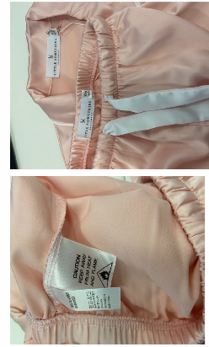
Feb 24, 2020 | Bed Rail | Toys and Childcare articles | Injury Hazard | 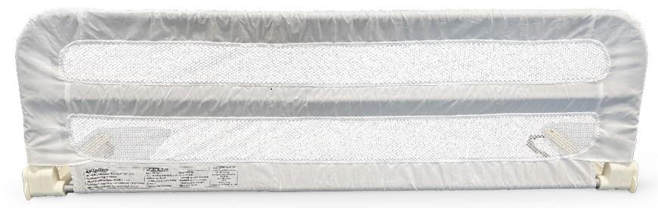
Feb 26, 2020 | Headboard | Furniture | Chemical Hazard | 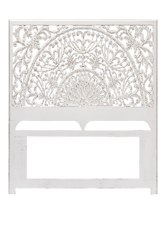
Feb 27, 2020 | Alarm system Plug-in | Computer / Audio / Video / Other Electronics & Accessories | Electric Shock Hazard | 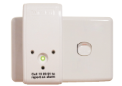
Feb 28, 2020 | Bedside Table | Furniture | Chemical Hazard | 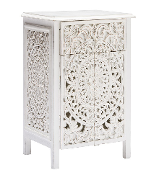
Feb 28, 2020 | Water Squirter Toy | Toys and Childcare articles | Chemical Hazard | 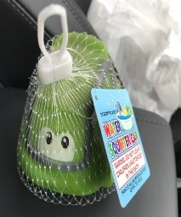
Mar 5, 2020 | Children's car seat | Toys and Childcare articles | Injury Hazard | 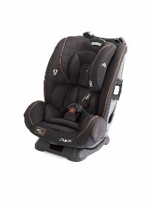
Mar 8, 2020 | Praying Mantis Toy | Toys and Childcare articles | Chemical Hazard | 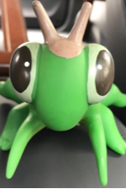
Mar 8, 2020 | Skin Cleanser | Cosmetics | Health Risk Hazard | 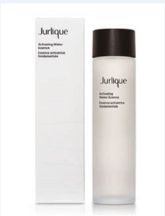
Mar 11, 2020 | Toy Train | Toys and Childcare articles | Choking Hazard & Suffocation Hazard | 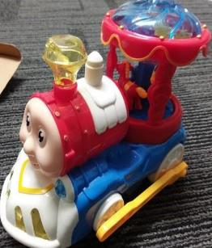
Mar 11, 2020 | Seat Buckles | Toys and Childcare articles | Injury Hazard | 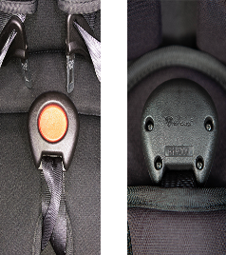
Mar 11, 2020 | Pellet Heater Fireplace | Home Electrical Appliances (Hair Dryer, Iron, etc.) | Electric Shock Hazard | 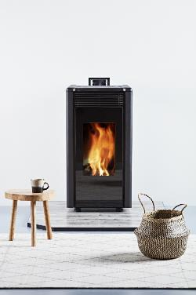
Mar 12, 2020 | Stainless Steel Water Bottle | Food Contact material | Choking Hazard | 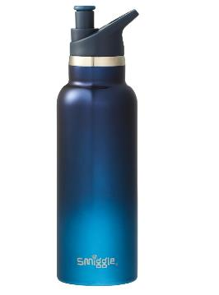
Mar 17, 2020 | Children's Jewelry | Toys and Childcare articles | Chemical Hazard | 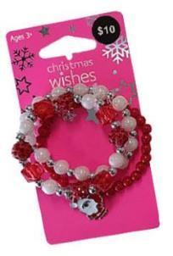
Mar 17, 2020 | Bean Bag Cover | Fabric / Textile / Garment / Home Textile | Choking hazard & Suffocation Hazard | 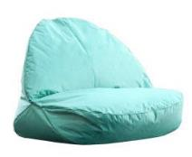
Mar 19, 2020 | Vacuum Cleaner | Home Electrical Appliances (Hair Dryer, Iron, etc.) | Fire Hazard | 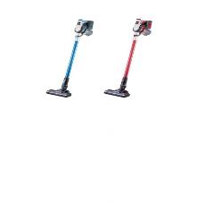
Mar 24, 2020 | SeatBuckles | Toys and Childcare articles | Injury Hazard | 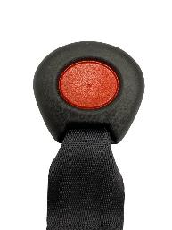
Mar 27, 2020 | Fishing Game Toy | Toys and Childcare articles | Choking hazard & Suffocation Hazard | 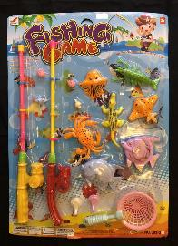
Mar 31, 2020 | Children's Toys | Toys and Childcare articles | Choking hazard & Suffocation Hazard | 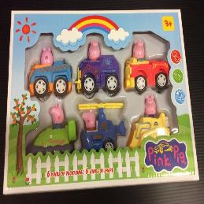
Apr 2, 2020 | Blender | Home Electrical Appliances (Hair Dryer, Iron, etc.) | Injury Hazard | 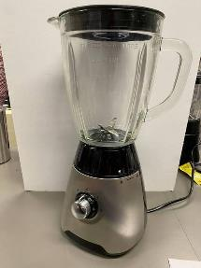
Apr 3, 2020 | Bean bag cover | Fabric / Textile / Garment / Home Textile | Suffocation Hazard | 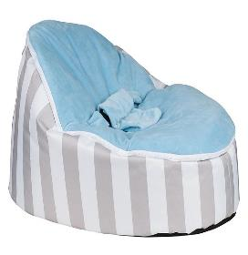
Apr 6, 2020 | Magnetic Balls | Toys and Childcare articles | Choking Hazard | 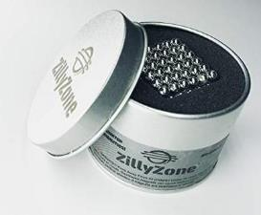
Apr 6, 2020 | Magnetic Building Blocks | Toys and Childcare articles | Choking Hazard | 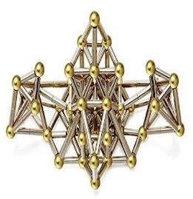
Apr 6, 2020 | Magnetic Cube Building Blocks | Toys and Childcare articles | Choking Hazard | 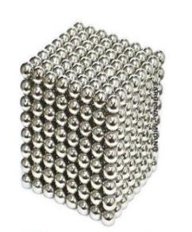
Apr 6, 2020 | Multi-coloured Magnetic Large Cube Toy | Toys and Childcare articles | Choking Hazard | 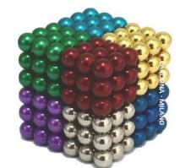
Apr 9, 2020 | Soft Gun Toy | Toys and Childcare articles | Damage to eyesight Hazard | 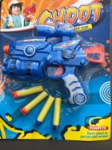
Apr 14, 2020 | Stroller | Toys and Childcare articles | Fall Hazard & Injury Hazard | 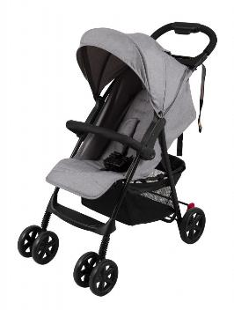
Apr 21, 2020 | Headphones and Carrying Case | Computer / Audio / Video / Other Electronics & Accessories | Health Risk Hazard | 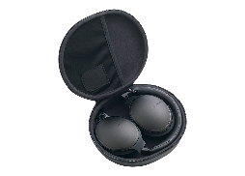
Apr 22, 2020 | Beanbags | Toys and Childcare articles | Choking Hazard & Suffocation Hazard | 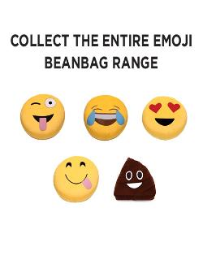
Apr 24, 2020 | Stroller | Toys and Childcare articles | Entrapment Hazard | 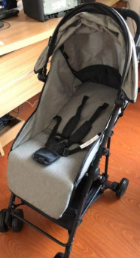
Apr 24, 2020 | Animal Bath toys | Toys and Childcare articles | Chemical Hazard | 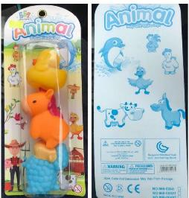
May 11, 2020 | Hard Drives | Computer / Audio / Video / Other Electronics & Accessories | Electric Shock Hazard | 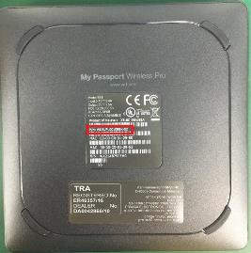
May12, 2020 | French Terry Coverall | Fabric / Textile / Garment / Home Textile | Fire Hazard | 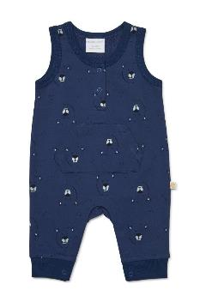
May 16, 2020 | Children's Toys | Toys and Childcare articles | Choking Hazard & Suffocation hazard | 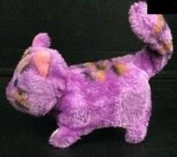
May 21, 2020 | Treadmill | Sporting Goods/ Equipment | Burn Hazard | 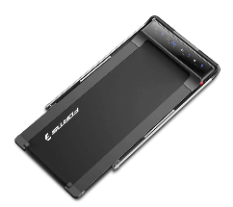
May 25, 2020 | Bicycle Baby Carrier | Toys and Childcare articles | Fall Hazard | 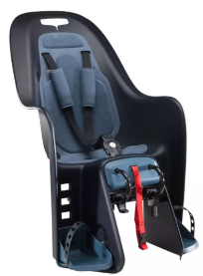
Jun 7, 2020 | Bicycles | Sporting Goods/ Equipment | Injury Hazard | 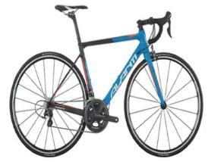
Jun 9, 2020 | High Chair | Furniture | Fall Hazard & Injury Hazard | 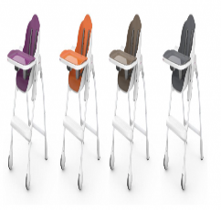
Jun 9, 2020 | Bean Bag Liner | Fabric / Textile / Garment / Home Textile | Choking Hazard & Suffocation hazard | 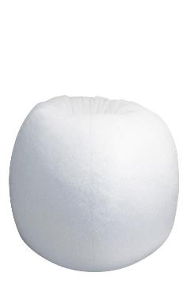
Jun 9, 2020 | Concealer | Cosmetics | Health Risk Hazard | 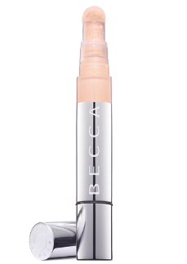
Jun 9, 2020 | Light Up Wand | Toys and Childcare articles | Health Risk Hazard & Choking Hazard | 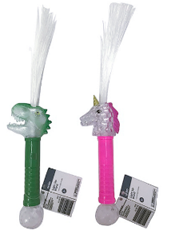
Jun 11, 2020 | Folding Tricycle | Toys and Childcare articles | Fall Hazard | 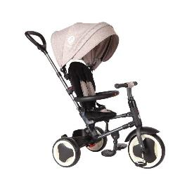
Jun 11, 2020 | Basketball Hoop Stand | Sporting Goods/ Equipment | Injury Hazard | 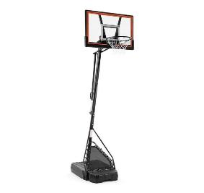
Jun 14, 2020 | Wireless Transmitter | Computer / Audio / Video / Other Electronics & Accessories | Fire Hazard & Burn Hazard | 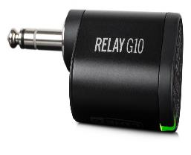
Jun 17, 2020 | Dining Chair | Furniture | Injury Hazard | 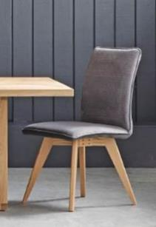
Jun 18, 2020 | Paw Patrol Water Bullet 4-in-1 Gun | Toys and Childcare articles | Damage to eyesight Hazard | 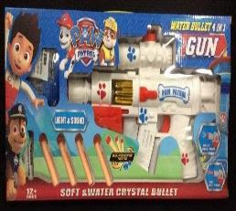
Jun 24, 2020 | Bean Bag Chair Liner | Fabric / Textile / Garment / Home Textile | Choking Hazard & Suffocation Hazard | 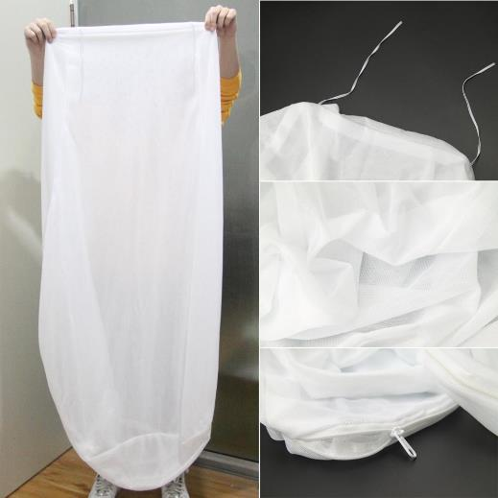
Jun 25, 2020 | Magnetic Office Desk Toy | Toys and Childcare articles | Choking Hazard | 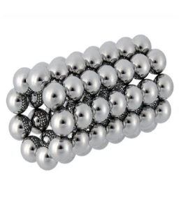
Jun 25, 2020 | Bean bag covers | Fabric / Textile / Garment / Home Textile | Choking Hazard & Suffocation Hazard | 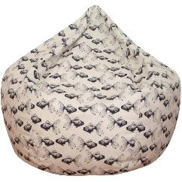
Jun 28, 2020 | Light Up Crab Toy | Toys and Childcare articles | Choking Hazard | 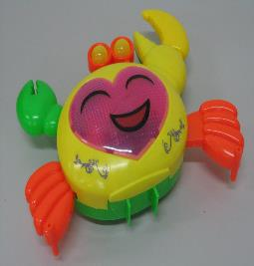
Jun 29, 2020 | Portable Butane Burner | Sporting Goods/ Equipment | Burn Hazard, Fire Hazard & Injury Hazard | 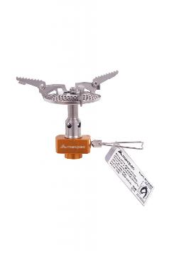
Jun 30, 2020 | Swim Snorkels | Sporting Goods/ Equipment | Choking Hazard | 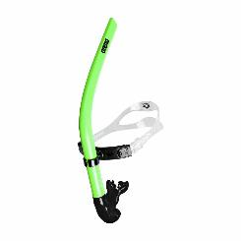

Jul 5, 2020 | Face & Body Jewels | Jewellery | Health risk Hazard | 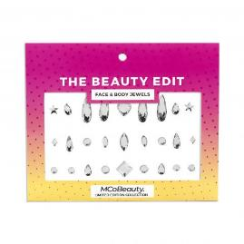
Jul 5, 2020 | Inflatable pool toys | Toys and Childcare articles | Drowning Hazard | 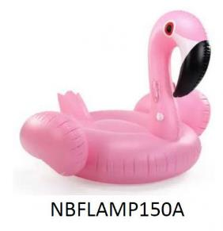
Jul 5, 2020 | Tricycle & Toddler Bike | Toys and Childcare articles | Injury Hazard | 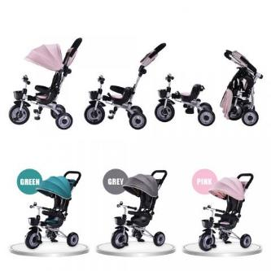
Jul 6, 2020 | Baby Sleepwear | Fabric / Textile / Garment / Home Textile | Fire Hazard | 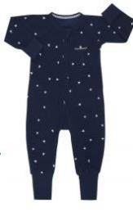
Jul 6, 2020 | Back pack style child carrier | Toys and Childcare articles | Fall Hazard | 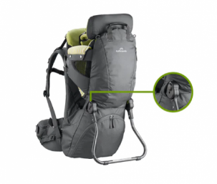
Jul 19, 2020 | Basketball Hoop Set | Sporting Goods/ Equipment | Injury Hazard | 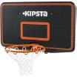
Jul 19, 2020 | Basketball Hoop Set | Sporting Goods/ Equipment | Injury Hazard | 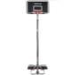
Jul 19,2020 | PAW Patrol Toy Truck | Toys and Childcare articles | Choking Hazard & Suffocation Hazard | 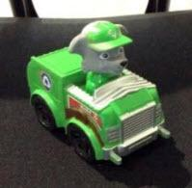
Jul 19, 2020 | Bicycle | Sporting Goods/ Equipment | Injury Hazard
Jul 23, 2020 | Pedestal fan | Home Electrical Appliances (Hair Dryer, Iron, etc.) | Injury Hazard | 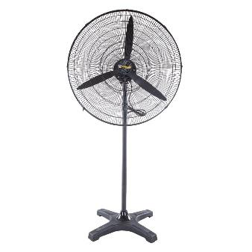
Jul 30, 2020 | Bicycles with two-piece slotted cranks | Sporting Goods/ Equipment | Injury Hazard | 