Recall Cases Summary – Canada (Last Update Date: 31 August 2021)

Date | Product | Categories | Hazard | Image
3-Aug-2021 | Woodlets Lifting Puzzles Alphabet, Vehicles, Safari, Farm | Toys and Childcare Products | Choking Hazard | 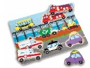  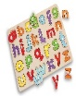  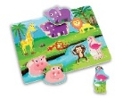  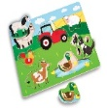
4-Aug-2021 | AeonAir, Danby and De'Longhi Dehumidifiers | Home Electrical Appliances | Fire Hazard | 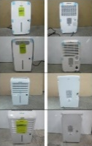
5-Aug-2021 | Model 520 Firepots | Household Items | Fire Hazard, Burn Hazard | 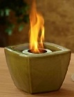
6-Aug-2021 | Janod Toy Shaving Kit | Toys and Childcare Products | Chemical Hazard | 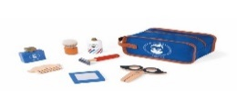
6-Aug-2021 | Specified Models of Usines Giant Factories Inc. Gas Water Heaters | Home Electrical Appliances | Chemical Hazard | 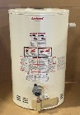
6-Aug-2021 | Magnet Game Set Assorted-12 Pieces | Toys and Childcare Products | Swallowing Risk | 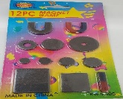
10-Aug-2021 | Trusted USB Rechargeable Fan | Electrical Appliances | Laceration Hazard | 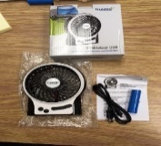
11-Aug-2021 | Snower 3-Drawer Chest | Furniture | Injury Hazard, Entrapment Hazard | 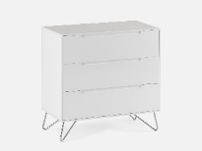
12-Aug-2021 | Rossignol 2018 and 2019 All Track DH Bicycle | Sporting Goods / Equipment | Fall Hazard | 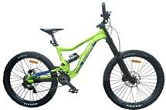  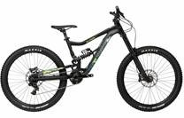
12-Aug-2021 | Nico SeeWonder Magnetic Rattle Snake Eggs | Toys and Childcare Products | Ingestion Hazard | 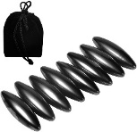
13-Aug-2021 | Concordia Furniture 3 Drawers 1 Door Dressers | Furniture | Entrapment Hazard | 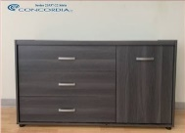
18-Aug-2021 | Intertex LLC B-Air Blower Fans | Electrical Appliances | Fire Hazard | 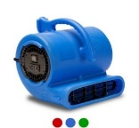
18-Aug-2021 | Hallmark Softwood Round Teethers with Attachments | Toys and Childcare Products | Choking Hazard | 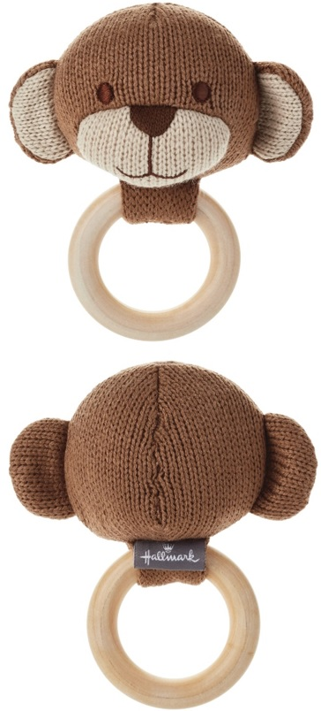  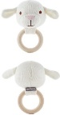  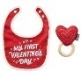  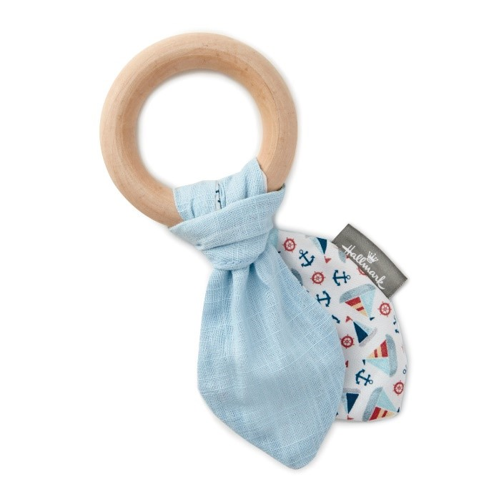  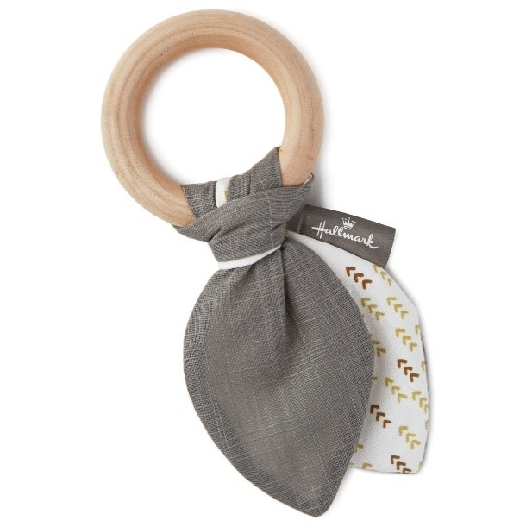  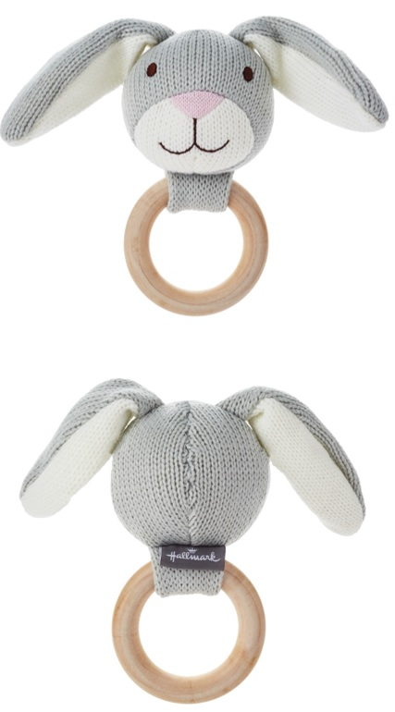  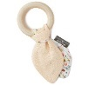
18-Aug-2021 | Marin Mountain Bikes | Sporting Goods / Equipment | Fall Hazard, Crash Hazard | 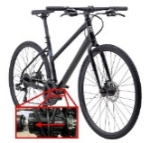
18-Aug-2021 | White Arrow Nocks | Sporting Goods / Equipment | Laceration Hazard | 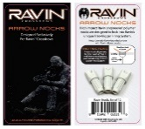
23-Aug-2021 | Moza Magical Sticks and Balls Kits | Toys and Childcare Products | Ingestion Hazard | 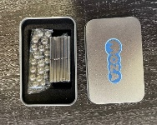
25-Aug-2021 | Wee Gallery Ocean and Safari Animal Wooden Tray Puzzles | Toys and Childcare Products | Choking Hazard | 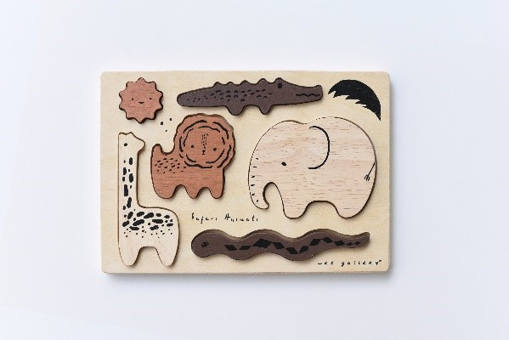  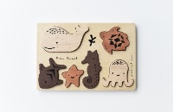
25-Aug-2021 | Children's Sleepwear Sets | Fabric / Textile / Garment / Home Textile | Burn Hazard | 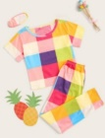  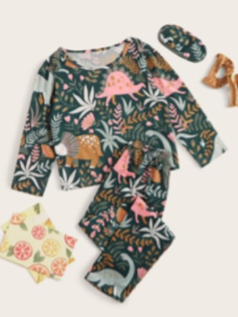
26-Aug-2021 | Ryan and Rose Cutie Spoovel | Toys and Childcare Products | Choking Hazard | 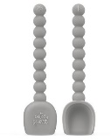
26-Aug-2021 | Crackle Glaze Mug | Food Contact Material | Burn Hazard | 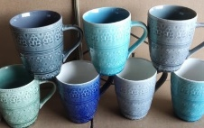
27-Aug-2021 | Fairy Princess Dress | Fabric / Textile / Garment / Home Textile | Burn Hazard | 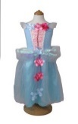
30-Aug-2021 | 5 Drawer Chest | Furniture | Entrapment Hazard | 