Recall Cases Summary – Europe (Last Update Date: 31 August 2021)

Date | Notifying Country | Product | Categories | Hazard | Image
3-Aug-2021 | Hungary | Eyelash Serum | Bodycare / Cosmetics | Chemical Hazard | 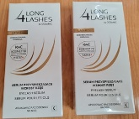
3-Aug-2021 | Germany | Dog Lead | Pet Items | Chemical Hazard | 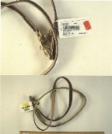
4-Aug-2021 | France | Ring | Jewelry | Chemical Hazard | 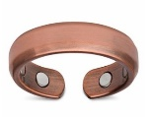
4-Aug-2021 | France | Bracelet | Jewelry | Chemical Hazard | 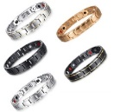
4-Aug-2021 | Germany | Laser Engraving Machine | Machinery | Damage to Sight | 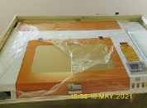
4-Aug-2021 | Germany | Laser Engraving Machine | Machinery | Damage to Sight | 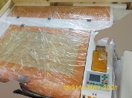
4-Aug-2021 | Germany | Laser Engraving Machine | Machinery | Damage to Sight | 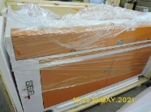
4-Aug-2021 | Germany | Laser Engraving Machine | Machinery | Damage to Sight | 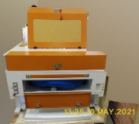
4-Aug-2021 | Germany | Laser Engraving Machine | Machinery | Damage to Sight | 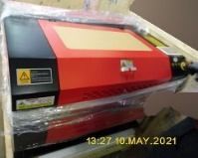
4-Aug-2021 | Germany | Laser Engraving Machine | Machinery | Damage to Sight | 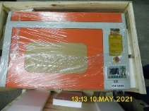
4-Aug-2021 | Germany | Laser Engraving Machine | Machinery | Damage to Sight | 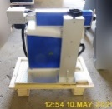
4-Aug-2021 | Slovakia | Particle Filter Mask | Protective Equipment | Health Risk / Other Hazard | 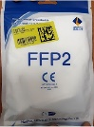
4-Aug-2021 | Portugal | Disposable Nitrile Gloves | Protective Equipment | Health Risk / Other Hazard | 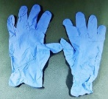
4-Aug-2021 | Portugal | Hand Disinfectant | Chemicals | Health Risk / Other Hazard | 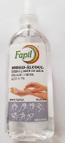
4-Aug-2021 | Portugal | Hand Disinfectant | Chemicals | Health Risk / Other Hazard | 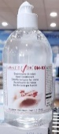
4-Aug-2021 | Portugal | Hand Disinfectant | Chemicals | Health Risk / Other Hazard | 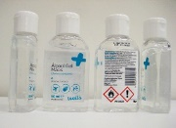
4-Aug-2021 | Germany | Particle Filter Mask | Protective Equipment | Health Risk / Other Hazard | 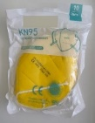  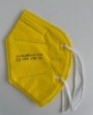
4-Aug-2021 | Poland | Plastic Toy | Toys and Childcare Products | Strangulation Hazard | 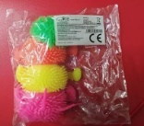
5-Aug-2021 | Germany | Laser Engraving Machine | Machinery | Damage to Sight | 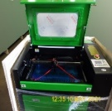
5-Aug-2021 | Poland | Toy Tent | Toys and Childcare Products | Injury Hazard | 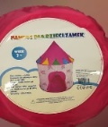
6-Aug-2021 | Poland | Toy Scooter | Toys and Childcare Products | Entrapment Hazard | 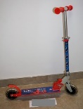
6-Aug-2021 | Slovakia | Children's Bicycle | Sporting Goods / Equipment | Injury Hazard | 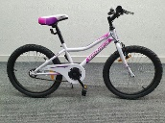
9-Aug-2021 | Denmark | Wooden Swing | Toys and Childcare Products | Entrapment Hazard | 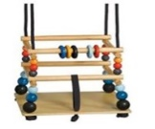
10-Aug-2021 | Germany | Particle Filter Mask | Protective Equipment | Health Risk / Other Hazard | 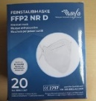  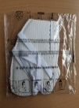
10-Aug-2021 | France | Jewelry Set | Jewelry | Chemical Hazard | 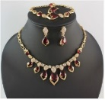
10-Aug-2021 | Croatia | Soft Toy | Toys and Childcare Products | Choking Hazard | 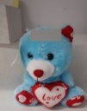  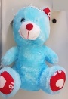
11-Aug-2021 | Poland | Chainsaw | Machinery | Injury Hazard | 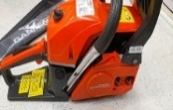
12-Aug-2021 | Hungary | Plastic Doll Set | Toys and Childcare Products | Health Risk / Other Hazard | 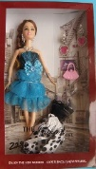
12-Aug-2021 | Bulgaria | Children’s Blouse | Fabric / Textile / Garment / Home Textile | Choking Hazard | 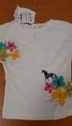  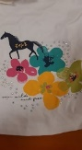
12-Aug-2021 | Hungary | Plastic Doll | Toys and Childcare Products | Health Risk / Other Hazard
12-Aug-2021 | Denmark | Wooden Rattle | Toys and Childcare Products | Choking Hazard | 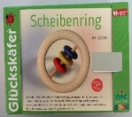
12-Aug-2021 | Denmark | Wooden Rattle | Toys and Childcare Products | Choking Hazard | 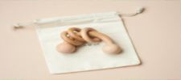
12-Aug-2021 | Germany | Children's Table Lamp | Home Electrical Appliances | Electric Shock Hazard | 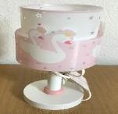
12-Aug-2021 | Germany | Particle Filter Mask | Protective Equipment | Health Risk / Other Hazard | 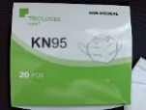
12-Aug-2021 | Hungary | Particle Filter Mask | Protective Equipment | Health Risk / Other Hazard | 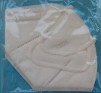  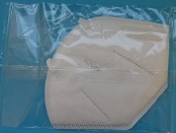
12-Aug-2021 | Hungary | USB Charger | Computer / Audio / Video / Other Electronics & Accessories | Electric Shock Hazard | 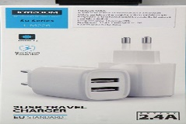
12-Aug-2021 | Germany | Particle Filter Mask | Protective Equipment | Health Risk / Other Hazard | 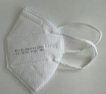  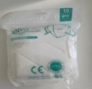
12-Aug-2021 | Germany | Particle Filter Mask | Protective Equipment | Health Risk / Other Hazard | 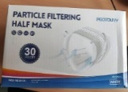
12-Aug-2021 | Poland | Toy Guitar | Toys and Childcare Products | Choking Hazard | 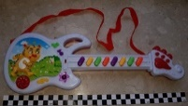
12-Aug-2021 | Poland | Whistle Toy | Toys and Childcare Products | Choking Hazard | 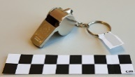
12-Aug-2021 | Hungary | Lighting Chains | Electrical Appliances | Electric Shock Hazard | 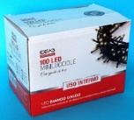
12-Aug-2021 | Bulgaria | Children's Clothing Set | Fabric / Textile / Garment / Home Textile | Choking Hazard | 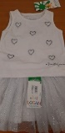
12-Aug-2021 | Bulgaria | Children’s Jeans | Fabric / Textile / Garment / Home Textile | Choking Hazard | 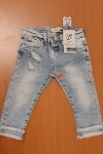
13-Aug-2021 | Poland | Plastic Toy | Toys and Childcare Products | Choking Hazard | 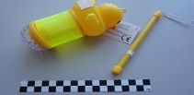
17-Aug-2021 | France | Ring | Jewelry | Chemical Hazard
17-Aug-2021 | Hungary | USB Charger | Computer / Audio / Video / Other Electronics & Accessories | Electric Shock Hazard | 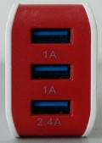  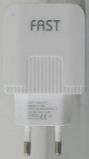
17-Aug-2021 | Hungary | USB Charger | Computer / Audio / Video / Other Electronics & Accessories | Electric Shock Hazard | 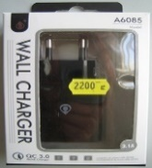
17-Aug-2021 | Poland | Plastic Doll | Toys and Childcare Products | Chemical Hazard | 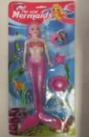
17-Aug-2021 | Germany | Particle Filter Mask | Protective Equipment | Health Risk / Other Hazard | 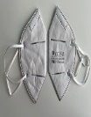  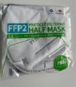
17-Aug-2021 | Germany | Particle Filter Mask | Protective Equipment | Health Risk / Other Hazard | 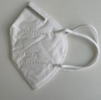  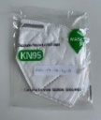
17-Aug-2021 | Finland | Key Ring | Toys and Childcare Products | Choking Hazard | 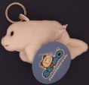  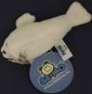
17-Aug-2021 | Finland | Plush Toy | Toys and Childcare Products | Choking Hazard | 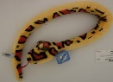  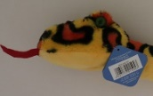
18-Aug-2021 | Denmark | Trampoline Sprinkler | Toys and Childcare Products | Injury Hazard | 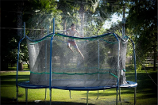
19-Aug-2021 | Finland | Massage Gun | Electrical Appliances | Electric Shock Hazard | 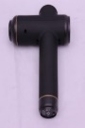  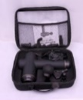
19-Aug-2021 | Hungary | USB Charger | Computer / Audio / Video / Other Electronics & Accessories | Electric Shock Hazard | 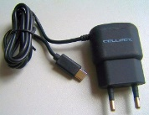  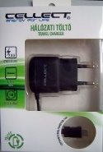
19-Aug-2021 | Czechia | Electric Kettle | Home Electrical Appliances | Electric Shock Hazard | 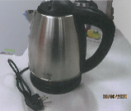
19-Aug-2021 | Lithuania | Glue | Stationery | Chemical Hazard | 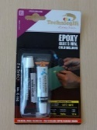
19-Aug-2021 | Germany | Necklace with Pendant | Jewelry | Chemical Hazard | 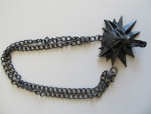
20-Aug-2021 | Ireland | Electrical Fan Heater | Home Electrical Appliances | Burn Hazard, Electric Shock Hazard | 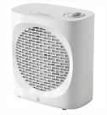
20-Aug-2021 | Ireland | Electrical Fan Heater | Home Electrical Appliances | Burn Hazard, Electric Shock Hazard | 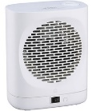
20-Aug-2021 | Lithuania | Plastic Doll | Toys and Childcare Products | Chemical Hazard | 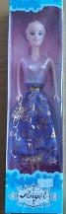
20-Aug-2021 | Ireland | Duvet and Pillowcase Set | Household Items | Injury Hazard, Strangulation Hazard | 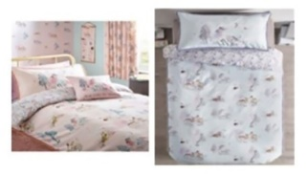
20-Aug-2021 | The Netherlands | Laser Pointer | Electrical Appliances | Damage to Sight | 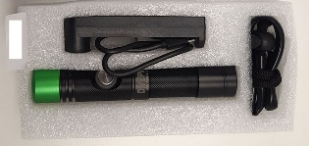
20-Aug-2021 | Romania | Children's Blouse | Fabric / Textile / Garment / Home Textile | Choking Hazard | 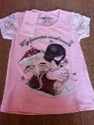
24-Aug-2021 | The Netherlands | Electrical Bicycle | Sporting Goods / Equipment | Injury Hazard | 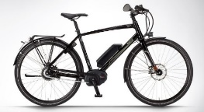
24-Aug-2021 | Germany | Particle Filter Mask | Protective Equipment | Health Risk / Other Hazard | 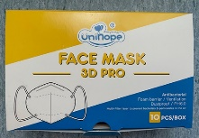
24-Aug-2021 | Romania | Charcoal Barbecue | Outdoor Living Items | Burn Hazard, Fire Hazard | 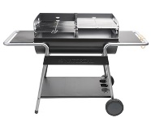
24-Aug-2021 | Lithuania | Christmas Light Chain | Electrical Appliances | Electric Shock Hazard | 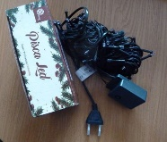
24-Aug-2021 | Finland | Pencil Case | Stationery | Chemical Hazard | 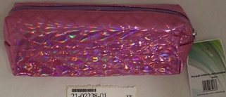
24-Aug-2021 | The Netherlands | Wooden Carrousel | Toys and Childcare Products | Choking Hazard | 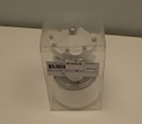
24-Aug-2021 | The Netherlands | Toy Bow and Arrows | Toys and Childcare Products | Choking Hazard | 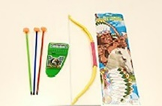
24-Aug-2021 | The Netherlands | Pacifier Clip | Toys and Childcare Products | Choking Hazard | 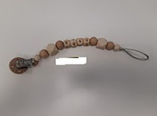
24-Aug-2021 | Poland | Plastic Doll | Toys and Childcare Products | Chemical Hazard | 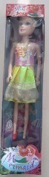
24-Aug-2021 | Ireland | Electrical Cables | Electrical Appliances | Fire Hazard | 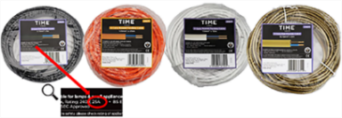
24-Aug-2021 | Slovenia | Audio Headset | Computer / Audio / Video / Other Electronics & Accessories | Environmental Hazard | 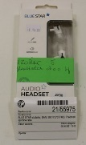
26-Aug-2021 | Spain | Elevating Platform for Waste Containers | Machinery | Cut Hazard, Entrapment Hazard, Health Risk Hazard | 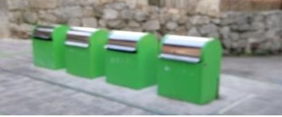
26-Aug-2021 | Finland | Children's Car Seat | Toys and Childcare Products | Injury Hazard | 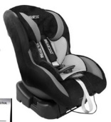
30-Aug-2021 | Slovenia | LED/UV Nail Lamp | Electrical Appliances | Environmental Hazard | 