Recall Cases Summary – US (Last Update Date: 31 August 2021)

Date | Product | Categories | Hazard | Image
4-Aug-2021 | LG Chem “RESU10H” Lithium-Ion Residential Energy Storage System Batteries | Home Electrical Appliances | Fire Hazard | 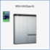
4-Aug-2021 | Dehumidifiers | Home Electrical Appliances | Fire Hazard, Burn Hazard | 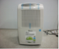  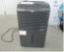  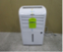  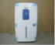  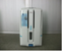
4-Aug-2021 | True Living Sling Loungers | Outdoor Living Items | Amputation Hazard, Laceration Hazard, Pinching Hazard | 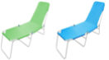
11-Aug-2021 | Delayed Egress Locks | Tools and Hardware | Entrapment Hazard | 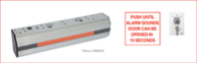
12-Aug-2021 | Andecor Girls Soft Tye Dye Area Rugs | Household Items | Fire Hazard
12-Aug-2021 | Pacapet Fluffy Pink Area Rugs | Household Items | Fire Hazard
12-Aug-2021 | Rossignol 2018 and 2019 Model Year All Track DH Bicycles | Sporting Goods / Equipment | Fall Hazard | 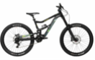
12-Aug-2021 | YOH Super Soft Purple Rugs | Household Items | Fire Hazard | 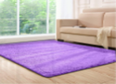
17-Aug-2021 | Zen Magnets and Neoballs Magnets | Toys and Childcare Articles | Health Risk Hazard | 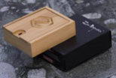  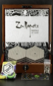
18-Aug-2021 | Teether Rings with Decorative Fabric and Plush Attachments | Toys and Childcare Articles | Choking Hazard | 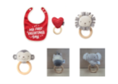  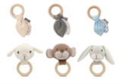
18-Aug-2021 | B-Air VP-33 Blower Fans | Electrical Appliances | Fire Hazard | 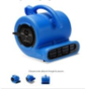
18-Aug-2021 | Mountain Bicycles | Sporting Goods / Equipment | Fall Hazard, Crash Hazard | 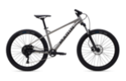
18-Aug-2021 | Swivel Counter Stools | Furniture | Fall Hazard, Injury Hazard | 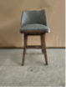  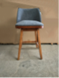
18-Aug-2021 | 8-Pack Scent Stamper Pens | Stationery | Skin Irritation Risk | 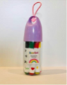
18-Aug-2021 | Ravin® White Arrow Nocks | Sporting Goods / Equipment | Injury Hazard | 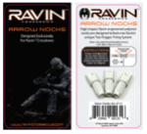
18-Aug-2021 | Tucker & Tate Children’s Socks | Fabric / Textile / Garment / Home Textile | Choking Hazard | 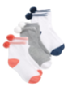
19-Aug-2021 | Infant Bath Seats | Toys and Childcare Articles | Drowning Hazard | 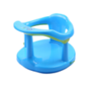
25-Aug-2021 | Hovertrax 2.0 Self-Balancing Scooters/Hoverboards with GLW Battery Packs | Sporting Goods / Equipment | Fire Hazard, Exploding Hazard | 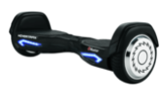
25-Aug-2021 | Ocean and Safari Animal Wooden Tray Puzzles | Toys and Childcare Articles | Choking Hazard | 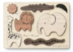  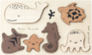
26-Aug-2021 | “Cutie Spoovel” Children’s Eating Utensils | Toys and Childcare Articles | Choking Hazard | 