Recall Cases Summary – Europe (Last Update Date: 30 November 2021)

Date | Notifying Country | Product | Categories | Hazard | Image
3-Nov-2021 | Cyprus | Friction Car-Rattle | Toys and Childcare Products | Choking Hazard | 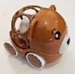
3-Nov-2021 | Cyprus | Push/Pull-Along Toy | Toys and Childcare Products | Choking Hazard | 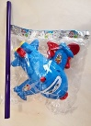
3-Nov-2021 | Denmark | Doll Pram | Toys and Childcare Products | Choking Hazard | 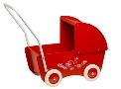
3-Nov-2021 | Denmark | Baby Walker | Toys and Childcare Products | Choking Hazard | 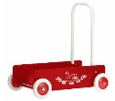
3-Nov-2021 | Poland | Table Cloth Weight | Outdoor Living Items | Choking Hazard | 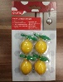  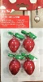
3-Nov-2021 | Denmark | Sling Cradle | Household Items | Damage to Sight, Injury Hazard | 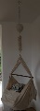
3-Nov-2021 | Estonia | Particle Filter Mask | Protective Equipment | Health Risk Hazard | 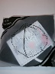
3-Nov-2021 | Hungary | Toy Scooter | Toys and Childcare Products | Injury Hazard | 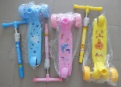
3-Nov-2021 | Hungary | Self-Balancing Scooter (Hoverboard) | Sporting Goods / Equipment | Burn Hazard, Fire Hazard | 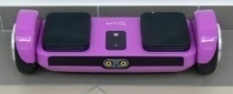
3-Nov-2021 | Hungary | Self-Balancing Scooter (Hoverboard) | Sporting Goods / Equipment | Injury Hazard | 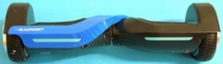
4-Nov-2021 | Cyprus | Plastic Doll | Toys and Childcare Products | Chemical Hazard
4-Nov-2021 | Cyprus | Plastic Doll | Toys and Childcare Products | Chemical Hazard | 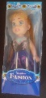
4-Nov-2021 | Slovakia | Water Playing Set | Toys and Childcare Products | Chemical Hazard | 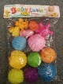
4-Nov-2021 | The Netherlands | Wooden Toy | Toys and Childcare Products | Choking Hazard, Strangulation Hazard | 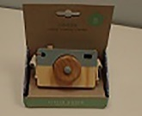
5-Nov-2021 | Cyprus | Children's Blouse | Fabric / Textile / Garment / Home Textile | Injury Hazard | 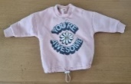
5-Nov-2021 | Cyprus | Children’s Cardigan | Fabric / Textile / Garment / Home Textile | Injury Hazard | 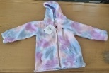
5-Nov-2021 | Slovakia | Wooden Puzzle | Toys and Childcare Products | Choking Hazard | 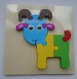
5-Nov-2021 | Slovakia | Soft Toy with LED | Toys and Childcare Products | Environmental Hazard | 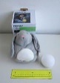
5-Nov-2021 | Sweden | Plastic Bag | Accessories | Chemical Hazard | 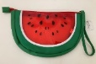
5-Nov-2021 | Hungary | Lighting Chain | Electrical Appliances | Burn Hazard, Electric Shock Hazard, Fire Hazard | 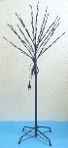
5-Nov-2021 | Poland | Plastic Doll | Toys and Childcare Products | Chemical Hazard | 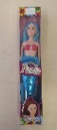
5-Nov-2021 | Hungary | Extension Cord | Electrical Appliances | Burn Hazard, Fire Hazard | 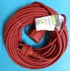
5-Nov-2021 | Hungary | USB Charger | Computer / Audio / Video / Other Electronics & Accessories | Electric Shock Hazard | 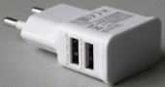
8-Nov-2021 | Belgium | Cupcake Paper | Food Contact Material | Health Risk Hazard | 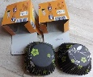
8-Nov-2021 | Croatia | Slime Toy | Toys and Childcare Products | Chemical Hazard | 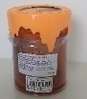
8-Nov-2021 | Finland | Rack-and-Pinion/Farm Jack | Tools and Hardware | Injury Hazard | 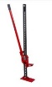
8-Nov-2021 | Finland | Off-Road Jack/Farm Jack | Tools and Hardware | Injury Hazard | 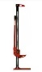
8-Nov-2021 | The Netherlands | Lamp Holder | Electrical Appliances | Electric Shock Hazard | 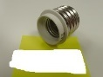
9-Nov-2021 | Poland | Toy Slime | Toys and Childcare Products | Chemical Hazard | 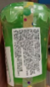
9-Nov-2021 | Slovakia | Toy Slime | Toys and Childcare Products | Chemical Hazard | 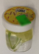
10-Nov-2021 | France | Children's Fancy Dress | Fabric / Textile / Garment / Home Textile | Strangulation Hazard, Suffocation Hazard | 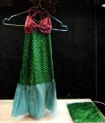
10-Nov-2021 | Germany | Hand Disinfectant | Chemicals | Health Risk Hazard | 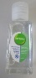
10-Nov-2021 | Poland | Plastic Doll | Toys and Childcare Products | Chemical Hazard | 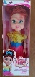
10-Nov-2021 | Germany | Particle Filter Mask | Protective Equipment | Health Risk Hazard | 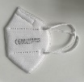
10-Nov-2021 | Germany | Particle Filter Mask | Protective Equipment | Health Risk Hazard | 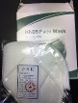
10-Nov-2021 | Sweden | Plastic Greenhouse | Outdoor Living Items | Environmental Hazard | 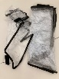
10-Nov-2021 | Estonia | Particle Filter Mask | Protective Equipment | Health Risk Hazard | 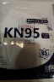
10-Nov-2021 | Lithuania | Plastic Toy Airplane | Toys and Childcare Products | Injury Hazard | 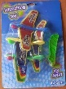
10-Nov-2021 | France | Plush Toy | Toys and Childcare Products | Choking Hazard | 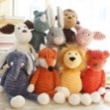
10-Nov-2021 | France | Plush Toy | Toys and Childcare Products | Choking Hazard | 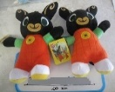
10-Nov-2021 | France | Plush Toy | Toys and Childcare Products | Chemical Hazard, Choking Hazard | 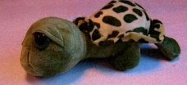
11-Nov-2021 | Poland | Fancy-Dress Mask | Toys and Childcare Products | Burn Hazard | 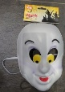
11-Nov-2021 | Estonia | Particle Filter Mask | Protective Equipment | Health Risk Hazard | 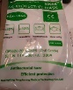
11-Nov-2021 | Sweden | Towel | Fabric / Textile / Garment / Home Textile | Chemical Hazard, Environmental Hazard
11-Nov-2021 | Sweden | Bag For Smartphone | Accessories | Chemical Hazard | 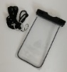
11-Nov-2021 | Sweden | Watering String | Tools and Hardware | Chemical Hazard, Environmental Hazard | 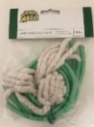
11-Nov-2021 | Czechia | Plastic Doll | Toys and Childcare Products | Chemical Hazard | 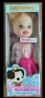
11-Nov-2021 | Poland | Particle Filter Mask | Protective Equipment | Health Risk Hazard | 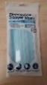
11-Nov-2021 | France | Skin-Lightening Product | Bodycare / Cosmetics | Chemical Hazard | 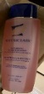
11-Nov-2021 | Sweden | Led Projector | Electrical Appliances | Environmental Hazard | 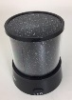
11-Nov-2021 | Sweden | Wireless Earphone | Sporting Goods / Equipment | Environmental Hazard | 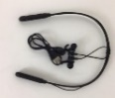
11-Nov-2021 | Sweden | Led Lamp | Electrical Appliances | Environmental Hazard | 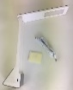
11-Nov-2021 | Sweden | Bouncing Ball | Toys and Childcare Products | Environmental Hazard | 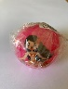
11-Nov-2021 | Sweden | Security Card Holder | Accessories | Environmental Hazard | 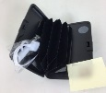
11-Nov-2021 | Sweden | Fabric Shaver | Electrical Appliances | Environmental Hazard | 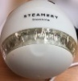
11-Nov-2021 | Sweden | Fabric Steamer | Electrical Appliances | Environmental Hazard | 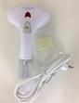
11-Nov-2021 | Hungary | Plastic Doll | Toys and Childcare Products | Chemical Hazard | 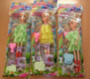
11-Nov-2021 | France | Rechargeable Li-Ion Battery | Electrical Appliances | Burn Hazard, Fire Hazard | 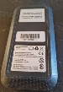  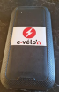
11-Nov-2021 | France | Wristwatch | Jewelry | Chemical Hazard | 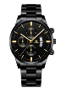
11-Nov-2021 | France | Necklace | Jewelry | Chemical Hazard | 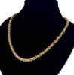
12-Nov-2021 | Germany | Laser Safety Glasses | Protective Equipment | Damage to Sight | 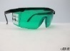
12-Nov-2021 | Germany | Laser Safety Glasses | Protective Equipment | Damage to Sight | 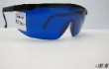
12-Nov-2021 | Germany | Laser Safety Glasses | Protective Equipment | Damage to Sight | 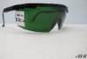
12-Nov-2021 | Germany | Laser Safety Glasses | Protective Equipment | Damage to Sight | 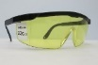
12-Nov-2021 | Romania | Lifejacket | Protective Equipment | Drowning Hazard | 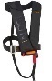
12-Nov-2021 | Germany | Laser Safety Glasses | Protective Equipment | Damage to Sight | 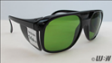
12-Nov-2021 | Germany | Laser Safety Glasses | Protective Equipment | Damage to Sight | 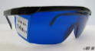
12-Nov-2021 | Germany | Laser Safety Glasses | Protective Equipment | Damage to Sight | 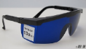
12-Nov-2021 | Germany | Laser Safety Glasses | Protective Equipment | Damage to Sight | 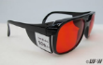
12-Nov-2021 | Germany | Laser Safety Glasses | Protective Equipment | Damage to Sight | 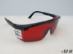
12-Nov-2021 | Germany | Laser Safety Glasses | Protective Equipment | Damage to Sight | 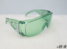
12-Nov-2021 | Germany | Laser Safety Glasses | Protective Equipment | Damage to Sight | 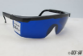
12-Nov-2021 | Germany | Laser Safety Glasses | Protective Equipment | Damage to Sight | 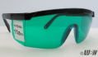
12-Nov-2021 | Germany | Laser Safety Glasses | Protective Equipment | Damage to Sight | 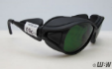
12-Nov-2021 | Germany | Laser Safety Glasses | Protective Equipment | Damage to Sight | 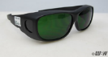
15-Nov-2021 | Germany | Chainsaw Blade | Tools and Hardware | Cut Hazard | 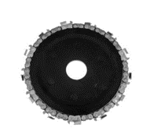
16-Nov-2021 | Sweden | Gaming Headset | Computer / Audio / Video / Other Electronics & Accessories | Chemical Hazard | 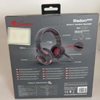
16-Nov-2021 | Poland | Toy Telephone | Toys and Childcare Products | Damage to Hearing | 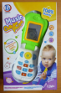
16-Nov-2021 | Lithuania | Toy Car with Candy | Toys and Childcare Products | Choking Hazard | 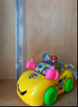
16-Nov-2021 | Hungary | Plastic Doll | Toys and Childcare Products | Chemical Hazard
17-Nov-2021 | Denmark | F2 Battery | Electrical Appliances | Damage to Hearing, Damage to Sight | 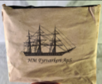
17-Nov-2021 | Hungary | Sandbox Toy Set | Toys and Childcare Products | Choking Hazard | 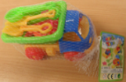
17-Nov-2021 | Germany | Particle Filter Mask | Protective Equipment | Health Risk Hazard | 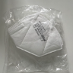
18-Nov-2021 | Sweden | Radio-Controlled Excavator | Toys and Childcare Products | Environmental Hazard | 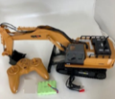
18-Nov-2021 | Sweden | Quatrocopter/ Drone | Outdoor Living Items | Environmental Hazard | 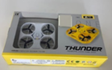
18-Nov-2021 | Sweden | Solar Cell Driven Lantern | Outdoor Living Items | Environmental Hazard | 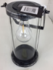
18-Nov-2021 | Germany | Particle Filter Mask | Protective Equipment | Health Risk Hazard | 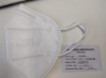
18-Nov-2021 | Germany | Particle Filter Mask | Protective Equipment | Health Risk Hazard | 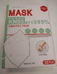
18-Nov-2021 | Germany | Particle Filter Mask | Protective Equipment | Health Risk Hazard | 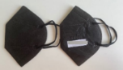
18-Nov-2021 | Slovakia | Earrings | Jewelry | Chemical Hazard | 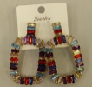
18-Nov-2021 | Germany | Particle Filter Mask | Protective Equipment | Health Risk Hazard | 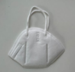
18-Nov-2021 | France | Children's Motorcycle Helmet | Protective Equipment | Injury Hazard | 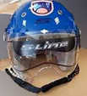
18-Nov-2021 | Germany | Children’s Sandals | Footwear | Chemical Hazard | 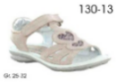
18-Nov-2021 | France | Luminous Balloon | Toys and Childcare Products | Chemical Hazard, Choking Hazard | 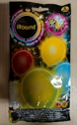
19-Nov-2021 | Lithuania | Rattle Owl | Toys and Childcare Products | Injury Hazard | 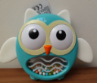
19-Nov-2021 | Lithuania | Swing | Toys and Childcare Products | Injury Hazard | 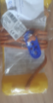
19-Nov-2021 | Bulgaria | Children’s Dress | Fabric / Textile / Garment / Home Textile | Choking Hazard | 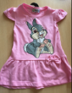
19-Nov-2021 | Hungary | Toy Ironing Set | Toys and Childcare Products | Injury Hazard | 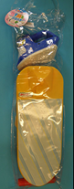
19-Nov-2021 | Ireland | Baby Carrier | Toys and Childcare Products | Injury Hazard | 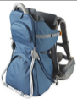
19-Nov-2021 | Lithuania | Snake Toy | Toys and Childcare Products | Chemical Hazard | 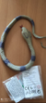
19-Nov-2021 | Sweden | Waterproof Cellphone Case with Bracelet | Sporting Goods / Equipment | Chemical Hazard, Environmental Hazard | 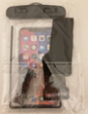
19-Nov-2021 | Poland | Soft Toy | Toys and Childcare Products | Choking Hazard | 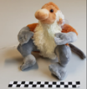
19-Nov-2021 | France | Children's Fancy Dress Costume | Fabric / Textile / Garment / Home Textile | Burn Hazard
19-Nov-2021 | France | LED Lighting Chain | Electrical Appliances | Electric Shock Hazard | 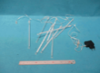
19-Nov-2021 | Finland | Electric Luminaire | Electrical Appliances | Electric Shock Hazard | 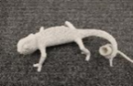
19-Nov-2021 | Hungary | Extension Cord | Electrical Appliances | Burn Hazard, Electric Shock Hazard | 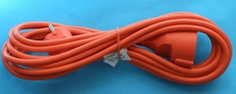
19-Nov-2021 | Hungary | Extension Cord | Electrical Appliances | Burn Hazard, Fire Hazard | 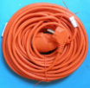
19-Nov-2021 | Hungary | Lighting Chain | Electrical Appliances | Burn Hazard, Electric Shock Hazard, Fire Hazard | 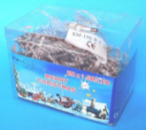
19-Nov-2021 | Croatia | Slime Toy | Toys and Childcare Products | Chemical Hazard | 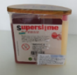
19-Nov-2021 | Bulgaria | Children’s Jacket | Fabric / Textile / Garment / Home Textile | Strangulation Hazard | 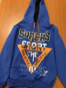
19-Nov-2021 | Hungary | Extension Cord | Electrical Appliances | Burn Hazard, Fire Hazard | 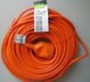
19-Nov-2021 | Bulgaria | Children’s Dress | Fabric / Textile / Garment / Home Textile | Choking Hazard | 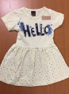
19-Nov-2021 | Bulgaria | Children’s Blouse | Fabric / Textile / Garment / Home Textile | Choking Hazard | 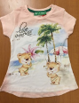
19-Nov-2021 | Finland | Soother Holder | Toys and Childcare Products | Choking Hazard | 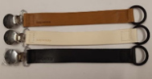
22-Nov-2021 | Lithuania | Tyre Repair Kit | Tools and Hardware | Chemical Hazard | 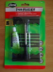
23-Nov-2021 | Hungary | Air Humidifier | Home Electrical Appliances | Electric Shock Hazard, Microbiological Hazard | 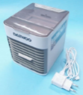
23-Nov-2021 | Hungary | Lighting Chain | Electrical Appliances | Electric Shock Hazard | 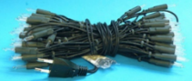
23-Nov-2021 | Sweden | Plastic Ball | Toys and Childcare Products | Chemical Hazard | 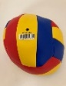
23-Nov-2021 | Belgium | Particle Filter Mask | Protective Equipment | Health Risk Hazard | 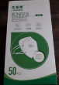
23-Nov-2021 | Lithuania | Plastic Doll | Toys and Childcare Products | Chemical Hazard | 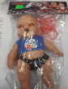
23-Nov-2021 | Sweden | Sunglasses | Protective Equipment | Chemical Hazard | 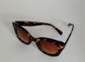
23-Nov-2021 | Poland | Plastic Doll | Toys and Childcare Products | Chemical Hazard | 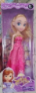
23-Nov-2021 | Sweden | Plastic Doll with Accessories | Toys and Childcare Products | Chemical Hazard, Environmental Hazard | 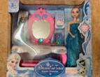
23-Nov-2021 | Poland | Plastic Doll | Toys and Childcare Products | Chemical Hazard
23-Nov-2021 | Sweden | Wireless Phone Charger | Computer / Audio / Video / Other Electronics & Accessories | Environmental Hazard | 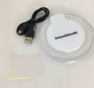
23-Nov-2021 | Sweden | Portable Mini Fan | Electrical Appliances | Environmental Hazard | 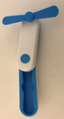
23-Nov-2021 | Sweden | Baby Doll | Toys and Childcare Products | Environmental Hazard | 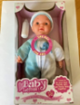
23-Nov-2021 | Sweden | Led Strip | Electrical Appliances | Environmental Hazard | 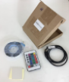
23-Nov-2021 | Sweden | USB Fan | Electrical Appliances | Environmental Hazard | 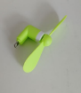
23-Nov-2021 | Sweden | Electrical Toy Wand | Toys and Childcare Products | Environmental Hazard | 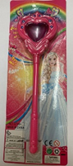
23-Nov-2021 | Sweden | Portable Blender | Home Electrical Appliances | Environmental Hazard | 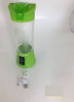
23-Nov-2021 | Sweden | Plastic Ball with Spikes (with Light and Sound) | Toys and Childcare Products | Environmental Hazard | 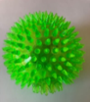
23-Nov-2021 | Sweden | Electrical Toy Piano | Toys and Childcare Products | Environmental Hazard | 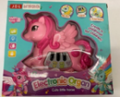
23-Nov-2021 | Hungary | Lighting Chain | Electrical Appliances | Burn Hazard, Electric Shock Hazard, Fire Hazard | 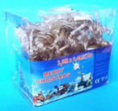
23-Nov-2021 | Germany | Bracelet | Jewelry | Chemical Hazard | 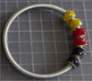
23-Nov-2021 | Finland | Shoes | Footwear | Chemical Hazard | 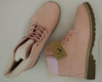  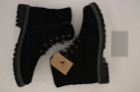
24-Nov-2021 | Slovakia | Necklace with Heart-Shaped Pendant | Jewelry | Chemical Hazard | 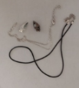
25-Nov-2021 | Slovakia | Wooden Puzzle | Toys and Childcare Products | Choking Hazard | 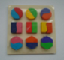
25-Nov-2021 | Poland | Toy Musical Instrument Set | Toys and Childcare Products | Choking Hazard, Cut Hazard, Damage to Hearing | 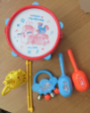
25-Nov-2021 | Poland | Plastic Toy | Toys and Childcare Products | Chemical Hazard, Choking Hazard | 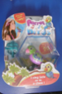
25-Nov-2021 | France | Earthed Socket Wall | Electrical Appliances | Electric Shock Hazard | 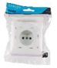
25-Nov-2021 | Lithuania | Electric Plug | Electrical Appliances | Electric Shock Hazard | 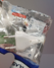
25-Nov-2021 | Finland | Cutting Mat | Stationery | Chemical Hazard | 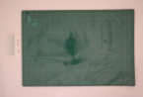
25-Nov-2021 | Hungary | Hair Dryer | Home Electrical Appliances | Electric Shock Hazard | 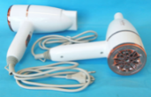
25-Nov-2021 | Italy | Particle Filter Mask | Protective Equipment | Health Risk Hazard | 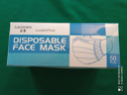
26-Nov-2021 | Poland | Magnetic Block | Toys and Childcare Products | Injury Hazard | 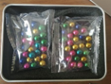
30-Nov-2021 | Ireland | Sleeping Bag | Toys and Childcare Products | Suffocation Hazard | 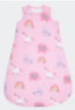
30-Nov-2021 | France | Children's Fancy-Dress Costume | Fabric / Textile / Garment / Home Textile | Choking Hazard, Suffocation Hazard | 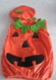
30-Nov-2021 | Lithuania | Electrical Toy Plane | Toys and Childcare Products | Environmental Hazard | 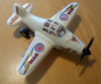
30-Nov-2021 | Sweden | Mosquito Racket | Electrical Appliances | Environmental Hazard | 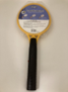
30-Nov-2021 | Hungary | Lighting Chain | Electrical Appliances | Burn Hazard, Electric Shock Hazard, Fire Hazard | 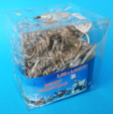
30-Nov-2021 | Hungary | Plastic Doll | Toys and Childcare Products | Chemical Hazard
30-Nov-2021 | Hungary | Plastic Doll | Toys and Childcare Products | Chemical Hazard | 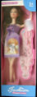
30-Nov-2021 | Hungary | Plastic Doll | Toys and Childcare Products | Chemical Hazard | 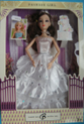
30-Nov-2021 | France | Babies' Soother | Toys and Childcare Products | Chemical Hazard | 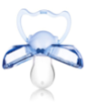
30-Nov-2021 | France | Babies' Soother | Toys and Childcare Products | Chemical Hazard | 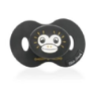
30-Nov-2021 | France | Babies' Soother | Toys and Childcare Products | Chemical Hazard | 