Recall Cases Summary – Europe (Last Update Date: 31 December 2021)

Date |  | Notifying Country | Product | Categories | Hazard | Image
 | 1-Dec-2021 | France | Children's Fancy Dress | Fabric / Textile / Garment / Home Textile | Injury Hazard, Strangulation Hazard, Suffocation Hazard | 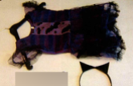
 | 1-Dec-2021 | France | Toy Telephone | Toys and Childcare Products | Choking Hazard, Suffocation Hazard | 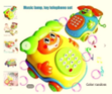
 | 1-Dec-2021 | France | Teddy Bear | Toys and Childcare Products | Choking Hazard | 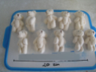
 | 1-Dec-2021 | France | Soft Toy | Toys and Childcare Products | Chemical Hazard, Choking Hazard, Suffocation Hazard | 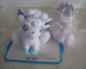
 | 1-Dec-2021 | Slovakia | Milling Machine | Machinery | Electric Shock Hazard, Injury Hazard | 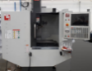
 | 1-Dec-2021 | Hungary | Bath Toy Set | Toys and Childcare Products | Choking Hazard | 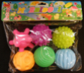
 | 1-Dec-2021 | Lithuania | Toy Bow with Arrow | Toys and Childcare Products | Choking Hazard | 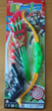
 | 1-Dec-2021 | Hungary | Toy Kitchen Set | Toys and Childcare Products | Suffocation Hazard | 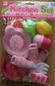
 | 1-Dec-2021 | Hungary | Plastic Doll | Toys and Childcare Products | Chemical Hazard | 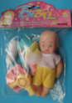
 | 1-Dec-2021 | Hungary | Toy Musical Instrument Set | Toys and Childcare Products | Choking Hazard | 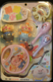
 | 1-Dec-2021 | Finland | Adjustable Wrench | Tools and Hardware | Chemical Hazard | 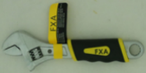
 | 1-Dec-2021 | Czechia | Inflatable Armband | Toys and Childcare Products | Chemical Hazard | 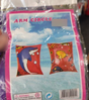
 | 1-Dec-2021 | Slovakia | Lighting Chain | Electrical Appliances | Electric Shock Hazard | 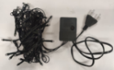
 | 2-Dec-2021 | Lithuania | Folding Chair | Furniture | Injury Hazard | 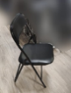
 | 2-Dec-2021 | Finland | Plush Toy with Suction Cup | Toys and Childcare Products | Chemical Hazard | 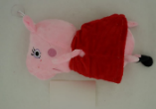
 | 2-Dec-2021 | Sweden | Soft Toy Rattle | Toys and Childcare Products | Choking Hazard | 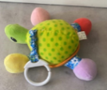
 | 2-Dec-2021 | France | Hair Colouring Shampoo | Bodycare / Cosmetics | Chemical Hazard
 | 2-Dec-2021 | France | Cream | Bodycare / Cosmetics | Chemical Hazard | 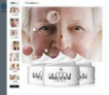
 | 2-Dec-2021 | Finland | Padel Racket | Sporting Goods / Equipment | Chemical Hazard | 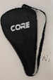  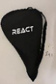
 | 2-Dec-2021 | France | Necklace | Jewelry | Chemical Hazard | 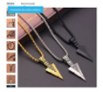
 | 2-Dec-2021 | Lithuania | Plastic Doll | Toys and Childcare Products | Chemical Hazard | 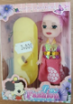
 | 2-Dec-2021 | Belgium | Toy Bow with Arrow | Toys and Childcare Products | Chemical Hazard | 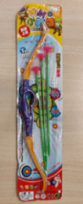
 | 2-Dec-2021 | Lithuania | Electric Toy | Toys and Childcare Products | Environmental Hazard | 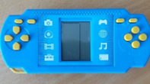
 | 2-Dec-2021 | France | Bracelet | Jewelry | Chemical Hazard | 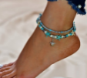
 | 2-Dec-2021 | France | Bracelet | Jewelry | Chemical Hazard | 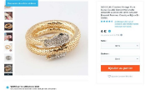
 | 2-Dec-2021 | France | Ring | Jewelry | Chemical Hazard | 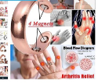
 | 2-Dec-2021 | France | Bracelet | Jewelry | Chemical Hazard | 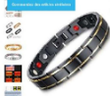
 | 2-Dec-2021 | Bulgaria | Plastic Fork | Food Contact Material | Injury Hazard | 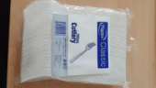
 | 2-Dec-2021 | Germany | Water Spray for Face and Body | Bodycare / Cosmetics | Microbiological Hazard | 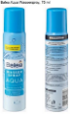  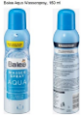
 | 3-Dec-2021 | Lithuania | Multiplug Socket | Electrical Appliances | Electric Shock Hazard | 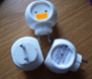
 | 3-Dec-2021 | Finland | Drinking Bottle | Food Contact Material | Choking Hazard, Suffocation Hazard | 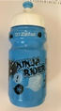
 | 3-Dec-2021 | Lithuania | Toy Plane | Toys and Childcare Products | Environmental Hazard | 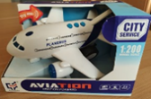
 | 3-Dec-2021 | Lithuania | Toy with Battery | Toys and Childcare Products | Environmental Hazard | 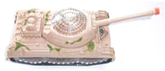
 | 3-Dec-2021 | Hungary | Toy Kitchen Set | Toys and Childcare Products | Suffocation Hazard | 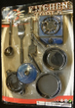
 | 6-Dec-2021 | Czechia | Plastic Doll | Toys and Childcare Products | Chemical Hazard | 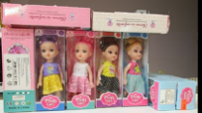
 | 7-Dec-2021 | Sweden | Electrical Toy Piano and Drum | Toys and Childcare Products | Environmental Hazard | 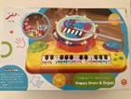
 | 7-Dec-2021 | Sweden | Electrical Remote-Controlled Car | Toys and Childcare Products | Environmental Hazard | 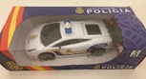
 | 7-Dec-2021 | Sweden | Tattoo Ink | Chemicals | Chemical Hazard | 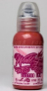
 | 7-Dec-2021 | Slovakia | Lighting Chain | Electrical Appliances | Electric Shock Hazard | 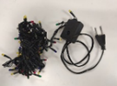
 | 7-Dec-2021 | France | Charger | Electrical Appliances | Electric Shock Hazard | 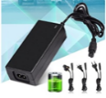
 | 7-Dec-2021 | France | Charger | Electrical Appliances | Electric Shock Hazard | 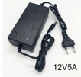
 | 7-Dec-2021 | Hungary | Fancy-Dress Mask | Toys and Childcare Products | Fire Hazard | 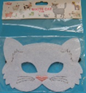
 | 7-Dec-2021 | Lithuania | Children's Sweater | Fabric / Textile / Garment / Home Textile | Strangulation Hazard | 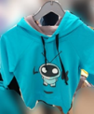
 | 7-Dec-2021 | Lithuania | Children's Sweater | Fabric / Textile / Garment / Home Textile | Strangulation Hazard | 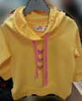
 | 7-Dec-2021 | Austria | Rattle Toy | Toys and Childcare Products | Choking Hazard | 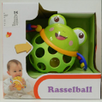
 | 7-Dec-2021 | Finland | Leather Skirt | Fabric / Textile / Garment / Home Textile | Chemical Hazard | 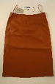
 | 7-Dec-2021 | Poland | Magnetic Ball | Toys and Childcare Products | Injury Hazard | 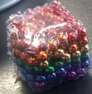
 | 7-Dec-2021 | Finland | Battery Charger | Electrical Appliances | Electric Shock Hazard | 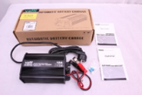
 | 7-Dec-2021 | Czechia | Plastic Doll | Toys and Childcare Products | Chemical Hazard | 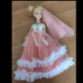
 | 7-Dec-2021 | France | Ring | Jewelry | Chemical Hazard | 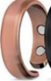
 | 7-Dec-2021 | Hungary | Toy Stroller with Doll | Toys and Childcare Products | Chemical Hazard | 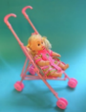
 | 7-Dec-2021 | France | Men’s Bracelet | Jewelry | Chemical Hazard | 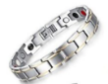
 | 7-Dec-2021 | France | USB Charger | Computer / Audio / Video / Other Electronics & Accessories | Electric Shock Hazard | 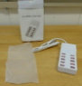  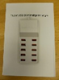
 | 8-Dec-2021 | Hungary | Toy Slime | Toys and Childcare Products | Chemical Hazard | 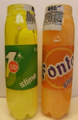
 | 8-Dec-2021 | France | Children's Mermaid Costume | Fabric / Textile / Garment / Home Textile | Strangulation Hazard | 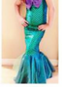
 | 8-Dec-2021 | Lithuania | Cement | Construction Products | Chemical Hazard | 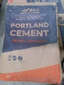
 | 8-Dec-2021 | Sweden | Toy Iron | Toys and Childcare Products | Environmental Hazard | 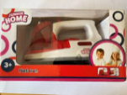
 | 9-Dec-2021 | France | Costume | Fabric / Textile / Garment / Home Textile | Choking Hazard | /
 | 9-Dec-2021 | Hungary | Air Humidifier | Home Electrical Appliances | Microbiological Hazard | 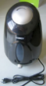
 | 9-Dec-2021 | France | Finger Paint | Toys and Childcare Products | Chemical Hazard | 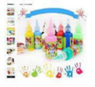
 | 9-Dec-2021 | Hungary | Lighting Chain | Electrical Appliances | Burn Hazard, Electric Shock Hazard, Fire Hazard | 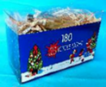
 | 9-Dec-2021 | France | Light Curtain | Electrical Appliances | Electric Shock Hazard | 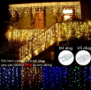
 | 9-Dec-2021 | France | USB Charger | Computer / Audio / Video / Other Electronics & Accessories | Electric Shock Hazard | 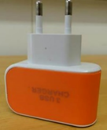
 | 9-Dec-2021 | France | USB Charger | Computer / Audio / Video / Other Electronics & Accessories | Electric Shock Hazard | 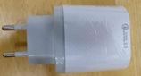
 | 9-Dec-2021 | France | Plush Toy | Toys and Childcare Products | Choking Hazard | 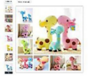
 | 10-Dec-2021 | Hungary | Filled-In Balloon | Toys and Childcare Products | Choking Hazard | 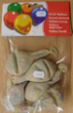
 | 10-Dec-2021 | France | Ankle Bracelet | Jewelry | Chemical Hazard | 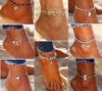
 | 10-Dec-2021 | France | Children's Bikini | Fabric / Textile / Garment / Home Textile | Strangulation Hazard | 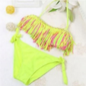
 | 10-Dec-2021 | Belgium | Plastic Doll | Toys and Childcare Products | Chemical Hazard | 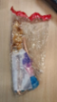
 | 10-Dec-2021 | Finland | Worktop for Ladder | Tools and Hardware | Injury Hazard | 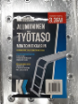
 | 10-Dec-2021 | France | Children’s Bath Thermometer | Toys and Childcare Products | Burn Hazard, Choking Hazard, Cut Hazard | 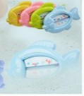
 | 10-Dec-2021 | Romania | Children's Tracksuit | Fabric / Textile / Garment / Home Textile | Injury Hazard, Strangulation Hazard | 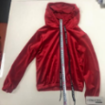  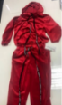
 | 13-Dec-2021 | Italy | Decorative Spray | Chemicals | Burn Hazard | 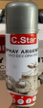
 | 13-Dec-2021 | Italy | Decorative Spray | Chemicals | Burn Hazard | 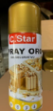
 | 13-Dec-2021 | Denmark | Baby Gym | Toys and Childcare Products | Choking Hazard | 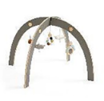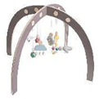
 | 13-Dec-2021 | Germany | Particle Filter Mask | Protective Equipment | Health Risk Hazard | 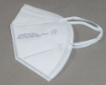
 | 13-Dec-2021 | Belgium | Particle Filter Mask | Protective Equipment | Health Risk Hazard | 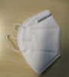
 | 13-Dec-2021 | Portugal | Disposable Vinyl Gloves | Protective Equipment | Health Risk Hazard | 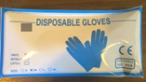
 | 13-Dec-2021 | Portugal | Community Face Covering | Protective Equipment | Health Risk Hazard | 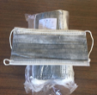
 | 14-Dec-2021 | Hungary | Extension Cord | Electrical Appliances | Burn Hazard, Fire Hazard | 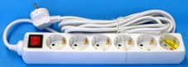
 | 14-Dec-2021 | France | USB Charger | Computer / Audio / Video / Other Electronics & Accessories | Electric Shock Hazard | 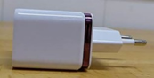
 | 14-Dec-2021 | Lithuania | Children's Sweater | Fabric / Textile / Garment / Home Textile | Strangulation Hazard | 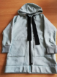
 | 14-Dec-2021 | Lithuania | Children's Tracksuit | Fabric / Textile / Garment / Home Textile | Strangulation Hazard | 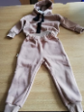
 | 14-Dec-2021 | Romania | Babies' Hat | Fabric / Textile / Garment / Home Textile | Choking Hazard | 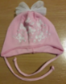
 | 14-Dec-2021 | Romania | Babies' Hat | Fabric / Textile / Garment / Home Textile | Choking Hazard | 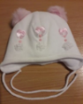
 | 14-Dec-2021 | Ireland | Children's Sleepwear | Fabric / Textile / Garment / Home Textile | Burn Hazard | 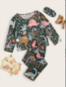  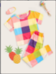
 | 14-Dec-2021 | Italy | Lighting Chain | Electrical Appliances | Electric Shock Hazard, Fire Hazard | 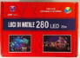  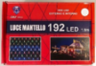  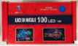
 | 14-Dec-2021 | Lithuania | Plastic Toy | Toys and Childcare Products | Choking Hazard, Suffocation Hazard | 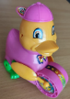
 | 14-Dec-2021 | Hungary | Toy Set | Toys and Childcare Products | Chemical Hazard | 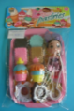
 | 14-Dec-2021 | Poland | Magnetic Ball | Toys and Childcare Products | Injury Hazard | 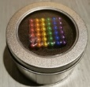
 | 14-Dec-2021 | Cyprus | Children's Bikini | Fabric / Textile / Garment / Home Textile | Injury Hazard, Strangulation Hazard | 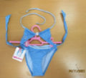
 | 14-Dec-2021 | Cyprus | Children's Bikini | Fabric / Textile / Garment / Home Textile | Injury Hazard, Strangulation Hazard | 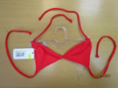
 | 14-Dec-2021 | Lithuania | Yoyo Ball | Toys and Childcare Products | Suffocation Hazard | 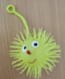
 | 14-Dec-2021 | Germany | Water Spray | Bodycare / Cosmetics | Microbiological Hazard
 | 14-Dec-2021 | Cyprus | Multi-Functional Toy | Toys and Childcare Products | Choking Hazard | 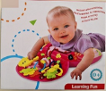
 | 14-Dec-2021 | Cyprus | Plastic Doll | Toys and Childcare Products | Choking Hazard | 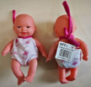
 | 14-Dec-2021 | Austria | Children’s Gardening Set | Toys and Childcare Products | Chemical Hazard | 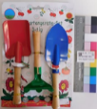
 | 15-Dec-2021 | Belgium | Protective Filter Mask for Children | Protective Equipment | Health Risk Hazard | 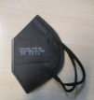
 | 15-Dec-2021 | Belgium | Firework | Outdoor Living Items | Injury Hazard | 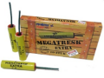
 | 15-Dec-2021 | Belgium | Firework | Outdoor Living Items | Injury Hazard | 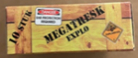  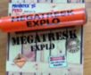
 | 15-Dec-2021 | Ireland | Baby Nest | Toys and Childcare Products | Strangulation Hazard | 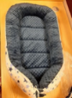
15-Dec-2021 |  | Hungary | Musical Toy | Toys and Childcare Products | Chemical Hazard | 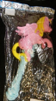
15-Dec-2021 |  | Hungary | Soother Holder | Toys and Childcare Products | Choking Hazard, Suffocation Hazard | 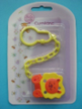
16-Dec-2021 |  | Sweden | Charger | Electrical Appliances | Electric Shock Hazard | 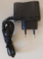
16-Dec-2021 |  | Hungary | Aroma Diffuser | Home Electrical Appliances | Microbiological Hazard | 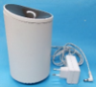  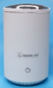
16-Dec-2021 |  | Hungary | Aroma Diffuser | Home Electrical Appliances | Microbiological Hazard | 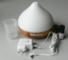
16-Dec-2021 |  | Sweden | Hand Fan | Outdoor Living Items | Chemical Hazard | 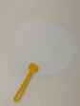
16-Dec-2021 |  | Sweden | Plastic Doll | Toys and Childcare Products | Chemical Hazard, Environmental Hazard | 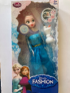
16-Dec-2021 |  | Lithuania | Toy Set | Toys and Childcare Products | Choking Hazard, Injury Hazard | 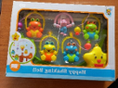
16-Dec-2021 |  | Hungary | Particle Filter Mask | Protective Equipment | Health Risk Hazard | 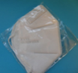  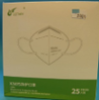
16-Dec-2021 |  | Sweden | Electrical Toy Gun | Toys and Childcare Products | Environmental Hazard | 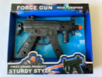
16-Dec-2021 |  | Sweden | Beach Sandals | Footwear | Chemical Hazard, Environmental Hazard | 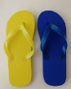
16-Dec-2021 |  | Sweden | Beach Sandals | Footwear | Chemical Hazard, Environmental Hazard | 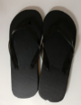
16-Dec-2021 |  | Sweden | Toy Robot | Toys and Childcare Products | Chemical Hazard | 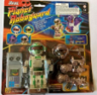
16-Dec-2021 |  | Finland | Air Cooler | Home Electrical Appliances | Electric Shock Hazard | 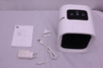
16-Dec-2021 |  | Poland | Toy Xylophone | Toys and Childcare Products | Choking Hazard | 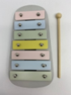
16-Dec-2021 |  | Hungary | Toy Cooking Set | Toys and Childcare Products | Choking Hazard | 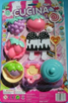
16-Dec-2021 |  | Poland | Children’s Hair Clip with LED Light | Accessories | Chemical Hazard, Choking Hazard | 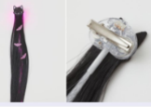
 | 17-Dec-2021 | Hungary | Cord Extension Set | Electrical Appliances | Burn Hazard, Fire Hazard | 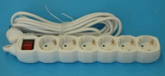
 | 17-Dec-2021 | Sweden | Anti-Insect Lamp | Home Electrical Appliances | Chemical Hazard, Environmental Hazard | 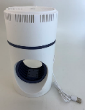
 | 17-Dec-2021 | Hungary | Lighting Chain | Electrical Appliances | Burn Hazard, Electric Shock Hazard, Fire Hazard | 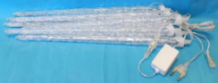
 | 17-Dec-2021 | Cyprus | Plastic Toy | Toys and Childcare Products | Choking Hazard | 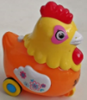
 | 17-Dec-2021 | Cyprus | Toy Car | Toys and Childcare Products | Choking Hazard | 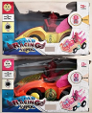
 | 17-Dec-2021 | Hungary | Toy Mask | Toys and Childcare Products | Burn Hazard | 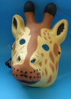
 | 17-Dec-2021 | Germany | Respirator/FFP3 Protective Mask | Protective Equipment | Health Risk Hazard | 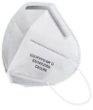
 | 17-Dec-2021 | Hungary | Extension Cord | Electrical Appliances | Burn Hazard, Fire Hazard | 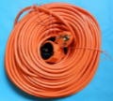
 | 17-Dec-2021 | France | LED Lighting Chain | Electrical Appliances | Electric Shock Hazard, Fire Hazard | 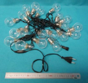
 | 17-Dec-2021 | France | Babies' Soother with Thermometer | Toys and Childcare Products | Chemical Hazard | 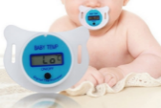
 | 17-Dec-2021 | Belgium | Particle Filter Mask | Protective Equipment | Health Risk Hazard | 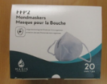
 | 17-Dec-2021 | Germany | Tukataka Learning Tower | Furniture | Injury Hazard | 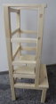
 | 17-Dec-2021 | Romania | False Nails | Bodycare / Cosmetics | Chemical Hazard | 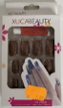
17-Dec-2021 |  | Belgium | Toy Bow and Arrow | Toys and Childcare Products | Choking Hazard | 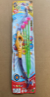
17-Dec-2021 |  | Belgium | Toy Rattle | Toys and Childcare Products | Choking Hazard, Suffocation Hazard | 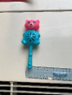  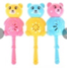
17-Dec-2021 |  | Belgium | Toy Musical Instrument | Toys and Childcare Products | Choking Hazard, Damage to Hearing, Strangulation Hazard | 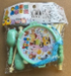  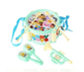
17-Dec-2021 |  | Belgium | Pull-Along Toy | Toys and Childcare Products | Choking Hazard, Suffocation Hazard
17-Dec-2021 |  | Belgium | Toy Rattle | Toys and Childcare Products | Choking Hazard | 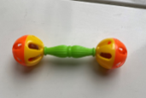
17-Dec-2021 |  | Belgium | Inflatable Toy | Toys and Childcare Products | Choking Hazard | 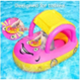
20-Dec-2021 |  | Ireland | Eyebrow Gel | Bodycare / Cosmetics | Microbiological Hazard | 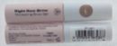  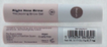  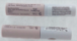  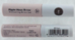  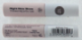
20-Dec-2021 |  | Germany | Particle Filter Mask | Protective Equipment | Health Risk Hazard | 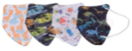
20-Dec-2021 |  | Bulgaria | Wooden Bed | Furniture | Injury Hazard
20-Dec-2021 |  | Sweden | Sun Protection for Windshield | Outdoor Living Items | Chemical Hazard, Environmental Hazard | 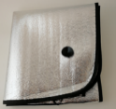
20-Dec-2021 |  | Cyprus | Teething Toy | Toys and Childcare Products | Choking Hazard | 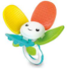  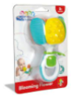
20-Dec-2021 |  | Cyprus | Toy Police Set | Toys and Childcare Products | Choking Hazard | 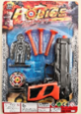
20-Dec-2021 |  | Sweden | Wader Boots | Footwear | Chemical Hazard, Environmental Hazard | 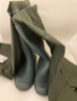
20-Dec-2021 |  | France | Welding Glue | Chemicals | Chemical Hazard, Health Risk Hazard | 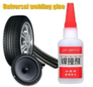
20-Dec-2021 |  | Hungary | Plastic String | Toys and Childcare Products | Chemical Hazard
20-Dec-2021 |  | Finland | Children's Cutlery Set | Food Contact Material | Choking Hazard, Suffocation Hazard | 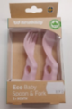
20-Dec-2021 |  | Hungary | Costume Beard with Moustache | Toys and Childcare Products | Burn Hazard | 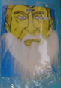
21-Dec-2021 |  | Hungary | Vibroshaper (Stationary Training Equipment) | Sporting Goods / Equipment | Injury Hazard | 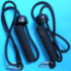  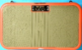
21-Dec-2021 |  | Czechia | Scissor Jack | Machinery | Injury Hazard | 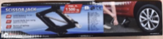
21-Dec-2021 |  | Sweden | Headphones | Computer / Audio / Video / Other Electronics & Accessories | Chemical Hazard, Environmental Hazard | 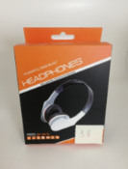
21-Dec-2021 |  | France | Lightening Cream | Bodycare / Cosmetics | Chemical Hazard | 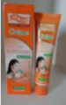
21-Dec-2021 |  | Hungary | Laser Pointer | Electrical Appliances | Damage to Sight, Electric Shock Hazard | 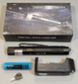
21-Dec-2021 |  | Romania | Baby Sweater | Fabric / Textile / Garment / Home Textile | Choking Hazard | 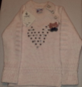  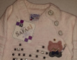
21-Dec-2021 |  | Sweden | Neck Massager | Electrical Appliances | Chemical Hazard, Environmental Hazard | 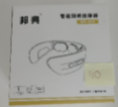
21-Dec-2021 |  | Sweden | Toy Light Saber | Toys and Childcare Products | Environmental Hazard | 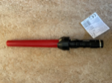
21-Dec-2021 |  | Sweden | Portable Mini Fan | Electrical Appliances | Environmental Hazard | 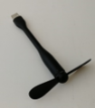
21-Dec-2021 |  | Sweden | Electrical Toy Squirrel | Toys and Childcare Products | Environmental Hazard | 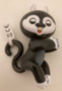
21-Dec-2021 |  | Belgium | Particle Filter Mask | Protective Equipment | Health Risk Hazard | 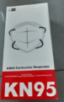
21-Dec-2021 |  | Hungary | Laser Pointer | Electrical Appliances | Damage to Sight
21-Dec-2021 |  | Belgium | Particle Filter Mask | Protective Equipment | Health Risk Hazard | 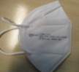  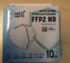
21-Dec-2021 |  | Romania | Baby Sweater | Fabric / Textile / Garment / Home Textile | Choking Hazard | 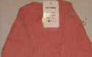  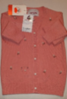
22-Dec-2021 |  | Germany | Robot Vacuum Cleaner | Home Electrical Appliances | Electric Shock Hazard | 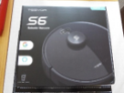
22-Dec-2021 |  | Sweden | Headphones | Computer / Audio / Video / Other Electronics & Accessories | Chemical Hazard, Environmental Hazard | 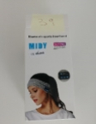
22-Dec-2021 |  | Sweden | Tattoo Ink | Chemicals | Chemical Hazard | 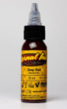
22-Dec-2021 |  | Sweden | Tattoo Ink | Chemicals | Chemical Hazard | 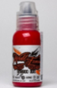
22-Dec-2021 |  | Sweden | Tattoo Ink | Chemicals | Chemical Hazard | 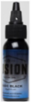
22-Dec-2021 |  | Sweden | Tattoo Ink | Chemicals | Chemical Hazard | 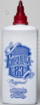
22-Dec-2021 |  | Italy | Toy Slime | Toys and Childcare Products | Chemical Hazard | 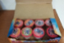  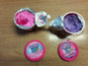
22-Dec-2021 |  | Ireland | Disposable Electronic Cigarette | Chemicals | Chemical Hazard | 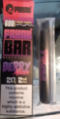
22-Dec-2021 |  | Ireland | Disposable Electronic Cigarette | Chemicals | Chemical Hazard | 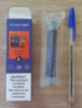
22-Dec-2021 |  | Ireland | Disposable Electronic Cigarette | Chemicals | Chemical Hazard | 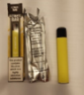
22-Dec-2021 |  | Ireland | Disposable Electronic Cigarette | Chemicals | Chemical Hazard
22-Dec-2021 |  | Ireland | Disposable Electronic Cigarette | Chemicals | Chemical Hazard | 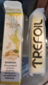
22-Dec-2021 |  | Ireland | Disposable Electronic Cigarette | Chemicals | Chemical Hazard | 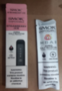
22-Dec-2021 |  | Ireland | Disposable Electronic Cigarette | Chemicals | Chemical Hazard
22-Dec-2021 |  | Ireland | Disposable Electronic Cigarette | Chemicals | Chemical Hazard
22-Dec-2021 |  | Ireland | Disposable Electronic Cigarette | Chemicals | Chemical Hazard | 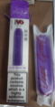
22-Dec-2021 |  | Ireland | Disposable Electronic Cigarette | Chemicals | Chemical Hazard | 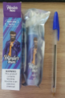
22-Dec-2021 |  | Ireland | Disposable Electronic Cigarette | Chemicals | Chemical Hazard | 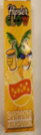
22-Dec-2021 |  | Ireland | Disposable Electronic Cigarette | Chemicals | Chemical Hazard | 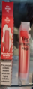  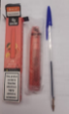
22-Dec-2021 |  | Ireland | Disposable Electronic Cigarette | Chemicals | Chemical Hazard | 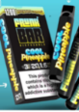
22-Dec-2021 |  | Ireland | Disposable Electronic Cigarette | Chemicals | Chemical Hazard | 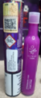
22-Dec-2021 |  | Ireland | Disposable Electronic Cigarette | Chemicals | Chemical Hazard
22-Dec-2021 |  | Ireland | Disposable Electronic Cigarette | Chemicals | Chemical Hazard | 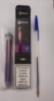
22-Dec-2021 |  | Ireland | Disposable Electronic Cigarette | Chemicals | Chemical Hazard | 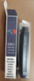  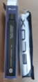
22-Dec-2021 |  | Ireland | Disposable Electronic Cigarette | Chemicals | Chemical Hazard | 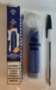
22-Dec-2021 |  | Ireland | Disposable Electronic Cigarette | Chemicals | Chemical Hazard | 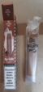
22-Dec-2021 |  | Ireland | Disposable Electronic Cigarette | Chemicals | Chemical Hazard | 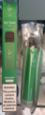
22-Dec-2021 |  | Ireland | Disposable Electronic Cigarette | Chemicals | Chemical Hazard | 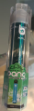
22-Dec-2021 |  | Germany | Particle Filter Mask | Protective Equipment | Health Risk Hazard | 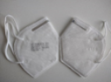  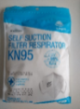
22-Dec-2021 |  | Sweden | Plastic Ball | Sporting Goods / Equipment | Environmental Hazard | 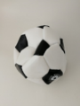
22-Dec-2021 |  | Germany | Plastic Straw | Food Contact Material | Chemical Hazard | 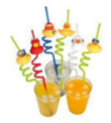
22-Dec-2021 |  | Germany | Children’s Strapped Sandals | Footwear | Chemical Hazard | 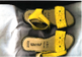
22-Dec-2021 |  | Sweden | Ceiling Lamp | Electrical Appliances | Electric Shock Hazard | 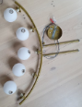
23-Dec-2021 |  | The Netherlands | Bracelet | Jewelry | Environmental Hazard, Health Risk Hazard,  Radiation Hazard | 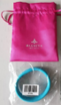  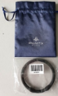  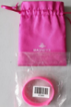
23-Dec-2021 |  | The Netherlands | Necklace | Jewelry | Environmental Hazard, Health Risk Hazard, Radiation Hazard | 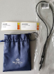
23-Dec-2021 |  | The Netherlands | Bracelet | Jewelry | Environmental Hazard, Health Risk Hazard, Radiation Hazard | 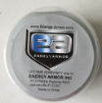  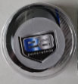
23-Dec-2021 |  | The Netherlands | Necklace | Jewelry | Environmental Hazard, Health Risk Hazard, Radiation Hazard | 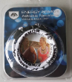
23-Dec-2021 |  | The Netherlands | Pendant | Jewelry | Environmental Hazard, Health Risk Hazard, Radiation Hazard | 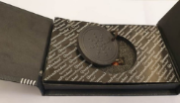
24-Dec-2021 |  | Poland | Circular Saw | Machinery | Cut Hazard, Injury Hazard | 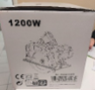  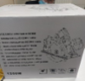
24-Dec-2021 |  | Hungary | USB Charger | Computer / Audio / Video / Other Electronics & Accessories | Electric Shock Hazard | 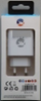  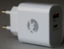
24-Dec-2021 |  | Hungary | Extension Cord | Electrical Appliances | Burn Hazard, Fire Hazard | 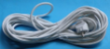
24-Dec-2021 |  | Portugal | Child’s Sleeping Bag | Toys and Childcare Products | Entrapment Hazard, Suffocation Hazard | 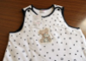  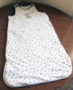
24-Dec-2021 |  | Poland | Bath Toy | Toys and Childcare Products | Chemical Hazard | 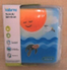
24-Dec-2021 |  | Denmark | Soother | Toys and Childcare Products | Choking Hazard | 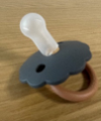
24-Dec-2021 |  | Bulgaria | Babies' Cot | Furniture | Injury Hazard | 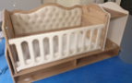
24-Dec-2021 |  | Cyprus | Toy Bow and Arrow Set | Toys and Childcare Products | Choking Hazard | 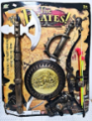
24-Dec-2021 |  | France | Glue | Chemicals | Chemical Hazard, Health Risk Hazard | 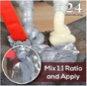
24-Dec-2021 |  | Sweden | Skip Rope | Sporting Goods / Equipment | Chemical Hazard, Environmental Hazard | 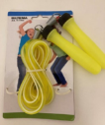
24-Dec-2021 |  | Sweden | Plastic Cover for Greenhouse | Outdoor Living Items | Environmental Hazard | 