Recall Cases Summary – Australia (Last Update Date: 31 January 2022)

Date | Product | Categories | Hazard | Image
4-Jan-2022 | Chocolate Domes - Milk Chocolate - Coconut Crunch 124g | Food | Risk of Allergy | 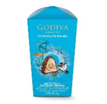  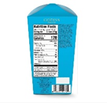
4-Jan-2022 | Detox Tea with Added Probiotics 30g (20 Tea Bags) | Food | Microbiological Hazard | 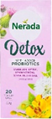
6-Jan-2022 | Baby Wooden Rattle with Wood Rings and Hand Grip | Toys and Childcare Products | Choking Hazard, Suffocation Hazard | 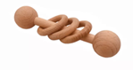
7-Jan-2022 | Dual Gas and Particulate Respirator Combination Cartridge | Protective Equipment | Health Risk Hazard | 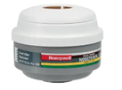
11-Jan-2022 | Wooden Rattle Gift Set Containing a Wooden Rattle, Rattle Ring and Pacifier Chain | Toys and Childcare Products | Choking Hazard, Suffocation Hazard | 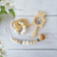  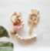
12-Jan-2022 | HUGGIES Thick Baby Wipes, Fragrance Free - Limited Edition Tropical - The Little Mermaid and Toy Story's Rex Dinosaur Design | Bodycare / Cosmetics | Microbiological Hazard | 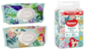  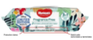
14-Jan-2022 | Lidocaine Hydrochloride Topical Solution USP, 4%, 50mL | Pharmacy | Health Risk Hazard | /
14-Jan-2022 | Tohato Caramel Corn Original Flavour 80g | Food | Risk of Allergy | 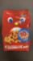  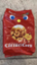
14-Jan-2022 | Wooden Baby Infant Montessori Rattle Interlock Beads Ring Set of 5 with Bag Natural Finish Bundle | Toys and Childcare Products | Choking Hazard, Suffocation Hazard
17-Jan-2022 | IQ Bar 45g  1. Chocolate Sea Salt  2. Peanut Butter Chip  3. Almond Butter Chip | Food | Risk of Allergy | 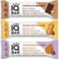
18-Jan-2022 | Silicone Koala Rattle | Toys and Childcare Products | Choking Hazard, Suffocation Hazard | 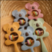
19-Jan-2022 | Bestway Aqua Bone Assorted Characters Pool Noodle | Sporting Goods / Equipment | Drowning Hazard | 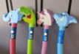  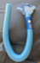
19-Jan-2022 | The Sun Print Romper | Fabric / Textile / Garment / Home Textile | Choking Hazard, Suffocation Hazard | 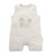
19-Jan-2022 | Invacare Perfecto2 V Oxygen Concentrator | Pharmacy | Fire Hazard | /
20-Jan-2022 | Learn 500 Oxelo Scooters in Blue and Pink | Sporting Goods / Equipment | Injury Hazard | 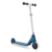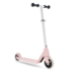
20-Jan-2022 | NutTAG Find3 Bluetooth Key Finder | Electrical Appliances | Burn Hazard, Choking Hazard
20-Jan-2022 | Hooded Towels with Sleeves or Arm Openings | Fabric / Textile / Garment / Home Textile | Fire Hazard | 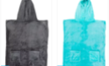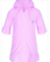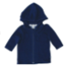
21-Jan-2022 | Devondale Salted Butter 250g, Devondale Salted Butter 500g, Devondale Salted Butter 3 x 500g, Devondale Unsalted Butter 500g, Devondale Spreadable Dairy Soft Original 500g, Devondale Spreadable Dairy Soft Salt Reduced 500g, Woolworths Australian Butter Salted 250g, Woolworths Australian Butter Unsalted 250g | Food | Microbiological Hazard | 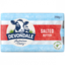  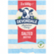  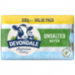  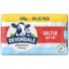  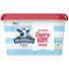  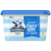  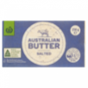  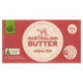
25-Jan-2022 | Silicone Koala Rattle | Toys and Childcare Products | Choking Hazard, Suffocation Hazard | 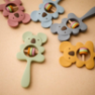
27-Jan-2022 | TWM Pedestal Misting Fan | Home Electrical Appliances | Electric Shock Hazard | 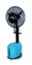
28-Jan-2022 | Barbell Ring Rattle | Toys and Childcare Products | Choking Hazard, Suffocation Hazard | 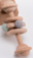
28-Jan-2022 | LED Neon Light Power Supply | Electrical Appliances | Electric Shock Hazard | 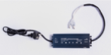
31-Jan-2022 | Googly Eyes, Flashing Candy Critters and Candy Jellyfish | Toys and Childcare Products | Strangulation Hazard | 