Recall Cases Summary – Canada (Last Update Date: 31 March 2022)

Date | Product | Categories | Hazard | Image
1-Mar-2022 | Inderal-LA (Propranolol Hydrochloride) Capsule | Pharmacy | Health Risk Hazard | /
2-Mar-2022 | Petzl PIRANA Descender | Tools and Hardware | Drowning Hazard | 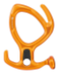  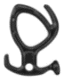
2-Mar-2022 | Ionic Smartwatch | Electrical Appliances | Burn Hazard | 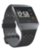
2-Mar-2022 | Savaria and Garaventa Branded Residential Elevator | Machinery | Entrapment Hazard | 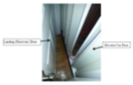
3-Mar-2022 | Accuretic Blood Pressure Tablet | Pharmacy | Health Risk Hazard | /
4-Mar-2022 | Bioderma Sensibio H2O Micellar Water Makeup Remover | Bodycare / Cosmetics | Microbiological Hazard | 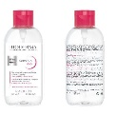
4-Mar-2022 | Frozen Fish Cake | Food | Risk of Allergy | /
9-Mar-2022 | Be the Band Music set | Toys and Childcare Products | Choking Hazard | 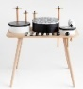  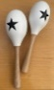
9-Mar-2022 | Giant Value Drain Opener | Chemicals | Injury Hazard | 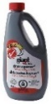
10-Mar-2022 | Dark Chocolate | Food | Risk of Allergy | 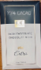  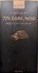
11-Mar-2022 | Vegetarian Mushroom Jerky | Food | Risk of Allergy | 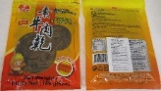
12-Mar-2022 | Classic Hash Brown Patties, Potato Patties | Food | Risk of Allergy | /
16-Mar-2022 | Wooden Activity Toddler Walker | Toys and Childcare Products | Choking Hazard | 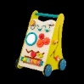
16-Mar-2022 | RH Illuminated Mirror | Home Electrical Appliances | Fire Hazard, Electric Shock Hazard | 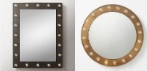  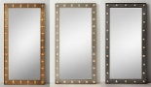
16-Mar-2022 | Mushroom | Food | Microbiological Hazard
17-Mar-2022 | Watch | Accessories | Burn Hazard, Fire Hazard | 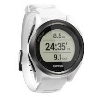  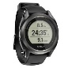
18-Mar-2022 | Oyster | Food | Microbiological Hazard | 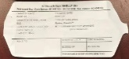
21-Mar-2022 | Urban Kids Plush All-Over Print Robe | Fabric / Textile / Garment / Home Textile | Burn Hazard | 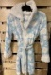  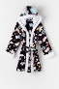  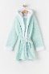  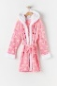  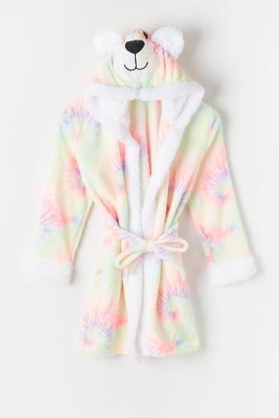  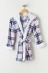  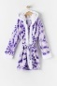
22-Mar-2022 | Wooden Magnetic Alphabet Train Set | Toys and Childcare Products | Chemical Hazard | 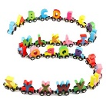
22-Mar-2022 | Vegetarian Mushroom Jerky (Hot) | Food | Risk of Allergy | 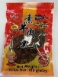
23-Mar-2022 | Chef Creek Oyster | Food | Microbiological Hazard | 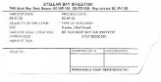
24-Mar-2022 | Bluetooth Speaker Helmet | Protective Equipment | Injury Hazard | 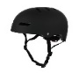
25-Mar-2022 | Electric Corded Snowblower | Electrical Appliances | Electric Shock Hazard | 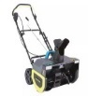
25-Mar-2022 | Progressive Nut Chopper | Home Electrical Appliances | Ingestion Hazard, Injury Hazard | 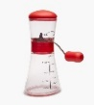
25-Mar-2022 | Jimel’s Bakery Brand Baked Goods | Food | Microbiological Hazard | 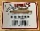  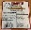  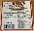  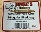  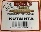  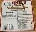  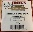  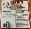  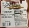  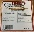  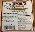  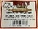  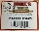  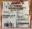  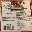
27-Mar-2022 | Oyster | Food | Microbiological Hazard | 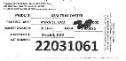  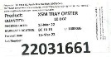
27-Mar-2022 | Oyster | Food | Microbiological Hazard | 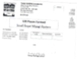  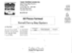
29-Mar-2022 | Safety Shoes | Footwear | Safety Risk Hazard | 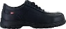  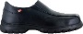  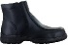
30-Mar-2022 | OLAIAN, Kids' Surf Ponchos | Fabric / Textile / Garment / Home Textile | Burn Hazard | 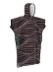  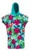  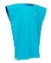  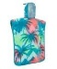  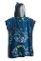
30-Mar-2022 | Paw Patrol Plastic Drinking Bottle | Food Contact Material | Choking Hazard | 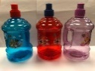
31-Mar-2022 | Kid O Hudson Glow Rattle | Toys and Childcare Products | Choking Hazard | 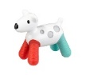
31-Mar-2022 | Oysters | Food | Microbiological Hazard | 