Recall Cases Summary – Australia (Last Update Date: 31 July 2022)

Date | Product | Categories | Hazard | Image
1-Jul-2022 | Thai Coconut Wild Rice Prepared Salad 500g | Food | Risk of Allergy | 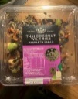
1-Jul-2022 | Jenny Craig Melting Moment 21g | Food | Risk of Allergy | 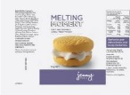
5-Jul-2022 | Lay's Potato Chips 70g | Food | Risk of Allergy | 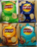
7-Jul-2022 | Coles Tomato Paste 170g and 500g | Food | Risk of Allergy | 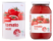
7-Jul-2022 | Schwinn Voador and Kettle Valley Electric Bicycles MY2021-2022 | Sporting Goods / Equipment | Injury Hazard | 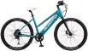  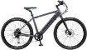  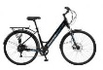
8-Jul-2022 | Smoked Salmon Pate 175g and Everyday Smoked Salmon Pate 150g | Food | Microbiological Hazard | 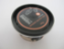  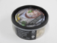
10-Jul-2022 | Häagen-Dazs Vanilla 457mL and Häagen-Dazs Classic Collection Mini Cups 4 x 95mL | Food | Chemical Hazard | 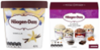
12-Jul-2022 | Lucas’ Papaw Ointment 15g, 75g, 200g | Bodycare / Cosmetics | Microbiological Hazard | 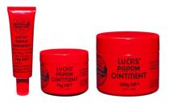
15-Jul-2022 | Reese’s Dipped Pretzels 120g | Food | Risk of Allergy | 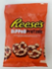
18-Jul-2022 | Cleanfit Plant Protein Bar Chocolate Brownie 50g | Food | Risk of Allergy | 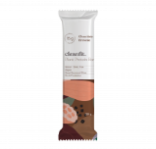
19-Jul-2022 | Noirot Spot Plus Wifi Electric Panel Heater | Home Electrical Appliances | Fire Hazard, Electric Shock Hazard, Injury Hazard | 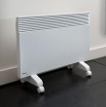
19-Jul-2022 | Brompton P Line Bike | Sporting Goods / Equipment | Injury Hazard | 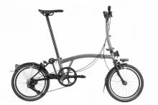
19-Jul-2022 | Fantastic Sea Ocean Series Dolphin Swimming Bath Toy | Toys and Childcare Products | Choking Hazard, Suffocation Hazard, Injury Hazard | 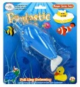
20-Jul-2022 | Bean Bag Cover with Footstool Cover | Household Items | Choking Hazard, Suffocation Hazard | 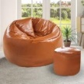
20-Jul-2022 | Wooden Bead Octagon Toy Set | Toys and Childcare Products | Choking Hazard, Suffocation Hazard, Injury Hazard | 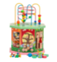
20-Jul-2022 | Wooden Toy Playhouse Set | Toys and Childcare Products | Choking Hazard, Suffocation Hazard, Injury Hazard | 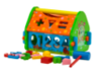
22-Jul-2022 | Raita Spice Blend 30g, Chaat Masala 50g and Black Salt 40g | Food | Risk of Allergy | 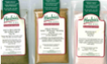
25-Jul-2022 | Little Tikes 3-in-1 Activity Walker | Toys and Childcare Products | Fall Hazard, Injury Hazard | 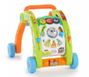
26-Jul-2022 | Various Smoked Fish Product | Food | Microbiological Hazard | 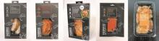
28-Jul-2022 | Base Bar of Bicycle | Sporting Goods / Equipment | Fall Hazard, Injury Hazard | 