Recall Cases Summary – Canada (Last Update Date: 31 July 2022)

Date | Product | Categories | Hazard | Image
1-Jul-2022 | TWA Fungi Brand King Oyster Mushroom | Food | Microbiological Hazard | 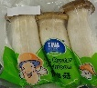
5-Jul-2022 | PADERNO 1.7 Qt Glass Square Baking Dish | Food Contact Material | Injury Hazard | 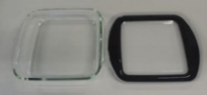
5-Jul-2022 | Horizontal Venetian Slat Light Filtering Mini Window Blind | Household Items | Strangulation Hazard, Choking Hazard, Entanglement Hazard
5-Jul-2022 | Dark Chocolate Fig Truffles | Food | Risk of Allergy | /
7-Jul-2022 | Scholastic Canada Ltd. The Shake Look Touch book | Toys and Childcare Products | Choking Hazard | 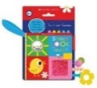  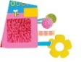
12-Jul-2022 | Enoki Mushroom | Food | Microbiological Hazard | 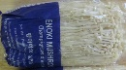
12-Jul-2022 | Arlo Blinds Cordless Lift Bamboo Shade | Household Items | Strangulation Hazard, Entanglement Hazard | 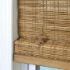  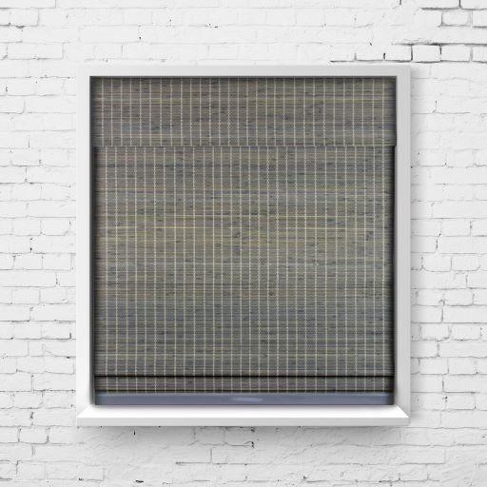  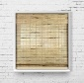  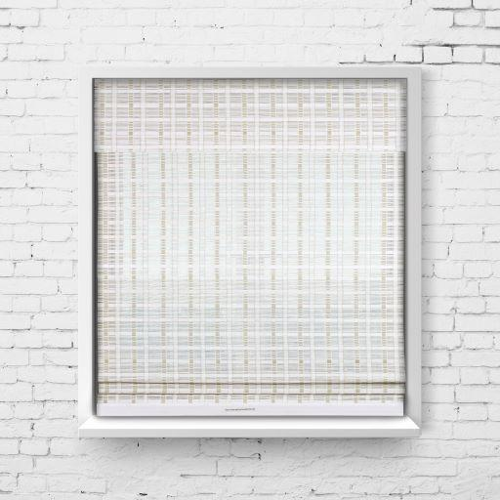
13-Jul-2022 | Cyme-Tech Low Profile Murphy Bed | Furniture | Tip-Over Hazard, Entanglement Hazard, Injury Hazard | 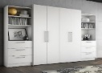  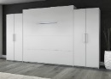
13-Jul-2022 | Vichy LiftActiv Peptide-C Ampoules, 1.8ml | Bodycare / Cosmetics | Laceration Hazard | 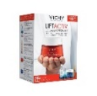  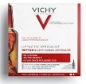  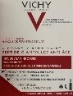
14-Jul-2022 | Cabela’s Outfitter and Big Horn Tent | Outdoor Living Items | Injury Hazard | 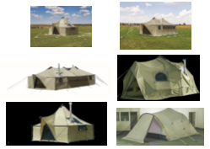
15-Jul-2022 | Crave Stevia Brand Chocolate Product | Food | Risk of Allergy | 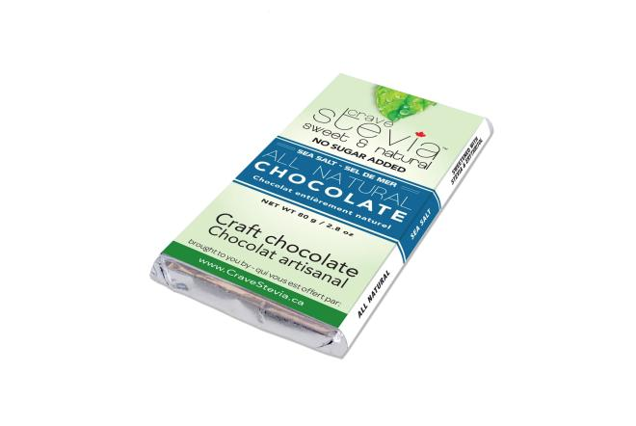  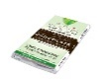  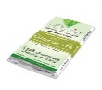  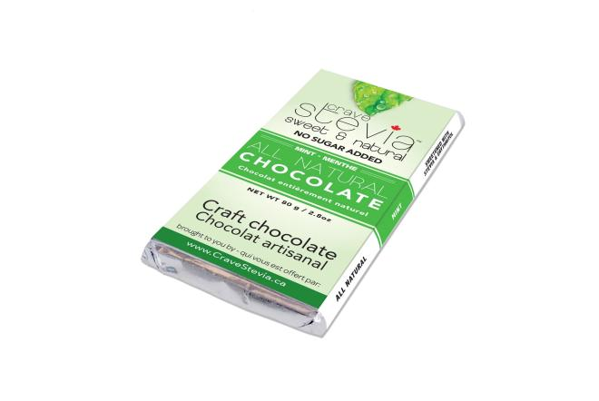  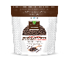  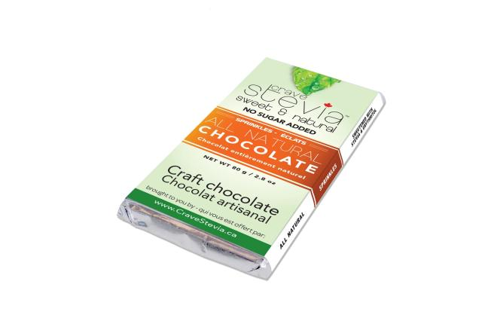
15-Jul-2022 | Stuffed Fish Ball | Food | Risk of Allergy | 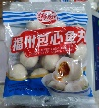
15-Jul-2022 | Fry's Brand Orange Cream (Dark Chocolate Bar) | Food | Risk of Allergy | /
18-Jul-2022 | Petilou Sensory Shapes By Le Toy Van | Toys and Childcare Products | Choking Hazard | 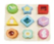
18-Jul-2022 | Player’s, Player’s Smooth and Player’s Original, Regular Size, 20 and 25 Cigarettes | Chemicals | Fire Hazard | 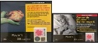  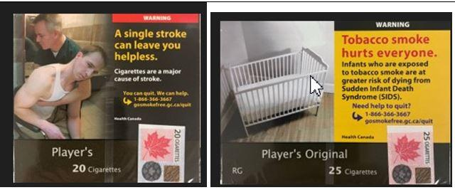  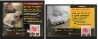  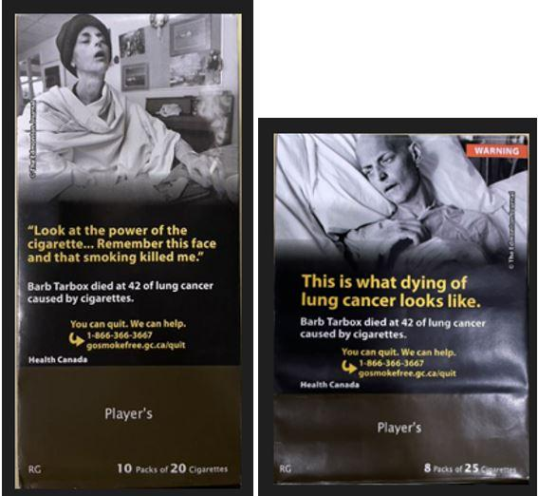  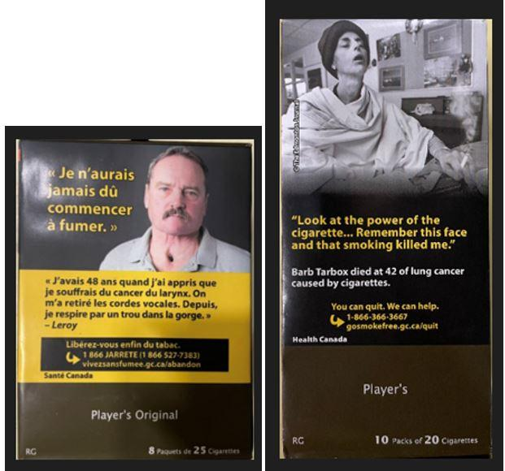  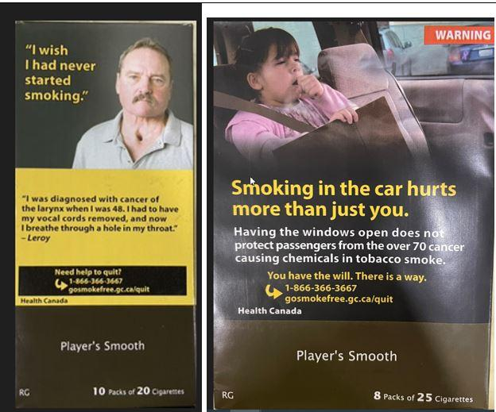  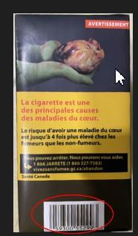
18-Jul-2022 | Knorr Professional Soup Du Jour Brand Red Thai Curry Chicken with Rice Soup Mix | Food | Risk of Allergy | /
18-Jul-2022 | Chocolate Product | Food | Risk of Allergy | /
20-Jul-2022 | The Better Shade Shroud Model #SHROUD002 | Household Items | Choking Hazard | 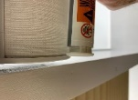
21-Jul-2022 | Certain Chicken Wiener Product | Food | Risk of Allergy | 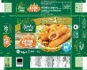  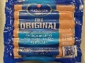  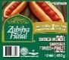
22-Jul-2022 | Dark Chocolate Nut Product | Food | Risk of Allergy | /
23-Jul-2022 | Dark Chocolate Truffle | Food | Risk of Allergy | 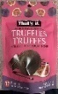  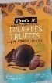
25-Jul-2022 | Magnesium Citrate Oral Solution | Pharmacy | Microbiological Hazard | /
27-Jul-2022 | Eight Lots of NightNight Pomegranate Sunset CBN+CBD Shot Edible Cannabis | Cannabis | Microbiological Hazard, Health Risk Hazard | 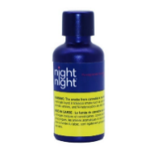
27-Jul-2022 | Meat Lasagna | Food | Risk of Allergy | 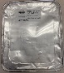  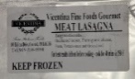
28-Jul-2022 | Play Tent | Toys and Childcare Products | Burn Hazard | 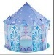  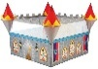  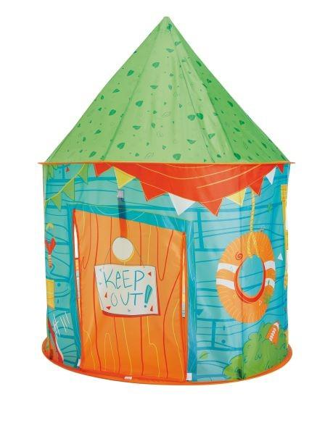  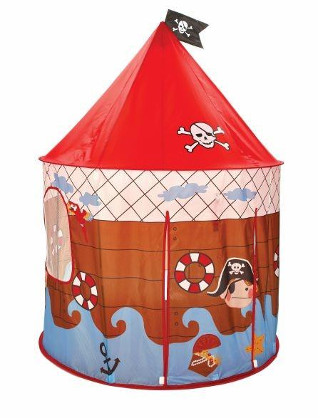  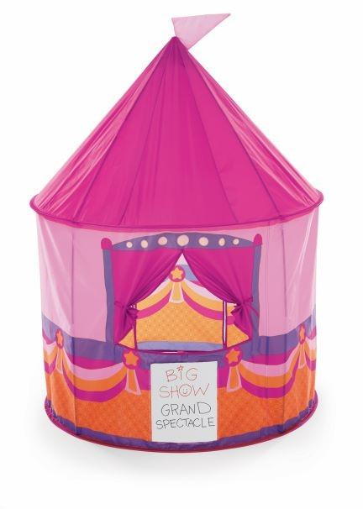  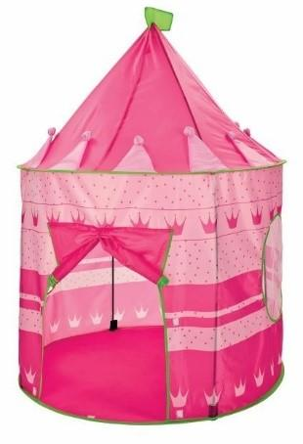  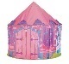
28-Jul-2022 | PIEPS and Black Diamond Avalanche Transceiver and Beacon | Electrical Appliances | Injury Hazard | 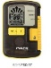  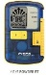  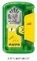  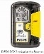  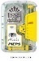  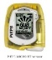  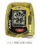  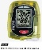  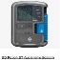  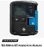
28-Jul-2022 | Powercom/Milcom Underwater Wireless Diver Unit | Sporting Goods / Equipment | Fire Hazard | 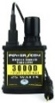  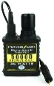  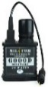
28-Jul-2022 | Aesop Post-Poo Drop and Various Aesop Oil Burner Blend | Bodycare / Cosmetics | Aspiration Hazard, Injury Hazard, Health Risk Hazard | 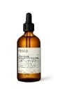  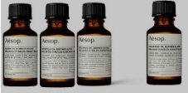
28-Jul-2022 | NUK First Choice Glass Baby Bottle | Toys and Childcare Products | Chemical Hazard | 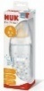  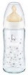
28-Jul-2022 | Evaporator Coil Drain Pan | Tools and Hardware | Fire Hazard | 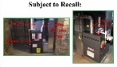  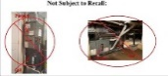  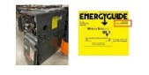  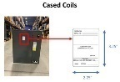  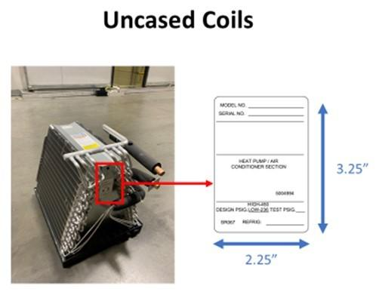  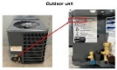
28-Jul-2022 | Certain Groove Chocolate Brand and Daniel Chocolates Brand Dark Chocolate Bar | Food | Risk of Allergy | 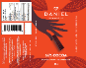  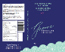  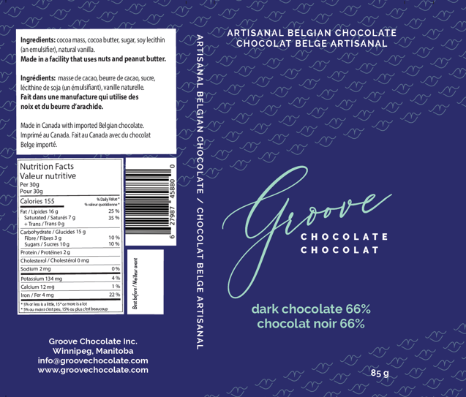
29-Jul-2022 | Lasagna Product | Food | Risk of Allergy | /

