Recall Cases Summary – Europe (Last Update Date: 31 July 2022)

Date | Notifying Country | Product | Categories | Hazard | Image
1-Jul-2022 | Lithuania | Cosmetic Face Mask | Bodycare / Cosmetics | Chemical Hazard
1-Jul-2022 | Lithuania | Revitalizing Cream | Bodycare / Cosmetics | Chemical Hazard | 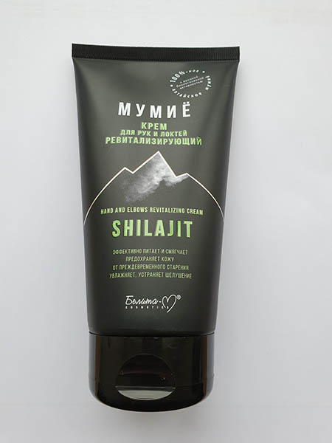
1-Jul-2022 | Lithuania | Hand Cream | Bodycare / Cosmetics | Chemical Hazard | 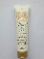
1-Jul-2022 | Lithuania | Hair Growth Serum | Bodycare / Cosmetics | Chemical Hazard | 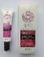
2-Jul-2022 | Germany | Hair Dye | Bodycare / Cosmetics | Chemical Hazard | 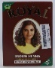
4-Jul-2022 | Belgium | USB Charger | Electrical Appliances | Electric Shock Hazard, Fire Hazard | 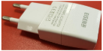
4-Jul-2022 | Germany | Particle Filter Mask | Protective Equipment | Health Risk Hazard | 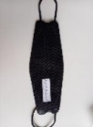
5-Jul-2022 | Germany | Circular Saw Blade | Tools and Hardware | Injury Hazard | 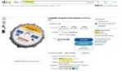
5-Jul-2022 | Germany | Circular Saw Blade | Tools and Hardware | Injury Hazard | 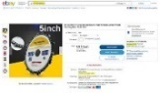
5-Jul-2022 | Germany | Circular Saw Blade | Tools and Hardware | Injury Hazard | 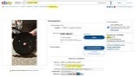
5-Jul-2022 | Germany | Circular Saw Blade | Tools and Hardware | Injury Hazard | 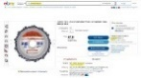
5-Jul-2022 | Germany | Circular Saw Blade | Tools and Hardware | Injury Hazard | 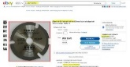
5-Jul-2022 | Germany | Circular Saw Blade | Tools and Hardware | Injury Hazard | 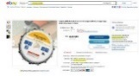  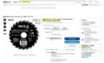
5-Jul-2022 | Germany | Circular Saw Blade | Tools and Hardware | Injury Hazard | 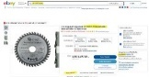
5-Jul-2022 | Germany | Circular Saw Blade | Tools and Hardware | Injury Hazard | 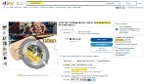
5-Jul-2022 | Germany | Circular Saw Blade | Tools and Hardware | Injury Hazard | 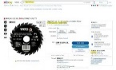
6-Jul-2022 | Germany | Circular Saw Blade | Tools and Hardware | Injury Hazard | 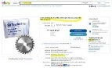
6-Jul-2022 | Germany | Circular Saw Blade | Tools and Hardware | Cut Hazard | 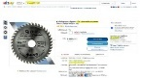
6-Jul-2022 | Luxembourg | Cordless Soldering Iron | Electrical Appliances | Chemical Hazard | 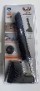  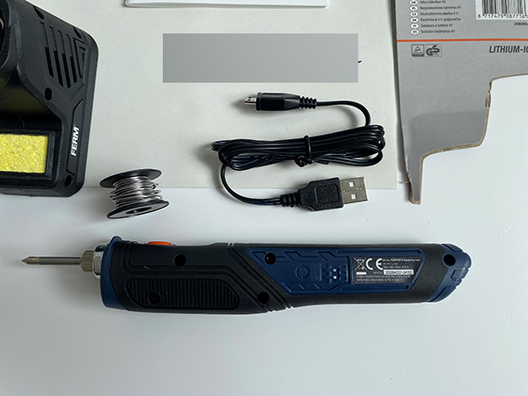
6-Jul-2022 | Ireland | Remote Controlled Lightbulb | Electrical Appliances | Electric Shock Hazard | 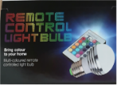
6-Jul-2022 | Poland | Plastic Ball | Toys and Childcare Products | Chemical Hazard | 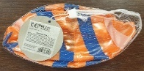
6-Jul-2022 | Belgium | Children's Trousers | Fabric / Textile / Garment / Home Textile | Injury Hazard | 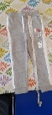
7-Jul-2022 | France | Children's Sweatshirt | Fabric / Textile / Garment / Home Textile | Strangulation Hazard | 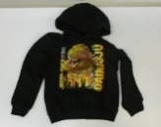
7-Jul-2022 | France | Children's Sports Outfit | Fabric / Textile / Garment / Home Textile | Strangulation Hazard | 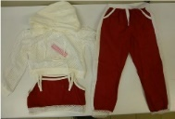
7-Jul-2022 | France | Children's Swimsuit | Fabric / Textile / Garment / Home Textile | Strangulation Hazard | 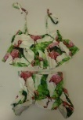
7-Jul-2022 | Latvia | Ladder | Tools and Hardware | Injury Hazard | 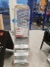
7-Jul-2022 | Latvia | Ladder | Tools and Hardware | Injury Hazard | 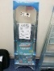
7-Jul-2022 | Ireland | Cabinet with Mirror | Furniture | Injury Hazard | 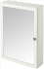
7-Jul-2022 | Germany | Smartphone for Explosive Atmospheres | Computer / Audio / Video / Other Electronics & Accessories | Burn Hazard, Injury Hazard | 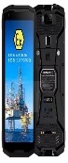
7-Jul-2022 | Germany | Smartphone for Explosive Atmospheres | Computer / Audio / Video / Other Electronics & Accessories | Burn Hazard, Injury Hazard | 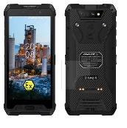
7-Jul-2022 | Germany | Smartphone for Explosive Atmospheres | Computer / Audio / Video / Other Electronics & Accessories | Burn Hazard, Injury Hazard | 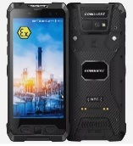
7-Jul-2022 | Germany | Smartphone for Explosive Atmospheres | Computer / Audio / Video / Other Electronics & Accessories | Burn Hazard, Injury Hazard | 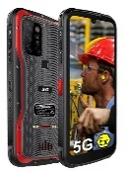
7-Jul-2022 | Germany | Tablet for Explosive Atmospheres | Computer / Audio / Video / Other Electronics & Accessories | Burn Hazard, Injury Hazard | 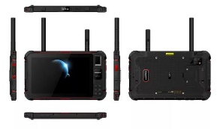
7-Jul-2022 | Latvia | Electric Kettle | Home Electrical Appliances | Burn Hazard, Electric Shock Hazard | 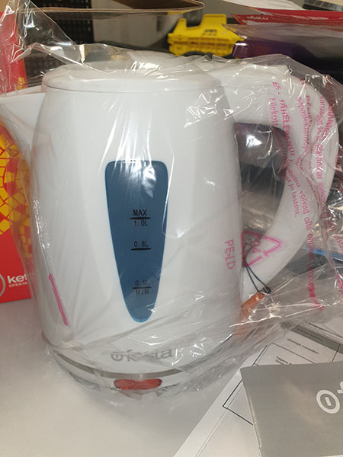
7-Jul-2022 | Germany | Bicycle Part / Saddle Joint | Sporting Goods / Equipment | Injury Hazard | 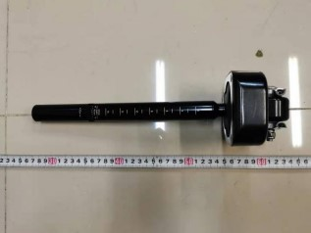
7-Jul-2022 | Germany | Smartphone for Explosive Atmospheres | Computer / Audio / Video / Other Electronics & Accessories | Burn Hazard, Injury Hazard | 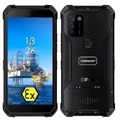
7-Jul-2022 | Germany | Hair Dye | Bodycare / Cosmetics | Chemical Hazard | 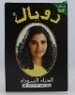
7-Jul-2022 | Hungary | Plastic Swing | Toys and Childcare Products | Injury Hazard | 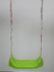
7-Jul-2022 | Lithuania | Hair Styling Mousse | Bodycare / Cosmetics | Chemical Hazard | 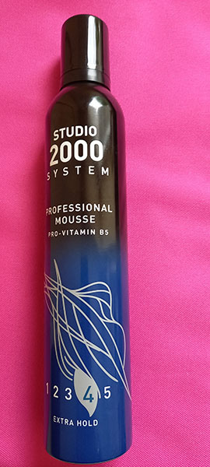
7-Jul-2022 | Germany | Motorcycle Helmet | Protective Equipment | Injury Hazard | 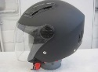
7-Jul-2022 | Hungary | Air Humidifier | Home Electrical Appliances | Microbiological Hazard | 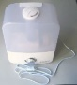
7-Jul-2022 | Czechia | Toy Gun | Toys and Childcare Products | Environmental Hazard | 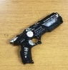
7-Jul-2022 | Poland | Plastic Doll | Toys and Childcare Products | Chemical Hazard | 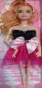
7-Jul-2022 | Poland | Plastic Doll | Toys and Childcare Products | Chemical Hazard
7-Jul-2022 | Finland | Portable Power Station | Electrical Appliances | Electric Shock Hazard | 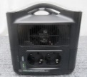
7-Jul-2022 | Estonia | Plastic Doll | Toys and Childcare Products | Chemical Hazard | 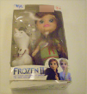
7-Jul-2022 | Latvia | Inflatable Boat | Sporting Goods / Equipment | Drowning Hazard | 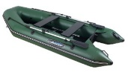
7-Jul-2022 | Latvia | Inflatable Boat | Sporting Goods / Equipment | Drowning Hazard | 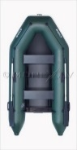
7-Jul-2022 | Poland | Magnetic Balls | Toys and Childcare Products | Injury Hazard | 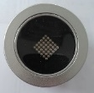
7-Jul-2022 | Poland | Magnetic Balls | Toys and Childcare Products | Injury Hazard | 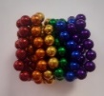
7-Jul-2022 | Poland | Magnetic Balls | Toys and Childcare Products | Injury Hazard | 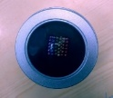
7-Jul-2022 | Estonia | Stacking Toy | Toys and Childcare Products | Choking Hazard | 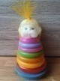
7-Jul-2022 | Poland | Fixed Luminaire | Electrical Appliances | Electric Shock Hazard | 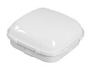
8-Jul-2022 | Germany | Circular Saw Blade | Tools and Hardware | Cut Hazard | 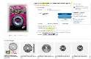
8-Jul-2022 | Germany | Circular Saw Blade | Tools and Hardware | Cut Hazard | 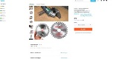
8-Jul-2022 | Germany | Circular Saw Blade | Tools and Hardware | Cut Hazard | 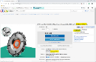
11-Jul-2022 | Sweden | Face Cream | Bodycare / Cosmetics | Microbiological Hazard | 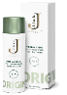
12-Jul-2022 | Slovakia | Earrings | Jewelry | Chemical Hazard | 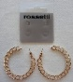  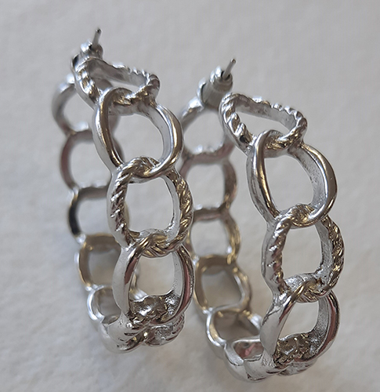  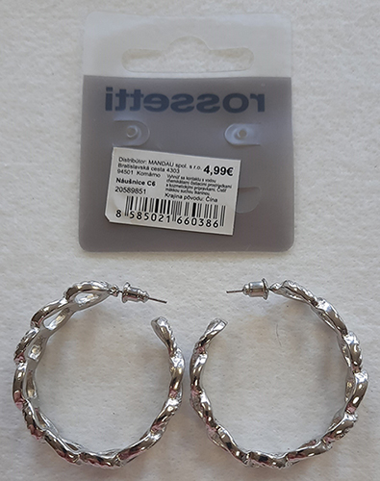
12-Jul-2022 | Germany | Earrings | Jewelry | Chemical Hazard | 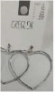
12-Jul-2022 | Germany | Earrings | Jewelry | Chemical Hazard | 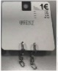
12-Jul-2022 | Germany | Earrings | Jewelry | Chemical Hazard | 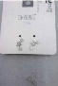
12-Jul-2022 | Poland | Soft Toy | Toys and Childcare Products | Choking Hazard | 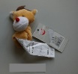
12-Jul-2022 | Germany | Children's Lederhosen | Fabric / Textile / Garment / Home Textile | Chemical Hazard | 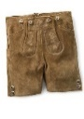
12-Jul-2022 | France | Soft Toy | Toys and Childcare Products | Choking Hazard | 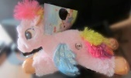
12-Jul-2022 | Hungary | Hair Dryer | Home Electrical Appliances | Burn Hazard, Electric Shock Hazard, Fire Hazard | 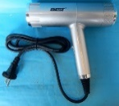  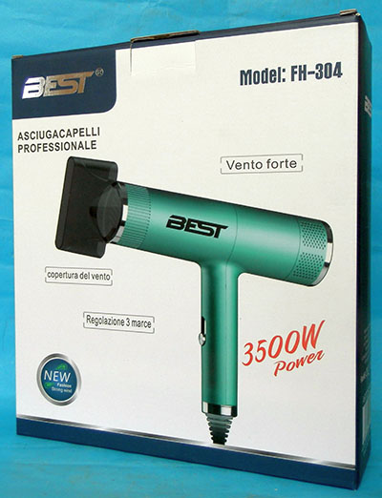  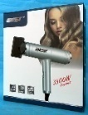
12-Jul-2022 | Hungary | Hair Dryer | Home Electrical Appliances | Burn Hazard, Electric Shock Hazard, Fire Hazard | 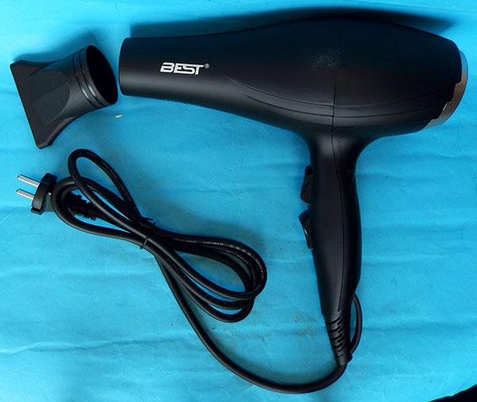
13-Jul-2022 | Italy | Skin Cream | Bodycare / Cosmetics | Chemical Hazard | 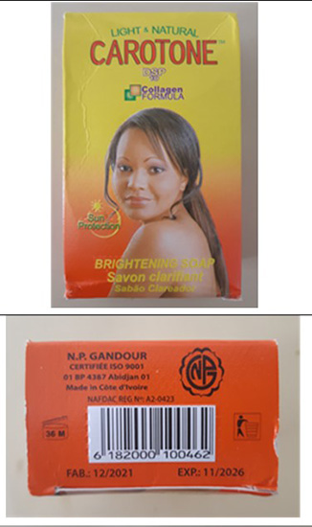
13-Jul-2022 | Latvia | Lighting Chain | Electrical Appliances | Burn Hazard, Electric Shock Hazard, Fire Hazard | 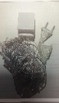
13-Jul-2022 | Latvia | USB Charger | Electrical Appliances | Electric Shock Hazard | 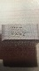  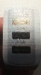
13-Jul-2022 | Italy | Skin Cream/Soap | Bodycare / Cosmetics | Chemical Hazard | 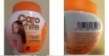  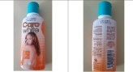
13-Jul-2022 | Germany | Wood Saw Blade for Angle Grinder | Tools and Hardware | Cut Hazard | 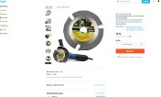
13-Jul-2022 | Germany | Circular Saw Blade | Tools and Hardware | Cut Hazard | 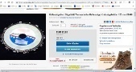
13-Jul-2022 | Germany | Circular Saw Blade | Tools and Hardware | Cut Hazard | 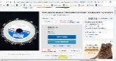  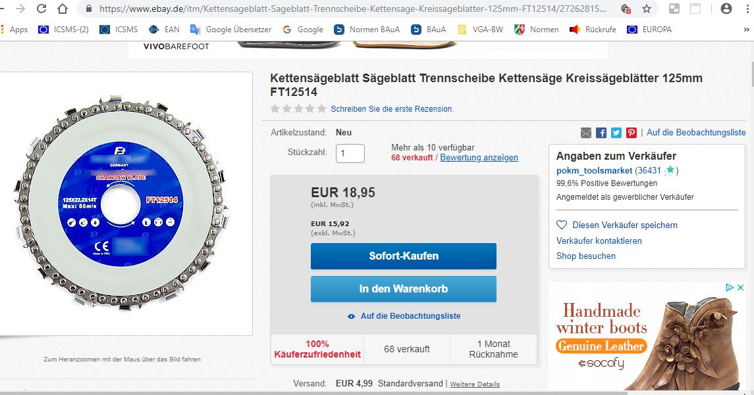
13-Jul-2022 | Denmark | Firework | Outdoor Living Items | Burn Hazard | 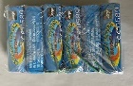  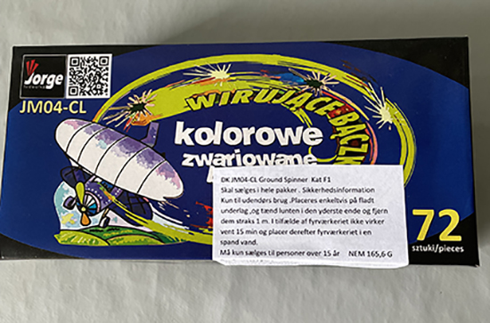
14-Jul-2022 | Cyprus | Plastic Doll | Toys and Childcare Products | Chemical Hazard | 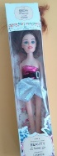
14-Jul-2022 | Cyprus | Plastic Dolls with Accessories | Toys and Childcare Products | Chemical Hazard | 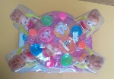
14-Jul-2022 | Italy | Skin Cream | Bodycare / Cosmetics | Chemical Hazard | 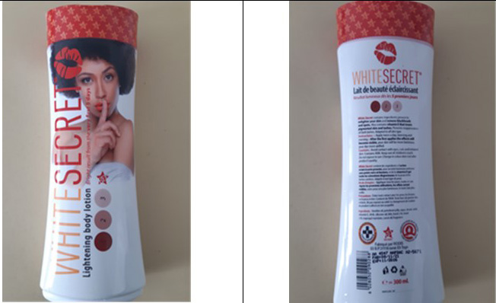
14-Jul-2022 | The Netherlands | Insect Killer | Electrical Appliances | Electric Shock Hazard | 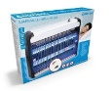
14-Jul-2022 | Germany | Protective Mask | Protective Equipment | Health Risk Hazard | 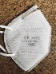
14-Jul-2022 | Finland | Camping Stove - Windscreen | Outdoor Living Items | Asphyxiation Hazard | 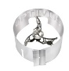  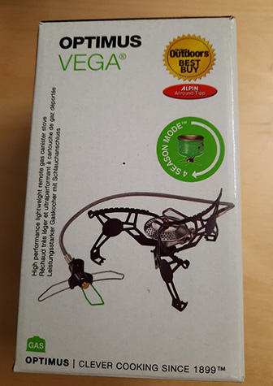
14-Jul-2022 | Germany | Circular Saw Blade | Tools and Hardware | Cut Hazard | 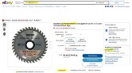
14-Jul-2022 | Germany | Circular Saw Blade | Tools and Hardware | Cut Hazard | 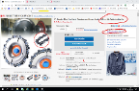
14-Jul-2022 | Germany | Circular Saw Blade | Tools and Hardware | Cut Hazard | 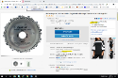
14-Jul-2022 | Czechia | Magnetic Balls | Toys and Childcare Products | Choking Hazard, Injury Hazard | 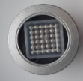
14-Jul-2022 | Bulgaria | Coffee Maker | Food Contact Material | Burn Hazard, Injury Hazard | 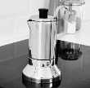
14-Jul-2022 | Luxembourg | Bath Mat | Household Items | Chemical Hazard | 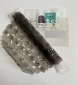
14-Jul-2022 | Lithuania | Face Cream | Bodycare / Cosmetics | Chemical Hazard | 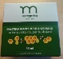
14-Jul-2022 | Lithuania | Face Cream | Bodycare / Cosmetics | Chemical Hazard | 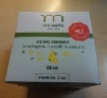
14-Jul-2022 | Austria | Beauty Cream | Bodycare / Cosmetics | Chemical Hazard | 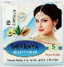
14-Jul-2022 | Lithuania | Face Cream | Bodycare / Cosmetics | Chemical Hazard | 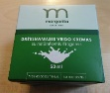
14-Jul-2022 | Poland | Magnetic Balls | Toys and Childcare Products | Injury Hazard | 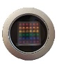
14-Jul-2022 | Romania | Waterproof Children's Jumpsuit | Fabric / Textile / Garment / Home Textile | Strangulation Hazard | 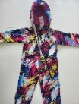  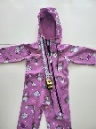
14-Jul-2022 | Poland | Plastic Doll | Toys and Childcare Products | Chemical Hazard | 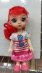
14-Jul-2022 | Poland | Plastic Doll | Toys and Childcare Products | Chemical Hazard | 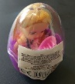  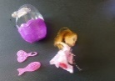
14-Jul-2022 | Poland | Plastic Doll | Toys and Childcare Products | Chemical Hazard
14-Jul-2022 | Poland | Plastic Doll | Toys and Childcare Products | Chemical Hazard | 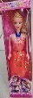
14-Jul-2022 | Denmark | Fireworks | Outdoor Living Items | Burn Hazard, Damage to Sight | 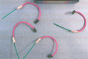  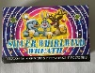
14-Jul-2022 | Denmark | Ground Spinner | Outdoor Living Items | Burn Hazard | 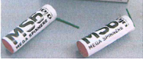  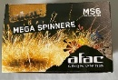
14-Jul-2022 | Finland | Beach Sandals | Footwear | Chemical Hazard | 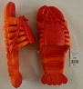
14-Jul-2022 | Finland | Soap Bubble Stick | Toys and Childcare Products | Microbiological Hazard | 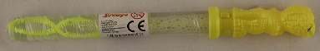
14-Jul-2022 | Denmark | Fireworks | Outdoor Living Items | Burn Hazard | 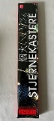
14-Jul-2022 | Germany | Laser Processing Machine | Machinery | Damage to Sight
14-Jul-2022 | Iceland | Visibility Vest | Protective Equipment | Injury Hazard | 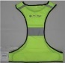  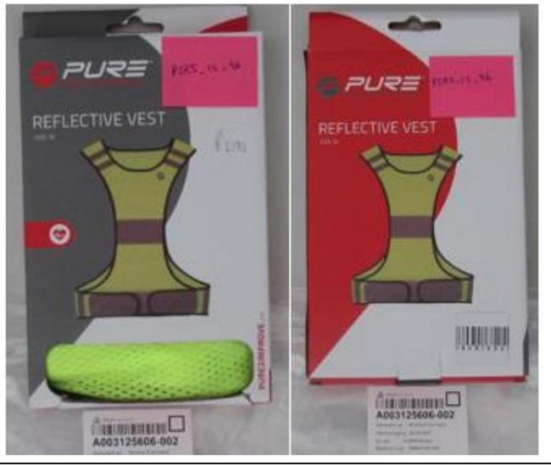
14-Jul-2022 | Luxembourg | Shower Mat | Household Items | Chemical Hazard | 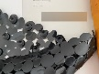
14-Jul-2022 | Cyprus | Children's Bikini | Fabric / Textile / Garment / Home Textile | Injury Hazard | 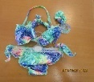  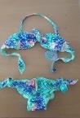
14-Jul-2022 | Slovakia | Earrings | Jewelry | Chemical Hazard | 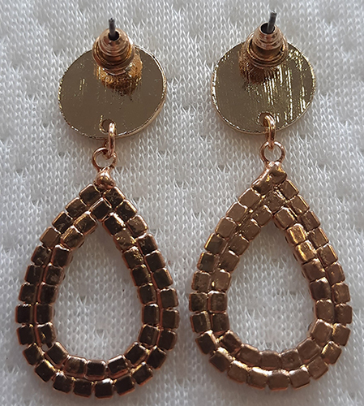
14-Jul-2022 | Slovakia | Earrings | Jewelry | Chemical Hazard | 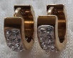
15-Jul-2022 | Slovenia | Safety Bedrail | Toys and Childcare Products | Injury Hazard | 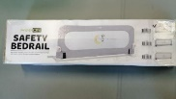
15-Jul-2022 | Slovenia | Safety Bedrail | Toys and Childcare Products | Injury Hazard | 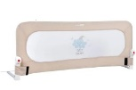
15-Jul-2022 | Slovenia | Safety Bedrail | Toys and Childcare Products | Injury Hazard | 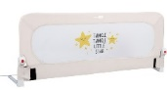
15-Jul-2022 | Cyprus | Children's Clothing Set | Fabric / Textile / Garment / Home Textile | Strangulation Hazard | 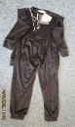
15-Jul-2022 | Cyprus | Children's Clothing Set | Fabric / Textile / Garment / Home Textile | Injury Hazard | 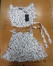
15-Jul-2022 | Cyprus | Plastic Baby Doll | Toys and Childcare Products | Chemical Hazard | 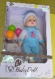
15-Jul-2022 | Cyprus | Plastic Dolls | Toys and Childcare Products | Chemical Hazard | 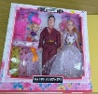
15-Jul-2022 | Cyprus | Children's Head Band | Accessories | Chemical Hazard | 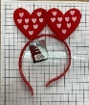
15-Jul-2022 | Cyprus | Children's Head Band | Accessories | Chemical Hazard | 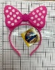
15-Jul-2022 | Austria | Puffer Toy | Toys and Childcare Products | Choking Hazard | 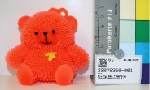
15-Jul-2022 | Austria | Battery Pack | Electrical Appliances | Burn Hazard | 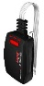
18-Jul-2022 | Germany | Hair Dye | Bodycare / Cosmetics | Chemical Hazard | 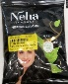
18-Jul-2022 | Slovakia | Earrings | Jewelry | Chemical Hazard | 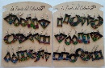
19-Jul-2022 | Germany | Chainsaw Attachment | Tools and Hardware | Cut Hazard | 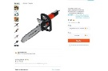
19-Jul-2022 | Ireland | Disposable Electronic Cigarette | Chemicals | Chemical Hazard | /
19-Jul-2022 | The Netherlands | Plush Toy | Toys and Childcare Products | Choking Hazard | 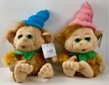
19-Jul-2022 | Cyprus | Children's Bikini | Fabric / Textile / Garment / Home Textile | Injury Hazard | 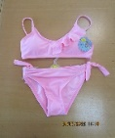  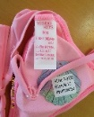
19-Jul-2022 | France | Cleaning and Degreasing Agent | Chemicals | Chemical Hazard | 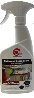
19-Jul-2022 | France | Descaler | Chemicals | Chemical Hazard | 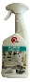
19-Jul-2022 | France | Cleaning and Degreasing Agent | Chemicals | Chemical Hazard | 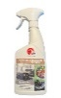
19-Jul-2022 | Luxembourg | Lighting Chain | Electrical Appliances | Chemical Hazard | 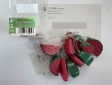
19-Jul-2022 | Czechia | Magnetic Balls | Toys and Childcare Products | Injury Hazard | 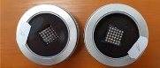
19-Jul-2022 | Austria | Soft Toy | Toys and Childcare Products | Choking Hazard | 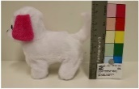
19-Jul-2022 | Germany | Skin-Lightening Cream | Bodycare / Cosmetics | Chemical Hazard | 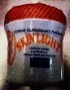
19-Jul-2022 | Germany | Skin-Lightening Body Lotion | Bodycare / Cosmetics | Chemical Hazard
19-Jul-2022 | Czechia | Magnetic Balls | Toys and Childcare Products | Injury Hazard | 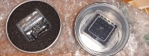
19-Jul-2022 | Bulgaria | Candle | Accessories | Choking Hazard | 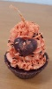
19-Jul-2022 | Hungary | Hair Dryer | Home Electrical Appliances | Burn Hazard, Electric Shock Hazard, Fire Hazard | 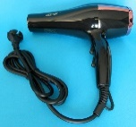
19-Jul-2022 | Hungary | Portable Wall Lamp | Electrical Appliances | Electric Shock Hazard | 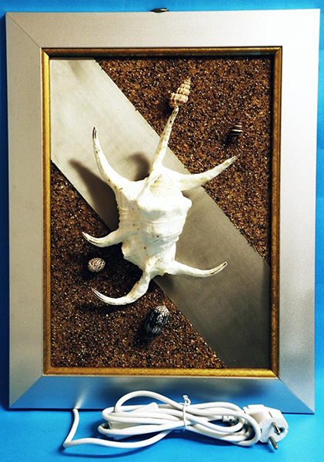
20-Jul-2022 | Denmark | Fireworks | Outdoor Living Items | Burn Hazard, Fire Hazard, Injury Hazard | 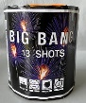
20-Jul-2022 | Belgium | Sun Milk | Bodycare / Cosmetics | Burn Hazard | 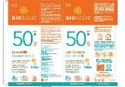
20-Jul-2022 | Belgium | Sun Spray | Bodycare / Cosmetics | Burn Hazard
20-Jul-2022 | Belgium | Sun Milk | Bodycare / Cosmetics | Burn Hazard | 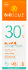
20-Jul-2022 | France | Scuba-Diving Compressor | Machinery | Electric Shock Hazard, Fire Hazard | 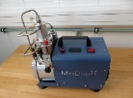
20-Jul-2022 | Germany | Particle Filter Mask | Protective Equipment | Health Risk Hazard | 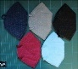
20-Jul-2022 | Denmark | Fireworks | Outdoor Living Items | Burn Hazard | 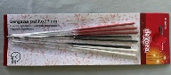
20-Jul-2022 | Czechia | Battery Operated Toy | Toys and Childcare Products | Environmental Hazard | 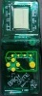  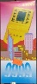
20-Jul-2022 | Finland | Beach Sandals | Footwear | Chemical Hazard | 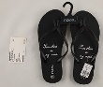
20-Jul-2022 | Finland | Plush Toy | Toys and Childcare Products | Choking Hazard | 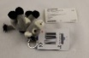  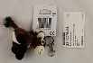
20-Jul-2022 | Bulgaria | Plastic Chair | Furniture | Injury Hazard | 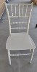
25-Jul-2022 | Hungary | USB Charger | Electrical Appliances | Electric Shock Hazard | 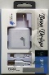
25-Jul-2022 | Germany | Body Powder | Bodycare / Cosmetics | Chemical Hazard | 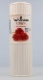
26-Jul-2022 | Romania | Children's Sweatpants | Fabric / Textile / Garment / Home Textile | Injury Hazard | 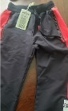
26-Jul-2022 | Germany | Safety Vest | Protective Equipment | Injury Hazard | 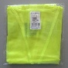
26-Jul-2022 | Czechia | Magnetic Ball | Toys and Childcare Products | Choking Hazard, Injury Hazard | 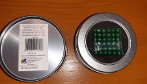
26-Jul-2022 | Lithuania | Tanning Lotion | Bodycare / Cosmetics | Chemical Hazard | 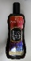
26-Jul-2022 | Lithuania | Tanning Cream | Bodycare / Cosmetics | Chemical Hazard | 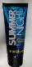
26-Jul-2022 | Lithuania | Face Cream | Bodycare / Cosmetics | Chemical Hazard | 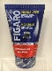
26-Jul-2022 | Lithuania | Face Gel | Bodycare / Cosmetics | Chemical Hazard | 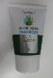
28-Jul-2022 | Cyprus | Children's Clothing Set | Fabric / Textile / Garment / Home Textile | Injury Hazard | 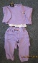
28-Jul-2022 | Cyprus | Children's Clothing Set | Fabric / Textile / Garment / Home Textile | Strangulation Hazard | 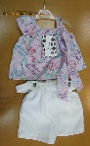
28-Jul-2022 | The Netherlands | Toy Set | Toys and Childcare Products | Choking Hazard | 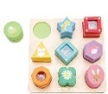
28-Jul-2022 | Germany | Particle Filter Mask | Protective Equipment | Health Risk Hazard | 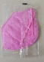
28-Jul-2022 | Germany | Safety Vest | Protective Equipment | Injury Hazard | 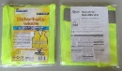
28-Jul-2022 | Bulgaria | Children's Clothing Set | Fabric / Textile / Garment / Home Textile | Choking Hazard, Suffocation Hazard
28-Jul-2022 | Lithuania | Moisturizing Cream | Bodycare / Cosmetics | Chemical Hazard | 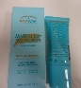
28-Jul-2022 | Lithuania | Moisturizing Cream | Bodycare / Cosmetics | Chemical Hazard | 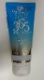
28-Jul-2022 | Lithuania | Body Cream | Bodycare / Cosmetics | Chemical Hazard | 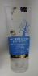
28-Jul-2022 | Lithuania | Body Cream | Bodycare / Cosmetics | Chemical Hazard | 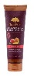
28-Jul-2022 | Lithuania | Body Cream | Bodycare / Cosmetics | Chemical Hazard | 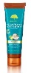
28-Jul-2022 | Lithuania | Leave-On Body Spray | Bodycare / Cosmetics | Chemical Hazard | 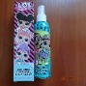
28-Jul-2022 | Lithuania | Shaving Foam | Bodycare / Cosmetics | Chemical Hazard | 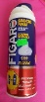
28-Jul-2022 | Lithuania | Toy Aeroplane | Toys and Childcare Products | Choking Hazard | 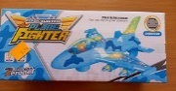
28-Jul-2022 | Lithuania | Soft Toy | Toys and Childcare Products | Choking Hazard | 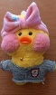
28-Jul-2022 | Czechia | Battery Operated Toy | Toys and Childcare Products | Environmental Hazard | 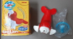
28-Jul-2022 | France | Beach Ball | Toys and Childcare Products | Choking Hazard, Suffocation Hazard | 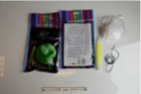
28-Jul-2022 | Lithuania | Toy Car | Toys and Childcare Products | Choking Hazard | 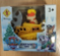
28-Jul-2022 | Poland | Chainsaw | Machinery | Injury Hazard | 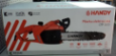
28-Jul-2022 | Poland | Hedge Trimmer | Machinery | Cut Hazard, Injury Hazard | 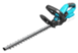
28-Jul-2022 | Poland | Hedge Trimmer | Machinery | Cut Hazard, Injury Hazard | 