Recall Cases Summary – US (Last Update Date: 31 July 2022)

Date | Product | Categories | Hazard | Image
7-Jul-2022 | Shake Look Touch Book | Toys and Childcare Products | Choking Hazard | 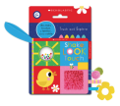  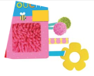
7-Jul-2022 | Cayden 9-Drawer Chest | Furniture | Fall Hazard, Entrapment Hazard, Tip-Over Hazard | 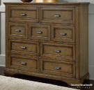
14-Jul-2022 | Outfitter and Big Horn Tent | Outdoor Living Items | Injury Hazard | 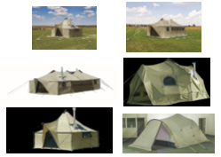
14-Jul-2022 | Tony Hawk Silver Helmet | Protective Equipment | Injury Hazard | 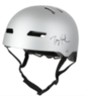
21-Jul-2022 | Key West Knock Down Hammock Stand | Outdoor Living Items | Fall Hazard | 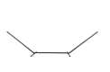
21-Jul-2022 | i330R SCUBA Diving Computer | Sporting Goods / Equipment | Injury Hazard, Drowning Hazard | 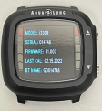
21-Jul-2022 | Silicone Baby Toy Bear Activity Toy | Toys and Childcare Products | Laceration Hazard | 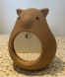
21-Jul-2022 | Toy Box with Bin | Toys and Childcare Products | Choking Hazard | 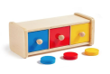
21-Jul-2022 | LiftActiv Peptide-C Ampoule | Bodycare / Cosmetics | Laceration Hazard | 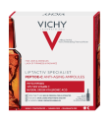
21-Jul-2022 | LRB™ Leg Loops | Protective Equipment | Fall Hazard | 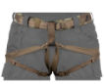  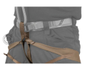
28-Jul-2022 | Bathroom Deodorizing Drop and Oil Burner Blend | Bodycare / Cosmetics | Poisoning Hazard | 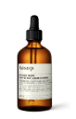  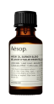  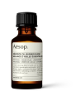  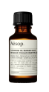
28-Jul-2022 | Underwater Communication Device | Sporting Goods / Equipment | Fire Hazard | 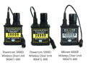  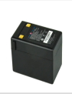
28-Jul-2022 | Play Tent and Playhouse | Toys and Childcare Products | Burn Hazard | 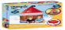  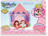  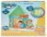  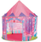  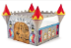  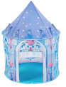  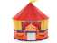  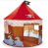
28-Jul-2022 | Evaporator Coil Drain Pan | Tools and Hardware | Fire Hazard | 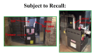  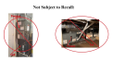  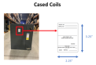  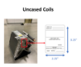  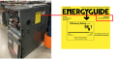  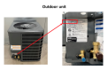
28-Jul-2022 | PIEPS and Black Diamond Avalanche Transceiver | Electrical Appliances | Injury Hazard | 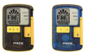  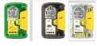  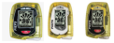  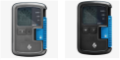
28-Jul-2022 | Ceramic Pulley for Cabrinha Switchblade and Drifter Kite Sailing Kite | Sporting Goods / Equipment | Injury Hazard | 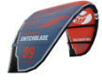  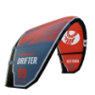  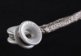
28-Jul-2022 | First Choice Glass Baby Bottle | Toys and Childcare Products | Chemical Hazard, Health Risk Hazard | 