Recall Cases Summary – Australia (Last Update Date: 31 August 2022)

Date | Product | Categories | Hazard | Image
1-Aug-2022 | Roller Blind with Cord/Bead Chain | Household Items | Strangulation Hazard
3-Aug-2022 | Folding Electric Bicycle | Sporting Goods / Equipment | Injury Hazard | 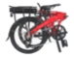
4-Aug-2022 | LED Night Light | Electrical Appliances | Burn Hazard, Injury Hazard, Choking Hazard | 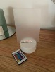  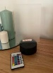  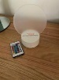  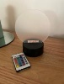
5-Aug-2022 | Salt&Pepper Wanderlust 3 Wick Candle - Various Fragrances 425g | Household Items | Burn Hazard, Fire Hazard, Injury Hazard | 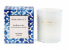  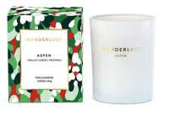  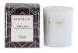  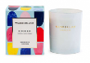  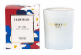  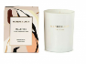  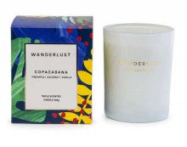  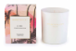
11-Aug-2022 | Westinghouse Black Tempered Glass Gas Cooktop | Home Electrical Appliances | Injury Hazard | 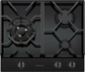  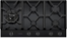
15-Aug-2022 | Omer Invictus Speargun | Sporting Goods / Equipment | Injury Hazard | 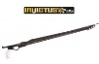  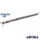
18-Aug-2022 | Blackfin Stand Up Inflatable Paddle Boards Models V, X and XL | Sporting Goods / Equipment | Injury Hazard, Drowning Hazard | 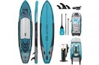  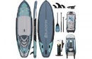  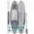
24-Aug-2022 | Snorkelling Inflatable Wand Float - Blue | Sporting Goods / Equipment | Drowning Hazard | 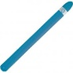
25-Aug-2022 | Vuly 360 Pro 'Yoga Swing' Attachment | Sporting Goods / Equipment | Injury Hazard, Entrapment Hazard | 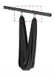
25-Aug-2022 | Promotional Emergency Hammer Torch | Protective Equipment | Injury Hazard, Choking Hazard | 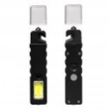  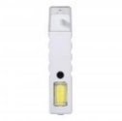
25-Aug-2022 | Mill Electrical Convection Panel Heater | Electrical Appliances | Fire Hazard, Electric Shock Hazard, Injury Hazard | 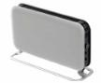  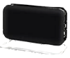
30-Aug-2022 | Royal Doulton Lunar Decanter Set | Food Contact Material | Injury Hazard | 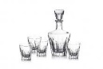
30-Aug-2022 | BiPAP A40 Ventilator | Medical Devices | Chemical Hazard, Asphyxiation Hazard | 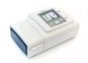
31-Aug-2022 | CRUDO and Bocadilla Ready to Eat Meals 200g, 250g and 275g | Food | Microbiological Hazard | 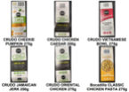
31-Aug-2022 | Eagle Bay Brewing Co XPA 375mL | Food | Health Risk Hazard, Injury Hazard | 