Recall Cases Summary – Canada (Last Update Date: 31 August 2022)

Date | Product | Categories | Hazard | Image
1-Aug-2022 | Cozy Flame CA Tabletop Fire Pit | Outdoor Living Items | Fire Hazard, Burn Hazard | 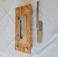  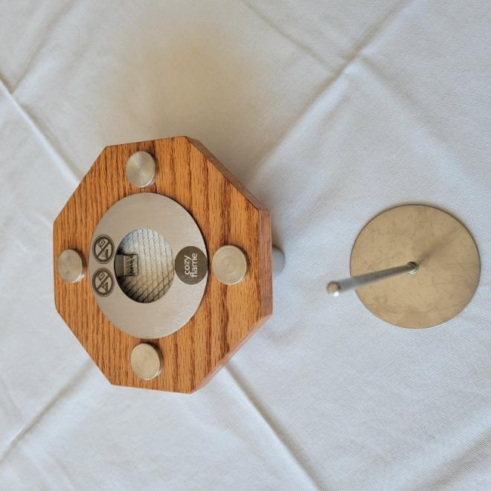  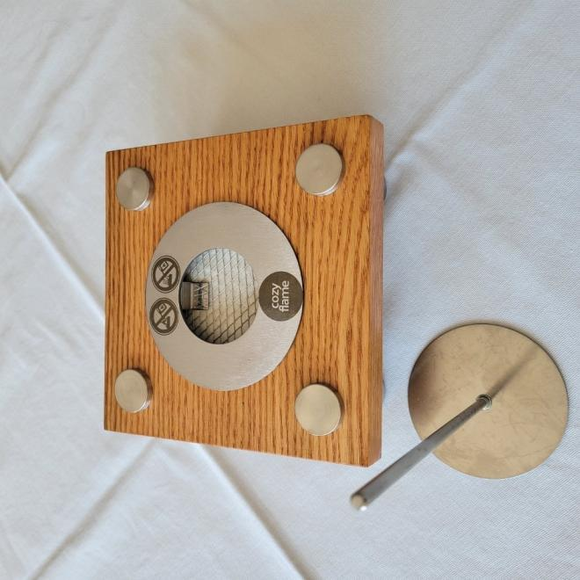  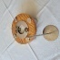
4-Aug-2022 | DEWALT 12-Inch Sliding Compound Miter Saw | Tools and Hardware | Laceration Hazard | 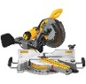  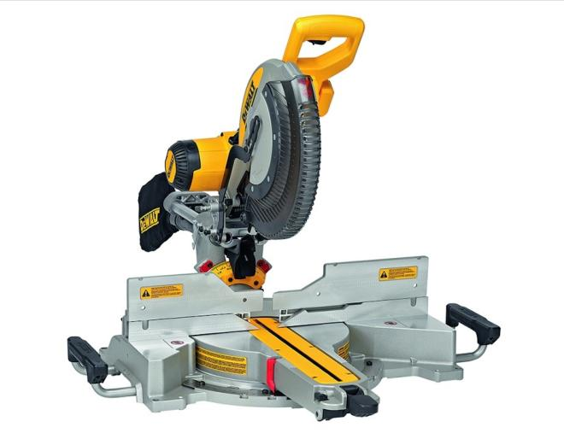  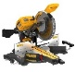
4-Aug-2022 | Paneer Fresh Cheese | Food | Microbiological Hazard | /
4-Aug-2022 | OG Oyster | Food | Microbiological Hazard | /
5-Aug-2022 | Art Coat Resin Kit | Chemicals | Injury Hazard, Health Risk Hazard | 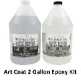  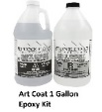  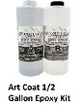
5-Aug-2022 | Primal Patties for Dogs Beef Formula | Pet Food | Microbiological Hazard | 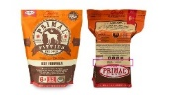
8-Aug-2022 | JAMP-ATORVASTATIN | Pharmacy | Health Risk Hazard, Choking Hazard, Risk of Allergy | /
9-Aug-2022 | For Living 1" Light Filtering Cordless Blind | Household Items | Strangulation Hazard, Choking Hazard | 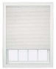
9-Aug-2022 | Silicone Baby Mirror Toy Bear Activity Toy | Toys and Childcare Products | Laceration Hazard | 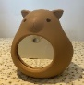
9-Aug-2022 | Classic Potato Chips | Food | Risk of Allergy | /
10-Aug-2022 | Top-Down Bottom-Up Cordless Cellular Shade | Household Items | Strangulation Hazard, Choking Hazard | 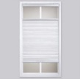
10-Aug-2022 | Premium Day & Night Zebra Roller Blind Dual Layer Shade | Household Items | Strangulation Hazard | 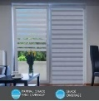
10-Aug-2022 | Magic Resin Table Top & Art Epoxy Resin Product | Chemicals | Injury Hazard, Health Risk Hazard | 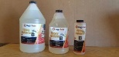  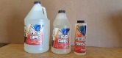
10-Aug-2022 | Chicken Pelmeni | Food | Risk of Allergy | /
11-Aug-2022 | Pastrami and Turkey Breast - Tuscan Flavoured | Food | Microbiological Hazard | 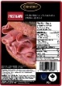
15-Aug-2022 | 4moms MamaRoo and RockaRoo Infant Swing and Rocker | Toys and Childcare Products | Entanglement Hazard, Strangulation Hazard | 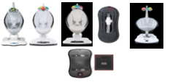
16-Aug-2022 | Various Bouclair Blinds | Household Items | Strangulation Hazard, Choking Hazard | 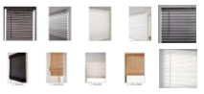
16-Aug-2022 | Paneer Fresh Cheese | Food | Microbiological Hazard | /
17-Aug-2022 | Makita LXT Cordless Hedge Trimmer | Tools and Hardware | Laceration Hazard, Injury Hazard | 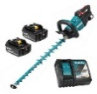
17-Aug-2022 | Various Corded Window Coverings | Household Items | Strangulation Hazard, Choking Hazard | 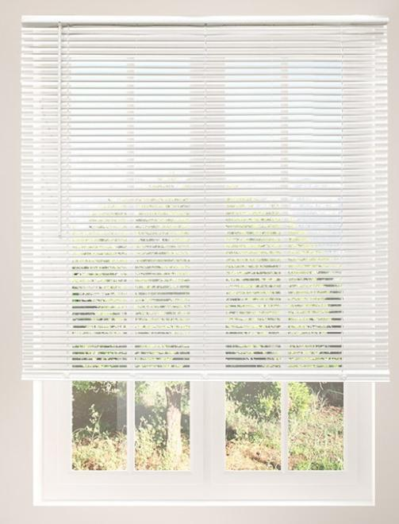
19-Aug-2022 | Pro-Licious Protein Pancake & Waffle Mix | Food | Risk of Allergy | 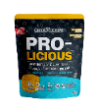
19-Aug-2022 | Charcuterie Trio – Prosciutto Cotto, Capocollo, Mortadella | Food | Risk of Allergy | 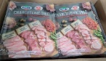
22-Aug-2022 | Tootsie Baby Water-Filled Teether and Teether Key | Toys and Childcare Products | Microbiological Hazard | 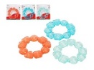  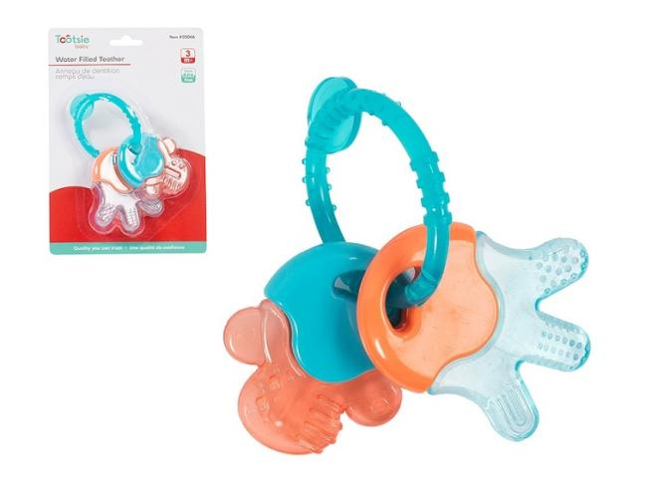
24-Aug-2022 | Natural Chicken Burger | Food | Risk of Allergy | /
24-Aug-2022 | Ricotta Di Bufala Campana Dop | Food | Microbiological Hazard | /
24-Aug-2022 | Kidoozie Brand My First Activity Desk | Toys and Childcare Products | Entrapment Hazard | 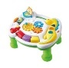
24-Aug-2022 | Paneer Fresh Cheese | Food | Microbiological Hazard | /
25-Aug-2022 | Trek Carbon Handlebars/Stems and Bicycles | Sporting Goods / Equipment | Fall Hazard | 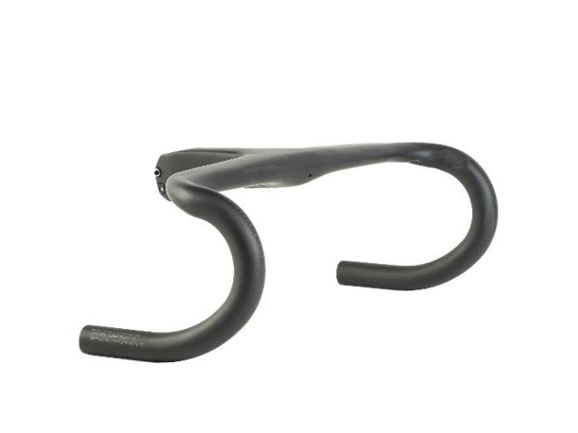  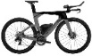  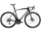
26-Aug-2022 | Home Basics Cordless Cellular Blackout Shade | Household Items | Choking Hazard | 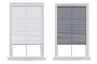
26-Aug-2022 | MyHome Gll Morningstar Cordless Blind | Household Items | Strangulation Hazard, Choking Hazard | 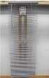
26-Aug-2022 | Shredded IQF Hash Brown | Food | Microbiological Hazard | /
26-Aug-2022 | 4 In. Split Top Brioche Style Bun | Food | Microbiological Hazard | /
29-Aug-2022 | Rexall Water Filled Teether | Toys and Childcare Products | Microbiological Hazard | 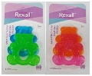
30-Aug-2022 | Aqua Lung i330R SCUBA Diving Computer | Sporting Goods / Equipment | Drowning Hazard | 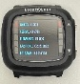  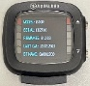
31-Aug-2022 | Enoki Mushroom | Food | Microbiological Hazard | 