Recall Cases Summary – Europe (Last Update Date: 31 August 2022)

Date | Notifying Country | Product | Categories | Hazard | Image
2-Aug-2022 | Czechia | Battery Operated Toy | Toys and Childcare Products | Environmental Hazard | 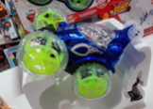
2-Aug-2022 | Czechia | Battery Operated Toy | Toys and Childcare Products | Environmental Hazard | 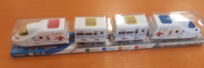
2-Aug-2022 | Czechia | Battery Operated Toy | Toys and Childcare Products | Environmental Hazard | 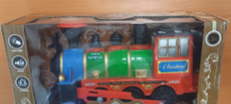
2-Aug-2022 | Belgium | Children's Dress | Fabric / Textile / Garment / Home Textile | Injury Hazard, Strangulation Hazard | 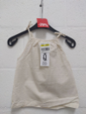
2-Aug-2022 | Poland | Battery Charger | Electrical Appliances | Burn Hazard, Electric Shock Hazard, Fire Hazard | 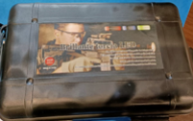
4-Aug-2022 | Finland | Padel Racket | Sporting Goods / Equipment | Chemical Hazard | 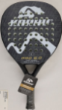
4-Aug-2022 | Germany | Particle Filter Mask | Protective Equipment | Health Risk Hazard | 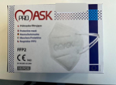
4-Aug-2022 | Estonia | Particle Filter Mask | Protective Equipment | Health Risk Hazard | 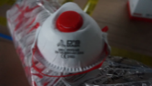
4-Aug-2022 | Poland | Plastic Doll | Toys and Childcare Products | Chemical Hazard | 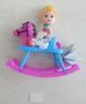
4-Aug-2022 | Lithuania | Hair Lotion | Bodycare / Cosmetics | Chemical Hazard | 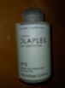
4-Aug-2022 | Poland | Expandable Toy | Toys and Childcare Products | Choking Hazard, Injury Hazard | 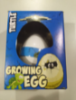
4-Aug-2022 | Poland | Expandable Toy | Toys and Childcare Products | Choking Hazard, Injury Hazard
4-Aug-2022 | Poland | Expandable Toy | Toys and Childcare Products | Choking Hazard, Injury Hazard | 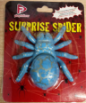
4-Aug-2022 | France | Bunk Bed | Furniture | Injury Hazard | 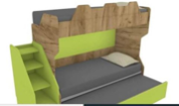
4-Aug-2022 | Poland | Plastic Doll | Toys and Childcare Products | Chemical Hazard
4-Aug-2022 | Poland | Ceiling Lamp | Electrical Appliances | Electric Shock Hazard | 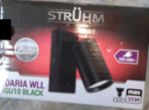
4-Aug-2022 | Czechia | Battery Operated Toy | Toys and Childcare Products | Environmental Hazard | 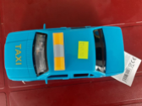
4-Aug-2022 | Czechia | Battery Operated Toy | Toys and Childcare Products | Choking Hazard, Injury Hazard | 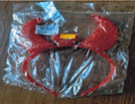
4-Aug-2022 | Ireland | Paint | Chemicals | Chemical Hazard | 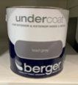  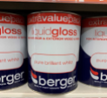  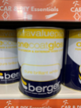
4-Aug-2022 | Slovakia | Bracelet | Jewelry | Chemical Hazard | 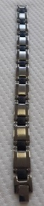  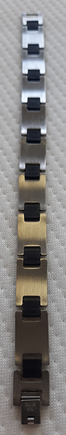
4-Aug-2022 | Slovakia | Ring | Jewelry | Chemical Hazard | 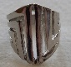
4-Aug-2022 | Finland | Rings Set | Jewelry | Chemical Hazard | 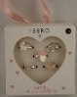
4-Aug-2022 | Finland | Puffer Toy | Toys and Childcare Products | Choking Hazard | 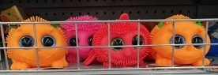
4-Aug-2022 | Finland | Sandals | Footwear | Chemical Hazard | 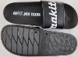
4-Aug-2022 | Finland | Pencil Case | Stationery | Chemical Hazard | 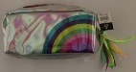
5-Aug-2022 | Slovakia | Bracelet | Jewelry | Chemical Hazard | 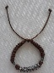
5-Aug-2022 | Slovakia | Bracelet | Jewelry | Chemical Hazard | 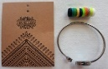  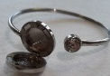
9-Aug-2022 | Ireland | Disposable Electronic Cigarette | Chemicals | Chemical Hazard | 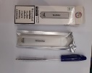
9-Aug-2022 | Ireland | Disposable Electronic Cigarette | Chemicals | Chemical Hazard | 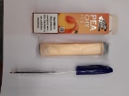
9-Aug-2022 | Ireland | Disposable Electronic Cigarette | Chemicals | Chemical Hazard | 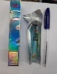
9-Aug-2022 | Ireland | Disposable Electronic Cigarette | Chemicals | Chemical Hazard | 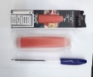
9-Aug-2022 | Ireland | Disposable Electronic Cigarette | Chemicals | Chemical Hazard | 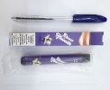
10-Aug-2022 | France | Climbing Chalk | Chemicals | Burn Hazard, Fire Hazard | 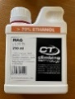
11-Aug-2022 | Sweden | Food Dehydrator | Home Electrical Appliances | Burn Hazard, Electric Shock Hazard, Fire Hazard | 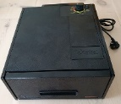
11-Aug-2022 | Slovakia | Necklace and Earrings Set | Jewelry | Chemical Hazard | 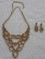
11-Aug-2022 | Slovakia | Jewelry Set | Jewelry | Chemical Hazard | 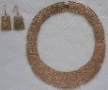
11-Aug-2022 | Slovakia | Earrings | Jewelry | Chemical Hazard | 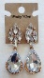  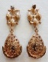
11-Aug-2022 | Slovakia | Necklace | Jewelry | Chemical Hazard | 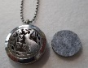  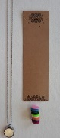
11-Aug-2022 | Czechia | Battery Operated Toy | Toys and Childcare Products | Environmental Hazard | 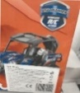
11-Aug-2022 | Czechia | Battery Operated Toy | Toys and Childcare Products | Environmental Hazard | 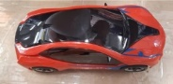  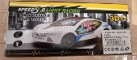
11-Aug-2022 | The Netherlands | Squeeze Toy | Toys and Childcare Products | Microbiological Hazard | 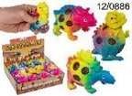
11-Aug-2022 | Lithuania | Toy-Helicopter with Sweet | Toys and Childcare Products | Choking Hazard, Injury Hazard | 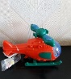
11-Aug-2022 | Germany | Particle Filter Mask | Protective Equipment | Health Risk Hazard | 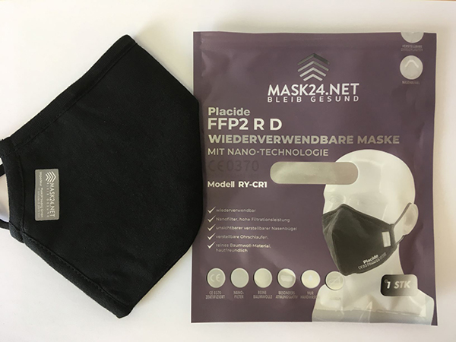
11-Aug-2022 | Romania | False Nails | Bodycare / Cosmetics | Chemical Hazard | 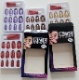
11-Aug-2022 | Germany | Muslin Cloths | Fabric / Textile / Garment / Home Textile | Chemical Hazard | 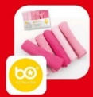
11-Aug-2022 | France | Fancy Dress | Fabric / Textile / Garment / Home Textile | Choking Hazard | /
11-Aug-2022 | Germany | Children’s Sandals | Footwear | Chemical Hazard | 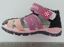
11-Aug-2022 | Finland | Pendant | Jewelry | Chemical Hazard | 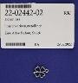
11-Aug-2022 | Czechia | Perfume | Bodycare / Cosmetics | Chemical Hazard | 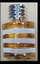
12-Aug-2022 | Finland | Padel Racket | Sporting Goods / Equipment | Chemical Hazard | 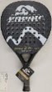
17-Aug-2022 | Bulgaria | Disposable Electronic Cigarette | Chemicals | Chemical Hazard | 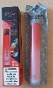
18-Aug-2022 | Austria | Massage Lotion | Bodycare / Cosmetics | Chemical Hazard | 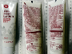
18-Aug-2022 | Poland | Plastic Toy | Toys and Childcare Products | Chemical Hazard | 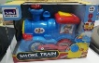
18-Aug-2022 | Ireland | Hammock | Outdoor Living Items | Injury Hazard | 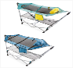
18-Aug-2022 | Czechia | Perfume | Bodycare / Cosmetics | Chemical Hazard | 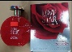
18-Aug-2022 | Lithuania | Glue | Chemicals | Chemical Hazard | 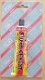
18-Aug-2022 | Poland | Lighting Chains | Electrical Appliances | Electric Shock Hazard | 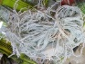
18-Aug-2022 | Czechia | Eau De Toilette | Bodycare / Cosmetics | Chemical Hazard | 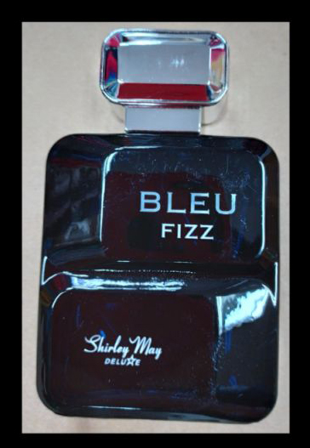
18-Aug-2022 | Czechia | Inflatable Armbands | Toys and Childcare Products | Chemical Hazard | 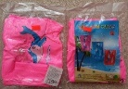
18-Aug-2022 | Lithuania | Perfume | Bodycare / Cosmetics | Chemical Hazard | 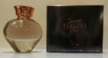
18-Aug-2022 | Lithuania | Perfume | Bodycare / Cosmetics | Chemical Hazard | 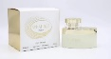
18-Aug-2022 | Sweden | Perfume | Bodycare / Cosmetics | Chemical Hazard | 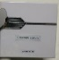
18-Aug-2022 | Sweden | Perfume | Bodycare / Cosmetics | Chemical Hazard | 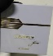
18-Aug-2022 | Sweden | Perfume | Bodycare / Cosmetics | Chemical Hazard | 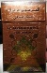
18-Aug-2022 | Lithuania | Shaving Gel | Bodycare / Cosmetics | Chemical Hazard | 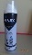
18-Aug-2022 | Lithuania | Shower Gel | Bodycare / Cosmetics | Chemical Hazard | 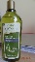
18-Aug-2022 | Sweden | Hair Dye | Bodycare / Cosmetics | Chemical Hazard | 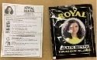
18-Aug-2022 | Finland | Police Toy Set | Toys and Childcare Products | Chemical Hazard | 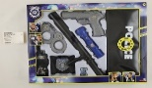
18-Aug-2022 | Bulgaria | Disposable Electronic Cigarette | Chemicals | Chemical Hazard | 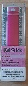
18-Aug-2022 | Norway | Particle Filter Mask | Protective Equipment | Health Risk Hazard
18-Aug-2022 | Germany | Wristwatch | Jewelry | Chemical Hazard | 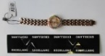
18-Aug-2022 | Belgium | Children's Trousers | Fabric / Textile / Garment / Home Textile | Injury Hazard | 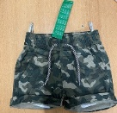
18-Aug-2022 | Sweden | Perfume | Bodycare / Cosmetics | Chemical Hazard
18-Aug-2022 | Sweden | Perfume | Bodycare / Cosmetics | Chemical Hazard | 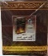
18-Aug-2022 | Sweden | Perfume | Bodycare / Cosmetics | Chemical Hazard | 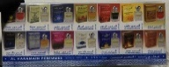
18-Aug-2022 | Finland | Reflective Pendant | Accessories | Injury Hazard | 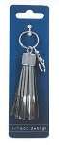
18-Aug-2022 | Belgium | Children's Trousers | Fabric / Textile / Garment / Home Textile | Injury Hazard | 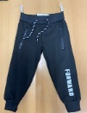
18-Aug-2022 | Sweden | Soap | Bodycare / Cosmetics | Chemical Hazard | 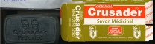
18-Aug-2022 | Bulgaria | Disposable Electronic Cigarette | Chemicals | Chemical Hazard
18-Aug-2022 | Lithuania | After Shave Balm | Bodycare / Cosmetics | Chemical Hazard | 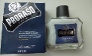
18-Aug-2022 | Lithuania | After Shave Balm | Bodycare / Cosmetics | Chemical Hazard | 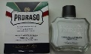
18-Aug-2022 | Lithuania | Face Cream | Bodycare / Cosmetics | Chemical Hazard | 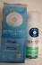
18-Aug-2022 | Poland | Fireworks | Outdoor Living Items | Burn Hazard | 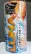
19-Aug-2022 | Germany | Textile Freshener | Chemicals | Chemical Hazard | 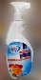
23-Aug-2022 | Germany | Particle Filter Mask | Protective Equipment | Health Risk Hazard | 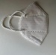
23-Aug-2022 | Poland | Lighting Chain | Electrical Appliances | Burn Hazard, Electric Shock Hazard, Fire Hazard | 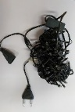
23-Aug-2022 | Germany | Work Gloves | Protective Equipment | Chemical Hazard | 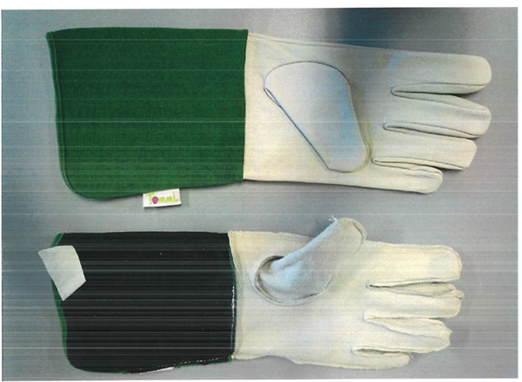
23-Aug-2022 | Germany | Leather Belt | Fabric / Textile / Garment / Home Textile | Chemical Hazard | 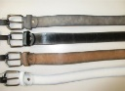
23-Aug-2022 | Bulgaria | Disposable Electronic Cigarette | Chemicals | Chemical Hazard | 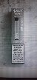
23-Aug-2022 | Poland | Infant Swing / Rocker | Toys and Childcare Products | Strangulation Hazard | 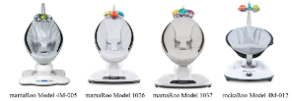
24-Aug-2022 | Sweden | Children's Crib | Furniture | Injury Hazard | 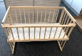
24-Aug-2022 | France | Toy Car Circuit | Toys and Childcare Products | Choking Hazard | 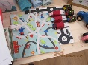
24-Aug-2022 | Poland | Toy Slime | Toys and Childcare Products | Chemical Hazard | 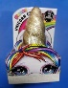
24-Aug-2022 | Czechia | Inflatable Armbands | Sporting Goods / Equipment | Chemical Hazard | 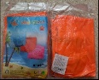
24-Aug-2022 | Sweden | Perfume | Bodycare / Cosmetics | Chemical Hazard | 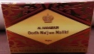
24-Aug-2022 | Poland | Desk Lamp | Electrical Appliances | Electric Shock Hazard, Fire Hazard | 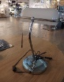
24-Aug-2022 | Ireland | Children's Pyjamas | Fabric / Textile / Garment / Home Textile | Choking Hazard | 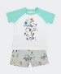  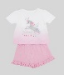  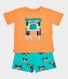  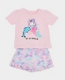
24-Aug-2022 | Luxembourg | Truck Trailer Tyre | Car Components | Injury Hazard, Damage to Hearing | 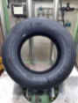
24-Aug-2022 | Romania | Children's Sweatshirt | Fabric / Textile / Garment / Home Textile | Strangulation Hazard | 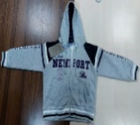
25-Aug-2022 | Germany | Particle Filter Mask | Protective Equipment | Health Risk Hazard | 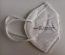
25-Aug-2022 | Germany | Fiber-Laser Cutting Machine | Machinery | Damage to Sight | 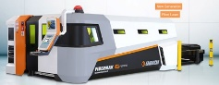
25-Aug-2022 | Sweden | Perfume | Bodycare / Cosmetics | Chemical Hazard | 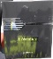
25-Aug-2022 | Lithuania | Toy-Helicopter with Sweet | Toys and Childcare Products | Choking Hazard, Injury Hazard | 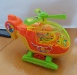
25-Aug-2022 | Sweden | Skin Cream | Bodycare / Cosmetics | Chemical Hazard | 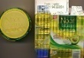
25-Aug-2022 | Sweden | Skin Care Cream | Bodycare / Cosmetics | Chemical Hazard | 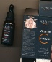
25-Aug-2022 | Sweden | Skin Cream | Bodycare / Cosmetics | Chemical Hazard | 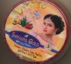
25-Aug-2022 | Sweden | Skin Cream and Soap Set | Bodycare / Cosmetics | Chemical Hazard | 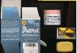
25-Aug-2022 | Poland | Soft Toy | Toys and Childcare Products | Chemical Hazard, Choking Hazard, Suffocation Hazard | 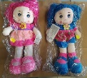
25-Aug-2022 | Austria | Plastic Toy | Toys and Childcare Products | Choking Hazard | 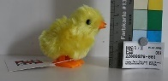
25-Aug-2022 | France | Wooden Puzzle | Toys and Childcare Products | Choking Hazard | 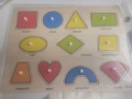
25-Aug-2022 | France | Table Lamp | Electrical Appliances | Electric Shock Hazard | 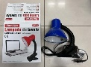
25-Aug-2022 | Lithuania | Glue | Chemicals | Chemical Hazard | 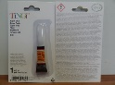
26-Aug-2022 | Luxembourg | LED Lighting Chain | Electrical Appliances | Chemical Hazard, Environmental Hazard | 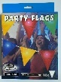
30-Aug-2022 | Slovakia | Earrings | Jewelry | Chemical Hazard | 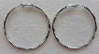  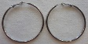
30-Aug-2022 | Slovakia | Necklace | Jewelry | Chemical Hazard | 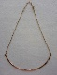
30-Aug-2022 | Slovakia | Necklace | Jewelry | Chemical Hazard
30-Aug-2022 | Finland | LED Strip | Electrical Appliances | Electric Shock Hazard | 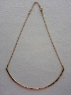  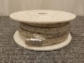  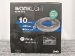
30-Aug-2022 | Poland | Plastic Swing | Toys and Childcare Products | Entrapment Hazard, Injury Hazard, Strangulation Hazard | 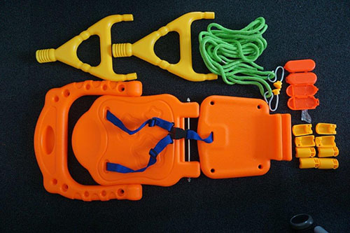  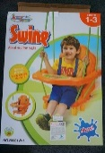
30-Aug-2022 | Poland | Plastic Toy | Toys and Childcare Products | Choking Hazard | 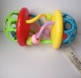
31-Aug-2022 | Norway | Digital Thermometer | Home Electrical Appliances | Environmental Hazard | 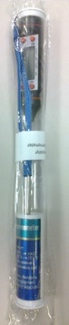
31-Aug-2022 | Norway | Digital Cooking Thermometer | Home Electrical Appliances | Environmental Hazard | 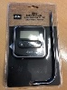
31-Aug-2022 | Germany | Baby Blanket | Toys and Childcare Products | Choking Hazard, Entrapment Hazard, Strangulation Hazard | 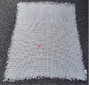  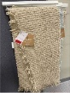  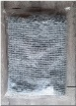
31-Aug-2022 | Slovakia | Bath Fizzer | Bodycare / Cosmetics | Chemical Hazard, Choking Hazard | 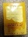  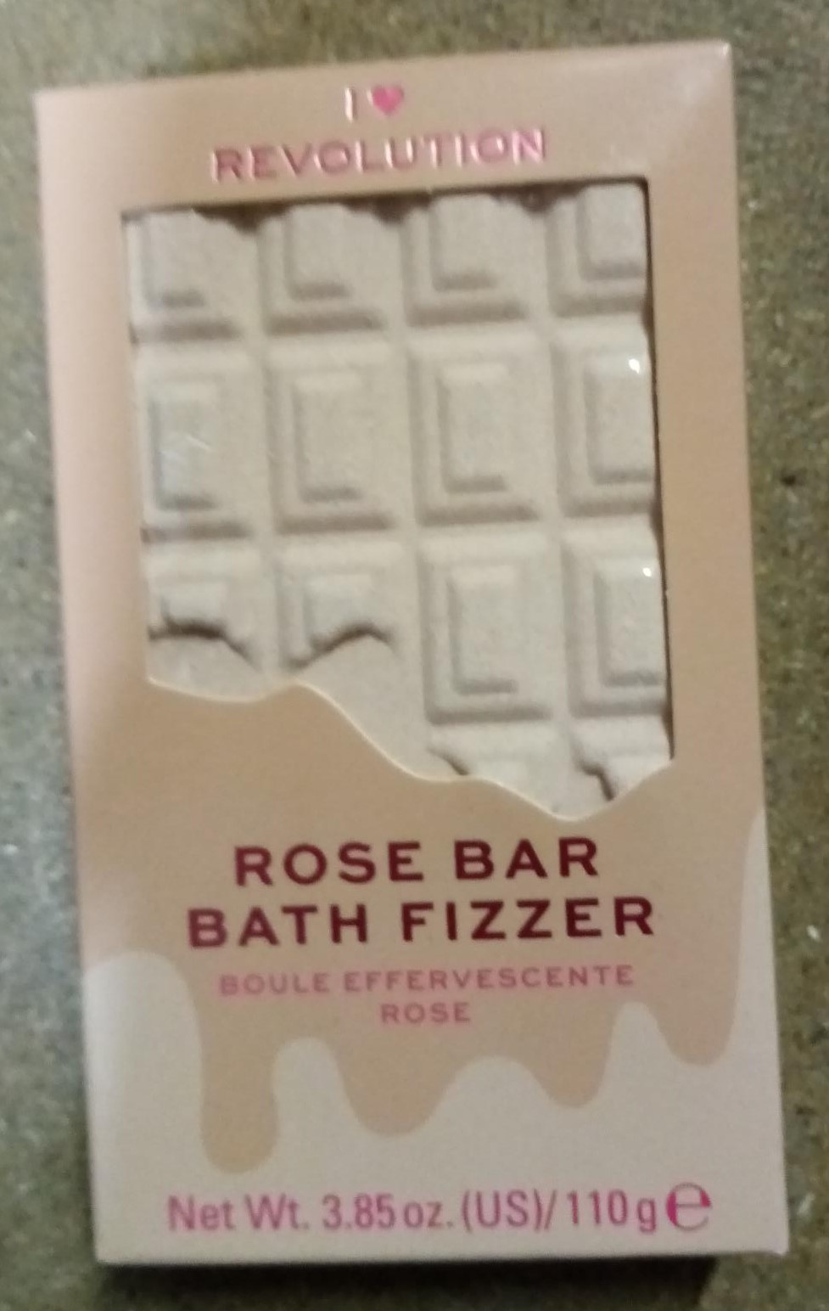  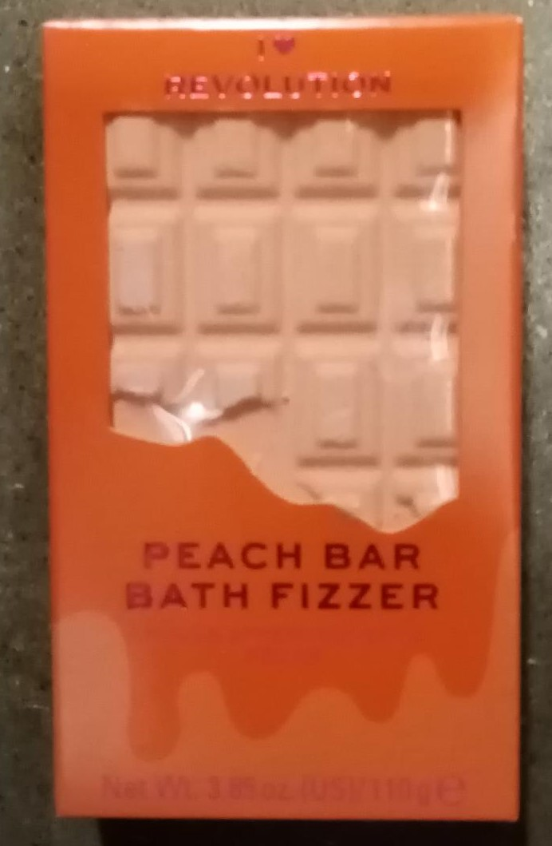  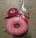  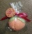  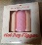  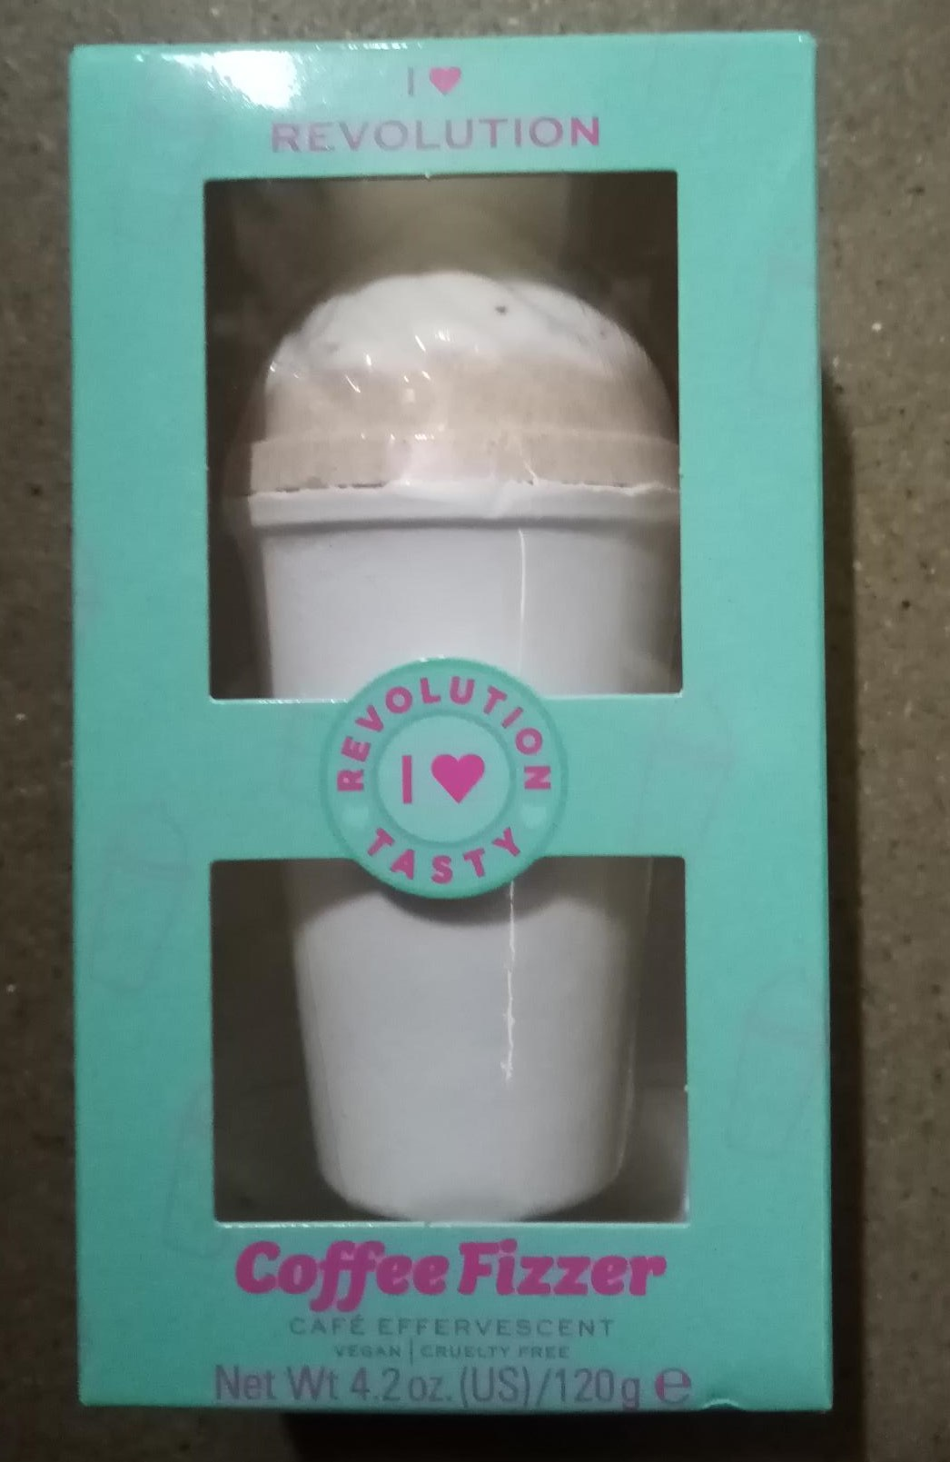  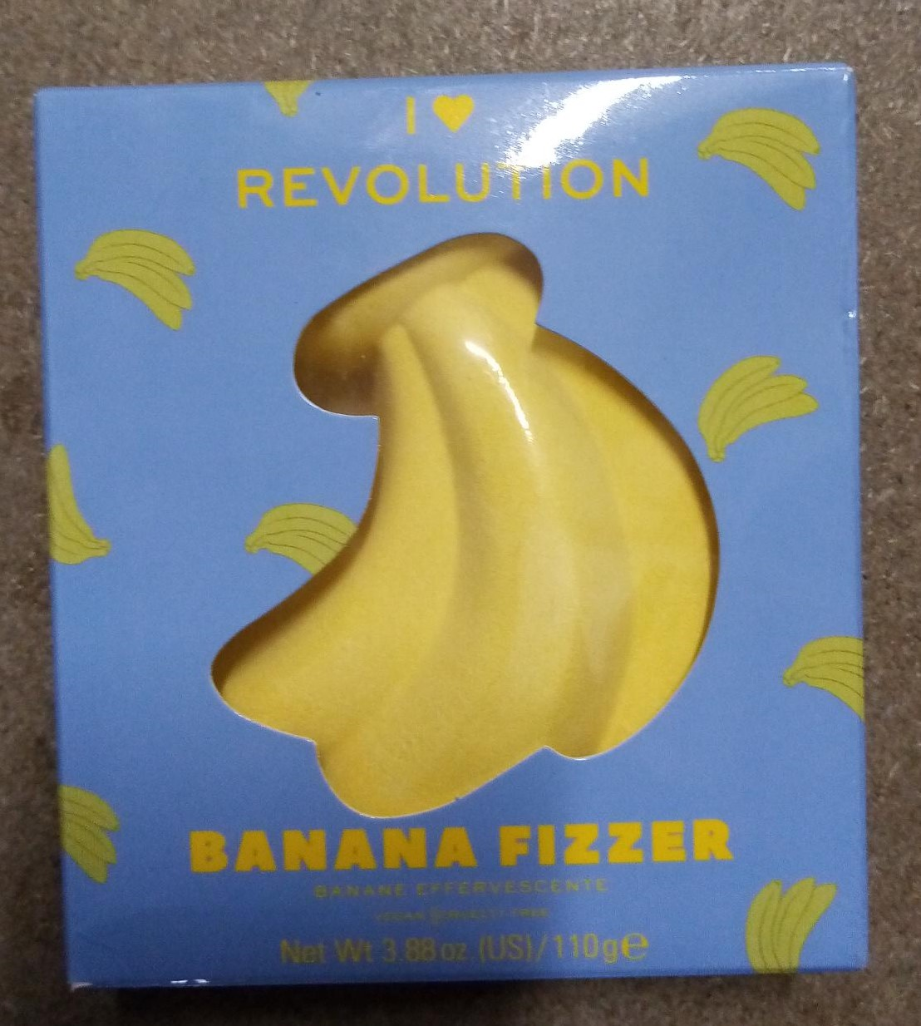  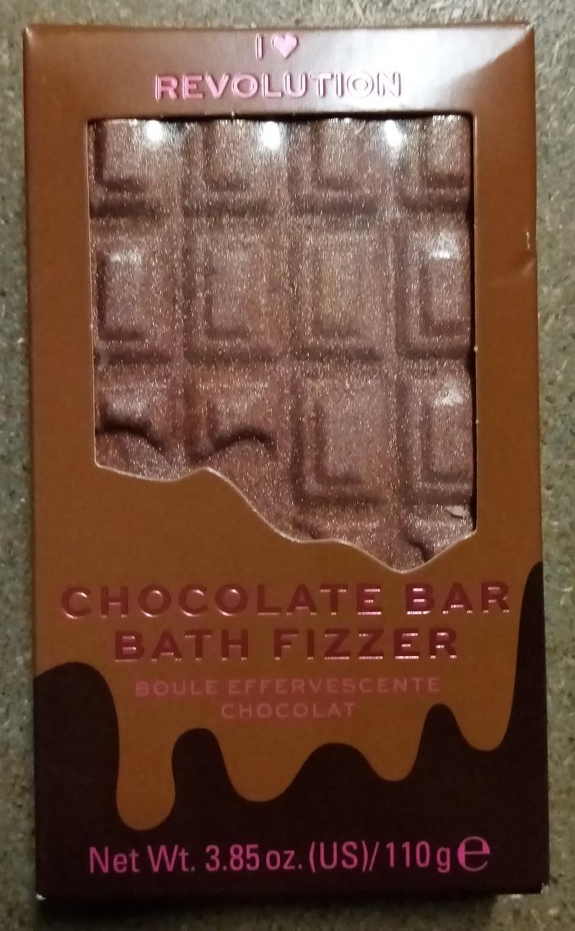  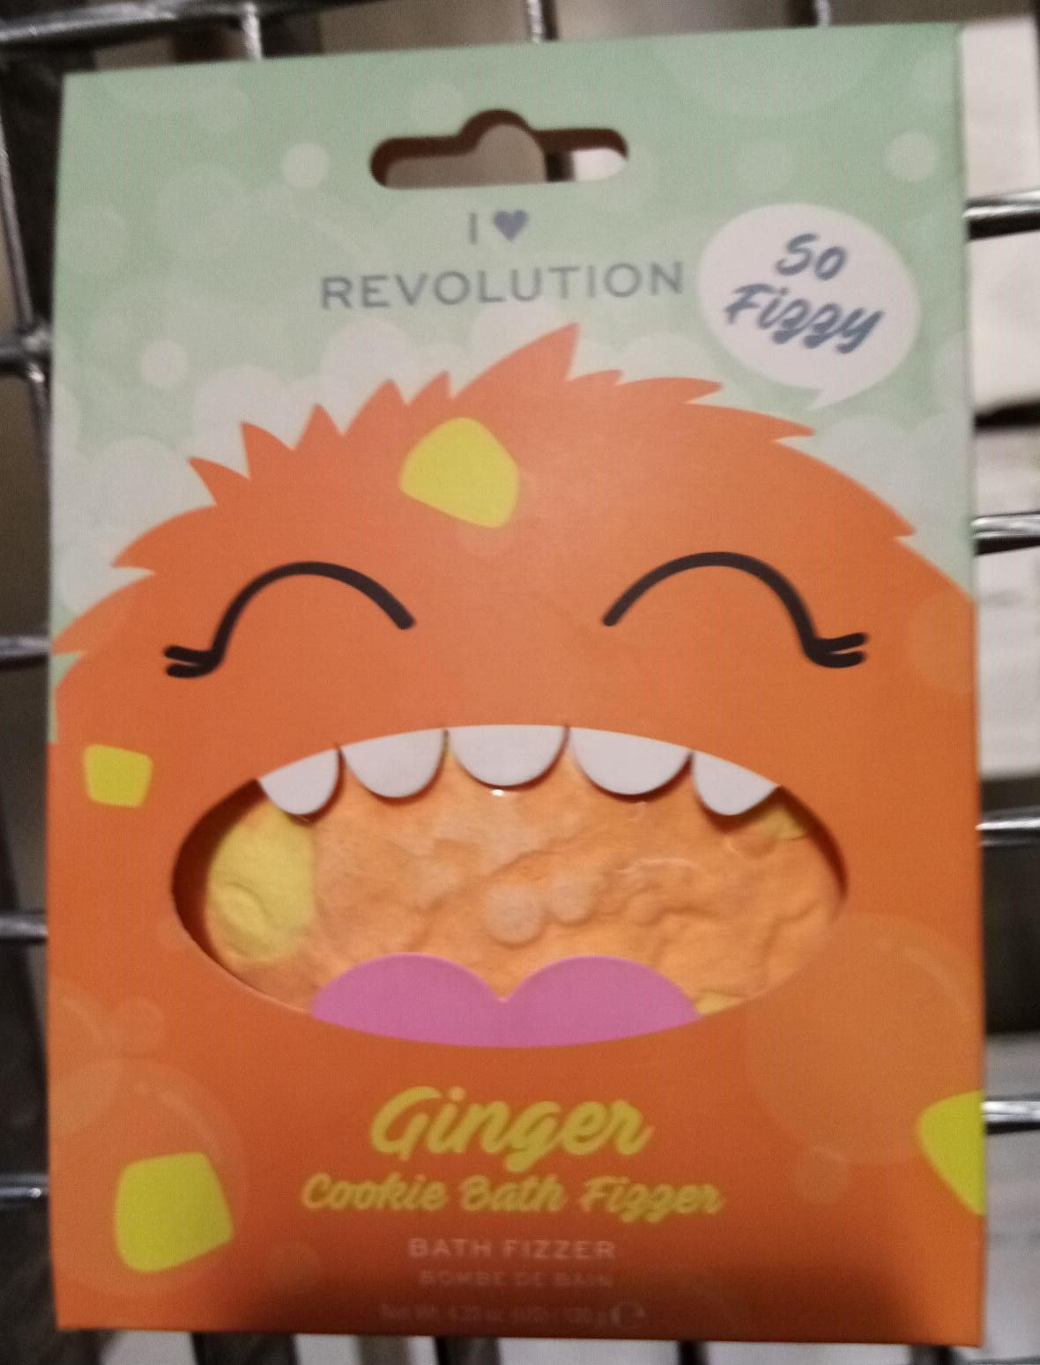
31-Aug-2022 | Poland | Plastic Swing | Toys and Childcare Products | Entrapment Hazard, Injury Hazard, Strangulation Hazard | 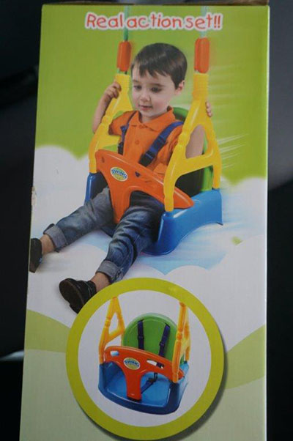  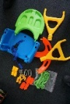
31-Aug-2022 | Cyprus | Sandwich Maker | Home Electrical Appliances | Burn Hazard, Electric Shock Hazard, Fire Hazard | 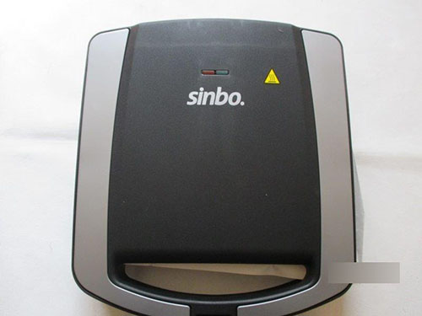
31-Aug-2022 | Slovakia | Necklace and Earrings Set | Jewelry | Chemical Hazard | 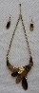  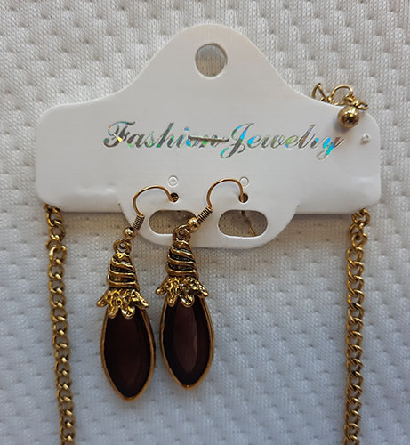
31-Aug-2022 | Cyprus | Baby Swing | Toys and Childcare Products | Injury Hazard | 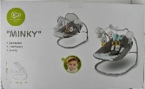
31-Aug-2022 | Cyprus | Baby Swing | Toys and Childcare Products | Injury Hazard | 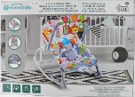
31-Aug-2022 | Cyprus | Baby Swing | Toys and Childcare Products | Injury Hazard | 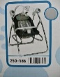
31-Aug-2022 | Cyprus | Reclined Cradle | Toys and Childcare Products | Injury Hazard | 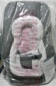
31-Aug-2022 | Germany | Children's Drinking Bottle | Food Contact Material | Chemical Hazard | 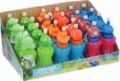
31-Aug-2022 | Germany | Vehicle Part / Battery Charger | Car Components | Fire Hazard | 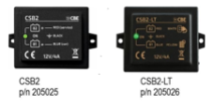
31-Aug-2022 | Germany | Motorcycle/  Spare Part | Car Components | Injury Hazard | 