Recall Cases Summary – US (Last Update Date: 31 August 2022)

Date | Product | Categories | Hazard | Image
4-Aug-2022 | Cordless Hedge Trimmer | Tools and Hardware | Laceration Hazard | 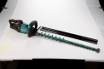  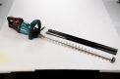
4-Aug-2022 | 1.4 Million Miter Saw | Tools and Hardware | Laceration Hazard, Injury Hazard | 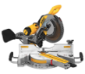  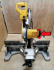  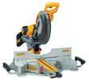
11-Aug-2022 | Home Elevator | Electrical Appliances | Entrapment Hazard, Injury Hazard | 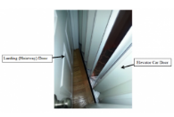
11-Aug-2022 | Footpad for Onewheel GT Electric Skateboard | Sporting Goods / Equipment | Injury Hazard | 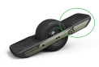
15-Aug-2022 | MamaRoo and RockaRoo Infant Swing and Rocker | Toys and Childcare Products | Entanglement Hazard, Strangulation Hazard | 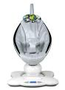  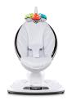  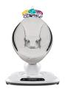  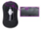  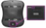
18-Aug-2022 | ASUS ROG Maximus Z690 Hero Motherboard | Computer / Audio / Video / Other Electronics & Accessories | Fire Hazard, Burn Hazard | 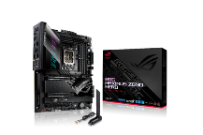  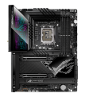
18-Aug-2022 | Children’s Hooded Sweatshirts with Drawstrings | Fabric / Textile / Garment / Home Textile | Strangulation Hazard | 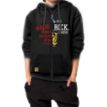
25-Aug-2022 | Paddles Sold with Stand-Up Paddleboard | Sporting Goods / Equipment | Injury Hazard, Laceration Hazard
25-Aug-2022 | Kidoozie™ Activity Desk Toy | Toys and Childcare Products | Entanglement Hazard, Entrapment Hazard | 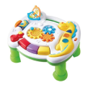
25-Aug-2022 | Big Game Hunters Children’s Outdoor Kitchen | Toys and Childcare Products | Lead Poisoning Hazard, Health Risk Hazard | 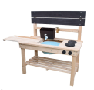  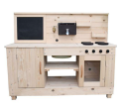
25-Aug-2022 | Road Bike and Bicycle Handlebar/ Stem | Sporting Goods / Equipment | Fall Hazard, Crash Hazard | 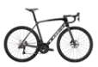  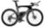
25-Aug-2022 | Ride-On Toy | Toys and Childcare Products | Fall Hazard, Injury Hazard | 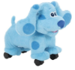
25-Aug-2022 | Steel Rolling Chassis for Utility Vehicle | Car Components | Crash Hazard, Injury Hazard | 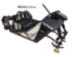
25-Aug-2022 | METALLISK Espresso Maker | Food Contact Material | Burn Hazard, Injury Hazard | 