Recall Cases Summary – Australia (Last Update Date: 30 September 2022)

Date | Product | Categories | Hazard | Image
1-Sep-2022 | Shoot & Catch Set - 4 Piece | Toys and Childcare Products | Injury Hazard | 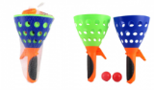
1-Sep-2022 | CLICK Electric Panel Heater | Home Electrical Appliances | Injury Hazard, Fire Hazard, Electric Shock Hazard | 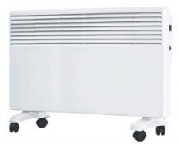
2-Sep-2022 | GRUNT Vehicle Recovery & Snatch Strap | Tools and Hardware | Injury Hazard | 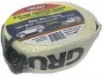  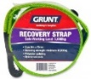
2-Sep-2022 | Early Learning Centre Little Senses Lights & Sounds Shape Sorter from Modern Brands Pty Ltd | Toys and Childcare Products | Choking Hazard, Injury Hazard | 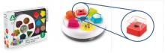
2-Sep-2022 | Yamaha Outboard Engine | Machinery | Injury Hazard, Fire Hazard | 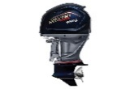  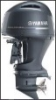
2-Sep-2022 | Sea-Doo Passenger Seat | Sporting Goods / Equipment | Injury Hazard | 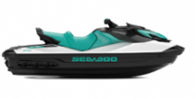
8-Sep-2022 | Wheelchair | Medical Devices | Injury Hazard, Fall Hazard | 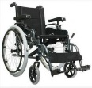
8-Sep-2022 | Mitre Saw | Machinery | Injury Hazard | 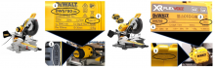
9-Sep-2022 | Electronic Weighing Stainless Bowl | Food Contact Material | Burn Hazard, Choking Hazard | 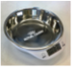
12-Sep-2022 | Water Filter Monitor Timer for Various Water Filter System Products | Electrical Appliances | Burn Hazard, Choking Hazard | 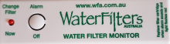
13-Sep-2022 | Crispbic Wafer Bics Original Gluten Free 100g | Food | Risk of Allergy | 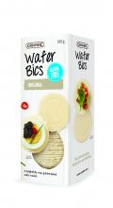
13-Sep-2022 | Aluminium Paddle Sold with Wavestorm Agit Stand-Up Paddle Board | Sporting Goods / Equipment | Laceration Hazard, Injury Hazard
14-Sep-2022 | Early Learning Centre Little Senses Lights & Sounds Shape Sorter from Target Australia Pty Ltd | Toys and Childcare Products | Choking Hazard, Injury Hazard | 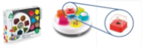
19-Sep-2022 | Light Up Party Wand | Toys and Childcare Products | Burn Hazard, Injury Hazard, Choking Hazard | 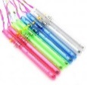  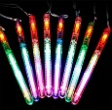
19-Sep-2022 | Light-Up Flower Crown | Toys and Childcare Products | Burn Hazard, Injury Hazard, Choking Hazard | 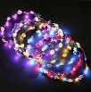
19-Sep-2022 | Mini Bobo Light Up Balloon | Toys and Childcare Products | Burn Hazard, Injury Hazard, Choking Hazard | 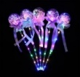
21-Sep-2022 | Handheld Electric Concrete Cutting Saw | Machinery | Fire Hazard, Burn Hazard, Injury Hazard | 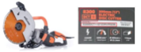
23-Sep-2022 | Hawaiian Haze Pale Ale 375mL, Hawaiian Haze IPA 375mL and Reef Pale Ale 375mL | Food | Health Risk Hazard, Injury Hazard | 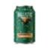  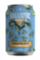  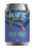
27-Sep-2022 | Aluminium Rear Bar with Tow Bar | Car Components | Injury Hazard | 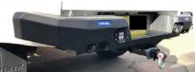
29-Sep-2022 | Brownes Dairy Mango Yoghurt 120g | Food | Health Risk Hazard, Injury Hazard | 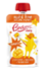
30-Sep-2022 | Fusion Apollo Marine Amplifier | Electrical Appliances | Fire Hazard, Injury Hazard | 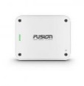  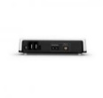
30-Sep-2022 | Pizza | Food | Health Risk Hazard | 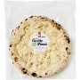  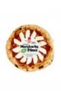  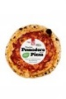  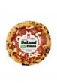
30-Sep-2022 | Happi Free From Oat M!lk Chocolate Bars 80g- Plain M!lk, Salted Caramel and Plain White | Food | Risk of Allergy | 