Recall Cases Summary – Canada (Last Update Date: 30 September 2022)

Date | Product | Categories | Hazard | Image
1-Sep-2022 | Steel Hanging Chair | Furniture | Fall Hazard | 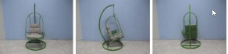
1-Sep-2022 | Sun Joe iON+ Cordless Lawn Mower Kit | Machinery | Injury Hazard | 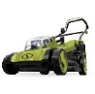
1-Sep-2022 | Citrus Solvent | Chemicals | Aspiration Hazard, Health Risk Hazard, Injury Hazard | 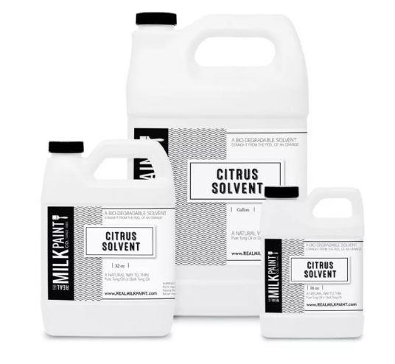
1-Sep-2022 | UPPAbaby All-Terrain RIDGE Jogging Stroller | Toys and Childcare Products | Injury Hazard | 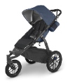
1-Sep-2022 | Keampferia Galanga Powder (Sand Ginger Powder) | Food | Microbiological Hazard | 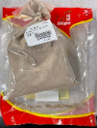
2-Sep-2022 | Roller Blind | Household Items | Strangulation Hazard | 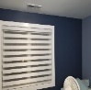
2-Sep-2022 | Enoki Mushroom | Food | Microbiological Hazard | 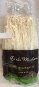
2-Sep-2022 | Nevat (Cheese) | Food | Microbiological Hazard | /
6-Sep-2022 | IKEA TRIPPEVALS and HOPPVALS Cellular Blind | Household Items | Choking Hazard | 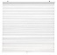  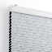  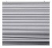
9-Sep-2022 | Chicology Cordless 1-Inch Vinyl Mini Blind | Household Items | Choking Hazard, Strangulation Hazard, Entanglement Hazard | 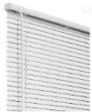
13-Sep-2022 | Air Steward Portable Radon Monitor | Electrical Appliances | Health Risk Hazard | 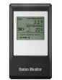
15-Sep-2022 | Cervélo R5 and Caledonia-5 Bicycle and ST31 LT Replacement Stem | Sporting Goods / Equipment | Fall hazard | 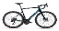  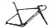  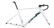  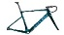  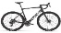  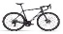  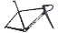  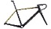  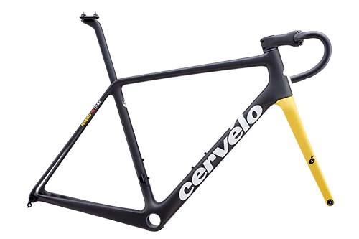  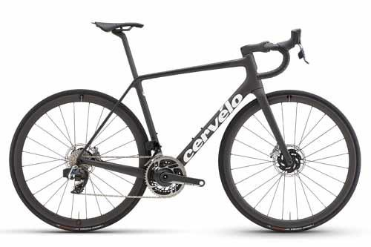  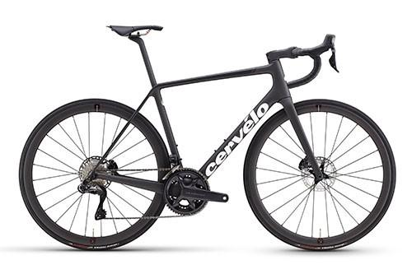  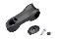
15-Sep-2022 | Various Hilti DHS Gas Cut-Off Saw | Machinery | Injury Hazard | 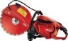  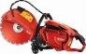  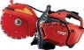
15-Sep-2022 | Various Brands of Salad Products | Food | Health Risk Hazard | /
16-Sep-2022 | Veggie Cevapcici | Food | Risk of Allergy | 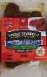
18-Sep-2022 | Enoki Mushroom | Food | Microbiological Hazard | 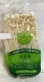
21-Sep-2022 | Krystal Epoxy Resin Tabletop & Art Epoxy Kit | Chemicals | Health Risk Hazard, Injury Hazard | 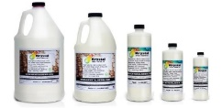
21-Sep-2022 | Fresh and Local Brand Turkey, Bacon Sub | Food | Microbiological Hazard | 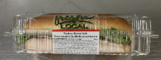
22-Sep-2022 | Spalding Momentous EZ Portable Basketball Goal | Sporting Goods / Equipment | Impact Hazard | 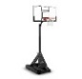  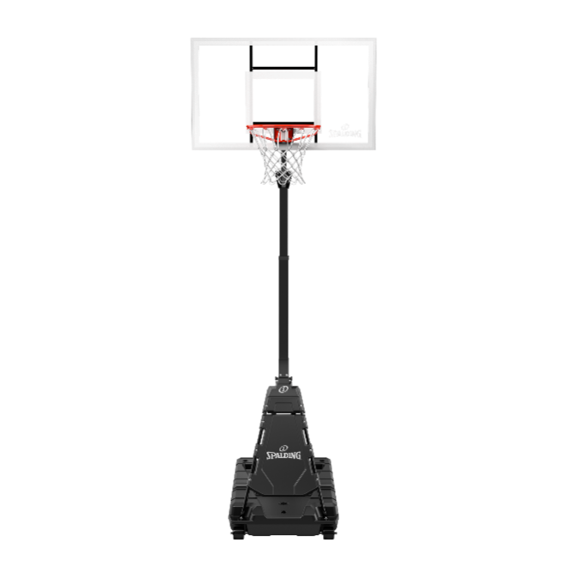  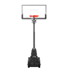  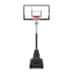  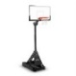  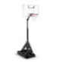
22-Sep-2022 | German Frikadellen | Food | Risk of Allergy | /
27-Sep-2022 | Various Brands of Oyster | Food | Microbiological Hazard | 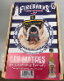
28-Sep-2022 | In Home BIRK Shag Rug (Light Grey) | Fabric / Textile / Garment / Home Textile | Fire Hazard
29-Sep-2022 | Universal Branded Custom Filled Spray Can | Chemicals | Injury Hazard | 