Recall Cases Summary – Europe (Last Update Date: 30 September 2022)

Date | Notifying Country | Product | Categories | Hazard | Image
1-Sep-2022 | Austria | Wooden Rattle | Toys and Childcare Products | Choking Hazard | 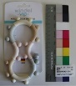
6-Sep-2022 | Slovakia | Ring | Jewelry | Chemical Hazard | 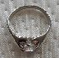  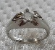
6-Sep-2022 | Poland | Toy Gun | Toys and Childcare Products | Damage to Sight, Injury Hazard | 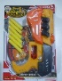
6-Sep-2022 | Ireland | Disposable Electronic Cigarette | Chemicals | Chemical Hazard | 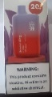
6-Sep-2022 | Ireland | Disposable Electronic Cigarette | Chemicals | Chemical Hazard | 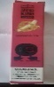
6-Sep-2022 | Poland | Power Supply | Electrical Appliances | Environmental Hazard | 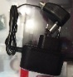
7-Sep-2022 | Czechia | Plastic Doll | Toys and Childcare Products | Chemical Hazard | 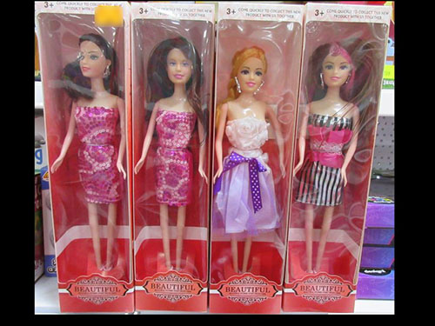  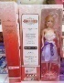
8-Sep-2022 | Norway | Food Thermometer | Food Contact Material | Environmental Hazard | 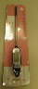
8-Sep-2022 | Austria | Soft Toy | Toys and Childcare Products | Choking Hazard | 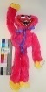
8-Sep-2022 | Germany | Soother Holder | Toys and Childcare Products | Choking Hazard | 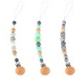  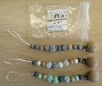
8-Sep-2022 | Germany | Soother Holder | Toys and Childcare Products | Choking Hazard | 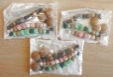  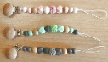  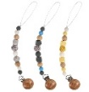
8-Sep-2022 | Austria | Soft Toy | Toys and Childcare Products | Choking Hazard | 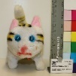
8-Sep-2022 | Austria | Pull-Along Toy | Toys and Childcare Products | Choking Hazard | 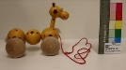  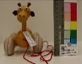
8-Sep-2022 | Germany | Baby Carrier | Toys and Childcare Products | Injury Hazard | 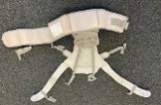
8-Sep-2022 | Austria | Puffer Toy | Toys and Childcare Products | Choking Hazard | 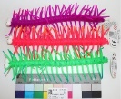
8-Sep-2022 | Germany | Piercing Jewelry | Jewelry | Chemical Hazard | 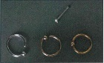
8-Sep-2022 | Hungary | Plastic Doll | Toys and Childcare Products | Chemical Hazard | 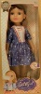
8-Sep-2022 | Hungary | Plastic Doll with Accessories | Toys and Childcare Products | Chemical Hazard
8-Sep-2022 | Hungary | Plastic Doll Set | Toys and Childcare Products | Chemical Hazard | 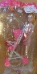
8-Sep-2022 | Hungary | Plastic Doll with Accessories | Toys and Childcare Products | Chemical Hazard | 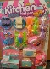
8-Sep-2022 | Romania | Children's T-Shirt | Fabric / Textile / Garment / Home Textile | Choking Hazard | 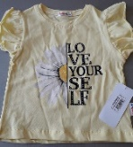
9-Sep-2022 | Germany | Fitness Gloves | Sporting Goods / Equipment | Chemical Hazard | 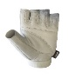  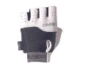
9-Sep-2022 | Germany | Particle Filter Mask | Protective Equipment | Health Risk Hazard | 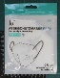  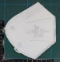
9-Sep-2022 | Latvia | Hand Disinfectant | Chemicals | Health Risk Hazard | 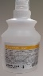
9-Sep-2022 | Germany | Eyelash Adhesive | Bodycare / Cosmetics | Chemical Hazard | 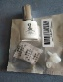
9-Sep-2022 | Germany | Eyelash Adhesive | Bodycare / Cosmetics | Chemical Hazard | 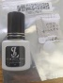
12-Sep-2022 | Germany | Rattle Toy | Toys and Childcare Products | Choking Hazard | 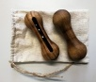
12-Sep-2022 | Germany | Rattle Toy | Toys and Childcare Products | Choking Hazard | 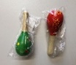
12-Sep-2022 | Germany | Rattle Toy | Toys and Childcare Products | Choking Hazard | 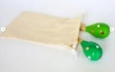  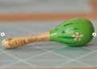
12-Sep-2022 | Belgium | Plastic Doll | Toys and Childcare Products | Chemical Hazard, Environmental Hazard | 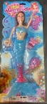  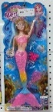
13-Sep-2022 | France | Soft Toy | Toys and Childcare Products | Choking Hazard, Damage to Sight, Injury Hazard | 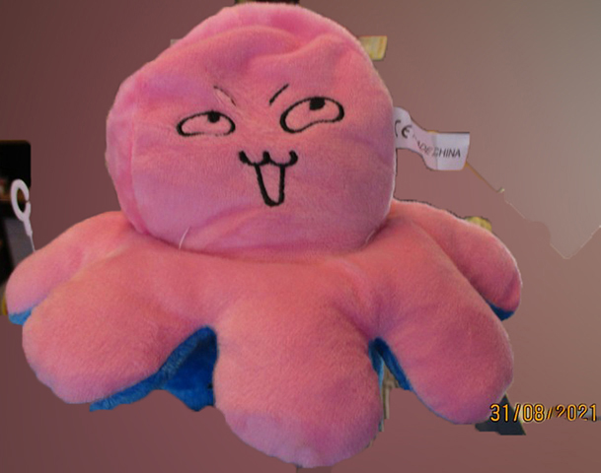
13-Sep-2022 | Germany | Particle Filter Mask | Protective Equipment | Health Risk Hazard | 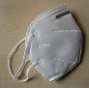
13-Sep-2022 | Austria | Wooden Toy | Toys and Childcare Products | Choking Hazard | 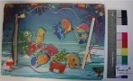
13-Sep-2022 | Hungary | Plastic Doll with Accessories | Toys and Childcare Products | Chemical Hazard
13-Sep-2022 | Romania | Children's Hat | Fabric / Textile / Garment / Home Textile | Choking Hazard | 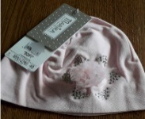
13-Sep-2022 | Poland | Ceiling Lamp | Electrical Appliances | Electric Shock Hazard | 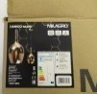  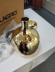
13-Sep-2022 | Norway | Electric Ride-On Tricycle | Toys and Childcare Products | Choking Hazard | 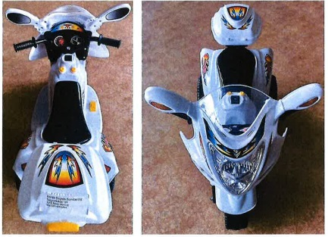  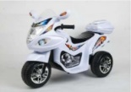
14-Sep-2022 | Poland | Fireworks | Outdoor Living Items | Burn Hazard, Injury Hazard | 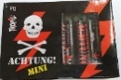  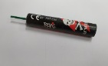
14-Sep-2022 | Hungary | Laser Pointer | Electrical Appliances | Damage to Sight, Electric Shock Hazard | 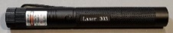  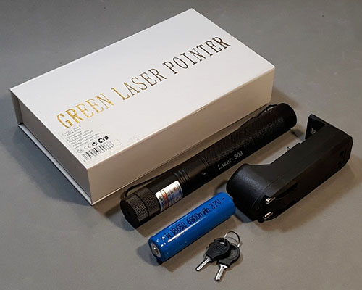
15-Sep-2022 | Norway | Muffin Forms | Food Contact Material | Chemical Hazard, Environmental Hazard | 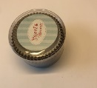
15-Sep-2022 | Norway | Blender | Home Electrical Appliances | Environmental Hazard | 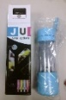
15-Sep-2022 | Norway | Digital Scale | Home Electrical Appliances | Environmental Hazard | 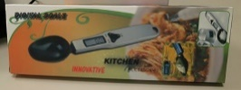
15-Sep-2022 | Finland | Portable Power Station | Electrical Appliances | Electric Shock Hazard | 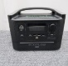
15-Sep-2022 | France | Sunglasses | Toys and Childcare Products | Damage to Sight | 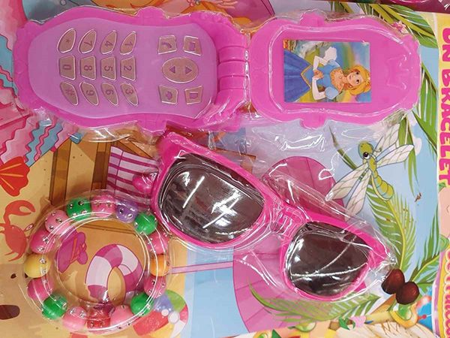  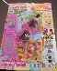
15-Sep-2022 | Austria | Puzzle | Toys and Childcare Products | Choking Hazard | 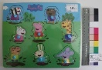
15-Sep-2022 | Germany | Power Supply | Electrical Appliances | Electric Shock Hazard, Fire Hazard | 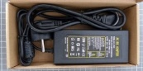  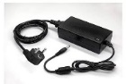
15-Sep-2022 | Austria | Puzzle | Toys and Childcare Products | Choking Hazard | 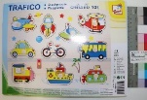
15-Sep-2022 | Germany | Oil for Skin and Hair | Bodycare / Cosmetics | Chemical Hazard | 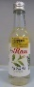
15-Sep-2022 | Hungary | Wooden Swing | Toys and Childcare Products | Injury Hazard | 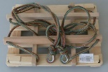
15-Sep-2022 | Hungary | Wooden Swing | Toys and Childcare Products | Injury Hazard | 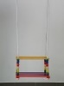
15-Sep-2022 | Hungary | Laser Pointer | Electrical Appliances | Damage to Sight | 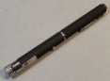
15-Sep-2022 | Hungary | Electrical Hot Plate | Electrical Appliances | Electric Shock Hazard | 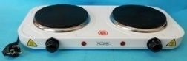
15-Sep-2022 | Hungary | Electrical Hot Plate | Electrical Appliances | Electric Shock Hazard | 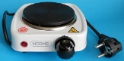
19-Sep-2022 | Slovenia | Bicycle Light Set | Sporting Goods / Equipment | Environmental Hazard | 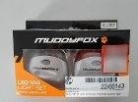
20-Sep-2022 | Greece | Piercings Set | Jewelry | Chemical Hazard | 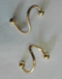  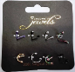
20-Sep-2022 | Greece | Plastic Tablecloth | Food Contact Material | Chemical Hazard | 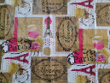
20-Sep-2022 | The Netherlands | Baby Gym | Toys and Childcare Products | Choking Hazard | 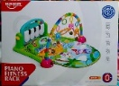
20-Sep-2022 | Romania | Children's Hat | Fabric / Textile / Garment / Home Textile | Choking Hazard | 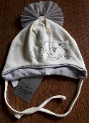
20-Sep-2022 | Lithuania | Silicone Sealant | Chemicals | Chemical Hazard | 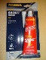
20-Sep-2022 | Lithuania | Silicone Sealant | Chemicals | Chemical Hazard | 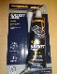
20-Sep-2022 | Germany | Baby Carrier | Toys and Childcare Products | Injury Hazard | 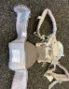
20-Sep-2022 | Ireland | Vase | Household Items | Injury Hazard | 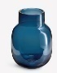
20-Sep-2022 | Sweden | Skin Whitening Cream | Bodycare / Cosmetics | Chemical Hazard | 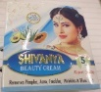  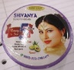  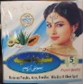
21-Sep-2022 | Greece | Children's Leather Shoes | Footwear | Chemical Hazard | 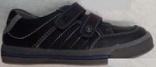
21-Sep-2022 | Czechia | Particle Filter Mask | Protective Equipment | Health Risk Hazard | 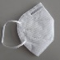
22-Sep-2022 | Germany | Laser Marking Machine | Machinery | Damage to Sight | 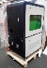
22-Sep-2022 | Hungary | Electric Kettle | Home Electrical Appliances | Electric Shock Hazard | 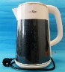
22-Sep-2022 | Germany | Vehicle Part | Car Components | Injury Hazard | 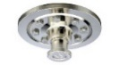
22-Sep-2022 | France | Air Compressor | Machinery | Injury Hazard | 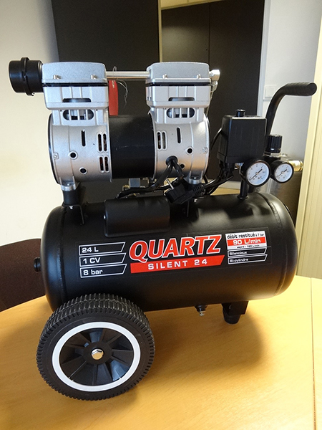
22-Sep-2022 | France | Safety Valve | Tools and Hardware | Injury Hazard | 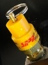
22-Sep-2022 | Sweden | Wax Heater | Home Electrical Appliances | Burn Hazard, Electric Shock Hazard | 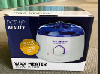
22-Sep-2022 | Poland | Portable Lamp | Electrical Appliances | Electric Shock Hazard | 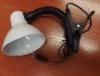
22-Sep-2022 | Czechia | Inflatable Baby Swimming Float | Sporting Goods / Equipment | Chemical Hazard | 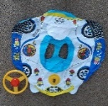
22-Sep-2022 | Germany | Vehicle Part | Car Components | Injury Hazard | 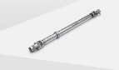
22-Sep-2022 | Poland | Flip Flops | Footwear | Chemical Hazard, Environmental Hazard | 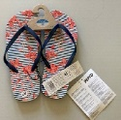
22-Sep-2022 | Poland | Foldable Pouffe | Furniture | Chemical Hazard | 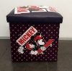
22-Sep-2022 | Slovenia | Particle Filter Mask | Protective Equipment | Health Risk Hazard | 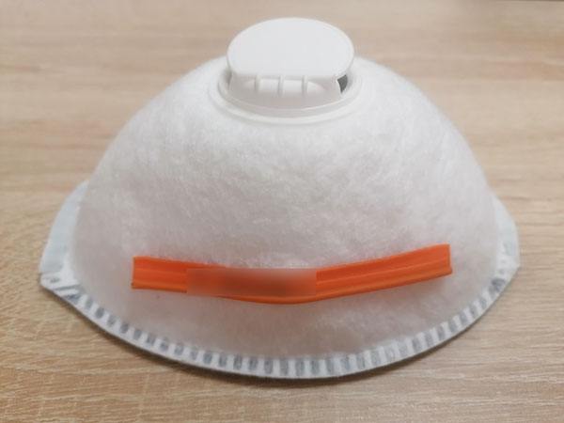  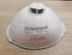
22-Sep-2022 | Romania | Clothing Set | Fabric / Textile / Garment / Home Textile | Choking Hazard | 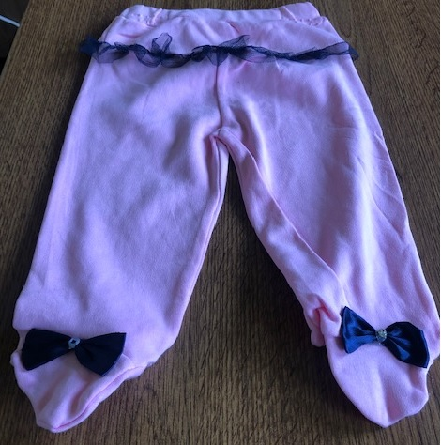  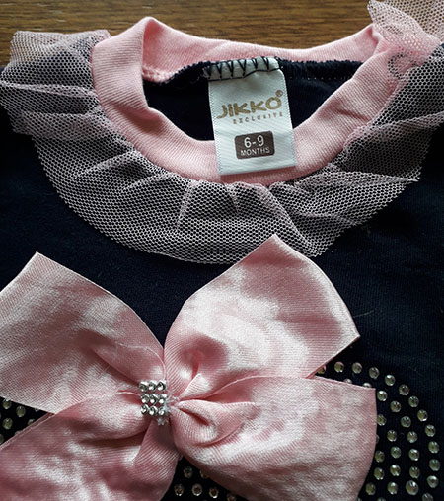  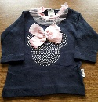
22-Sep-2022 | Czechia | Plastic Doll | Toys and Childcare Products | Chemical Hazard | 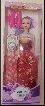
22-Sep-2022 | Hungary | Toy Rattle Set | Toys and Childcare Products | Choking Hazard | 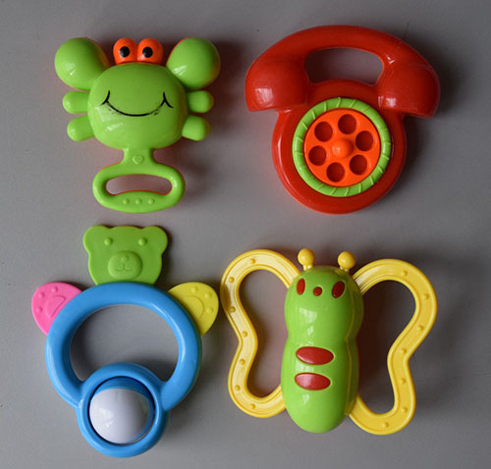
22-Sep-2022 | Hungary | Rattle Toy Set | Toys and Childcare Products | Choking Hazard | 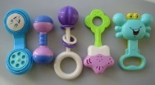
27-Sep-2022 | Austria | Soother Holder | Toys and Childcare Products | Choking Hazard | 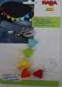
27-Sep-2022 | Bulgaria | Chair | Furniture | Injury Hazard | 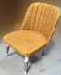
27-Sep-2022 | Bulgaria | Chair | Furniture | Injury Hazard | 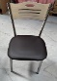
27-Sep-2022 | Czechia | Plastic Doll | Toys and Childcare Products | Chemical Hazard | 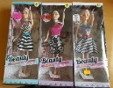
27-Sep-2022 | Czechia | Key Ring | Toys and Childcare Products | Chemical Hazard | 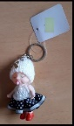
27-Sep-2022 | Poland | UV Lamp | Electrical Appliances | Electric Shock Hazard | 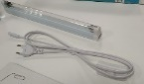
27-Sep-2022 | Hungary | Rattle Toy | Toys and Childcare Products | Chemical Hazard | 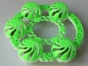  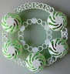
28-Sep-2022 | Greece | Notebook | Stationery | Chemical Hazard
28-Sep-2022 | Bulgaria | Chair | Furniture | Injury Hazard | 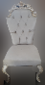
28-Sep-2022 | Bulgaria | Chair | Furniture | Injury Hazard | 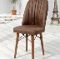
29-Sep-2022 | Denmark | Fireworks | Outdoor Living Items | Burn Hazard, Damage to Hearing, Injury Hazard | 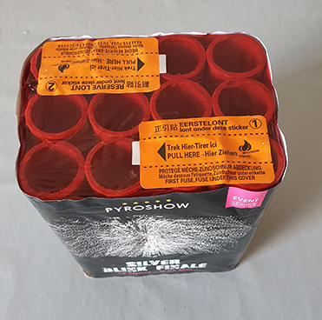  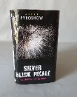
29-Sep-2022 | Denmark | Fireworks | Outdoor Living Items | Burn Hazard, Injury Hazard | 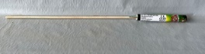
29-Sep-2022 | Denmark | Fireworks | Outdoor Living Items | Burn Hazard, Damage to Hearing, Fire Hazard, Injury Hazard | 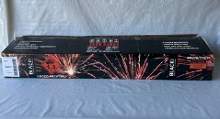
29-Sep-2022 | Denmark | Fireworks | Outdoor Living Items | Burn Hazard, Fire Hazard, Injury Hazard | 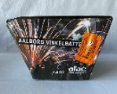
29-Sep-2022 | Denmark | Fireworks | Outdoor Living Items | Burn Hazard, Fire Hazard, Injury Hazard | 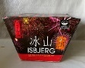
29-Sep-2022 | Denmark | Fireworks | Outdoor Living Items | Burn Hazard, Fire Hazard, Injury Hazard | 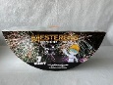
29-Sep-2022 | Slovakia | Children's Sandals | Footwear | Injury Hazard | 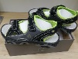
29-Sep-2022 | Bulgaria | Chair | Furniture | Injury Hazard | 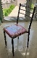
29-Sep-2022 | Finland | Slap Wrap with LED | Accessories | Injury Hazard | 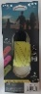  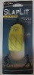
29-Sep-2022 | Hungary | Mobile Musical Toy | Toys and Childcare Products | Choking Hazard | 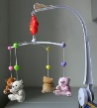  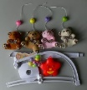
29-Sep-2022 | Czechia | Plastic Doll | Toys and Childcare Products | Chemical Hazard | 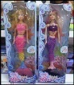
29-Sep-2022 | Hungary | Activity Play Mat | Toys and Childcare Products | Choking Hazard | 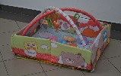
29-Sep-2022 | Lithuania | Rattle Toy | Toys and Childcare Products | Choking Hazard | 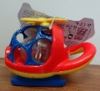
29-Sep-2022 | Poland | Power Supply | Electrical Appliances | Environmental Hazard | 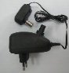
30-Sep-2022 | France | Lubricant | Chemicals | Chemical Hazard | 