Recall Cases Summary – US (Last Update Date: 30 September 2022)

Date | Product | Categories | Hazard | Image
1-Sep-2022 | Cordless Lawn Mower | Machinery | Laceration Hazard | 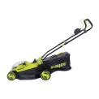  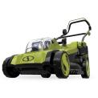
1-Sep-2022 | Outdoor Metal Hanging Chair | Furniture | Fall Hazard | 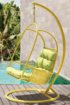
1-Sep-2022 | RIDGE Jogging Stroller | Toys and Childcare Products | Injury Hazard | 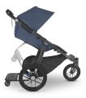
1-Sep-2022 | Infant Bath Seat | Toys and Childcare Products | Drowning Hazard | 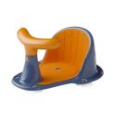
1-Sep-2022 | Children’s Sandal | Footwear | Lead Poisoning Hazard | 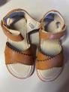  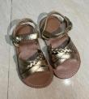  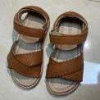
8-Sep-2022 | Children’s HearMuffs Sound Compression Ear Muff | Computer / Audio / Video / Other Electronics & Accessories | Burn Hazard, Injury Hazard | 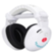
8-Sep-2022 | Roots & Harvest Wide Mouth Pint Canning Jar | Tools and Hardware | Laceration Hazard | 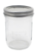
8-Sep-2022 | Tethrd One Stick GEN 2 Climbing Stick | Tools and Hardware | Fall Hazard, Injury Hazard | 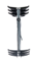
8-Sep-2022 | Ivy Bronx, Orren Ellis, Stellar Home Furniture, and Wade Logan Branded Murphy Bed | Furniture | Impact Hazard, Crushing Hazard
14-Sep-2022 | Inspect Home Elevator | Machinery | Entrapment Hazard, Injury Hazard | 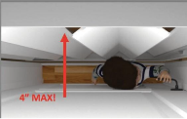
15-Sep-2022 | R5 and Caledonia-5 Bicycle and Cervélo Replacement Stem | Sporting Goods / Equipment | Fall Hazard | 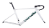  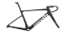  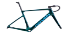  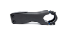  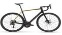  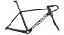  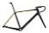  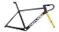
15-Sep-2022 | Cityscape Travel Jogger Stroller | Toys and Childcare Products | Fall Hazard, Injury Hazard | 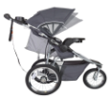
22-Sep-2022 | Miffy First Light | Electrical Appliances | Burn Hazard | 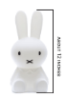
22-Sep-2022 | Spalding® Momentous EZ Portable Basketball Goal | Sporting Goods / Equipment | Impact Hazard, Injury Hazard | 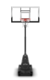
22-Sep-2022 | Ceramic Mug | Food Contact Material | Burn Hazard | 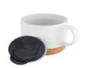  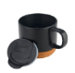
22-Sep-2022 | Pool and Spa Drain Cover | Tools and Hardware | Entrapment Hazard | 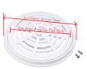
22-Sep-2022 | Wadoy Pool and Spa Drain Cover | Tools and Hardware | Entrapment Hazard | 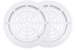
22-Sep-2022 | Pool and Spa Drain Cover | Tools and Hardware | Entrapment Hazard | 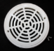
22-Sep-2022 | Pool and Spa Drain Cover | Tools and Hardware | Entrapment Hazard | 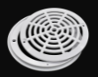
22-Sep-2022 | Ladder Sold with Bunk Bed and Hutch Set | Furniture | Entrapment Hazard, Strangulation Hazard | 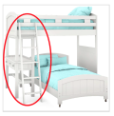
29-Sep-2022 | HyperJuice USB-C Battery Pack | Electrical Appliances | Fire Hazard | 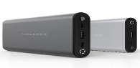
29-Sep-2022 | BarJam Bracket | Tools and Hardware | Injury Hazard, Crash Hazard | 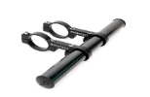
29-Sep-2022 | Children’s Hairclips | Accessories | Health Risk Hazard | 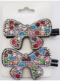  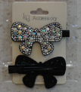
29-Sep-2022 | Cambridge Elevating Residential Elevator | Machinery | Entrapment Hazard, Injury Hazard | 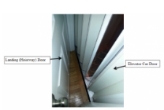
29-Sep-2022 | Toddleroo Rotating Cabinet Latch | Tools and Hardware | Choking Hazard | 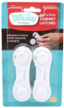
29-Sep-2022 | HyperJuice Stackable GaN USB-C Charger | Electrical Appliances | Fire Hazard | 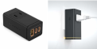
29-Sep-2022 | Flynn Twin Full Bunk Bed with Ladder | Furniture | Entrapment Hazard | 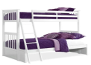
29-Sep-2022 | Residential Elevator | Machinery | Entrapment Hazard, Injury Hazard | 