Recall Cases Summary – Australia (Last Update Date: 31 October 2022)

Date | Product | Categories | Hazard | Image
4-Oct-2022 | Chips | Food | Injury Hazard | 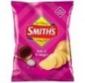
4-Oct-2022 | Chips | Food | Injury Hazard | 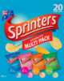
4-Oct-2022 | PIAK Rear Tow-Bar | Car Components | Injury Hazard | 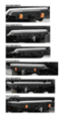
5-Oct-2022 | Battery Charger for Cleanskin Duo 2200 Lumen Bicycle Light | Electrical Appliances | Electric Shock Hazard, Injury Hazard | 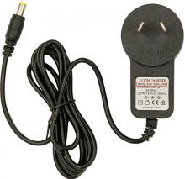  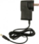
6-Oct-2022 | Dare Iced Coffee 750mL | Food | Injury Hazard, Health Risk Hazard | 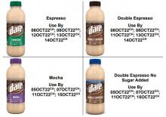
6-Oct-2022 | Dometic Marine Steering Cable | Tools and Hardware | Injury Hazard | 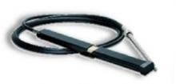
6-Oct-2022 | Oliveri Water Filter Monitor Timer | Electrical Appliances | Burn Hazard, Injury Hazard, Choking Hazard | 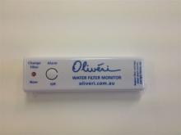
7-Oct-2022 | Various LED Puretec and Raymor Faucet, Sink Mixer, and Faucet Filter System, Plumbers Test Kit with Thermometer and Remote Control for Kleenmaid Rangehood | Electrical Appliances | Burn Hazard, Injury Hazard, Choking Hazard | 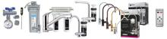
7-Oct-2022 | A’kin Mild & Gentle Shampoo Fragrance Free & Hypoallergenic 500mL | Bodycare / Cosmetics | Health Risk Hazard | 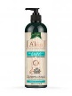
10-Oct-2022 | AMP External Battery Pack for Whisper Cellular Shade | Electrical Appliances | Fire Hazard, Injury Hazard | 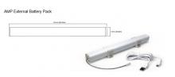  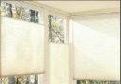
10-Oct-2022 | Collins Pharmacy Table Lamp Black 54cm | Electrical Appliances | Electric Shock Hazard, Injury Hazard | 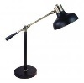
13-Oct-2022 | Riverina Italian Soup Mix 500g | Food | Risk of Allergy | 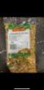
14-Oct-2022 | Dasatinib Dr. Reddy's Dasatinib 50 mg Film Coated Tablet Blister Pack and Dasatinib Dr. Reddy's Dasatinib 100 mg Film Coated Tablet Blister Pack | Pharmacy | Health Risk Hazard | 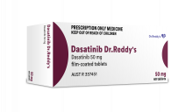  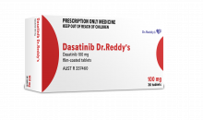
14-Oct-2022 | Murray River Smokehouse Salami Mild 180g and Murray River Smokehouse Salami Pepper 180g | Food | Microbiological Hazard | 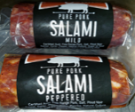
19-Oct-2022 | LED Flashing Starfish Necklace | Jewelry | Burn Hazard, Injury Hazard, Choking Hazard | 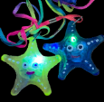
20-Oct-2022 | Jackson Model PEXT3M 3 Metre Extension Lead | Electrical Appliances | Electric Shock Hazard, Injury Hazard | 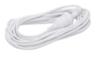
26-Oct-2022 | LED Tea Light Candles 24 Pack | Electrical Appliances | Injury Hazard, Choking Hazard, Burn Hazard | 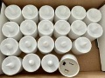  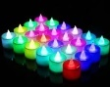
26-Oct-2022 | Lagos 90w LED Slim Batten 1200mm Linear Lighting Fixture | Electrical Appliances | Injury Hazard, Fire Hazard
28-Oct-2022 | Various Halloween Mask, Headband, Jewelry, Candle and Decoration | Accessories | Burn Hazard, Injury Hazard, Choking Hazard | 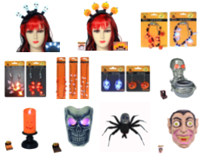
28-Oct-2022 | Various Christmas Novelty Decoration, Jewelry, Toy and Ornament | Accessories | Burn Hazard, Injury Hazard, Choking Hazard | 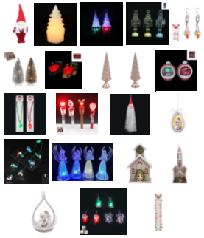
28-Oct-2022 | Design 2 Joystick Piloting System | Tools and Hardware | Injury Hazard | 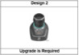
28-Oct-2022 | Halloween Ceramic LED Ornament | Accessories | Injury Hazard, Choking Hazard | 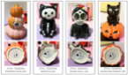
28-Oct-2022 | Portable Basketball Hoop System | Sporting Goods / Equipment | Injury Hazard | 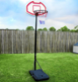
28-Oct-2022 | Anko Teething Llama | Toys and Childcare Products | Injury Hazard, Choking Hazard | 