Recall Cases Summary – Canada (Last Update Date: 31 October 2022)

Date | Product | Categories | Hazard | Image
3-Oct-2022 | Gümi Water-Filled Teether | Toys and Childcare Products | Microbiological Hazard | 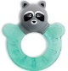  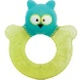
4-Oct-2022 | Cheese Product | Food | Microbiological Hazard | 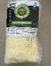  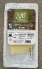  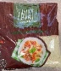
4-Oct-2022 | Cider | Food | Chemical Hazard | /
5-Oct-2022 | Tethrd One Stick GEN 2 Climbing Stick | Tools and Hardware | Fall Hazard, Injury Hazard
6-Oct-2022 | Specialized-Branded Sirrus Bicycles with Alloy Crank | Sporting Goods / Equipment | Fall Hazard, Injury Hazard | 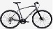  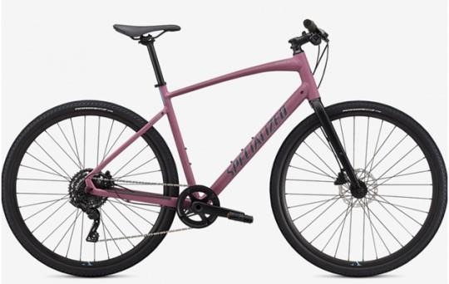  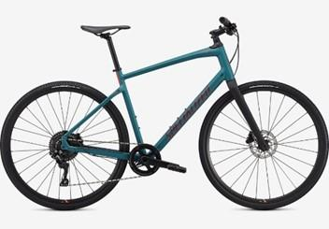  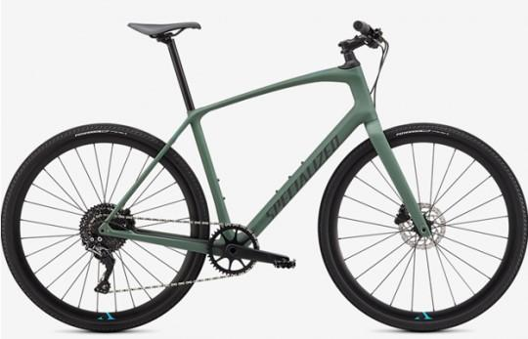  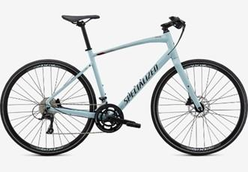  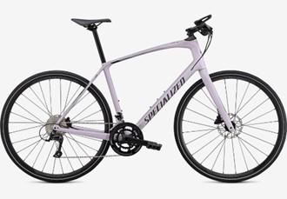
6-Oct-2022 | Optimus Gemini 2-Burner Gas Stove | Outdoor Living Items | Fire Hazard | 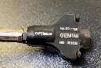  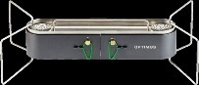
6-Oct-2022 | Mozzarella and Cheddar Cheese | Food | Microbiological Hazard | 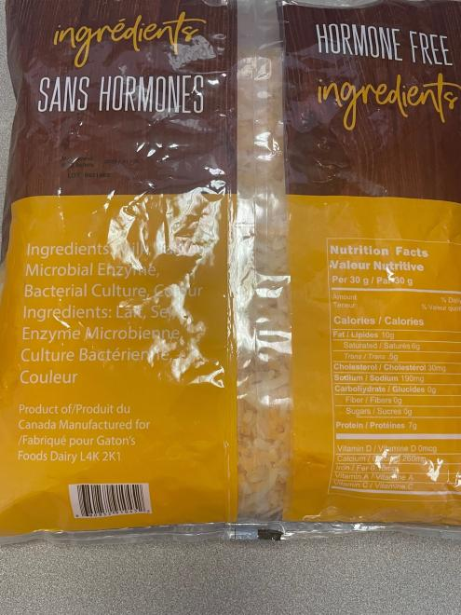  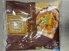  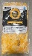  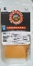  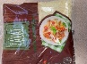  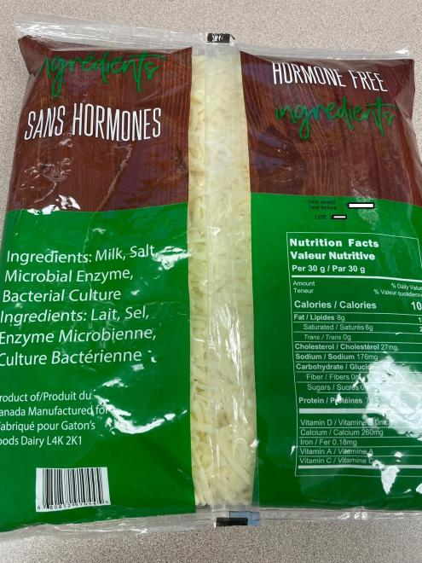  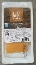
7-Oct-2022 | Sandwich | Food | Microbiological Hazard | 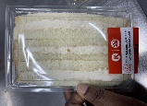
14-Oct-2022 | Infantino 3-Pack Water Teether | Toys and Childcare Products | Microbiological Hazard | 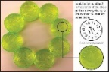  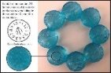
14-Oct-2022 | Abbott Brand Similac Sterilized Water | Pharmacy | Microbiological Hazard | /
14-Oct-2022 | Sandwich | Food | Microbiological Hazard | 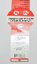
18-Oct-2022 | Unbranded Stroller and Travel System | Toys and Childcare Products | Injury Hazard | 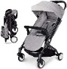  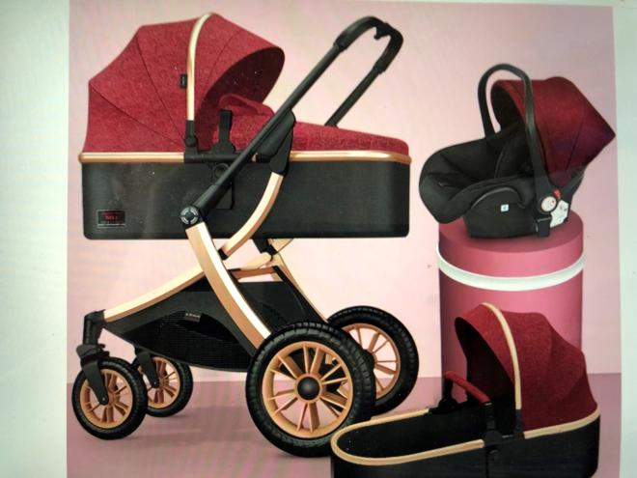
18-Oct-2022 | Enoki Mushroom | Food | Microbiological Hazard | 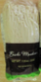
19-Oct-2022 | 300 Piece Army Action Figure Set | Toys and Childcare Products | Chemical Hazard | 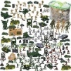
19-Oct-2022 | Children’s Butterfly Net | Outdoor Living Items | Chemical Hazard | 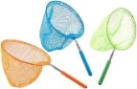
20-Oct-2022 | Mittal International Brand Chenille Weave Baby Blanket | Toys and Childcare Products | Entrapment Hazard, Strangulation Hazard, Choking Hazard | 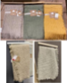
20-Oct-2022 | Meguiar’s Heavy Duty Headlight Restoration Kit | Tools and Hardware | Health Risk Hazard, Injury Hazard | 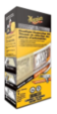
21-Oct-2022 | Dark Chocolate Coconut Mini | Food | Microbiological Hazard | 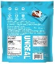  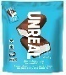
24-Oct-2022 | Family's Choice Distribution Brand Tahini Extra Sesame Seed Paste | Food | Microbiological Hazard | /
25-Oct-2022 | Spirit Signature Collection Kids Magical Unicorn Costume | Fabric / Textile / Garment / Home Textile | Choking Hazard, Ingestion Hazard | 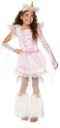
27-Oct-2022 | Pine-Sol® Scented Multi-Surface Cleaner in Lavender Clean®, Lemon Fresh, and Mandarin Sunrise® Scent | Chemicals | Microbiological Hazard | 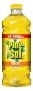  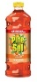  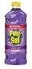
27-Oct-2022 | Horizon T101-05 Folding Treadmill | Sporting Goods / Equipment | Fall Hazard | 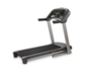
27-Oct-2022 | Amazon Basics High Back Executive Desk Chair | Furniture | Fall Hazard | 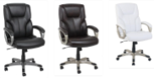
27-Oct-2022 | King Song KS-16S Electric Unicycle Battery | Electrical Appliances | Fire Hazard
27-Oct-2022 | BoxHot Glow Sticks Battery | Electrical Appliances | Fire Hazard, Burn Hazard | 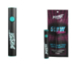
28-Oct-2022 | Body Glove Tandem Inflatable 2-Person Paddleboard | Sporting Goods / Equipment | Drowning Hazard | 