Recall Cases Summary – Europe (Last Update Date: 31 October 2022)

Date | Notifying Country | Product | Categories | Hazard | Image
5-Oct-2022 | Italy | Skin-Lightening Oil | Bodycare / Cosmetics | Chemical Hazard | 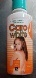
5-Oct-2022 | Poland | Soft Toy | Toys and Childcare Products | Choking Hazard, Suffocation Hazard | 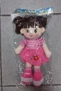
5-Oct-2022 | Hungary | Laser Pointer | Electrical Appliances | Damage to Sight | 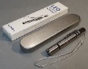  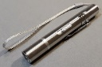
5-Oct-2022 | Hungary | Electric Kettle | Home Electrical Appliances | Electric Shock Hazard | 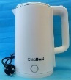
5-Oct-2022 | Luxembourg | Children's Digital Camera | Toys and Childcare Products | Chemical Hazard | 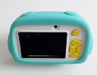  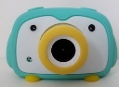
5-Oct-2022 | Germany | Mobile Phone for Explosive Atmospheres | Computer / Audio / Video / Other Electronics & Accessories | Burn Hazard, Injury Hazard | 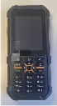  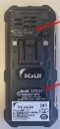
6-Oct-2022 | France | Air Compressor | Machinery | Injury Hazard | 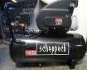
6-Oct-2022 | Denmark | Firework | Outdoor Living Items | Burn Hazard, Fire Hazard, Injury Hazard | 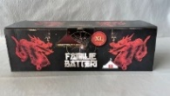
6-Oct-2022 | Malta | Motorboat | Sporting Goods / Equipment | Drowning Hazard | 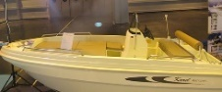
6-Oct-2022 | France | Winch Brake for Lifeboat | Tools and Hardware | Injury Hazard | /
6-Oct-2022 | Malta | Motorboat | Sporting Goods / Equipment | Drowning Hazard | 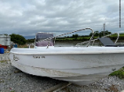
6-Oct-2022 | Finland | Plush Toy | Toys and Childcare Products | Choking Hazard | 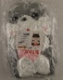  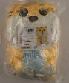
6-Oct-2022 | Poland | Expandable Toy | Toys and Childcare Products | Choking Hazard | 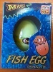  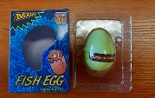
6-Oct-2022 | Bulgaria | Children's Swimsuit | Fabric / Textile / Garment / Home Textile | Strangulation Hazard | 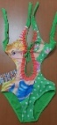  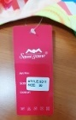  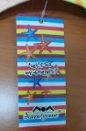
6-Oct-2022 | Malta | Inflatable Boat/Dinghy | Sporting Goods / Equipment | Drowning Hazard | 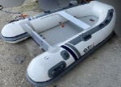
6-Oct-2022 | Czechia | Plastic Toy | Toys and Childcare Products | Choking Hazard | 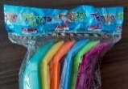  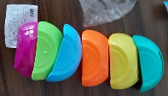
6-Oct-2022 | Czechia | Plastic Doll | Toys and Childcare Products | Chemical Hazard | 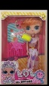  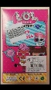
6-Oct-2022 | Hungary | Rattle Toy | Toys and Childcare Products | Choking Hazard | 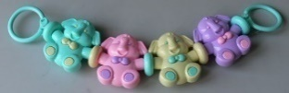
6-Oct-2022 | Czechia | Plastic Doll | Toys and Childcare Products | Chemical Hazard | 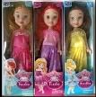
6-Oct-2022 | Czechia | Plastic Doll | Toys and Childcare Products | Chemical Hazard | 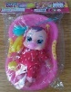
6-Oct-2022 | Ireland | Disposable Electronic Cigarette | Chemicals | Chemical Hazard | 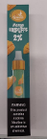
6-Oct-2022 | Finland | Pranking Toys Set | Toys and Childcare Products | Chemical Hazard | 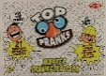  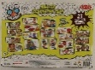
6-Oct-2022 | Germany | Make-Up | Bodycare / Cosmetics | Microbiological Hazard | 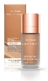
6-Oct-2022 | Finland | Pranking Toy | Toys and Childcare Products | Chemical Hazard | 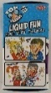  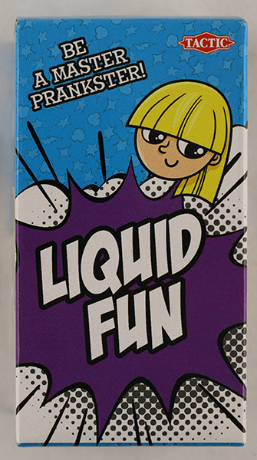  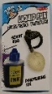
6-Oct-2022 | Poland | Puzzle Play Mat | Toys and Childcare Products | Choking Hazard | 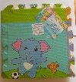
6-Oct-2022 | Hungary | Yoyo Puffer Ball | Toys and Childcare Products | Choking Hazard, Strangulation Hazard | 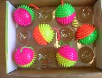  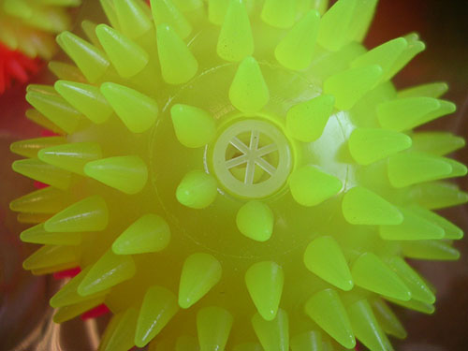
7-Oct-2022 | Italy | Skin Lotion | Bodycare / Cosmetics | Chemical Hazard | 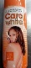
10-Oct-2022 | Malta | Motorboat | Sporting Goods / Equipment | Drowning Hazard | 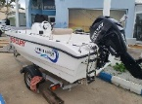
11-Oct-2022 | France | Smartphone Charger | Computer / Audio / Video / Other Electronics & Accessories | Electric Shock Hazard | 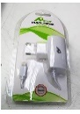  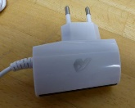
11-Oct-2022 | Finland | Toy Gun Set | Toys and Childcare Products | Choking Hazard | 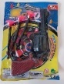
11-Oct-2022 | Iceland | Soother Holder | Toys and Childcare Products | Strangulation Hazard | 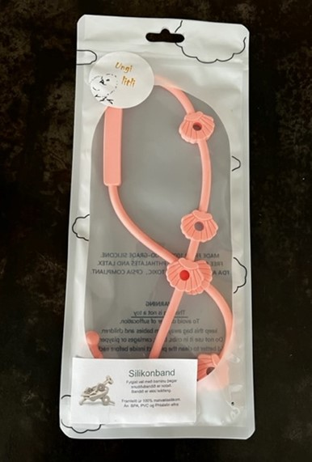
11-Oct-2022 | Lithuania | Plastic Doll Set | Toys and Childcare Products | Chemical Hazard | 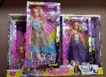  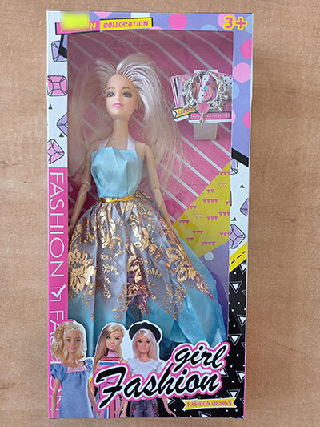  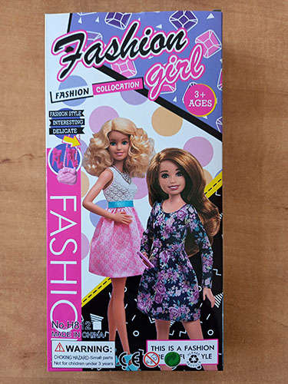
11-Oct-2022 | Finland | Soft Toy | Toys and Childcare Products | Choking Hazard | 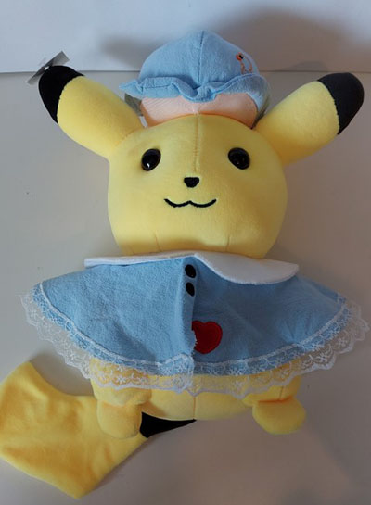
11-Oct-2022 | Lithuania | Earrings | Jewelry | Chemical Hazard | 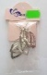  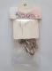
11-Oct-2022 | Finland | Toy Gun | Toys and Childcare Products | Choking Hazard | 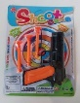
13-Oct-2022 | France | Pull-Along Toy | Toys and Childcare Products | Choking Hazard, Strangulation Hazard | 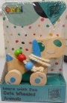  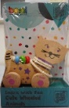
13-Oct-2022 | Sweden | Wooden Toy | Toys and Childcare Products | Choking Hazard | 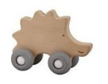
13-Oct-2022 | Cyprus | Children's Dress | Fabric / Textile / Garment / Home Textile | Injury Hazard | 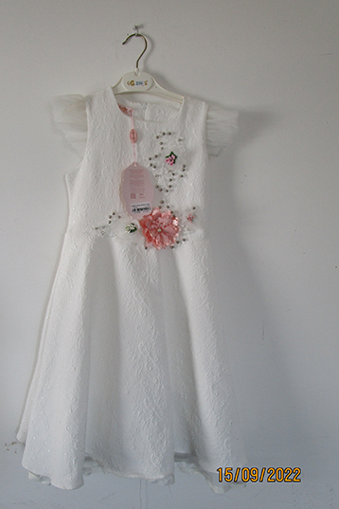  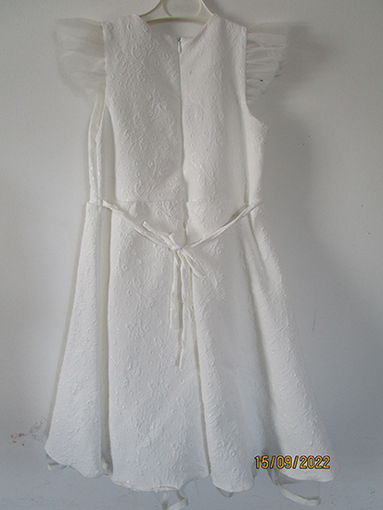
13-Oct-2022 | Cyprus | Babies' Clothing Set | Fabric / Textile / Garment / Home Textile | Injury Hazard, Strangulation Hazard | 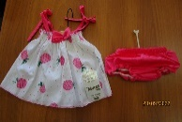
13-Oct-2022 | France | Lamp | Electrical Appliances | Electric Shock Hazard | 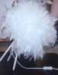
13-Oct-2022 | Ireland | Cement Cleaner | Chemicals | Chemical Hazard | 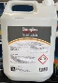
13-Oct-2022 | Czechia | Plastic Bottle with Sweet | Toys and Childcare Products | Chemical Hazard | 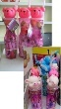
13-Oct-2022 | Ireland | Cervical Massager | Home Electrical Appliances | Electric Shock Hazard, Fire Hazard | 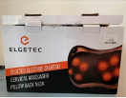
13-Oct-2022 | Slovakia | Earrings | Jewelry | Chemical Hazard | 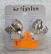  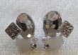
13-Oct-2022 | Poland | Firework | Outdoor Living Items | Burn Hazard, Fire Hazard, Injury Hazard | 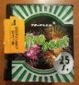
13-Oct-2022 | Malta | Inflatable Boat | Sporting Goods / Equipment | Drowning Hazard | 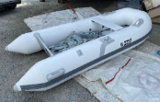
13-Oct-2022 | Luxembourg | Rattle Toy | Toys and Childcare Products | Choking Hazard, Damage to Hearing, Injury Hazard | 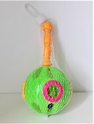
13-Oct-2022 | Hungary | Toy Bow Set | Toys and Childcare Products | Choking Hazard, Injury Hazard | 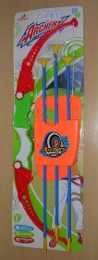
13-Oct-2022 | Hungary | Toy Gun Set | Toys and Childcare Products | Choking Hazard, Injury Hazard | 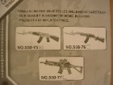
13-Oct-2022 | Hungary | Toy Gun Set | Toys and Childcare Products | Choking Hazard, Injury Hazard | 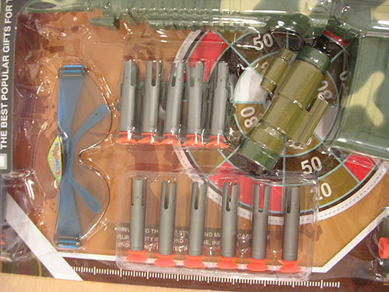
13-Oct-2022 | Finland | Reflective Pendant with LED-Light | Protective Equipment | Injury Hazard | 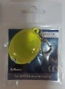
13-Oct-2022 | Hungary | Toy Gun Set | Toys and Childcare Products | Chemical Hazard, Choking Hazard | 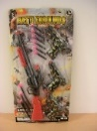
13-Oct-2022 | Romania | Children's Blouse | Fabric / Textile / Garment / Home Textile | Choking Hazard | 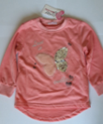
13-Oct-2022 | Czechia | Plastic Doll | Toys and Childcare Products | Chemical Hazard | 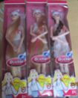
13-Oct-2022 | Germany | Vehicle Part / Steel Rim | Car Components | Injury Hazard | 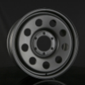
13-Oct-2022 | Poland | Scissor Jack | Machinery | Injury Hazard | 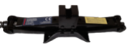
13-Oct-2022 | France | Battery Charger | Electrical Appliances | Electric Shock Hazard, Fire Hazard | 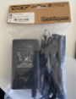
13-Oct-2022 | Lithuania | Hair Styling Product | Bodycare / Cosmetics | Chemical Hazard | 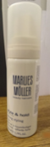
13-Oct-2022 | Finland | Reflective Pendant | Protective Equipment | Injury Hazard | 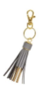
13-Oct-2022 | Lithuania | Soft Toy | Toys and Childcare Products | Choking Hazard | 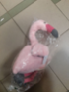
14-Oct-2022 | Romania | Babies' Clothing Set | Fabric / Textile / Garment / Home Textile | Choking Hazard | 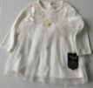
14-Oct-2022 | Romania | Babies' T-Shirt | Fabric / Textile / Garment / Home Textile | Choking Hazard | 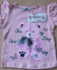
14-Oct-2022 | Romania | Babies' Dress | Fabric / Textile / Garment / Home Textile | Injury Hazard | 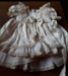
17-Oct-2022 | Lithuania | Hair Conditioner | Bodycare / Cosmetics | Chemical Hazard
17-Oct-2022 | Lithuania | Hair Styling Mousse | Bodycare / Cosmetics | Chemical Hazard | 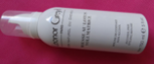
18-Oct-2022 | Poland | Soft Toy | Toys and Childcare Products | Choking Hazard | 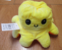
18-Oct-2022 | Italy | Sandals | Footwear | Chemical Hazard | 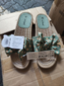
18-Oct-2022 | Italy | Flip-Flops | Footwear | Chemical Hazard | 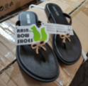
18-Oct-2022 | Italy | Flip-Flops | Footwear | Chemical Hazard | 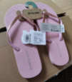
18-Oct-2022 | Austria | Teething Toy | Toys and Childcare Products | Choking Hazard | 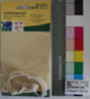
18-Oct-2022 | Italy | Skin Lightening Cream | Bodycare / Cosmetics | Chemical Hazard | 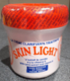
18-Oct-2022 | Cyprus | Children's Dress | Fabric / Textile / Garment / Home Textile | Injury Hazard | 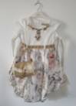
18-Oct-2022 | Italy | Skin Lightening Cream | Bodycare / Cosmetics | Chemical Hazard | 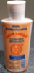
18-Oct-2022 | Finland | Watering Bulb | Accessories | Fire Hazard | 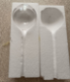
18-Oct-2022 | Poland | Self-Balancing Scooter (Hoverboard) | Sporting Goods / Equipment | Electric Shock Hazard, Fire Hazard, Injury Hazard | 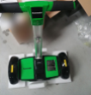
19-Oct-2022 | Slovakia | Bracelet | Jewelry | Chemical Hazard | 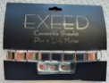
19-Oct-2022 | Czechia | Plastic Doll | Toys and Childcare Products | Chemical Hazard | 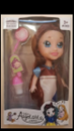
19-Oct-2022 | Czechia | Plastic Doll | Toys and Childcare Products | Chemical Hazard | 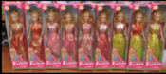
19-Oct-2022 | Hungary | Toy Gun Set | Toys and Childcare Products | Chemical Hazard, Choking Hazard, Injury Hazard | 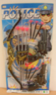
19-Oct-2022 | Italy | Children's Sandals | Footwear | Chemical Hazard | 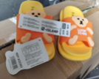
19-Oct-2022 | Slovakia | Earrings | Jewelry | Chemical Hazard | 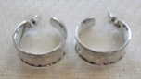
20-Oct-2022 | Spain | Children's Costume | Toys and Childcare Products | Choking Hazard | 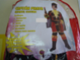
20-Oct-2022 | Cyprus | Plastic Doll | Toys and Childcare Products | Chemical Hazard | 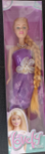
20-Oct-2022 | Czechia | Plastic Doll | Toys and Childcare Products | Chemical Hazard | 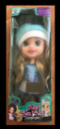
20-Oct-2022 | Slovakia | Bracelet | Jewelry | Chemical Hazard | 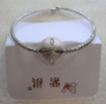
20-Oct-2022 | Bulgaria | Disposable Electronic Cigarette | Chemicals | Chemical Hazard | 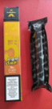
20-Oct-2022 | Finland | Soft Toy | Toys and Childcare Products | Choking Hazard | 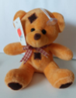
20-Oct-2022 | Italy | Flip-Flops | Footwear | Chemical Hazard | 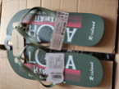
20-Oct-2022 | Romania | Children's Sports Outfit | Fabric / Textile / Garment / Home Textile | Injury Hazard | 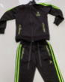
21-Oct-2022 | Finland | Recreational Craft | Sporting Goods / Equipment | Drowning Hazard | 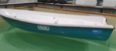
21-Oct-2022 | Bulgaria | Disposable Electronic Cigarette | Chemicals | Chemical Hazard | 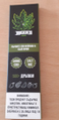
21-Oct-2022 | France | Soft Toy | Toys and Childcare Products | Choking Hazard | 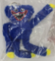  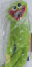  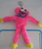
22-Oct-2022 | France | Children's Hat | Fabric / Textile / Garment / Home Textile | Strangulation Hazard
24-Oct-2022 | Norway | Jewelry Set | Jewelry | Chemical Hazard | 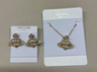
24-Oct-2022 | Bulgaria | Disposable Electronic Cigarette | Chemicals | Chemical Hazard | 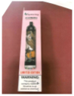
24-Oct-2022 | Bulgaria | Disposable Electronic Cigarette | Chemicals | Chemical Hazard
24-Oct-2022 | Czechia | Camping Lamp | Outdoor Living Items | Electric Shock Hazard | 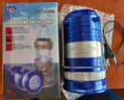
24-Oct-2022 | Poland | Firework | Outdoor Living Items | Burn Hazard, Injury Hazard | 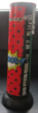
25-Oct-2022 | Iceland | Reflective Bag | Protective Equipment | Injury Hazard | 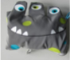
25-Oct-2022 | Czechia | Body Cream | Bodycare / Cosmetics | Chemical Hazard | 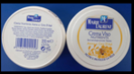
25-Oct-2022 | Poland | Rattle Toy | Toys and Childcare Products | Choking Hazard | 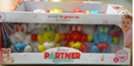
25-Oct-2022 | Finland | Bicycle Lighting | Sporting Goods / Equipment | Electric Shock Hazard | 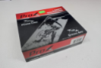
26-Oct-2022 | Germany | Laser Pointer | Electrical Appliances | Damage to Sight
27-Oct-2022 | France | Barbecue Smoker | Outdoor Living Items | Burn Hazard, Fire Hazard | 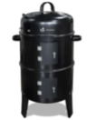
27-Oct-2022 | Czechia | Perfume | Bodycare / Cosmetics | Chemical Hazard | 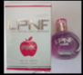
27-Oct-2022 | Romania | Babies’ Dress | Fabric / Textile / Garment / Home Textile | Injury Hazard | 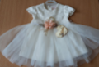
27-Oct-2022 | Poland | Plastic Doll | Toys and Childcare Products | Chemical Hazard | 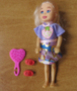
27-Oct-2022 | Bulgaria | Soother Holder | Toys and Childcare Products | Strangulation Hazard | 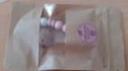
27-Oct-2022 | Norway | Jump Rope | Sporting Goods / Equipment | Chemical Hazard, Environmental Hazard | 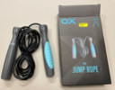
27-Oct-2022 | Czechia | Decorative Grape | Accessories | Choking Hazard | 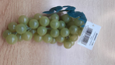
27-Oct-2022 | Norway | Children's Flip-Flops | Footwear | Chemical Hazard | 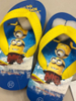
27-Oct-2022 | Lithuania | USB Charger | Electrical Appliances | Electric Shock Hazard | 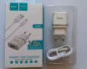
27-Oct-2022 | Lithuania | Earrings | Jewelry | Chemical Hazard | 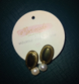
27-Oct-2022 | Lithuania | Chain with Pendant | Jewelry | Chemical Hazard | 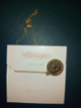
27-Oct-2022 | Cyprus | Glue | Chemicals | Chemical Hazard | 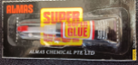
27-Oct-2022 | Norway | Air Humidifier | Home Electrical Appliances | Chemical Hazard, Environmental Hazard | 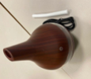
27-Oct-2022 | Norway | Electric Insect Trap | Toys and Childcare Products | Chemical Hazard, Environmental Hazard | 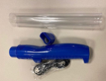
27-Oct-2022 | France | Electric Scooter | Sporting Goods / Equipment | Injury Hazard | 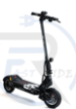
27-Oct-2022 | Finland | High-Visibility Gadget | Protective Equipment | Injury Hazard | 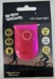
27-Oct-2022 | France | UV Insect Killer Lamp | Electrical Appliances | Fire Hazard, Electric Shock Hazard | 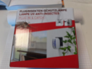
27-Oct-2022 | Slovakia | Earrings | Jewelry | Chemical Hazard | 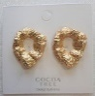
27-Oct-2022 | Czechia | Plastic Doll | Toys and Childcare Products | Chemical Hazard | 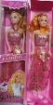
27-Oct-2022 | Sweden | Perfume | Bodycare / Cosmetics | Chemical Hazard | 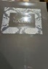
27-Oct-2022 | Sweden | Perfume | Bodycare / Cosmetics | Chemical Hazard | 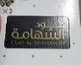
28-Oct-2022 | Finland | Recreational Craft | Sporting Goods / Equipment | Drowning Hazard | 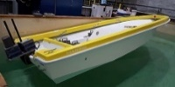
28-Oct-2022 | Poland | Rattle Toy | Toys and Childcare Products | Choking Hazard | 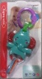
28-Oct-2022 | Poland | Plastic Toy | Toys and Childcare Products | Choking Hazard | 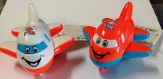
28-Oct-2022 | Hungary | Toy Gun Set | Toys and Childcare Products | Chemical Hazard, Choking Hazard, Injury Hazard | 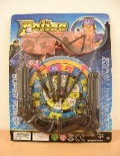
28-Oct-2022 | Sweden | Perfume | Bodycare / Cosmetics | Chemical Hazard | 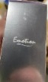
28-Oct-2022 | Sweden | Perfume | Bodycare / Cosmetics | Chemical Hazard | 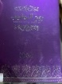
28-Oct-2022 | Sweden | Perfume | Bodycare / Cosmetics | Chemical Hazard | 