Recall Cases Summary – US (Last Update Date: 31 October 2022)

Date | Product | Categories | Hazard | Image
6-Oct-2022 | Tea Kettle | Food Contact Material | Fire Hazard, Burn Hazard | 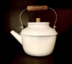
6-Oct-2022 | Rubber Strap for Swift Bicycle Bag | Tools and Hardware | Injury Hazard, Crash Hazard | 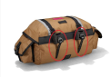  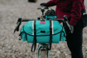  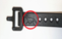
6-Oct-2022 | Gemini Portable Gas Stove | Outdoor Living Items | Fire Hazard | 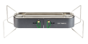  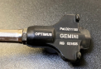
6-Oct-2022 | Desk and Storage Unit | Furniture | Lead Poisoning Hazard, Health Risk Hazard | 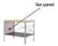  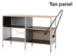  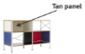  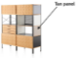  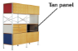  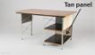  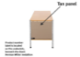
13-Oct-2022 | Snowmobile | Sporting Goods / Equipment | Fire Hazard | 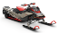  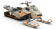  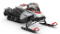  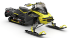  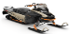  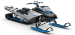
13-Oct-2022 | Children’s Sleepwear | Fabric / Textile / Garment / Home Textile | Burn Hazard | 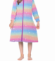  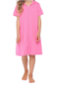  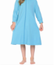
13-Oct-2022 | Scuba Diver Buoyancy Compensator Device | Tools and Hardware | Drowning Hazard | 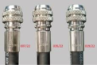  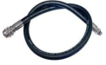
13-Oct-2022 | Early Learning Centre Little Senses Lights & Sounds Shape Sorter Toy | Toys and Childcare Products | Choking Hazard | 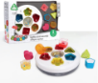
13-Oct-2022 | E-Bike | Sporting Goods / Equipment | Fire Hazard, Burn Hazard | 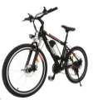
13-Oct-2022 | Outdoor Freezer | Electrical Appliances | Fire Hazard | 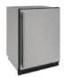  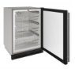
13-Oct-2022 | Air Fryer | Home Electrical Appliances | Fire Hazard, Burn Hazard | 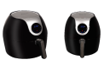  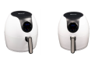
13-Oct-2022 | Children’s Ring | Jewelry | Health Risk Hazard | 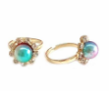  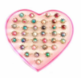
13-Oct-2022 | Children’s Sleepwear | Fabric / Textile / Garment / Home Textile | Burn Hazard | 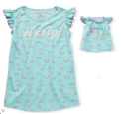
20-Oct-2022 | Mittal International Baby Blanket | Toys and Childcare Products | Choking Hazard, Entrapment Hazard, Strangulation Hazard
20-Oct-2022 | Gel Blaster SURGE 1.0 Toy Gun | Toys and Childcare Products | Fire Hazard | 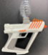
20-Oct-2022 | Birds Choice Hanging and Pole-Mounted Acrylic Bird Bath | Pet Items | Fire Hazard | 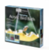
20-Oct-2022 | Apeks Exotec SCUBA Diving Buoyancy Compensator Device (BCDs) | Sporting Goods / Equipment | Injury Hazard, Drowning Hazard | 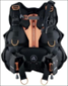
20-Oct-2022 | Butterfly Net Set and Army Action Figure Playset | Outdoor Living Items, Toys and Childcare Products | Health Risk Hazard | 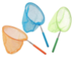  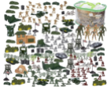
25-Oct-2022 | Pine-Sol® Scented Multi-Surface Cleaner, CloroxPro® Pine-Sol® All Purpose Cleaner, and Clorox® Professional™ Pine-Sol® Lemon Fresh Cleaner | Chemicals | Microbiological Hazard | 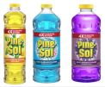  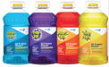  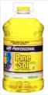
27-Oct-2022 | Horizon T101-05 Treadmill | Sporting Goods / Equipment | Fall Hazard | 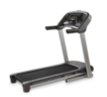
27-Oct-2022 | Punisher Adult Cycling Helmet | Sporting Goods / Equipment | Injury Hazard | 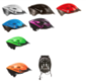
27-Oct-2022 | LG Energy Solution “RESU 10H” Lithium-Ion Residential Energy Storage System Battery | Electrical Appliances | Fire Hazard | 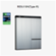
27-Oct-2022 | Amazon Basics Executive Desk Chair | Furniture | Fall Hazard, Injury Hazard | 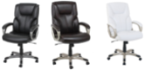
27-Oct-2022 | Meic Power Adapter Sold with Brother AirSure DF-2 Dynamic Filtration Tabletop Air Purifier | Electrical Appliances | Electric Shock Hazard | 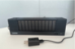
27-Oct-2022 | Goalsetter Wall-Mounted Basketball Goal | Sporting Goods / Equipment | Fall Hazard, Injury Hazard | 