Recall Cases Summary – Australia (Last Update Date: 30 November 2022)

Date | Product | Categories | Hazard | Image
1-Nov-2022 | Thermomix TM6 Measuring Cup | Food Contact Material | Burn Hazard | 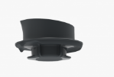
3-Nov-2022 | Arlo Bar Stool | Furniture | Injury Hazard | 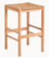
4-Nov-2022 | Tender Leaf Toys Bunny Tale | Toys and Childcare Products | Choking Hazard, Suffocation Hazard
4-Nov-2022 | Tender Leaf Toys Sailaway Boat | Toys and Childcare Products | Choking Hazard, Suffocation Hazard | 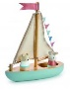
10-Nov-2022 | Handlebar for Certain Salsa Cutthroat and Warbird Bicycle | Sporting Goods / Equipment | Fall Hazard, Injury Hazard
10-Nov-2022 | Surprise 5 - Flavoured Drink 250mL with Toy Watch | Toys and Childcare Products | Injury Hazard, Choking Hazard | 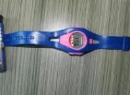  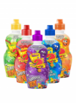
10-Nov-2022 | Dometic Steering Cable | Electrical Appliances | Injury Hazard | 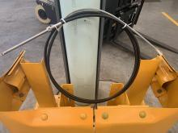
11-Nov-2022 | Omnipod DASH Personal Diabetes Manager (PDM) | Electrical Appliances | Fire Hazard, Injury Hazard, Health Risk Hazard | 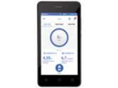
11-Nov-2022 | E-Glide Ultra Scooter | Sporting Goods / Equipment | Injury Hazard | 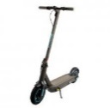
14-Nov-2022 | 3 in 1 Pram Bassinet with Push Chair Set | Toys and Childcare Products | Injury Hazard | 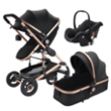  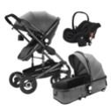
15-Nov-2022 | Sanjin Watermelon Frost Insufflation | Pharmacy | Health Risk Hazard | 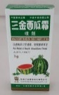
16-Nov-2022 | Electric Recliner and Sofa with Cupholder in The Armrest | Furniture | Fire Hazard, Burn Hazard, Injury Hazard | 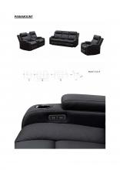  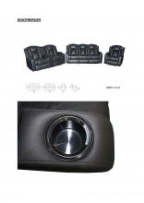  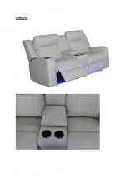
16-Nov-2022 | 4moms MamaRoo Multi-Motion Baby Swing and RockaRoo Baby Rocker | Toys and Childcare Products | Strangulation Hazard | 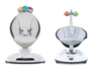
18-Nov-2022 | Kids Hooded Towel | Fabric / Textile / Garment / Home Textile | Fire Hazard | 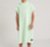
21-Nov-2022 | Roundup F Weedkiller Fast | Chemicals | Eye Irritation Risk | 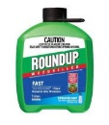
21-Nov-2022 | Roundup T Weedkiller Tough | Chemicals | Eye Irritation Risk | 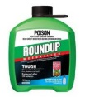
21-Nov-2022 | Roundup P Weedkiller Path | Chemicals | Eye Irritation Risk | 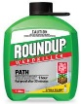
23-Nov-2022 | DreamWear Full Face Mask, DreamWisp Nasal Mask with Over the Nose Cushion, Wisp Nasal Mask and Wisp Youth Nasal Mask, Amara View Minimal Contact Full-Face Mask and Therapy Mask 3100 NC/SP | Protective Equipment | Health Risk Hazard | 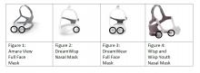
28-Nov-2022 | Vicks VapoRub Xtra Strong 100g | Pharmacy | Risk of Allergy, Health Risk Hazard | 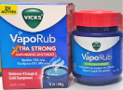
28-Nov-2022 | Detox + Debloat | Pharmacy | Health Risk Hazard | 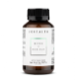
29-Nov-2022 | Wooden Baby Rattle | Toys and Childcare Products | Choking Hazard, Suffocation Hazard, Injury Hazard | 