Recall Cases Summary – Europe (Last Update Date: 30 November 2022)

Date | Notifying Country | Product | Categories | Hazard | Image
3-Nov-2022 | Finland | Reflective Sticker | Protective Equipment | Injury Hazard | 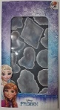
3-Nov-2022 | Finland | Angle Grinder | Machinery | Electric Shock Hazard | 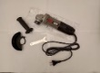
3-Nov-2022 | Slovakia | Earrings | Jewelry | Chemical Hazard | 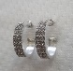
3-Nov-2022 | Poland | Extension Lead | Electrical Appliances | Electric Shock Hazard, Fire Hazard | 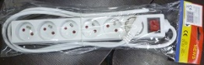
3-Nov-2022 | Luxembourg | Desk Chair | Furniture | Injury Hazard | 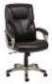  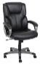  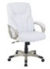
4-Nov-2022 | France | Hair Straightener | Home Electrical Appliances | Electric Shock Hazard | 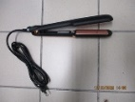
4-Nov-2022 | Ireland | Piercing | Jewelry | Chemical Hazard | 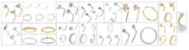  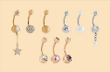
4-Nov-2022 | Slovakia | Earrings | Jewelry | Chemical Hazard | 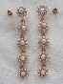
4-Nov-2022 | Hungary | Toy Gun Set | Toys and Childcare Products | Chemical Hazard, Choking Hazard, Injury Hazard | 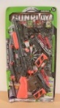
4-Nov-2022 | France | Sleeping Bag | Fabric / Textile / Garment / Home Textile | Strangulation Hazard | 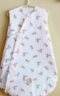
4-Nov-2022 | Finland | Doll Stroller | Toys and Childcare Products | Injury Hazard | 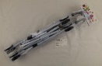
4-Nov-2022 | Lithuania | Plastic Doll | Toys and Childcare Products | Chemical Hazard | 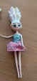  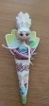
4-Nov-2022 | Lithuania | Plastic Doll | Toys and Childcare Products | Chemical Hazard | 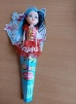
4-Nov-2022 | Denmark | Soother Holder | Toys and Childcare Products | Choking Hazard | 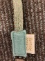  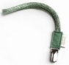
4-Nov-2022 | The Netherlands | Toy Slime | Toys and Childcare Products | Chemical Hazard | 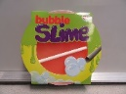
4-Nov-2022 | Ireland | Wax Melt Burner | Household Items | Burn Hazard | 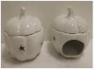
4-Nov-2022 | Romania | Babies' Clothing Set | Fabric / Textile / Garment / Home Textile | Injury Hazard, Strangulation Hazard | 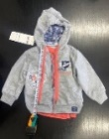  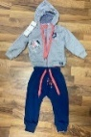
4-Nov-2022 | Romania | Children's Sweatpants | Fabric / Textile / Garment / Home Textile | Injury Hazard | 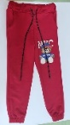
4-Nov-2022 | Romania | Babies' Clothing Set | Fabric / Textile / Garment / Home Textile | Choking Hazard | 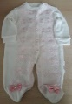  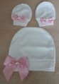
4-Nov-2022 | Romania | Babies' Clothing Set | Fabric / Textile / Garment / Home Textile | Choking Hazard | 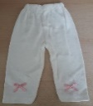  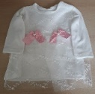
4-Nov-2022 | Romania | Children's Blouse | Fabric / Textile / Garment / Home Textile | Choking Hazard | 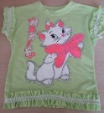
7-Nov-2022 | Sweden | Perfume | Bodycare / Cosmetics | Chemical Hazard | 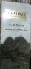
7-Nov-2022 | Cyprus | Dolls Set | Toys and Childcare Products | Chemical Hazard | 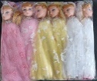
7-Nov-2022 | Sweden | Perfume | Bodycare / Cosmetics | Chemical Hazard | 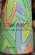
7-Nov-2022 | Sweden | Perfume | Bodycare / Cosmetics | Chemical Hazard
7-Nov-2022 | Sweden | Perfume | Bodycare / Cosmetics | Chemical Hazard | 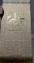
7-Nov-2022 | Sweden | Perfume | Bodycare / Cosmetics | Chemical Hazard | 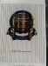
7-Nov-2022 | Sweden | Perfume | Bodycare / Cosmetics | Chemical Hazard
7-Nov-2022 | Cyprus | Doll with Accessories | Toys and Childcare Products | Chemical Hazard | 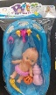
7-Nov-2022 | Lithuania | Plastic Doll | Toys and Childcare Products | Chemical Hazard | 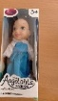
8-Nov-2022 | France | Soft Toy | Toys and Childcare Products | Choking Hazard | 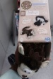  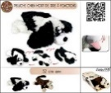
8-Nov-2022 | Austria | Nail Varnish | Bodycare / Cosmetics | Chemical Hazard | 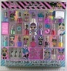
8-Nov-2022 | France | Soother Holder | Toys and Childcare Products | Choking Hazard, Strangulation Hazard | 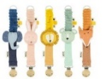  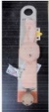
8-Nov-2022 | Sweden | Perfume | Bodycare / Cosmetics | Chemical Hazard | 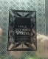
8-Nov-2022 | Sweden | Perfume | Bodycare / Cosmetics | Chemical Hazard | 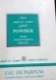
8-Nov-2022 | Sweden | Perfume | Bodycare / Cosmetics | Chemical Hazard | 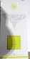
8-Nov-2022 | Sweden | Perfume | Bodycare / Cosmetics | Chemical Hazard | 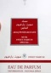
8-Nov-2022 | Sweden | Perfume | Bodycare / Cosmetics | Chemical Hazard | 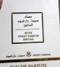  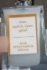
8-Nov-2022 | Sweden | Perfume | Bodycare / Cosmetics | Chemical Hazard
8-Nov-2022 | Sweden | Perfume | Bodycare / Cosmetics | Chemical Hazard
8-Nov-2022 | Sweden | Perfume | Bodycare / Cosmetics | Chemical Hazard | 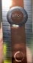
8-Nov-2022 | Sweden | Perfume | Bodycare / Cosmetics | Chemical Hazard | 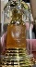
8-Nov-2022 | Sweden | Perfume | Bodycare / Cosmetics | Chemical Hazard | 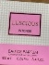
8-Nov-2022 | Slovakia | Plastic Doll with Accessories | Toys and Childcare Products | Chemical Hazard | 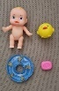  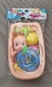
8-Nov-2022 | Finland | Plush Toy | Toys and Childcare Products | Strangulation Hazard | 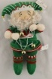
8-Nov-2022 | Cyprus | Children's Rain Jacket with Hood | Fabric / Textile / Garment / Home Textile | Strangulation Hazard | 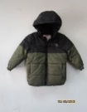
8-Nov-2022 | Finland | Hair Pin | Accessories | Chemical Hazard | 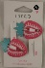
8-Nov-2022 | Ireland | Hairdryer | Home Electrical Appliances | Burn Hazard | 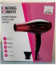  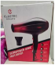
8-Nov-2022 | Romania | Babies' Jumpsuit | Fabric / Textile / Garment / Home Textile | Injury Hazard, Strangulation Hazard | 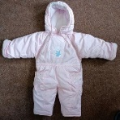
8-Nov-2022 | Romania | Babies' T-Shirt | Fabric / Textile / Garment / Home Textile | Choking Hazard | 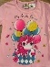
8-Nov-2022 | Poland | Push Along Toy | Toys and Childcare Products | Damage to Hearing | 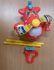  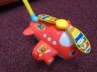
8-Nov-2022 | Poland | Portable Charcoal Grill | Outdoor Living Items | Burn Hazard | 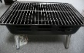  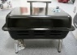  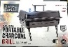
9-Nov-2022 | Poland | Extension Lead | Electrical Appliances | Electric Shock Hazard | 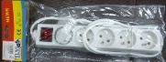
10-Nov-2022 | Ireland | LED Strip Light | Electrical Appliances | Injury Hazard | 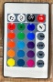  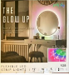
10-Nov-2022 | France | Electric Incense Burner | Electrical Appliances | Electric Shock Hazard, Fire Hazard | 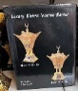  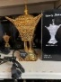  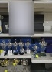
10-Nov-2022 | Germany | Music Box | Toys and Childcare Products | Choking Hazard | 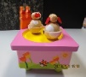
10-Nov-2022 | Germany | Music Box | Toys and Childcare Products | Choking Hazard | 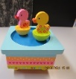
10-Nov-2022 | Sweden | Water Balloon | Toys and Childcare Products | Chemical Hazard | 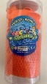
10-Nov-2022 | Czechia | Inflatable Baby Swimming Float | Sporting Goods / Equipment | Choking Hazard | 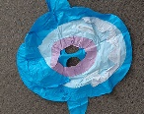
10-Nov-2022 | Germany | Vehicle Part / Replacement Wheel | Car Components | Injury Hazard | 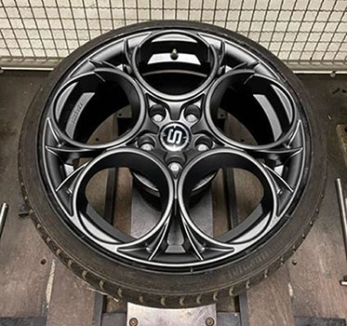
10-Nov-2022 | Finland | Doll´s Feeding Bottle | Toys and Childcare Products | Microbiological Hazard | 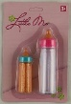
10-Nov-2022 | Czechia | 3D Pen | Stationery | Burn Hazard, Electric Shock Hazard | 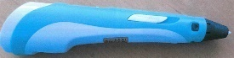
10-Nov-2022 | Lithuania | Toy Tricycle | Sporting Goods / Equipment | Injury Hazard | 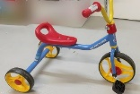
10-Nov-2022 | Lithuania | Plastic Doll | Toys and Childcare Products | Chemical Hazard | 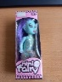
10-Nov-2022 | Poland | Children's High Chair | Furniture | Choking Hazard | 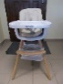
10-Nov-2022 | Cyprus | Doll with Accessories | Toys and Childcare Products | Chemical Hazard | 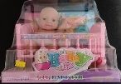
10-Nov-2022 | Romania | Children's Gloves | Fabric / Textile / Garment / Home Textile | Choking Hazard | 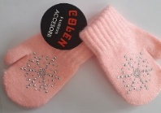
10-Nov-2022 | Romania | Children's Outfit | Fabric / Textile / Garment / Home Textile | Injury Hazard, Strangulation Hazard | 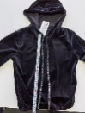  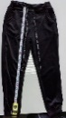
10-Nov-2022 | United Kingdom in Respect of Northern Ireland | Shaving Kit | Bodycare / Cosmetics | Microbiological Hazard | 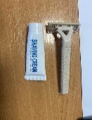
10-Nov-2022 | Ireland | Fancy Dress | Fabric / Textile / Garment / Home Textile | Strangulation Hazard | 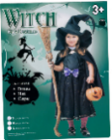
10-Nov-2022 | Poland | Toy Gun | Toys and Childcare Products | Choking Hazard | 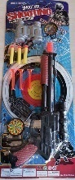
10-Nov-2022 | Poland | Plastic Toy | Toys and Childcare Products | Choking Hazard | 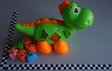
11-Nov-2022 | Italy | Women's Flat Shoes | Footwear | Chemical Hazard | 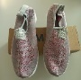
14-Nov-2022 | Bulgaria | Disposable Electronic Cigarette | Chemicals | Chemical Hazard | 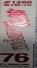  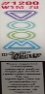
14-Nov-2022 | Sweden | Disposable Electronic Cigarette | Chemicals | Chemical Hazard | 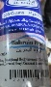
15-Nov-2022 | Spain | Baby Carrier | Toys and Childcare Products | Choking Hazard, Injury Hazard, Strangulation Hazard | 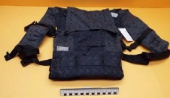
15-Nov-2022 | Sweden | Perfume | Bodycare / Cosmetics | Chemical Hazard | 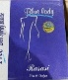
15-Nov-2022 | Italy | Women's Flat Shoes | Footwear | Chemical Hazard | 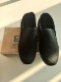
15-Nov-2022 | Italy | Women’s Boots | Footwear | Chemical Hazard | 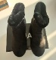
15-Nov-2022 | Italy | Women’s Flat Shoes | Footwear | Chemical Hazard | 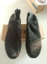
15-Nov-2022 | Italy | Toy Slime | Toys and Childcare Products | Chemical Hazard | 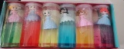  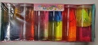
15-Nov-2022 | Germany | Earrings | Jewelry | Chemical Hazard | 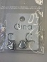
15-Nov-2022 | Germany | Plastic Doll | Toys and Childcare Products | Chemical Hazard | 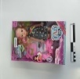
15-Nov-2022 | Czechia | Plastic Doll | Toys and Childcare Products | Chemical Hazard | 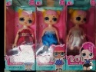
15-Nov-2022 | Czechia | Plastic Doll | Toys and Childcare Products | Chemical Hazard | 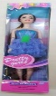
15-Nov-2022 | Czechia | Plastic Doll | Toys and Childcare Products | Chemical Hazard | 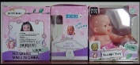
15-Nov-2022 | Slovakia | Ring | Jewelry | Chemical Hazard | 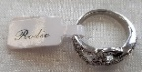  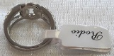
15-Nov-2022 | Hungary | Plastic Doll | Toys and Childcare Products | Chemical Hazard, Choking Hazard | 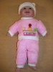
15-Nov-2022 | Romania | Children’s Clothing Set | Fabric / Textile / Garment / Home Textile | Choking Hazard | 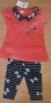
15-Nov-2022 | Hungary | Plastic Doll | Toys and Childcare Products | Chemical Hazard | 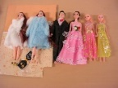
17-Nov-2022 | Italy | Soft Toy | Toys and Childcare Products | Chemical Hazard | 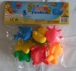
17-Nov-2022 | Italy | Musical Toy Set | Toys and Childcare Products | Chemical Hazard | 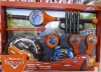
17-Nov-2022 | France | Fancy Dress | Toys and Childcare Products | Chemical Hazard | 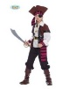
17-Nov-2022 | Germany | Laser Engraving Machine | Machinery | Damage to Sight | 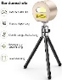
17-Nov-2022 | Italy | Women’s Shoes | Footwear | Chemical Hazard | 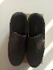
17-Nov-2022 | Italy | Women’s Ankle-Boots | Footwear | Chemical Hazard | 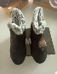
17-Nov-2022 | Cyprus | Children's Sweatshirt | Fabric / Textile / Garment / Home Textile | Injury Hazard | 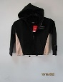
17-Nov-2022 | Greece | Earrings | Jewelry | Chemical Hazard | 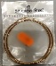
17-Nov-2022 | Greece | Pendant | Jewelry | Chemical Hazard
17-Nov-2022 | Italy | Toy Slime | Toys and Childcare Products | Chemical Hazard | 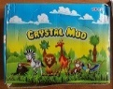
17-Nov-2022 | Italy | Squeezable Toy | Toys and Childcare Products | Suffocation Hazard | 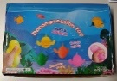
17-Nov-2022 | Italy | Squeezable Toy | Toys and Childcare Products | Suffocation Hazard | 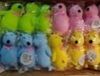
17-Nov-2022 | Romania | Babies' T-Shirt | Fabric / Textile / Garment / Home Textile | Choking Hazard | 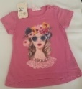
17-Nov-2022 | Finland | LED Strip | Electrical Appliances | Electric Shock Hazard | 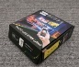
17-Nov-2022 | Czechia | Peripheral Component Interconnect (PCI) Card | Computer / Audio / Video / Other Electronics & Accessories | Environmental Hazard | 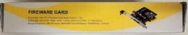
17-Nov-2022 | Slovenia | LED Floodlight | Electrical Appliances | Electric Shock Hazard, Injury Hazard | 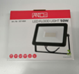
18-Nov-2022 | Ireland | Toothpaste | Bodycare / Cosmetics | Chemical Hazard | 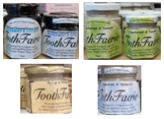
18-Nov-2022 | Germany | Particle Filter Mask | Protective Equipment | Health Risk Hazard | 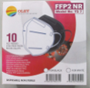
21-Nov-2022 | Poland | Skipping Rope | Toys and Childcare Products | Chemical Hazard | 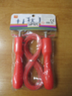
22-Nov-2022 | Ireland | Fragranced Reed Diffuser | Chemicals | Chemical Hazard | 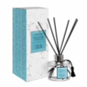
22-Nov-2022 | Ireland | Fragranced Reed Diffuser | Chemicals | Chemical Hazard | 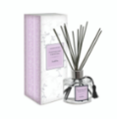
22-Nov-2022 | Sweden | Toy Slime | Toys and Childcare Products | Chemical Hazard | 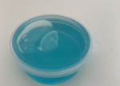
22-Nov-2022 | Sweden | Balloons | Toys and Childcare Products | Chemical Hazard | 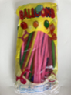
22-Nov-2022 | Romania | Portable Immersion Heater | Electrical Appliances | Burn Hazard, Electric Shock Hazard | 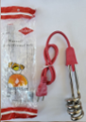
23-Nov-2022 | Luxembourg | Hedge Trimmer | Machinery | Burn Hazard, Fire Hazard | 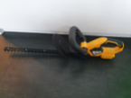
23-Nov-2022 | Luxembourg | Hedge Trimmer | Machinery | Burn Hazard, Fire Hazard | 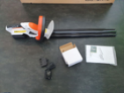
23-Nov-2022 | Croatia | Soft Toy | Toys and Childcare Products | Choking Hazard | 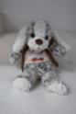
23-Nov-2022 | Romania | Children's Hat | Fabric / Textile / Garment / Home Textile | Choking Hazard | 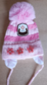
23-Nov-2022 | France | Hair Mask | Bodycare / Cosmetics | Chemical Hazard | 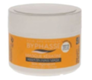
23-Nov-2022 | Germany | Toy Bow and Arrow Set | Toys and Childcare Products | Choking Hazard, Injury Hazard | 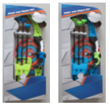
23-Nov-2022 | France | Plastic Toy | Toys and Childcare Products | Choking Hazard | 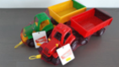
23-Nov-2022 | Germany | Laser Engraving Machine | Machinery | Damage to Sight | 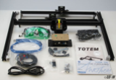
23-Nov-2022 | Ireland | Jointing Compound | Chemicals | Chemical Hazard | 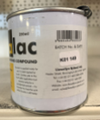
23-Nov-2022 | Bulgaria | Soother | Toys and Childcare Products | Injury Hazard | 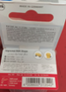
23-Nov-2022 | Austria | Trampoline | Sporting Goods / Equipment | Injury Hazard | 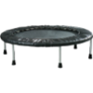
23-Nov-2022 | Poland | Toy Slime | Toys and Childcare Products | Chemical Hazard | 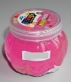
23-Nov-2022 | Poland | Toy Slime | Toys and Childcare Products | Chemical Hazard | 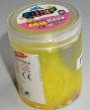
23-Nov-2022 | Poland | Plastic Doll | Toys and Childcare Products | Chemical Hazard | 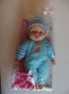
23-Nov-2022 | Hungary | Ozone Generator | Electrical Appliances | Electric Shock Hazard | 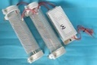  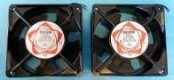
24-Nov-2022 | Hungary | Hot Plate | Electrical Appliances | Electric Shock Hazard | 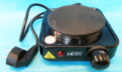
24-Nov-2022 | Ireland | Architectural Coating and Waterproofing Product | Chemicals | Chemical Hazard | 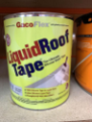
24-Nov-2022 | Ireland | Silicone Roof Sealant | Chemicals | Chemical Hazard | 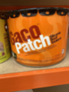
24-Nov-2022 | Czechia | Battery Operated Toy | Toys and Childcare Products | Environmental Hazard | 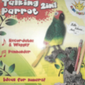
24-Nov-2022 | Sweden | Skin Whitening Cream | Bodycare / Cosmetics | Chemical Hazard | 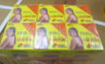
24-Nov-2022 | Sweden | Skin Lightening Cream | Bodycare / Cosmetics | Chemical Hazard | 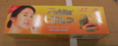
24-Nov-2022 | Cyprus | Children's Hooded Sweatshirt | Fabric / Textile / Garment / Home Textile | Injury Hazard | 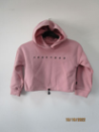
24-Nov-2022 | Poland | Rattle Toy | Toys and Childcare Products | Choking Hazard | 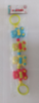
24-Nov-2022 | Hungary | Spiky Ball | Toys and Childcare Products | Chemical Hazard, Choking Hazard | 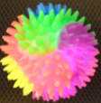
24-Nov-2022 | The Netherlands | Lamp Holder | Electrical Appliances | Electric Shock Hazard | 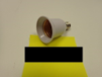
24-Nov-2022 | Sweden | Toy Slime | Toys and Childcare Products | Chemical Hazard | 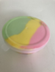
25-Nov-2022 | Luxembourg | Particle Filter Mask | Protective Equipment | Health Risk Hazard | 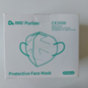
25-Nov-2022 | Luxembourg | Robotic Lawn Mower | Machinery | Cut Hazard | 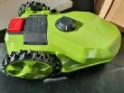
29-Nov-2022 | Italy | Balloons | Toys and Childcare Products | Chemical Hazard | 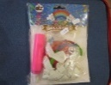
29-Nov-2022 | Italy | Body Gel | Bodycare / Cosmetics | Chemical Hazard | 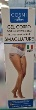
29-Nov-2022 | Italy | Hair Spray | Bodycare / Cosmetics | Chemical Hazard | 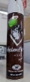
29-Nov-2022 | Italy | Hair Spray | Bodycare / Cosmetics | Chemical Hazard | 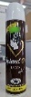
29-Nov-2022 | Italy | Perfume | Bodycare / Cosmetics | Chemical Hazard | 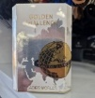
29-Nov-2022 | Spain | Laser Pointer | Electrical Appliances | 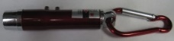  Damage to Sight | 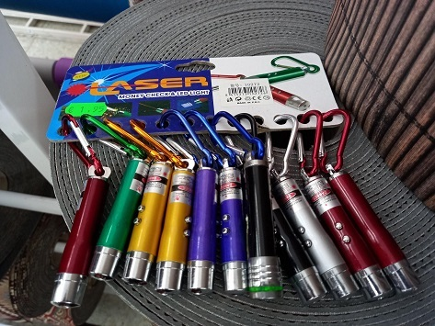
29-Nov-2022 | Spain | Soft Toy | Toys and Childcare Products | Choking Hazard | /
30-Nov-2022 | France | Water Bomb | Toys and Childcare Products | Chemical Hazard | 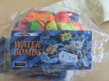
30-Nov-2022 | The Netherlands | Baby Lock | Toys and Childcare Products | Choking Hazard | 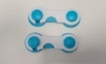  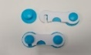
30-Nov-2022 | Hungary | Hot Plate | Electrical Appliances | Electric Shock Hazard | 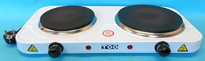
30-Nov-2022 | Finland | Christmas Calendar | Toys and Childcare Products | Chemical Hazard, Choking Hazard | 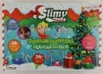
30-Nov-2022 | Croatia | Soft Toy | Toys and Childcare Products | Choking Hazard | 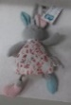
30-Nov-2022 | Luxembourg | Particle Filter Mask | Protective Equipment | Health Risk Hazard | 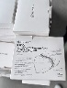
30-Nov-2022 | Romania | Babies' T-Shirt | Fabric / Textile / Garment / Home Textile | Choking Hazard | 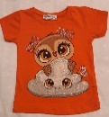
30-Nov-2022 | Austria | Plush Toy | Toys and Childcare Products | Choking Hazard | 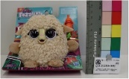
30-Nov-2022 | Poland | Plastic Bath Toy | Toys and Childcare Products | Choking Hazard | 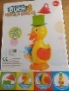
30-Nov-2022 | Lithuania | Adaptor | Electrical Appliances | Electric Shock Hazard | 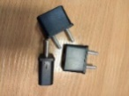
30-Nov-2022 | Lithuania | Children's Jacket | Fabric / Textile / Garment / Home Textile | Strangulation Hazard | 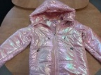
30-Nov-2022 | Lithuania | Children's Jacket | Fabric / Textile / Garment / Home Textile | Strangulation Hazard | 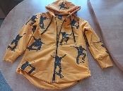
30-Nov-2022 | Lithuania | Children's Jacket | Fabric / Textile / Garment / Home Textile | Strangulation Hazard | 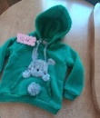
30-Nov-2022 | Lithuania | Children's Jacket | Fabric / Textile / Garment / Home Textile | Strangulation Hazard | 