Recall Cases Summary – US (Last Update Date: 30 November 2022)

Date | Product | Categories | Hazard | Image
3-Nov-2022 | Bolt Foldable Children’s Scooter | Toys and Childcare Products | Lead Poisoning Hazard | 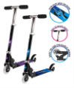
3-Nov-2022 | Tangame Busy Toy House | Toys and Childcare Products | Lead Poisoning Hazard | 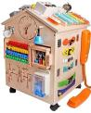
3-Nov-2022 | Women’s Navy Blue Canvas Shoes | Footwear | Chemical Hazard | 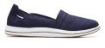  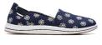  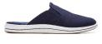  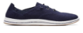  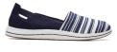
3-Nov-2022 | Stashables Children’s Ramp Set | Toys and Childcare Products | Lead Poisoning Hazard | 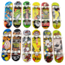  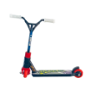  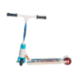
3-Nov-2022 | Exercise Bicycle | Sporting Goods / Equipment | Injury Hazard | 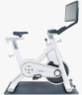  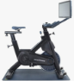
3-Nov-2022 | RadWagon 4 Electric Cargo Bike | Sporting Goods / Equipment | Fall Hazard, Crash Hazard | 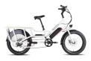  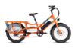  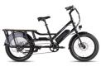
3-Nov-2022 | FUUL Lamp Oil Product | Chemicals | Poisoning Hazard | 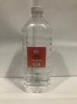
3-Nov-2022 | Garment Steamer | Home Electrical Appliances | Burn Hazard | 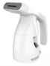
3-Nov-2022 | Tora Portable Power Charging Station | Electrical Appliances | Fire Hazard, Explosion Hazard | 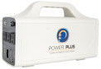
3-Nov-2022 | Air Freshener | Chemicals | Skin Irritation Risk, Injury Hazard, Laceration Hazard, Eye Irritation Risk | 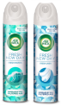
10-Nov-2022 | Generac® and DR® 6500 Watt and 8000 Watt Portable Generator | Electrical Appliances | Amputation Hazard, Crushing Hazard | 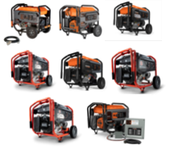
10-Nov-2022 | Hunter Branded Devon Park, Astwood, Highland Hill, Kerrison and Van Nuys Light Fixture | Electrical Appliances | Electric Shock Hazard | 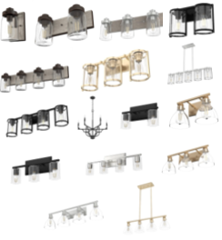
10-Nov-2022 | Mockingbird Single-to-Double Stroller | Toys and Childcare Products | Fall Hazard | 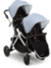
17-Nov-2022 | Infant’s Yellow Footed Fleece Pajamas with Animal Graphic | Fabric / Textile / Garment / Home Textile | Laceration Hazard, Puncture Hazard | 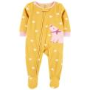
17-Nov-2022 | Children’s Rainbow Stacking Toys | Toys and Childcare Products | Choking Hazard | 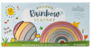  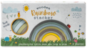
17-Nov-2022 | MATRYX, AXYS and Pro-Ride Snowmobile | Sporting Goods / Equipment | Fire Hazard | 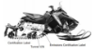  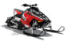  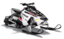  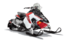  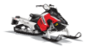  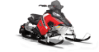  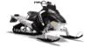  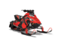  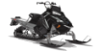  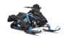  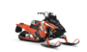  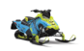  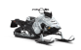  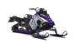  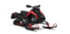  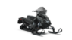  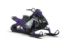  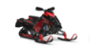  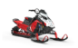  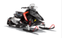
23-Nov-2022 | Children’s Clothing | Fabric / Textile / Garment / Home Textile | Lead Poisoning Hazard | 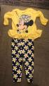  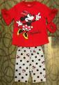  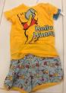  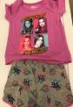  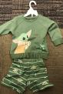  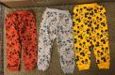  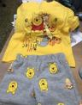  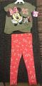
23-Nov-2022 | Indigo Branded Bear Mug | Food Contact Material | Burn Hazard, Laceration Hazard | 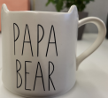  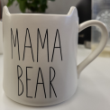
23-Nov-2022 | Toddler’s Stainless Steel Bottles and Cup | Food Contact Material | Lead Poisoning Hazard | 