Recall Cases Summary – Australia (Last Update Date: 31 January 2023)

Date | Product | Categories | Hazard | Image
4-Jan-2023 | Forearm Crutch - Tall and Adult Size | Medical Devices | Fall Hazard, Injury Hazard | 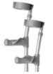
5-Jan-2023 | CW Radio Remote Control/  Transmitter for Roller Shutter, Blind and Awning | Electrical Appliances | Burn Hazard, Injury Hazard, Choking Hazard | 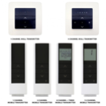
5-Jan-2023 | Guitar Tuner Contained in Fender FA-125 Dreadnought Acoustic Guitar Pack | Electrical Appliances | Burn Hazard, Injury Hazard, Choking Hazard | 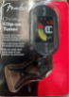
9-Jan-2023 | Bubpods Sleep Sack | Fabric / Textile / Garment / Home Textile | Suffocation Hazard | 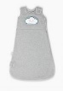
10-Jan-2023 | Brake Pad for Use in Car | Car Components | Health Risk Hazard | 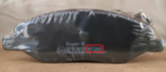
10-Jan-2023 | ODGER Swivel Chair - Anthracite Colour | Furniture | Injury Hazard | 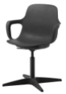
10-Jan-2023 | Green Sprouts Stainless-Steel Bottle | Food Contact Material | Lead Poisoning Hazard, Health Risk Hazard | 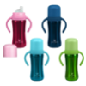
10-Jan-2023 | Various Button Batteries | Electrical Appliances | Burn Hazard, Injury Hazard, Choking Hazard | 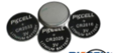  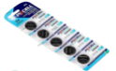
13-Jan-2023 | Halloween LED Ornament | Accessories | Burn Hazard, Injury Hazard, Choking Hazard | 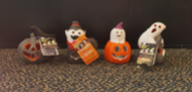
13-Jan-2023 | Young Living ComforCleanse Capsule | Pharmacy | Health Risk Hazard | 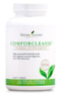
13-Jan-2023 | Pedal Clipper 54cm Electric Flat-Bar Road Bike | Sporting Goods / Equipment | Injury Hazard | 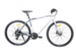
16-Jan-2023 | Stage Battery Charger | Electrical Appliances | Electric Shock Hazard, Injury Hazard | 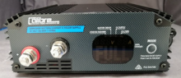
16-Jan-2023 | SCA 1.6 Amp 3 Stage Battery Charger | Electrical Appliances | Electric Shock Hazard, Injury Hazard | 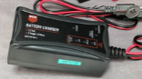
18-Jan-2023 | 3 Metre White Coloured Extension Lead Rated 250V 10A | Electrical Appliances | Burn Hazard, Injury Hazard, Fire Hazard | 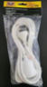
18-Jan-2023 | Babe Rattle 4 Piece and 7 Piece Set | Toys and Childcare Products | Injury Hazard, Suffocation Hazard, Choking Hazard | 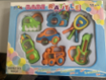
18-Jan-2023 | Shred Maxx, Shred Maxx Male, Shred Maxx Super Strength, Glow Maxx, Cli Maxx, X Maxx and GMax | Pharmacy | Injury Hazard, Health Risk Hazard | 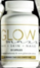
18-Jan-2023 | Fu Gui Ba Wei Tang A.K.A. Rehmannia Eight Vitality Formula & Nuan Gong Cheng Yun Fang A.K.A. Motherhood 1 Formula | Pharmacy | Health Risk Hazard | 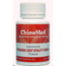  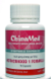
19-Jan-2023 | Jack The Barber Body Spray 150ml/90g Range - Rogue, Nomad and Rebel | Bodycare / Cosmetics | Injury Hazard | 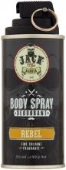  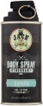  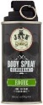
19-Jan-2023 | Pink Ombre Acrylic Vase | Household Items | Fire Hazard, Burn Hazard, Injury Hazard
20-Jan-2023 | LETTAN Mirror | Household Items | Laceration Hazard
20-Jan-2023 | Spider-Man: Far From Home - Mysterio 1/6th Scale Hot Toys Action Figure | Toys and Childcare Products | Burn Hazard, Injury Hazard, Choking Hazard | 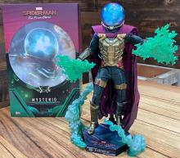
27-Jan-2023 | Wooden Rattle in Personalised Baby Gift Set | Toys and Childcare Products | Suffocation Hazard, Choking Hazard, Injury Hazard | 