Recall Cases Summary – Canada (Last Update Date: 31 January 2023)

Date | Product | Categories | Hazard | Image
5-Jan-2023 | Whiskey Parts Co. No.9 12F and No.9 24F Carbon Handlebar, Salsa Cowchipper and Salsa Cowbell Carbon Handlebar, and Select Salsa Bicycle that Came Equipped with The Salsa Cowchipper or Salsa Cowbell Carbon Handlebar | Sporting Goods / Equipment | Injury Hazard, Crash Hazard | 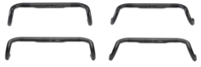  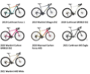
5-Jan-2023 | Mombella Mini Mushroom Soothing Teether | Toys and Childcare Products | Suffocation Hazard | 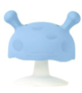  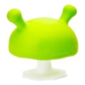
7-Jan-2023 | Potato Ring Salty Snack | Food | Risk of Allergy | 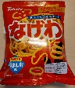  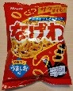
12-Jan-2023 | Salewa Alp Trainer 2 Mid GTX Hiking Boots | Footwear | Fall Hazard | 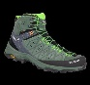  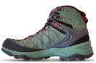
12-Jan-2023 | BISSELL® Cordless Multi-Surface Wet Dry Vacuum, Model 2551 | Home Electrical Appliances | Fire Hazard | 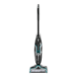
12-Jan-2023 | Certain LG 86-Inch Smart TV and Associated Support Stand | Home Electrical Appliances | Tip-Over Hazard, Entrapment Hazard, Injury Hazard
12-Jan-2023 | Giant Tiger Brands Sleepwear (Monkey Bars, Bella & Birdie, Mountain Ridge, Survival Gear), Men’s Sherpa Robe, Pajar Ski Pants and Men’s Ski Pants | Fabric / Textile / Garment / Home Textile | Microbiological Hazard | 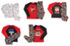  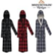  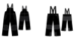
12-Jan-2023 | IKEA LETTAN Mirror | Household Items | Injury Hazard
14-Jan-2023 | Semi-Soft Surface-Ripened Cheese | Food | Microbiological Hazard | 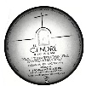
16-Jan-2023 | Mélo-Dieux – Surface-Ripened Soft Cheese | Food | Microbiological Hazard | 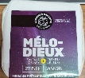
19-Jan-2023 | Hot Chocolate Pot | Food Contact Material | Fire Hazard | 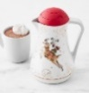  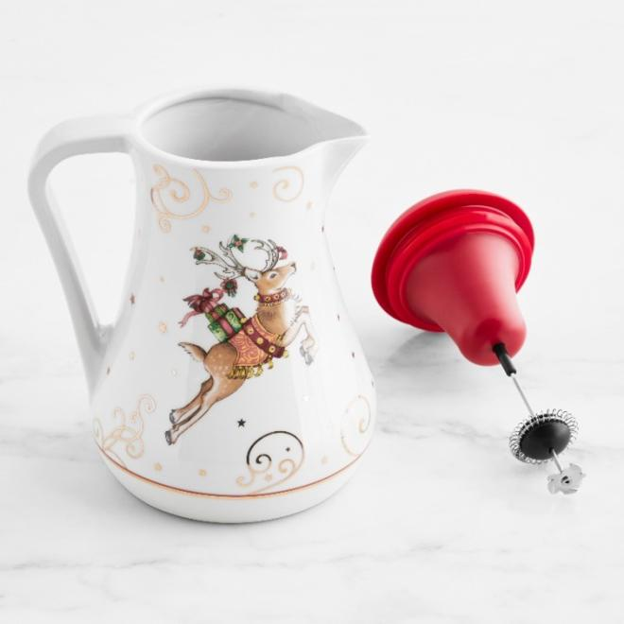
19-Jan-2023 | Surface-Ripened Soft and Semi-Soft Cheese | Food | Microbiological Hazard | 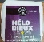  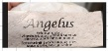  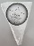  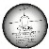  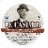
19-Jan-2023 | Nutty Kale Salad with Goat Cheese and Creamy Maple Dressing | Food | Risk of Allergy | /
20-Jan-2023 | Mixed Forest Mushroom | Food | Microbiological Hazard | /
25-Jan-2023 | Certain Ortal TR90 and TR110 Gas Fireplace | Household Items | Fire Hazard
25-Jan-2023 | Paneer Fresh Cheese | Food | Microbiological Hazard | /
26-Jan-2023 | ZLINE 30-Inch, 36-Inch, and 48-Inch RG Gas Range | Home Electrical Appliances | Carbon Monoxide Poisoning Hazard | 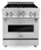  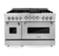  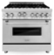
27-Jan-2023 | WARN® Handheld Wireless/Corded Remote Control for VR EVO Winch | Electrical Appliances | Injury Hazard | 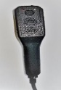  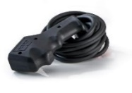
27-Jan-2023 | Potato Ring Seaweed Flavor Snack | Food | Risk of Allergy | /
31-Jan-2023 | Various Indigo-Branded Ceramic Mug, Mug Ornament, and Houseware Product | Food Contact Material | Microbiological Hazard | 