Recall Cases Summary – Europe (Last Update Date: 31 January 2023)

Date | Notifying Country | Product | Categories | Hazard | Image
3-Jan-2023 | Italy | Hairspray | Bodycare / Cosmetics | Chemical Hazard | 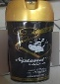
3-Jan-2023 | Italy | Perfume | Bodycare / Cosmetics | Chemical Hazard
3-Jan-2023 | Italy | Perfume | Bodycare / Cosmetics | Chemical Hazard | 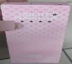
3-Jan-2023 | Italy | Aftershave | Bodycare / Cosmetics | Chemical Hazard
3-Jan-2023 | Italy | Aromatic Perfume | Bodycare / Cosmetics | Chemical Hazard
4-Jan-2023 | Finland | Head Band with LED Light | Accessories | Chemical Hazard | 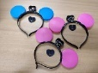
4-Jan-2023 | Poland | Plastic Toy | Toys and Childcare Products | Choking Hazard | 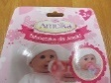
4-Jan-2023 | Poland | Set of Plastic Toys | Toys and Childcare Products | Chemical Hazard | 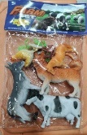
4-Jan-2023 | Poland | Lighting Chain | Electrical Appliances | Burn Hazard, Electric Shock Hazard, Fire Hazard | 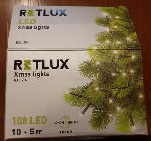
4-Jan-2023 | Poland | Plastic Toy | Toys and Childcare Products | Choking Hazard | 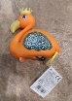
5-Jan-2023 | Sweden | Children´s Highchair | Furniture | Injury Hazard | 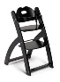
5-Jan-2023 | Germany | Laser Engraving Machine | Machinery | Damage to Sight | 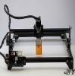
5-Jan-2023 | Germany | Electric Kettle | Home Electrical Appliances | Electric Shock Hazard | 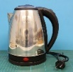
5-Jan-2023 | Italy | Plastic Doll | Toys and Childcare Products | Chemical Hazard, Choking Hazard | 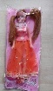
5-Jan-2023 | Poland | Children's Jumpsuit | Fabric / Textile / Garment / Home Textile | Choking Hazard | 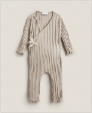
5-Jan-2023 | Poland | Puzzle Play Mat | Toys and Childcare Products | Choking Hazard | 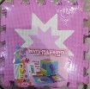
5-Jan-2023 | Poland | Carbon Monoxide Detector | Construction Products | Aspiration Hazard | 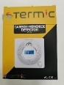
5-Jan-2023 | Poland | Plastic Ball | Toys and Childcare Products | Chemical Hazard | 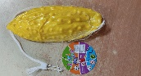
5-Jan-2023 | Italy | Mattress | Household Items | Choking Hazard | 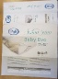  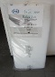
5-Jan-2023 | Poland | Squeezable Toy | Toys and Childcare Products | Choking Hazard | 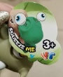  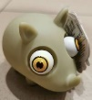
5-Jan-2023 | Poland | Soft Toy | Toys and Childcare Products | Choking Hazard | 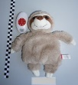
8-Jan-2023 | Luxembourg | Particle Filter Mask | Protective Equipment | Health Risk Hazard | 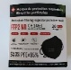  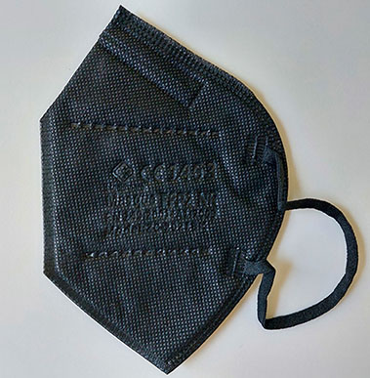
9-Jan-2023 | Cyprus | Body Cream | Bodycare / Cosmetics | Chemical Hazard
9-Jan-2023 | Ireland | Face Cream | Bodycare / Cosmetics | Chemical Hazard
9-Jan-2023 | Ireland | Face Cream | Bodycare / Cosmetics | Chemical Hazard | 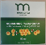
10-Jan-2023 | Germany | Air Purifier | Home Electrical Appliances | Electric Shock Hazard | 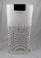
10-Jan-2023 | Italy | Perfume | Bodycare / Cosmetics | Chemical Hazard | 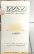
10-Jan-2023 | Italy | Perfume | Bodycare / Cosmetics | Chemical Hazard
10-Jan-2023 | Italy | Perfume | Bodycare / Cosmetics | Chemical Hazard | 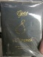
10-Jan-2023 | Italy | Eau De Toilette | Bodycare / Cosmetics | Chemical Hazard | 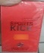
10-Jan-2023 | Ireland | Curling Wand Iron | Home Electrical Appliances | Electric Shock Hazard | 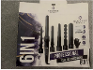
10-Jan-2023 | Ireland | Electric 3D Shaping Massage Roller | Home Electrical Appliances | Electric Shock Hazard | 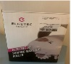
10-Jan-2023 | Germany | Decorative Fruit | Accessories | Choking Hazard | 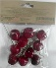  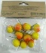
10-Jan-2023 | Germany | Squeeze Toy | Toys and Childcare Products | Microbiological Hazard | 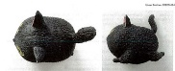
10-Jan-2023 | Norway | Earrings | Jewelry | Chemical Hazard | 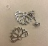
10-Jan-2023 | Germany | Tattoo Ink for Permanent Make-Up | Chemicals | Chemical Hazard | 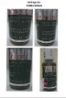  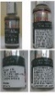
10-Jan-2023 | Germany | Jewellery Set | Jewelry | Chemical Hazard
10-Jan-2023 | Germany | Liquid for Electronic Cigarette | Chemicals | Chemical Hazard | 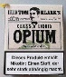  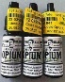
10-Jan-2023 | Lithuania | Lighting Chain | Electrical Appliances | Electric Shock Hazard | 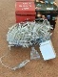
10-Jan-2023 | Luxembourg | Magnetic Ball | Toys and Childcare Products | Injury Hazard | 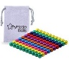
11-Jan-2023 | Italy | Perfume | Bodycare / Cosmetics | Chemical Hazard | 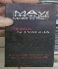
11-Jan-2023 | Italy | Perfume | Bodycare / Cosmetics | Chemical Hazard | 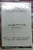
11-Jan-2023 | Italy | Perfume | Bodycare / Cosmetics | Chemical Hazard | 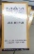
11-Jan-2023 | Italy | Perfume | Bodycare / Cosmetics | Chemical Hazard | 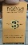
11-Jan-2023 | Italy | Perfume | Bodycare / Cosmetics | Chemical Hazard | 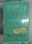
11-Jan-2023 | Italy | Perfume | Bodycare / Cosmetics | Chemical Hazard | 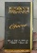
11-Jan-2023 | Italy | Perfume | Bodycare / Cosmetics | Chemical Hazard | 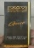
11-Jan-2023 | Italy | Perfume | Bodycare / Cosmetics | Chemical Hazard | 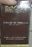
11-Jan-2023 | Italy | Perfume | Bodycare / Cosmetics | Chemical Hazard | 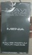
11-Jan-2023 | Italy | Eau De Toilette | Bodycare / Cosmetics | Chemical Hazard
11-Jan-2023 | Italy | Perfume | Bodycare / Cosmetics | Chemical Hazard | 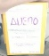
11-Jan-2023 | Italy | Perfume | Bodycare / Cosmetics | Chemical Hazard | 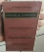
11-Jan-2023 | Italy | Eau De Toilette | Bodycare / Cosmetics | Chemical Hazard | 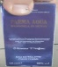
11-Jan-2023 | Italy | Eau De Parfum | Bodycare / Cosmetics | Chemical Hazard | 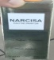
11-Jan-2023 | Italy | Aftershave | Bodycare / Cosmetics | Chemical Hazard | 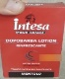
11-Jan-2023 | Italy | Aftershave | Bodycare / Cosmetics | Chemical Hazard | 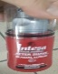
11-Jan-2023 | Italy | Eau De Toilette | Bodycare / Cosmetics | Chemical Hazard
11-Jan-2023 | Iceland | Children's Sweater | Fabric / Textile / Garment / Home Textile | Injury Hazard, Strangulation Hazard | 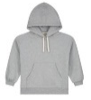
11-Jan-2023 | Italy | Hair Mousse | Bodycare / Cosmetics | Chemical Hazard | 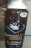
11-Jan-2023 | Italy | Perfume | Bodycare / Cosmetics | Chemical Hazard | 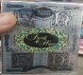
11-Jan-2023 | Italy | Perfume | Bodycare / Cosmetics | Chemical Hazard | 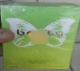
11-Jan-2023 | Italy | Perfume | Bodycare / Cosmetics | Chemical Hazard | 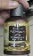
11-Jan-2023 | Italy | Perfume | Bodycare / Cosmetics | Chemical Hazard | 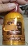
11-Jan-2023 | Italy | Perfume | Bodycare / Cosmetics | Chemical Hazard | 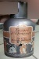
11-Jan-2023 | Italy | Perfume | Bodycare / Cosmetics | Chemical Hazard | 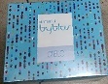
11-Jan-2023 | Italy | Slime Toy | Toys and Childcare Products | Chemical Hazard | 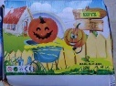  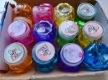
11-Jan-2023 | Denmark | Firework | Outdoor Living Items | Burn Hazard, Damage to Hearing | 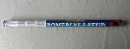
11-Jan-2023 | Denmark | Firework | Outdoor Living Items | Burn Hazard | 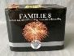
11-Jan-2023 | Poland | Pram Mobile | Toys and Childcare Products | Choking Hazard
11-Jan-2023 | Czechia | Eau De Toilette | Bodycare / Cosmetics | Chemical Hazard | 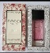
11-Jan-2023 | Czechia | Decorative Grape | Accessories | Choking Hazard
11-Jan-2023 | Hungary | Laser Pointer | Electrical Appliances | Damage to Sight | 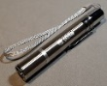
11-Jan-2023 | France | Skin Whitening Cream | Bodycare / Cosmetics | Chemical Hazard | 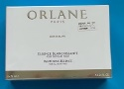
11-Jan-2023 | Italy | Perfume | Bodycare / Cosmetics | Chemical Hazard | 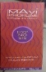
12-Jan-2023 | Germany | Primer | Chemicals | Chemical Hazard | 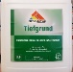
12-Jan-2023 | Cyprus | Children's Sweatshirt | Fabric / Textile / Garment / Home Textile | Strangulation Hazard | 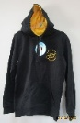
12-Jan-2023 | France | Climbing Chalk | Chemicals | Chemical Hazard | 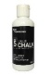
12-Jan-2023 | Finland | Circular Saw Blade | Machinery | Cut Hazard | 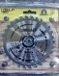
12-Jan-2023 | Finland | Circular Saw Blade | Machinery | Cut Hazard | /
12-Jan-2023 | Finland | Saw Blade for Angle Grinder | Machinery | Cut Hazard | 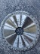
12-Jan-2023 | Finland | Saw Blade for Angle Grinder | Machinery | Cut Hazard | 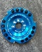
12-Jan-2023 | Finland | Saw Blade for Angle Grinder | Machinery | Cut Hazard | 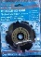
12-Jan-2023 | Finland | Saw Blade for Angle Grinder | Machinery | Cut Hazard | 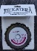
12-Jan-2023 | Italy | Multifunctional Toy | Toys and Childcare Products | Chemical Hazard | 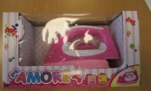
12-Jan-2023 | Austria | Soft Toy | Toys and Childcare Products | Choking Hazard | 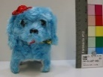
12-Jan-2023 | Ireland | Plastic Toy | Toys and Childcare Products | Chemical Hazard
12-Jan-2023 | Norway | Armband for Cell Phone | Computer / Audio / Video / Other Electronics & Accessories | Chemical Hazard, Environmental Hazard | 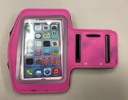
12-Jan-2023 | Germany | Table Cloth Weight | Household Items | Choking Hazard | 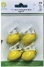
12-Jan-2023 | Poland | Laundry and Household Cleaning Product | Chemicals | Microbiological Hazard | 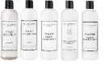  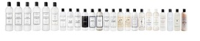
12-Jan-2023 | Norway | Children's Sandals | Footwear | Chemical Hazard, Environmental Hazard | 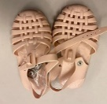
12-Jan-2023 | Denmark | Firework | Outdoor Living Items | Burn Hazard, Damage to Hearing | 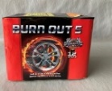
12-Jan-2023 | Finland | Bioethanol Fireplace | Household Items | Burn Hazard, Fire Hazard | 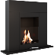
12-Jan-2023 | Norway | Jump Rope | Sporting Goods / Equipment | Chemical Hazard, Environmental Hazard | 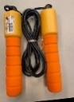
12-Jan-2023 | Czechia | Battery Operated Toy | Toys and Childcare Products | Environmental Hazard | 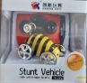
12-Jan-2023 | Czechia | Plastic Doll Set | Toys and Childcare Products | Chemical Hazard | 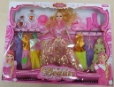
12-Jan-2023 | Czechia | Plastic Doll | Toys and Childcare Products | Chemical Hazard
12-Jan-2023 | Lithuania | Cleaner | Chemicals | Chemical Hazard | 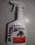
12-Jan-2023 | Czechia | Disposable Electronic Cigarette | Chemicals | Chemical Hazard | 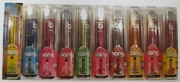
12-Jan-2023 | Italy | Perfume | Bodycare / Cosmetics | Chemical Hazard | 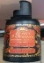
12-Jan-2023 | Romania | Baby T-Shirt | Fabric / Textile / Garment / Home Textile | Choking Hazard | 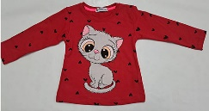
12-Jan-2023 | Romania | Children's Sweatshirt | Fabric / Textile / Garment / Home Textile | Injury Hazard, Strangulation Hazard | 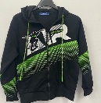
12-Jan-2023 | Norway | Necklace with Pendant | Jewelry | Chemical Hazard | 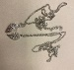
12-Jan-2023 | Lithuania | Body Lotion | Bodycare / Cosmetics | Chemical Hazard | 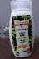
13-Jan-2023 | Italy | Eau De Toilette | Bodycare / Cosmetics | Chemical Hazard | 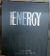
13-Jan-2023 | Italy | Shower and Bath Soap | Bodycare / Cosmetics | Chemical Hazard | 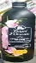
13-Jan-2023 | Italy | Hair Fixing Spray | Bodycare / Cosmetics | Chemical Hazard | 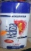
13-Jan-2023 | Italy | Perfume | Bodycare / Cosmetics | Chemical Hazard | 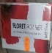
13-Jan-2023 | Italy | Modelling Clay | Toys and Childcare Products | Chemical Hazard | 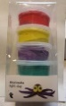
13-Jan-2023 | France | Hair Dye | Bodycare / Cosmetics | Chemical Hazard, Environmental Hazard | 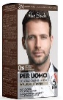
17-Jan-2023 | Germany | Jumping Ball | Toys and Childcare Products | Chemical Hazard | 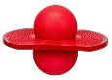
17-Jan-2023 | Finland | Particle Filter Mask | Protective Equipment | Health Risk Hazard | 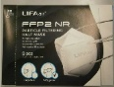
17-Jan-2023 | Poland | Plastic Doll | Toys and Childcare Products | Chemical Hazard | 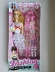
17-Jan-2023 | Lithuania | Eye Contour Gel | Bodycare / Cosmetics | Chemical Hazard | 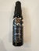
18-Jan-2023 | Czechia | Plastic Doll | Toys and Childcare Products | Chemical Hazard | 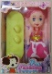
18-Jan-2023 | Denmark | Firework | Outdoor Living Items | Burn Hazard, Damage to Hearing | 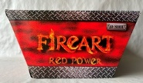
18-Jan-2023 | Czechia | Eau De Parfum | Bodycare / Cosmetics | Chemical Hazard
19-Jan-2023 | Italy | Bath Soap | Bodycare / Cosmetics | Chemical Hazard | 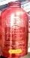
19-Jan-2023 | Romania | Lighting Chain | Electrical Appliances | Electric Shock Hazard | 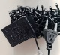
19-Jan-2023 | Italy | Multifunctional Toy | Toys and Childcare Products | Chemical Hazard, Choking Hazard, Damage to Hearing | 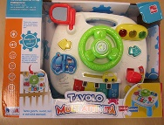
19-Jan-2023 | Germany | Baby Carrier | Toys and Childcare Products | Injury Hazard | 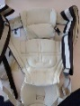
19-Jan-2023 | Latvia | Disposable Electronic Cigarette | Chemicals | Chemical Hazard | 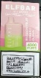
19-Jan-2023 | Latvia | Disposable Electronic Cigarette | Chemicals | Chemical Hazard | 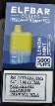
19-Jan-2023 | Luxembourg | Particle Filter Mask | Protective Equipment | Health Risk Hazard | 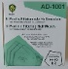
19-Jan-2023 | Germany | Hairdryer | Home Electrical Appliances | Burn Hazard, Fire Hazard | 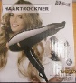
19-Jan-2023 | Germany | Baby Carrier | Toys and Childcare Products | Injury Hazard
19-Jan-2023 | Germany | Baby Carrier | Toys and Childcare Products | Injury Hazard | 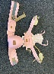
19-Jan-2023 | Norway | Cable for Floor Heating | Electrical Appliances | Environmental Hazard | 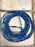
19-Jan-2023 | Romania | Children's Sweatshirt | Fabric / Textile / Garment / Home Textile | Injury Hazard, Strangulation Hazard | 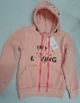
19-Jan-2023 | Romania | Children's Trousers | Fabric / Textile / Garment / Home Textile | Injury Hazard | 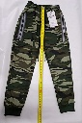
19-Jan-2023 | Romania | Children's Trousers | Fabric / Textile / Garment / Home Textile | Injury Hazard | 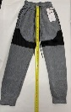
19-Jan-2023 | Romania | Children's Trousers | Fabric / Textile / Garment / Home Textile | Injury Hazard | 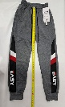
19-Jan-2023 | Romania | Children's Sweatshirt | Fabric / Textile / Garment / Home Textile | Injury Hazard, Strangulation Hazard | 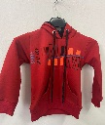
19-Jan-2023 | Lithuania | Head Lamp | Electrical Appliances | Burn Hazard, Fire Hazard | 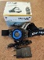
19-Jan-2023 | Lithuania | Car Engine Cleaner | Chemicals | Chemical Hazard | 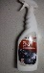
19-Jan-2023 | Lithuania | Car Wheel Cleaner | Chemicals | Chemical Hazard | 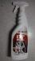
19-Jan-2023 | Lithuania | Car Dirt Cleaner | Chemicals | Chemical Hazard | 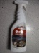
19-Jan-2023 | Czechia | Plastic Doll | Toys and Childcare Products | Chemical Hazard
19-Jan-2023 | Poland | Particle Filter Mask | Protective Equipment | Suffocation Hazard | 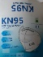
19-Jan-2023 | Ireland | Ring | Jewelry | Chemical Hazard | 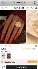
19-Jan-2023 | Czechia | Eau De Toilette | Bodycare / Cosmetics | Chemical Hazard | 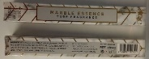
19-Jan-2023 | Czechia | Disposable Electronic Cigarette | Chemicals | Chemical Hazard | 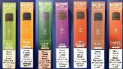
19-Jan-2023 | Lithuania | Children's Cot | Furniture | Entrapment Hazard | 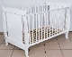
19-Jan-2023 | Romania | Extension Lead | Electrical Appliances | Electric Shock Hazard, Fire Hazard | 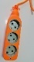
19-Jan-2023 | Romania | Plug Adaptor | Electrical Appliances | Electric Shock Hazard | 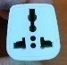
19-Jan-2023 | Romania | Multiplug Socket | Electrical Appliances | Electric Shock Hazard, Fire Hazard | 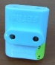
19-Jan-2023 | Iceland | Toy Train | Toys and Childcare Products | Choking Hazard | 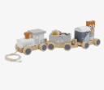
19-Jan-2023 | Poland | Plastic Toy | Toys and Childcare Products | Choking Hazard | 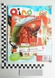
20-Jan-2023 | Ireland | Face Cream | Bodycare / Cosmetics | Chemical Hazard | 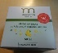
20-Jan-2023 | Estonia | Sun Lotion | Bodycare / Cosmetics | Chemical Hazard | 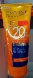
20-Jan-2023 | Lithuania | Soft Toy | Toys and Childcare Products | Choking Hazard | 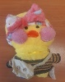
23-Jan-2023 | Finland | Circular Saw Blade | Machinery | Cut Hazard | 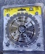
23-Jan-2023 | Finland | Circular Saw Blade | Machinery | Cut Hazard | 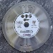
23-Jan-2023 | Poland | Mirror | Household Items | Cut Hazard, Injury Hazard
24-Jan-2023 | Ireland | Boots | Footwear | Injury Hazard | 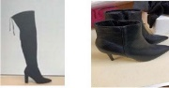
24-Jan-2023 | Denmark | Firework | Outdoor Living Items | Burn Hazard, Damage to Hearing | 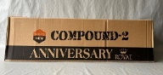
24-Jan-2023 | Denmark | Firework | Outdoor Living Items | Burn Hazard, Damage to Hearing | 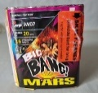
24-Jan-2023 | Germany | Waterproof Outdoor Socket | Electrical Appliances | Electric Shock Hazard | 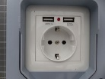  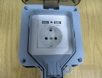
24-Jan-2023 | Lithuania | Lighting Chain | Electrical Appliances | Electric Shock Hazard | 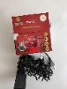
24-Jan-2023 | Lithuania | Lighting Chain | Electrical Appliances | Electric Shock Hazard | 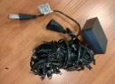  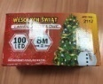
24-Jan-2023 | Lithuania | Lighting Chain | Electrical Appliances | Electric Shock Hazard | 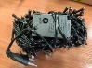  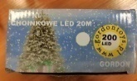
25-Jan-2023 | Germany | Baby Carrier | Toys and Childcare Products | Injury Hazard | 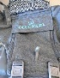  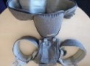
25-Jan-2023 | Germany | Baby Carrier | Toys and Childcare Products | Injury Hazard | 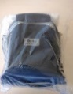
25-Jan-2023 | Germany | Baby Carrier | Toys and Childcare Products | Injury Hazard | 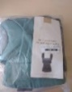  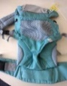
25-Jan-2023 | Finland | Portable Power Station | Electrical Appliances | Electric Shock Hazard | 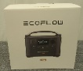  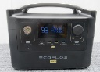
26-Jan-2023 | France | Shower Gel | Bodycare / Cosmetics | Chemical Hazard | 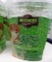
26-Jan-2023 | Norway | Wristwatch | Accessories | Chemical Hazard, Environmental Hazard | 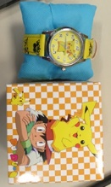
26-Jan-2023 | Poland | Inflatable Ball | Toys and Childcare Products | Chemical Hazard | 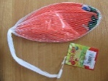
26-Jan-2023 | Estonia | Face Cream | Bodycare / Cosmetics | Chemical Hazard | 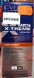
26-Jan-2023 | Germany | In-Wall Socket | Electrical Appliances | Electric Shock Hazard, Fire Hazard | 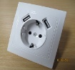
26-Jan-2023 | Czechia | Eau De Toilette | Bodycare / Cosmetics | Chemical Hazard | 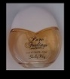
26-Jan-2023 | Germany | Fancy-Dress Mask | Toys and Childcare Products | Burn Hazard | 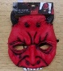
26-Jan-2023 | Lithuania | Toy Puppy | Toys and Childcare Products | Choking Hazard | 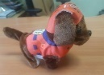
26-Jan-2023 | Hungary | Toy Telephone | Toys and Childcare Products | Damage to Hearing | 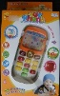
26-Jan-2023 | Belgium | Firework | Outdoor Living Items | Burn Hazard
26-Jan-2023 | Lithuania | Cosmetic Oil | Bodycare / Cosmetics | Chemical Hazard | 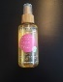
26-Jan-2023 | Finland | Toy Blanket | Toys and Childcare Products | Choking Hazard | 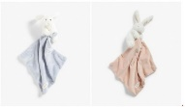
26-Jan-2023 | Poland | Inflatable Ball | Toys and Childcare Products | Chemical Hazard | 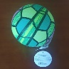
26-Jan-2023 | Ireland | Earring | Jewelry | Chemical Hazard | 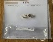  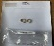  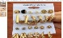  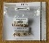
26-Jan-2023 | Ireland | Bracelet | Jewelry | Chemical Hazard | 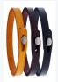
26-Jan-2023 | Ireland | Necklace | Jewelry | Chemical Hazard | 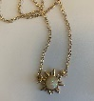  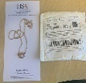
26-Jan-2023 | Poland | Electric Kettle | Home Electrical Appliances | Burn Hazard, Electric Shock Hazard, Fire Hazard | 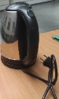
27-Jan-2023 | Slovenia | Particle Filter Mask | Protective Equipment | Health Risk Hazard | 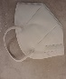
31-Jan-2023 | France | Table Lamp | Electrical Appliances | Fire Hazard | 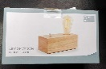
31-Jan-2023 | Italy | Ring | Jewelry | Chemical Hazard | 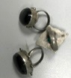
31-Jan-2023 | Slovakia | Safety Footwear | Footwear | Injury Hazard | 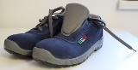
31-Jan-2023 | Slovakia | Safety Footwear | Footwear | Injury Hazard | 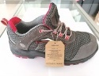
31-Jan-2023 | Slovakia | Safety Footwear | Footwear | Injury Hazard | 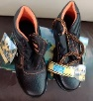
31-Jan-2023 | Germany | USB Charger | Electrical Appliances | Electric Shock Hazard | 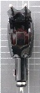
31-Jan-2023 | Slovakia | Hot Plate | Electrical Appliances | Electric Shock Hazard | 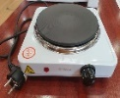
31-Jan-2023 | Romania | Wall Socket | Electrical Appliances | Electric Shock Hazard, Fire Hazard | 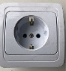
31-Jan-2023 | Romania | Multiplug Socket | Electrical Appliances | Electric Shock Hazard, Fire Hazard | 