Recall Cases Summary – US (Last Update Date: 31 January 2023)

Date | Product | Categories | Hazard | Image
5-Jan-2023 | Bicycle Handlebar and Bicycle | Sporting Goods / Equipment | Injury Hazard, Crash Hazard | 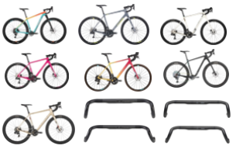
5-Jan-2023 | Children’s Pajamas | Fabric / Textile / Garment / Home Textile | Burn Hazard | 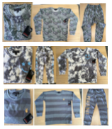
9-Jan-2023 | Rocking Sleeper | Toys and Childcare Products | Death Hazard | 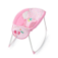
9-Jan-2023 | Rock ‘N Play Sleeper | Toys and Childcare Products | Death Hazard | 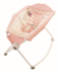
12-Jan-2023 | BISSELL® Cordless Multi-Surface Wet Dry Vacuum Models 2551, 2551W and 25519 | Home Electrical Appliances | Fire Hazard | 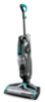
12-Jan-2023 | LG 86-Inch Smart Television and Stand | Home Electrical Appliances | Tip-Over Hazard, Entrapment Hazard, Injury Hazard | 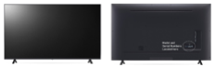
12-Jan-2023 | 1620 Vinyl Single-Hung Impact Window with Window Opening Control Device | Household Items | Fall Hazard, Injury Hazard | 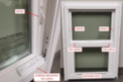
19-Jan-2023 | Headlight Sealant | Chemicals | Poisoning Hazard | 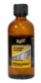
19-Jan-2023 | Vanessa Fire Table | Furniture | Fire Hazard
19-Jan-2023 | Children’s Robe | Fabric / Textile / Garment / Home Textile | Burn Hazard | 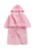
19-Jan-2023 | Hot Chocolate Pot | Food Contact Material | Fire Hazard | 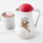  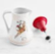
19-Jan-2023 | Multi-Purpose Helmet | Protective Equipment | Injury Hazard | 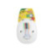  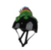  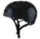
19-Jan-2023 | NewCosplay Children’s Sleepwear | Fabric / Textile / Garment / Home Textile | Burn Hazard | 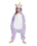  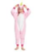  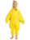  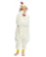  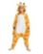
19-Jan-2023 | NewCosplay Children’s Sleepwear | Fabric / Textile / Garment / Home Textile | Burn Hazard | 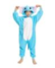  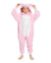  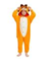
19-Jan-2023 | NewCosplay Children’s Sleepwear | Fabric / Textile / Garment / Home Textile | Burn Hazard | 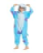  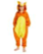
19-Jan-2023 | NewCosplay Children’s Sleepwear | Fabric / Textile / Garment / Home Textile | Burn Hazard | 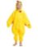  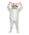  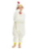  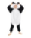  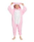  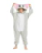  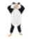
19-Jan-2023 | NewCosplay Children’s Sleepwear | Fabric / Textile / Garment / Home Textile | Burn Hazard | 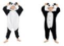
19-Jan-2023 | Children’s Pajama Set | Fabric / Textile / Garment / Home Textile | Burn Hazard | 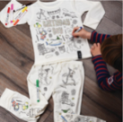
19-Jan-2023 | NewCosplay Children’s Sleepwear | Fabric / Textile / Garment / Home Textile | Burn Hazard | 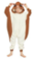
19-Jan-2023 | Taylor and Finch Six-Wick Scented Candle | Household Items | Fire Hazard, Injury Hazard | 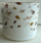
26-Jan-2023 | Children’s Lounge Pants | Fabric / Textile / Garment / Home Textile | Burn Hazard | 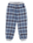  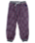  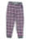  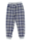
26-Jan-2023 | Gas Range to Include 48-Inch Gas Range | Home Electrical Appliances | Carbon Monoxide Poisoning Hazard | 