Recall Cases Summary – Australia (Last Update Date: 28 February 2023)

Date | Product | Categories | Hazard | Image
1-Feb-2023 | Junior Girls Top Summer Fiesta 2 Piece Set (EPJG7143) | Fabric / Textile / Garment / Home Textile | Choking Hazard, Injury Hazard | 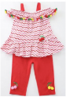
3-Feb-2023 | Light Up Wand - Snow Flake, Light Up Wand - Butterfly, Light Up Wand - Star | Toys and Childcare Products | Burn Hazard, Injury Hazard, Choking Hazard | 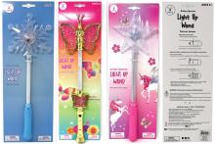
3-Feb-2023 | Daily Face Fuel 100ml | Bodycare / Cosmetics | Health Risk Hazard | 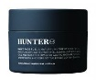
3-Feb-2023 | Warn VR EVO Winch (All Models) | Car Components | Injury Hazard | 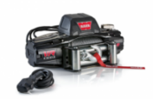
3-Feb-2023 | Smart Television | Home Electrical Appliances | Injury Hazard, Tip-Over Hazard
3-Feb-2023 | AEG 58V 8Ah Ultimate HD Battery # A58BAT18 and the AEG 58V 4Ah Ultimate Battery # A58BAT14 | Electrical Appliances | Fire Hazard, Burn Hazard | 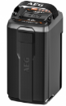  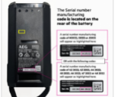
3-Feb-2023 | Output Connector Clamp Sold with Projecta Battery Charger | Electrical Appliances | Fire Hazard, Burn Hazard, Injury Hazard | 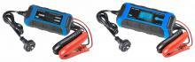  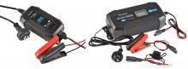
8-Feb-2023 | Wooden Montessori Baby Rattle | Toys and Childcare Products | Choking Hazard, Suffocation Hazard, Injury Hazard | 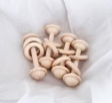
9-Feb-2023 | Warn VR EVO 4x4 Recovery Winch | Car Components | Injury Hazard | 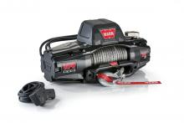
14-Feb-2023 | Dulux Concrete & Paving Bare Concrete Etch & Clean 52ZD0198-2L and 52ZD0198-4L | Chemicals | Eye Irritation Risk, Damage to Skin | 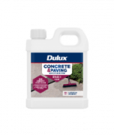
14-Feb-2023 | SPALDING NBA - 44 Inch and 52 Inch Acrylic Basketball Backboard and Mounting Bracket Set | Sporting Goods / Equipment | Injury Hazard | 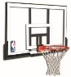  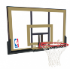
14-Feb-2023 | Beauty Salon Set | Toys and Childcare Products | Risk of Allergy | 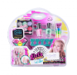
14-Feb-2023 | Bead Octagon Educational | Toys and Childcare Products | Choking Hazard, Suffocation Hazard | 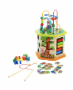
14-Feb-2023 | Christmas Bon Bon Set - Small Torch | Toys and Childcare Products | Choking Hazard, Burn Hazard | 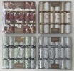  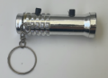
14-Feb-2023 | Dulux Precision Coating Remover Test Patch Kit | Chemicals | Burn Hazard | 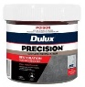  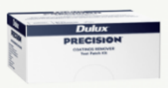
14-Feb-2023 | Silicone Sensory Teether | Toys and Childcare Products | Choking Hazard, Suffocation Hazard, Injury Hazard | 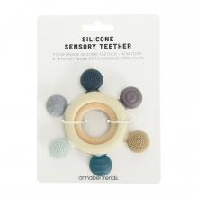  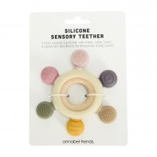
20-Feb-2023 | Adult Bicycle Helmet Provided in Multiple Colours | Protective Equipment | Injury Hazard
20-Feb-2023 | Mirage Junior Swim Vest | Sporting Goods / Equipment | Drowning Hazard | 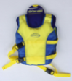
21-Feb-2023 | Glow in Dark Water Washable Body Paint | Bodycare / Cosmetics | Risk of Allergy | 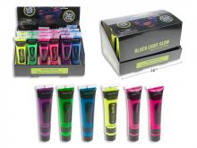  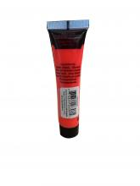
21-Feb-2023 | Intex Dinosaur Play Centre | Toys and Childcare Products | Drowning Hazard | 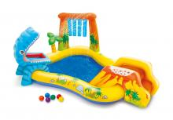
22-Feb-2023 | 30 Seconds Outdoor Cleaner Hose End 2 Litre | Chemicals | Damage to Skin, Eye Irritation Risk | 