Recall Cases Summary – Canada (Last Update Date: 28 February 2023)

Date | Product | Categories | Hazard | Image
1-Feb-2023 | Helly Hansen Sweater and Hoodie | Fabric / Textile / Garment / Home Textile | Burn Hazard | 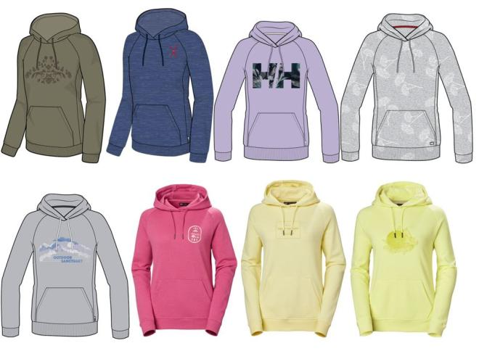  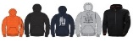  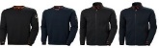  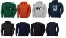  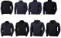  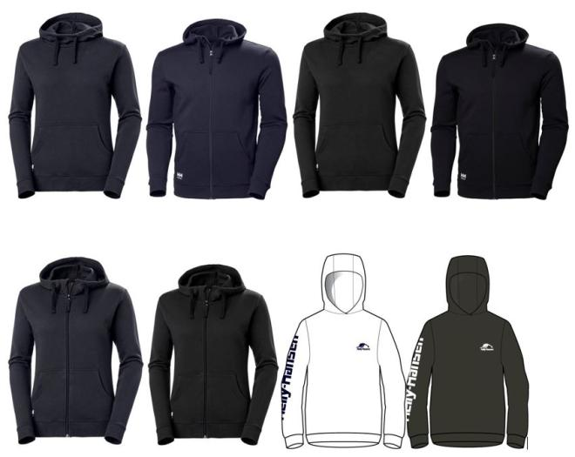  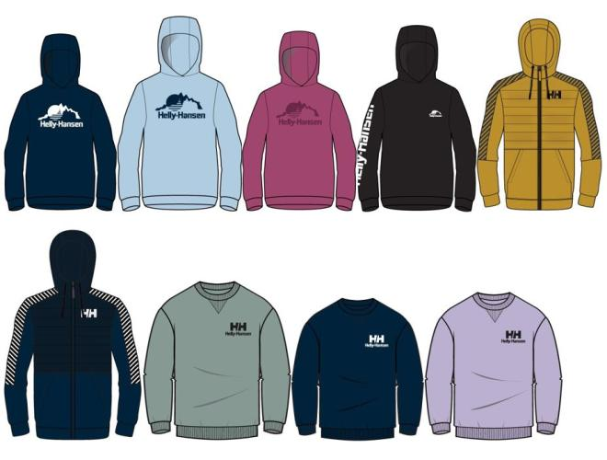  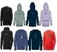  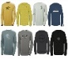  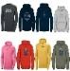  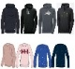  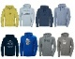  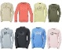  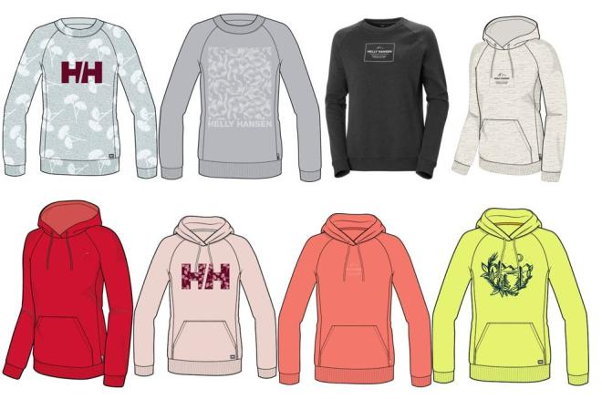  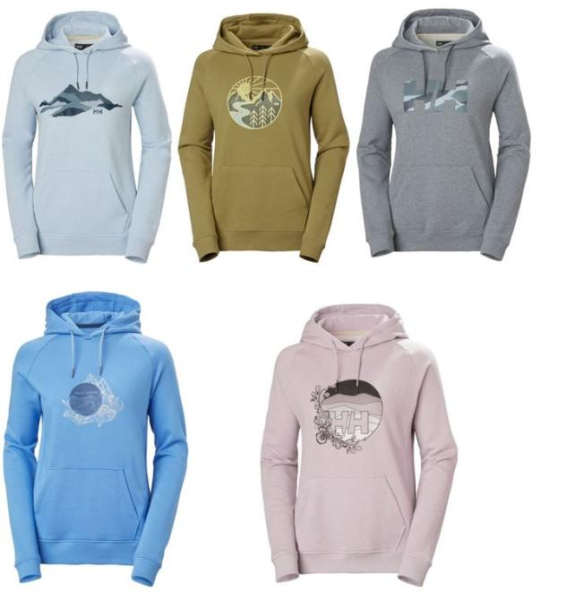
1-Feb-2023 | Falooda Drink with Almond Flavour | Food | Risk of Allergy | 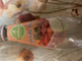
2-Feb-2023 | Fiber Plus Powder | Food | Microbiological Hazard | /
3-Feb-2023 | Nutrifresh Brand Falooda Drink | Food | Risk of Allergy
3-Feb-2023 | Meatball Product | Food | Risk of Allergy
4-Feb-2023 | Falooda Drink | Food | Risk of Allergy | 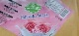
8-Feb-2023 | Fabuloso Multi-Purpose Cleaner - Lavender Scent, 1.65L | Chemicals | Microbiological Hazard | 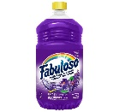
8-Feb-2023 | Ove Decors Vanessa Fire Table | Furniture | Fire Hazard | 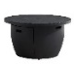
9-Feb-2023 | Skip Hop Silver Lining Activity Gym | Toys and Childcare Products | Choking Hazard | 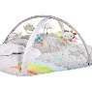
9-Feb-2023 | Ovation Protégé Equestrian Helmet | Protective Equipment | Impact Hazard | 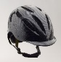
9-Feb-2023 | Certain LiftMaster Garage Door Control Panel | Electrical Appliances | Entrapment Hazard | 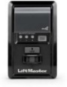
9-Feb-2023 | Sherbon Brand Falooda Drink – Mango | Food | Risk of Allergy | 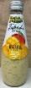
11-Feb-2023 | MacMillan's Specialty Foods Brand McCain 3/8" Staycrisp Straight Cut Fries | Food | Risk of Allergy | 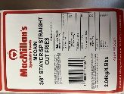
12-Feb-2023 | Le Fromage Au Village Brand Le Cru Du Clocher Raw Milk Cheddar Cheese | Food | Microbiological Hazard | 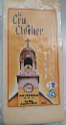  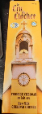  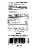  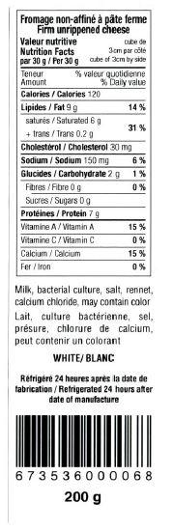  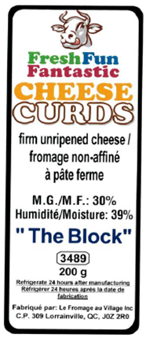
14-Feb-2023 | Le Fromage Au Village and FreshFun Fantastic Brand Cheese Product | Food | Microbiological Hazard | 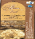  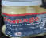  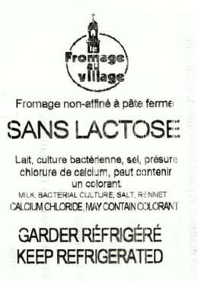  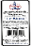  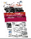  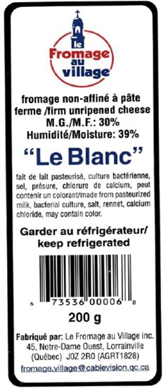  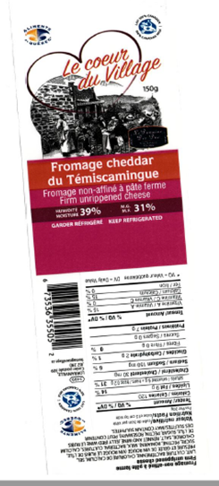  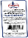  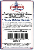  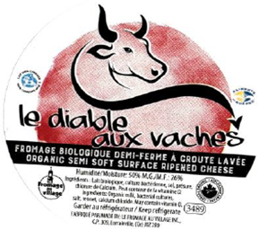  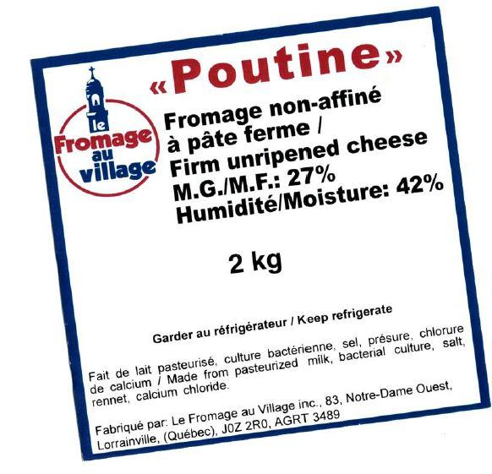  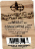  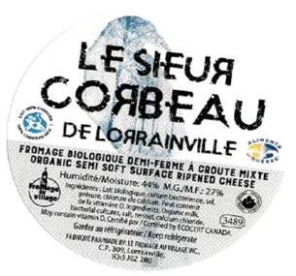
15-Feb-2023 | PC Brand Canadian Cheddar Cheese | Food | Microbiological Hazard | 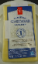
15-Feb-2023 | Chili Pepper Powder (Ichimi Togarashi) | Food | Risk of Allergy | /
16-Feb-2023 | Disney Baby "My First" Vinyl Figurine | Toys and Childcare Products | Choking Hazard | 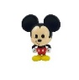  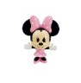  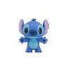  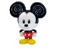  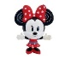  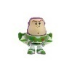
16-Feb-2023 | Jahaan's Brand of Falooda Drink | Food | Risk of Allergy | /
18-Feb-2023 | 1001 Fondues Brand La Fondue Au Village | Food | Microbiological Hazard | 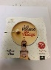  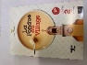
18-Feb-2023 | Maple Dale Cheese Co. Brand 1 Year Old Cheddar | Food | Microbiological Hazard | 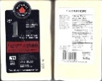
18-Feb-2023 | 1001 Fondues Brand Cheese Fondue | Food | Microbiological Hazard | 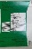  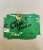  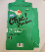  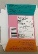  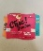  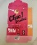  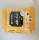  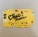  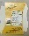  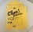  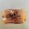  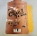  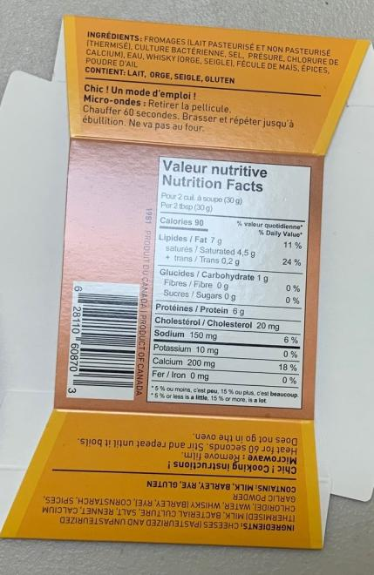  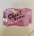  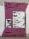  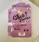  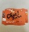  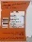  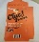
21-Feb-2023 | Falooda Drink | Food | Risk of Allergy | 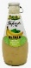  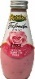  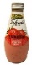
21-Feb-2023 | Falooda Drink | Food | Risk of Allergy | 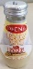  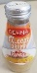  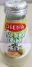  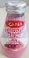
23-Feb-2023 | Air Fryer | Home Electrical Appliances | Burn Hazard, Fire Hazard | 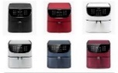  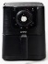  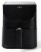  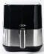
23-Feb-2023 | Lancaster Table & Seating Brand High Chair | Furniture | Fall Hazard | 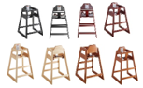
23-Feb-2023 | SCARPA F1 LT and F1 GT Ski Boot | Sporting Goods / Equipment | Fall Hazard, Injury Hazard | 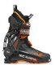  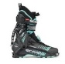  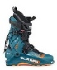  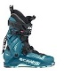
23-Feb-2023 | XDEEP NX700 Scuba Regulator | Sporting Goods / Equipment | Injury Hazard, Drowning Hazard | 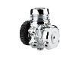  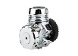  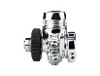  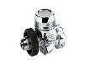
23-Feb-2023 | Power Bank | Electrical Appliances | Fire Hazard | 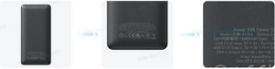
24-Feb-2023 | Rechargeable LED Armband Reflective Running Gear | Sporting Goods / Equipment | Fire Hazard | 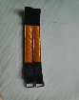  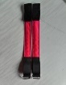  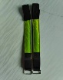  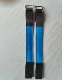
25-Feb-2023 | Various Salento Organics Brand Dark Chocolate Product | Food | Risk of Allergy | 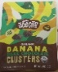  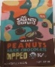  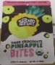  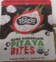
28-Feb-2023 | Yardworks 15-Amp Electric Corded Snowblower, 22-in | Tools and Hardware | Electric Shock Hazard | 