Recall Cases Summary – Europe (Last Update Date: 28 February 2023)

Date | Notifying Country | Product | Categories | Hazard | Image
1-Feb-2023 | Italy | Bracelet | Jewelry | Chemical Hazard | 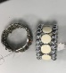
1-Feb-2023 | Italy | Bracelet | Jewelry | Chemical Hazard | 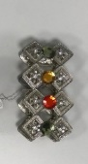
1-Feb-2023 | Italy | Earring | Jewelry | Chemical Hazard | 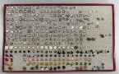
1-Feb-2023 | France | Prefabricated Portlight | Tools and Hardware | Drowning Hazard | 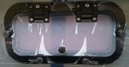
1-Feb-2023 | Italy | Outdoor Laser Projector | Electrical Appliances | Damage to Sight | 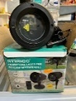
1-Feb-2023 | Italy | Outdoor Laser Projector | Electrical Appliances | Damage to Sight | 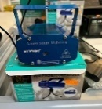
1-Feb-2023 | Italy | Outdoor Laser Projector | Electrical Appliances | Damage to Sight | 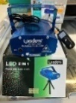
2-Feb-2023 | Ireland | Hair Dye | Bodycare / Cosmetics | Chemical Hazard | 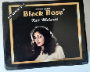
2-Feb-2023 | Ireland | Earring | Jewelry | Chemical Hazard | 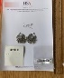
2-Feb-2023 | Ireland | Neck Collar | Jewelry | Chemical Hazard | 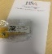  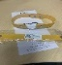  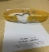
2-Feb-2023 | Ireland | Necklace with Pendant | Jewelry | Chemical Hazard | 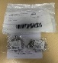  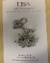
2-Feb-2023 | Ireland | Ankle Bracelet | Jewelry | Chemical Hazard | 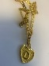  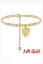
2-Feb-2023 | Bulgaria | Bicycle | Sporting Goods / Equipment | Injury Hazard | 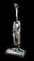  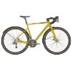
2-Feb-2023 | Lithuania | Face and Body Cream | Bodycare / Cosmetics | Chemical Hazard | 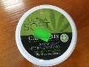
2-Feb-2023 | Lithuania | Electric Heater | Home Electrical Appliances | Burn Hazard, Electric Shock Hazard | 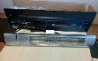
2-Feb-2023 | Lithuania | Chair | Furniture | Injury Hazard | 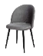
2-Feb-2023 | Italy | Wristwatch | Accessories | Chemical Hazard | 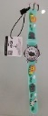  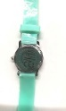
2-Feb-2023 | Italy | Children’s Trousers | Fabric / Textile / Garment / Home Textile | Injury Hazard | 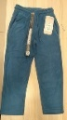
2-Feb-2023 | Germany | Multiplug Socket | Electrical Appliances | Electric Shock Hazard | 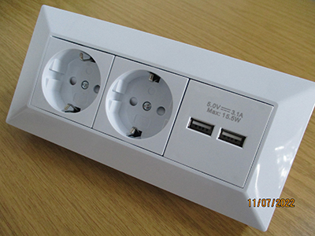
3-Feb-2023 | Italy | Children's Bag | Fabric / Textile / Garment / Home Textile | Chemical Hazard | 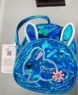
3-Feb-2023 | Italy | Plastic Book | Toys and Childcare Products | Chemical Hazard | 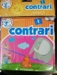
3-Feb-2023 | Italy | Crown Hair Clip | Jewelry | Chemical Hazard | 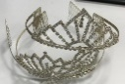
3-Feb-2023 | Cyprus | Gym Weight | Sporting Goods / Equipment | Chemical Hazard | 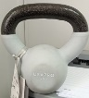
3-Feb-2023 | Cyprus | Yoga Ball | Sporting Goods / Equipment | Chemical Hazard, Environmental Hazard | 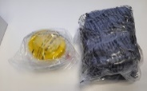
3-Feb-2023 | Italy | Ring | Jewelry | Chemical Hazard | 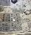  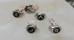
3-Feb-2023 | Hungary | Voltage Tester | Electrical Appliances | Electric Shock Hazard | 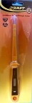
5-Feb-2023 | Romania | Cordless Vacuum Cleaner | Home Electrical Appliances | Burn Hazard, Fire Hazard | 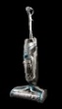
7-Feb-2023 | Austria | Hair Dye | Bodycare / Cosmetics | Chemical Hazard | 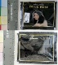  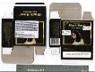
8-Feb-2023 | Finland | Candle | Accessories | Burn Hazard, Fire Hazard | 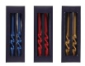
8-Feb-2023 | Poland | Plastic Toy | Toys and Childcare Products | Choking Hazard | 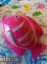  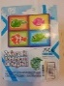
8-Feb-2023 | Sweden | Teeth Whitening Gel | Bodycare / Cosmetics | Chemical Hazard | 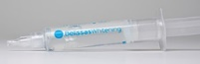
8-Feb-2023 | Sweden | Perfume | Bodycare / Cosmetics | Chemical Hazard | 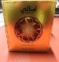
8-Feb-2023 | Sweden | Perfume | Bodycare / Cosmetics | Chemical Hazard | 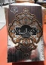
8-Feb-2023 | Lithuania | Face Mousse | Bodycare / Cosmetics | Chemical Hazard
8-Feb-2023 | Lithuania | Shaving Gel | Bodycare / Cosmetics | Chemical Hazard | 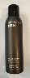
8-Feb-2023 | Lithuania | Skin Cream | Bodycare / Cosmetics | Chemical Hazard | 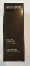
8-Feb-2023 | Lithuania | After Shave Balsam | Bodycare / Cosmetics | Chemical Hazard | 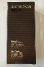
9-Feb-2023 | Cyprus | Bath Mat | Household Items | Chemical Hazard, Environmental Hazard | 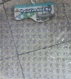
9-Feb-2023 | Austria | Electric Bike | Sporting Goods / Equipment | Injury Hazard | /
9-Feb-2023 | Austria | Hair Dye | Bodycare / Cosmetics | Chemical Hazard | 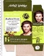  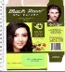
9-Feb-2023 | Germany | Sky Lantern | Outdoor Living Items | Fire Hazard | 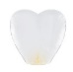
9-Feb-2023 | Germany | Sky Lantern | Outdoor Living Items | Fire Hazard | 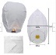
9-Feb-2023 | Germany | Sky Lantern | Outdoor Living Items | Fire Hazard | 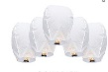
9-Feb-2023 | Germany | Baby Carrier | Toys and Childcare Products | Injury Hazard | 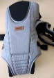
9-Feb-2023 | Finland | Ballpoint Pen | Stationery | Chemical Hazard
9-Feb-2023 | Ireland | Inflatable Children's Costume | Fabric / Textile / Garment / Home Textile | Burn Hazard, Fire Hazard, Injury Hazard | 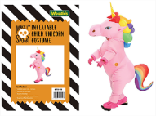
9-Feb-2023 | Czechia | Decorative Grape | Accessories | Choking Hazard
9-Feb-2023 | Hungary | Lighting Chain | Electrical Appliances | Burn Hazard, Electric Shock Hazard, Fire Hazard | 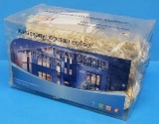
9-Feb-2023 | Czechia | Plastic Doll | Toys and Childcare Products | Chemical Hazard | 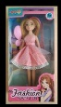
9-Feb-2023 | Poland | Soft Toy | Toys and Childcare Products | Choking Hazard, Suffocation Hazard | 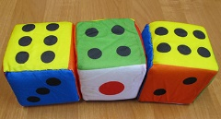
9-Feb-2023 | Hungary | Lighting Chain | Electrical Appliances | Burn Hazard, Electric Shock Hazard, Fire Hazard | 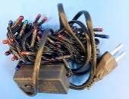
9-Feb-2023 | Hungary | Lighting Chain | Electrical Appliances | Burn Hazard, Electric Shock Hazard, Fire Hazard | 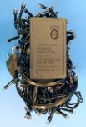
9-Feb-2023 | Germany | Sky Lantern | Outdoor Living Items | Fire Hazard
9-Feb-2023 | Germany | Sky Lantern | Outdoor Living Items | Fire Hazard | 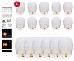
9-Feb-2023 | Germany | Sky Lantern | Outdoor Living Items | Fire Hazard | 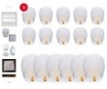
9-Feb-2023 | Poland | Pull-Along Toy | Toys and Childcare Products | Choking Hazard | 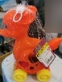
9-Feb-2023 | Hungary | Lighting Chain | Electrical Appliances | Burn Hazard, Electric Shock Hazard, Fire Hazard | 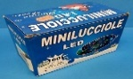  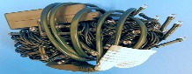
9-Feb-2023 | Poland | Rattle Toy | Toys and Childcare Products | Choking Hazard | 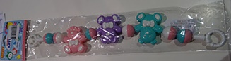
9-Feb-2023 | Sweden | Temporary Henna Tattoo | Bodycare / Cosmetics | Chemical Hazard | 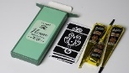
10-Feb-2023 | Slovakia | Travel Adapter | Electrical Appliances | Electric Shock Hazard | 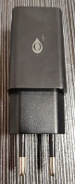
13-Feb-2023 | Latvia | Magnetic Toy | Toys and Childcare Products | Choking Hazard, Injury Hazard | 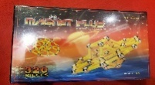
14-Feb-2023 | Germany | Particle Filter Mask | Protective Equipment | Health Risk Hazard | 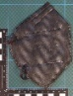
14-Feb-2023 | Romania | Puffer Toy | Toys and Childcare Products | Choking Hazard | 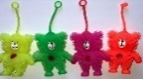
14-Feb-2023 | Slovakia | Smoke Detector | Electrical Appliances | Aspiration Hazard, Burn Hazard, Fire Hazard | 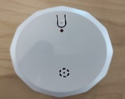
14-Feb-2023 | Croatia | Soft Toy | Toys and Childcare Products | Choking Hazard | 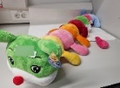
14-Feb-2023 | Germany | Particle Filter Mask | Protective Equipment | Health Risk Hazard | 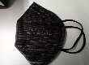
14-Feb-2023 | Slovakia | Smoke Detector | Electrical Appliances | Aspiration Hazard, Burn Hazard, Fire Hazard | 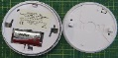  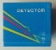  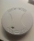  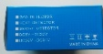
14-Feb-2023 | Croatia | Soft Toy | Toys and Childcare Products | Choking Hazard | 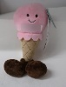
14-Feb-2023 | Sweden | Hair Straightener | Bodycare / Cosmetics | Chemical Hazard | 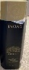
15-Feb-2023 | Sweden | Jewelry Set | Jewelry | Chemical Hazard | 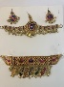
15-Feb-2023 | Austria | Sleeping Bag | Fabric / Textile / Garment / Home Textile | Strangulation Hazard | 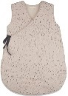
15-Feb-2023 | Austria | Sleeping Bag | Fabric / Textile / Garment / Home Textile | Strangulation Hazard | 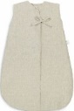
15-Feb-2023 | Sweden | Temporary Henna Tattoo | Bodycare / Cosmetics | Chemical Hazard | 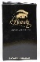  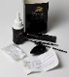
16-Feb-2023 | The Netherlands | Essential Oil Set | Bodycare / Cosmetics | Chemical Hazard
16-Feb-2023 | The Netherlands | Essential Oil | Bodycare / Cosmetics | Chemical Hazard, Health Risk Hazard | 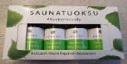
16-Feb-2023 | The Netherlands | Children's Cot | Furniture | Injury Hazard, Suffocation Hazard | 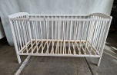
16-Feb-2023 | Germany | Bracelet Set | Jewelry | Chemical Hazard | 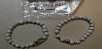
16-Feb-2023 | Sweden | Necklaces Set | Jewelry | Chemical Hazard | 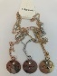
16-Feb-2023 | Sweden | Bracelet | Jewelry | Chemical Hazard | 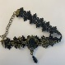
16-Feb-2023 | Sweden | Jewelry Set | Jewelry | Chemical Hazard | 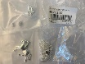
16-Feb-2023 | Sweden | Bracelet | Jewelry | Chemical Hazard | 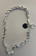
16-Feb-2023 | Sweden | Hair Buckle | Jewelry | Chemical Hazard | 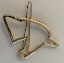
16-Feb-2023 | Sweden | Necklaces Set | Jewelry | Chemical Hazard | 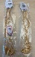
16-Feb-2023 | Sweden | Waist Jewelry | Jewelry | Chemical Hazard | 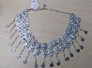
16-Feb-2023 | Sweden | Jewelry Set | Jewelry | Chemical Hazard | 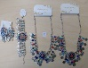
16-Feb-2023 | Slovakia | Modelling Clay | Toys and Childcare Products | Chemical Hazard | 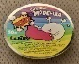  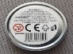  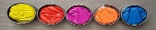
16-Feb-2023 | Poland | Toy Gun Set | Toys and Childcare Products | Choking Hazard, Cut Hazard, Damage to Sight | 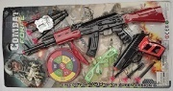
16-Feb-2023 | France | Children’s Balance Bike | Sporting Goods / Equipment | Chemical Hazard | 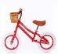  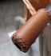  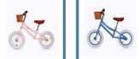
16-Feb-2023 | France | Bath Toy | Toys and Childcare Products | Chemical Hazard | 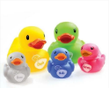
16-Feb-2023 | Ireland | Training Mitts | Sporting Goods / Equipment | Chemical Hazard | 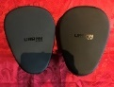
16-Feb-2023 | France | Electric Balance Bike for Children | Sporting Goods / Equipment | Chemical Hazard, Injury Hazard | 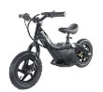
16-Feb-2023 | Sweden | Temporary Tattoo | Bodycare / Cosmetics | Chemical Hazard | 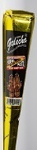
16-Feb-2023 | Ireland | Ankle Weight | Sporting Goods / Equipment | Chemical Hazard | 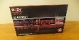  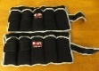  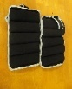
16-Feb-2023 | Ireland | Slam Ball | Sporting Goods / Equipment | Chemical Hazard | 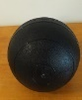
16-Feb-2023 | Finland | Power Wheel | Sporting Goods / Equipment | Chemical Hazard | 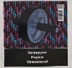
16-Feb-2023 | Latvia | Stroller | Toys and Childcare Products | Injury Hazard | 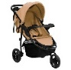
16-Feb-2023 | Finland | Hair-Slide | Jewelry | Chemical Hazard | 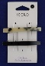
16-Feb-2023 | Finland | Toy Tractor | Toys and Childcare Products | Choking Hazard | 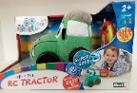
16-Feb-2023 | Hungary | Cosmetic Bag | Fabric / Textile / Garment / Home Textile | Chemical Hazard | 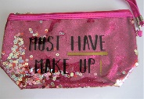
16-Feb-2023 | Hungary | Cosmetic Bag | Fabric / Textile / Garment / Home Textile | Chemical Hazard | 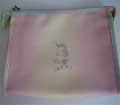
16-Feb-2023 | Croatia | Soft Toy | Toys and Childcare Products | Choking Hazard | 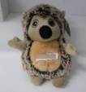
16-Feb-2023 | Hungary | Cosmetic Bag | Fabric / Textile / Garment / Home Textile | Chemical Hazard | 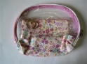
16-Feb-2023 | Lithuania | Table | Furniture | Injury Hazard | 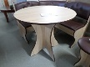
16-Feb-2023 | Sweden | Ring | Jewelry | Chemical Hazard
16-Feb-2023 | Sweden | Ring | Jewelry | Chemical Hazard
16-Feb-2023 | Germany | Baby Carrier | Toys and Childcare Products | Injury Hazard | 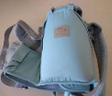  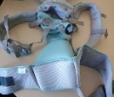
16-Feb-2023 | Finland | Soft Toy | Toys and Childcare Products | Choking Hazard | 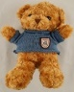  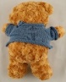
17-Feb-2023 | Ireland | Socket Night Light | Electrical Appliances | Electric Shock Hazard, Fire Hazard | 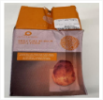  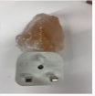
17-Feb-2023 | Germany | Sky Lantern | Outdoor Living Items | Fire Hazard | 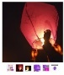
17-Feb-2023 | Sweden | Tattoo Ink | Chemicals | Chemical Hazard | 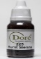
17-Feb-2023 | Sweden | Tattoo Ink | Chemicals | Chemical Hazard
21-Feb-2023 | Italy | Children’s Blouse | Fabric / Textile / Garment / Home Textile | Injury Hazard, Strangulation Hazard | 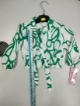
21-Feb-2023 | Italy | Children's Coat | Fabric / Textile / Garment / Home Textile | Injury Hazard | 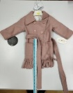
21-Feb-2023 | Italy | Modeling Clay | Toys and Childcare Products | Chemical Hazard | 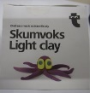
21-Feb-2023 | Italy | Flip-Flops | Footwear | Chemical Hazard | 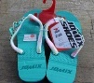
21-Feb-2023 | Italy | Children's Dress | Fabric / Textile / Garment / Home Textile | Injury Hazard, Strangulation Hazard | 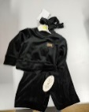
21-Feb-2023 | Italy | Children’s Trousers | Fabric / Textile / Garment / Home Textile | Injury Hazard | 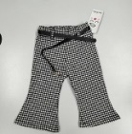
21-Feb-2023 | Italy | Children's Skirt | Fabric / Textile / Garment / Home Textile | Injury Hazard | 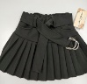
21-Feb-2023 | Italy | Children's Skirt | Fabric / Textile / Garment / Home Textile | Injury Hazard | 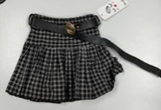
21-Feb-2023 | Italy | Children's Dress | Fabric / Textile / Garment / Home Textile | Injury Hazard | 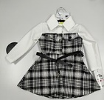
21-Feb-2023 | Germany | Sky Lantern | Outdoor Living Items | Fire Hazard | 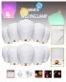
21-Feb-2023 | Sweden | Skin Lightening Cream | Bodycare / Cosmetics | Chemical Hazard | 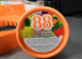
21-Feb-2023 | Finland | Soft Toy | Toys and Childcare Products | Choking Hazard | 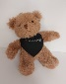
21-Feb-2023 | Germany | Sky Lantern | Outdoor Living Items | Fire Hazard | 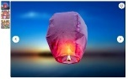
21-Feb-2023 | Germany | Sky Lantern | Outdoor Living Items | Fire Hazard | 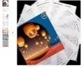
21-Feb-2023 | Romania | Perfume | Bodycare / Cosmetics | Chemical Hazard | 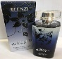
21-Feb-2023 | Romania | Perfume | Bodycare / Cosmetics | Chemical Hazard | 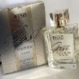
21-Feb-2023 | Romania | Perfume | Bodycare / Cosmetics | Chemical Hazard | 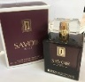
21-Feb-2023 | Romania | Children's Sports Outfit | Fabric / Textile / Garment / Home Textile | Injury Hazard, Strangulation Hazard | 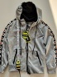  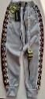
22-Feb-2023 | Italy | Pendant | Jewelry | Chemical Hazard | 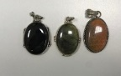
22-Feb-2023 | Latvia | Children’s Cot | Furniture | Entrapment Hazard, Injury Hazard, Suffocation Hazard | 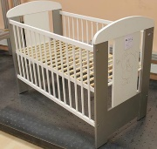
22-Feb-2023 | Italy | Children’s Dress | Fabric / Textile / Garment / Home Textile | Injury Hazard, Strangulation Hazard | 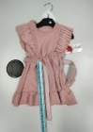
22-Feb-2023 | Italy | Children’s Dress | Fabric / Textile / Garment / Home Textile | Injury Hazard | 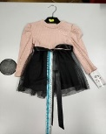
22-Feb-2023 | Italy | Children’s Shorts | Fabric / Textile / Garment / Home Textile | Injury Hazard | 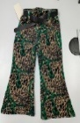
22-Feb-2023 | Italy | Children’s Shorts | Fabric / Textile / Garment / Home Textile | Injury Hazard | 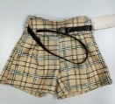
22-Feb-2023 | Italy | Children's Sweater | Fabric / Textile / Garment / Home Textile | Injury Hazard, Strangulation Hazard | 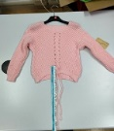
22-Feb-2023 | Italy | Children’s Dress | Fabric / Textile / Garment / Home Textile | Injury Hazard, Strangulation Hazard | 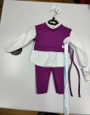
22-Feb-2023 | Italy | Children's Dress | Fabric / Textile / Garment / Home Textile | Injury Hazard | 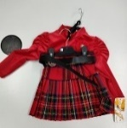
22-Feb-2023 | Sweden | Skin Lightening Cream | Bodycare / Cosmetics | Chemical Hazard | 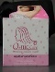
22-Feb-2023 | Romania | Hat | Fabric / Textile / Garment / Home Textile | Strangulation Hazard | 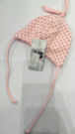
22-Feb-2023 | Italy | Necklace | Jewelry | Chemical Hazard | 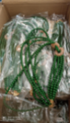
22-Feb-2023 | Italy | Hair Clip | Jewelry | Chemical Hazard | 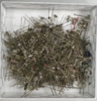
23-Feb-2023 | Luxembourg | Electric Balloon Puncher Toy | Toys and Childcare Products | Chemical Hazard | 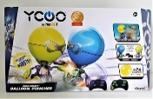
23-Feb-2023 | France | Bracelet and Earrings Set | Jewelry | Chemical Hazard | 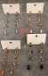  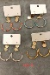  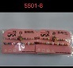
23-Feb-2023 | France | Earrings | Jewelry | Chemical Hazard | 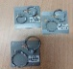  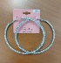  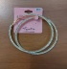
23-Feb-2023 | Germany | Circular Saw Blade | Machinery | Cut Hazard | 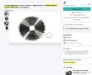
23-Feb-2023 | Germany | Circular Saw Blade | Machinery | Cut Hazard | 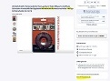
23-Feb-2023 | Germany | Circular Saw Blade | Machinery | Cut Hazard | 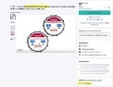
23-Feb-2023 | Germany | Circular Saw Blade | Machinery | Cut Hazard | 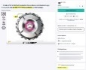
23-Feb-2023 | Latvia | Children’s Cot | Furniture | Entrapment Hazard, Injury Hazard, Suffocation Hazard | 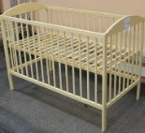
23-Feb-2023 | France | Electric Towel Dryer | Home Electrical Appliances | Fire Hazard | 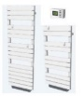
23-Feb-2023 | Latvia | Children’s Cot | Furniture | Entrapment Hazard, Injury Hazard, Suffocation Hazard | 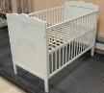
23-Feb-2023 | Finland | Gas Burner | Tools and Hardware | Burn Hazard, Fire Hazard | 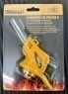
23-Feb-2023 | Latvia | Toilet Cleaning Gel | Chemicals | Chemical Hazard | 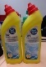
23-Feb-2023 | Italy | Bracelet | Jewelry | Chemical Hazard | 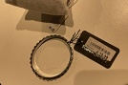
23-Feb-2023 | Italy | Flip Flops | Footwear | Chemical Hazard | 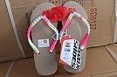
23-Feb-2023 | Italy | Flip Flops | Footwear | Chemical Hazard | 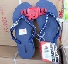
23-Feb-2023 | Italy | Flip Flops | Footwear | Chemical Hazard | 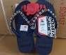
23-Feb-2023 | Germany | Baby Carrier | Toys and Childcare Products | Injury Hazard | 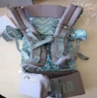
23-Feb-2023 | France | Toy Crossbow Set | Toys and Childcare Products | Injury Hazard | 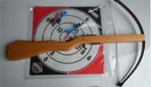
23-Feb-2023 | The Netherlands | Car Windscreen Washing Fluid | Chemicals | Chemical Hazard | 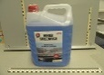
23-Feb-2023 | Germany | Laser Engraving Machine | Machinery | Damage to Sight | 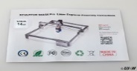  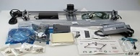
23-Feb-2023 | Finland | Soft Toy | Toys and Childcare Products | Chemical Hazard, Choking Hazard | 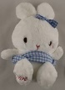
23-Feb-2023 | Finland | Soft Toy with Keychain | Toys and Childcare Products | Choking Hazard | 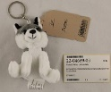
23-Feb-2023 | Finland | Soft Toy | Toys and Childcare Products | Choking Hazard
23-Feb-2023 | Greece | Training Weightlifting Gloves | Sporting Goods / Equipment | Chemical Hazard | 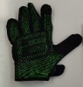  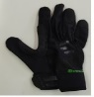
23-Feb-2023 | France | Toy Xylophone | Toys and Childcare Products | Choking Hazard | 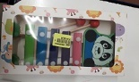
23-Feb-2023 | Greece | Plastic Doll | Toys and Childcare Products | Chemical Hazard | 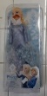
23-Feb-2023 | Greece | Plastic Doll | Toys and Childcare Products | Chemical Hazard | 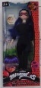
23-Feb-2023 | Greece | Bathroom Curtain | Household Items | Chemical Hazard | 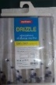
23-Feb-2023 | Lithuania | Lighting Chain | Electrical Appliances | Electric Shock Hazard | 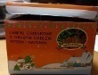  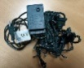
23-Feb-2023 | Romania | Children's Sports Outfit | Fabric / Textile / Garment / Home Textile | Injury Hazard, Strangulation Hazard | 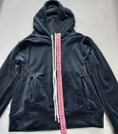  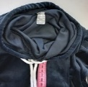  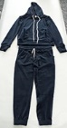
23-Feb-2023 | Finland | Soft Toy | Toys and Childcare Products | Chemical Hazard, Choking Hazard | 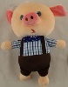
23-Feb-2023 | Finland | Soft Toy | Toys and Childcare Products | Chemical Hazard, Choking Hazard | 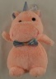
23-Feb-2023 | Poland | Toy Bow and Arrows Set | Toys and Childcare Products | Choking Hazard, Damage to Sight | 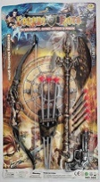
23-Feb-2023 | France | Balloon | Toys and Childcare Products | Chemical Hazard | 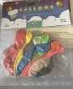
23-Feb-2023 | Italy | Corrector Pen | Stationery | Chemical Hazard | 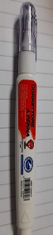
23-Feb-2023 | Malta | Fancy Dress | Fabric / Textile / Garment / Home Textile | Strangulation Hazard
23-Feb-2023 | Poland | Plastic Toy | Toys and Childcare Products | Cut Hazard | 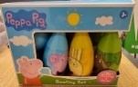  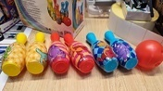
23-Feb-2023 | Belgium | Magnet Building Set | Toys and Childcare Products | Choking Hazard, Injury Hazard | 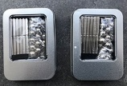  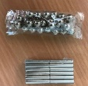
23-Feb-2023 | France | Toy Soap | Toys and Childcare Products | Choking Hazard | 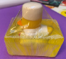  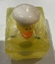  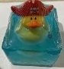
23-Feb-2023 | Lithuania | Body Cream | Bodycare / Cosmetics | Chemical Hazard | 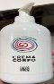
23-Feb-2023 | Finland | Gloves | Protective Equipment | Chemical Hazard | 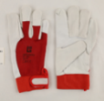
23-Feb-2023 | Finland | Gloves | Protective Equipment | Chemical Hazard | 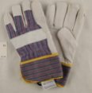
23-Feb-2023 | Sweden | Pendant | Jewelry | Chemical Hazard | 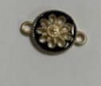
23-Feb-2023 | Sweden | Pendant | Jewelry | Chemical Hazard | 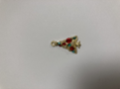
23-Feb-2023 | Sweden | Pendant | Jewelry | Chemical Hazard | 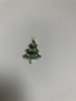
23-Feb-2023 | Sweden | Pendant | Jewelry | Chemical Hazard | 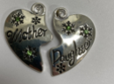
23-Feb-2023 | Sweden | Pendant | Jewelry | Chemical Hazard | 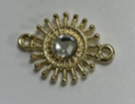
23-Feb-2023 | Sweden | Pendant | Jewelry | Chemical Hazard | 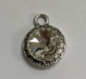
23-Feb-2023 | Germany | Motorcycle Helmet | Protective Equipment | Injury Hazard | 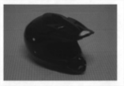
23-Feb-2023 | Sweden | Waist Jewelry | Jewelry | Chemical Hazard | 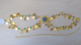  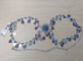
23-Feb-2023 | Germany | Chain Drive in Smoke and Heat Extraction System | Construction Products | Injury Hazard | 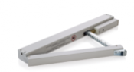
25-Feb-2023 | Czechia | Plastic Doll | Toys and Childcare Products | Chemical Hazard | 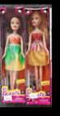
25-Feb-2023 | Lithuania | Hand Cream | Bodycare / Cosmetics | Chemical Hazard | 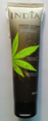
28-Feb-2023 | Sweden | Tattoo Ink | Chemicals | Chemical Hazard | 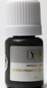
28-Feb-2023 | Sweden | Tattoo Ink | Chemicals | Chemical Hazard | 