Recall Cases Summary – US (Last Update Date: 28 February 2023)

Date | Product | Categories | Hazard | Image
2-Feb-2023 | Children’s Pajamas | Fabric / Textile / Garment / Home Textile | Burn Hazard | 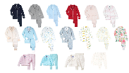  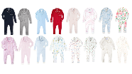
2-Feb-2023 | Children’s Robe | Fabric / Textile / Garment / Home Textile | Burn Hazard | 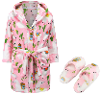  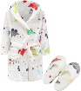  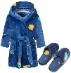  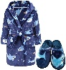  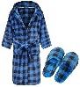
2-Feb-2023 | Children’s Robe | Fabric / Textile / Garment / Home Textile | Burn Hazard
2-Feb-2023 | Children’s Robe | Fabric / Textile / Garment / Home Textile | Burn Hazard | 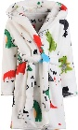  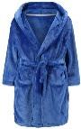  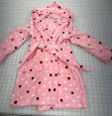
2-Feb-2023 | Children’s Robe | Fabric / Textile / Garment / Home Textile | Burn Hazard | 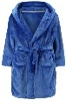  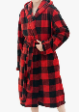  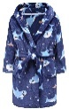  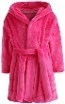  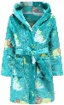  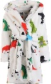
8-Feb-2023 | Fabuloso Multi-Purpose Cleaner | Chemicals | Microbiological Hazard | 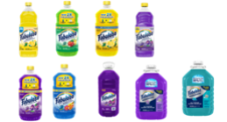
9-Feb-2023 | Ovation Protege Equestrian Helmet | Protective Equipment | Impact Hazard | 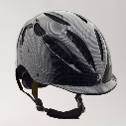
9-Feb-2023 | ODGER Swivel Chair | Furniture | Injury Hazard, Fall Hazard | 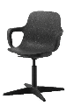
9-Feb-2023 | Silver Lining Cloud Activity Gym | Toys and Childcare Products | Choking Hazard | 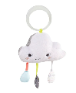  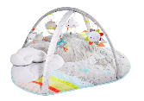
9-Feb-2023 | LiftMaster MyQ Garage Door Control Panel | Electrical Appliances | Entrapment Hazard | 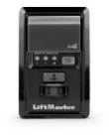
9-Feb-2023 | Baby Sleep Sack | Fabric / Textile / Garment / Home Textile | Choking Hazard | 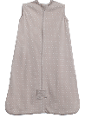  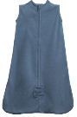  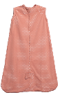
16-Feb-2023 | Electric Bicycle | Sporting Goods / Equipment | Crash Hazard | 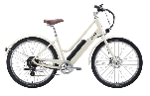  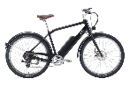
16-Feb-2023 | Wicked Lights Night Hunting Headlamp | Electrical Appliances | Burn Hazard | 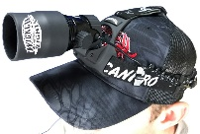
16-Feb-2023 | Children’s Nightgown | Fabric / Textile / Garment / Home Textile | Burn Hazard | 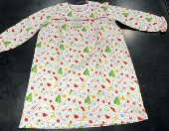
16-Feb-2023 | Children’s Pajamas | Fabric / Textile / Garment / Home Textile | Burn Hazard, Chemical Hazard | 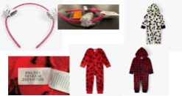
16-Feb-2023 | Children’s Nightgown | Fabric / Textile / Garment / Home Textile | Burn Hazard | 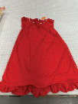
16-Feb-2023 | Outdoor Kitchen | Outdoor Living Items | Fire Hazard, Burn Hazard | 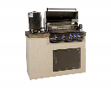  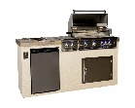  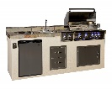  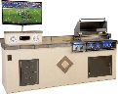  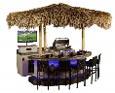  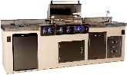  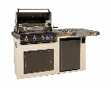
16-Feb-2023 | “My First” Disney-Character Figurine | Toys and Childcare Products | Choking Hazard
16-Feb-2023 | Backcountry Probe | Sporting Goods / Equipment | Injury Hazard | 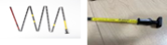
23-Feb-2023 | F1 Ski Boots | Sporting Goods / Equipment | Fall Hazard, Injury Hazard | 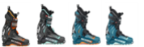
23-Feb-2023 | SmartBase Euro Slats Metal Platform Bed Frame | Furniture | Injury Hazard | 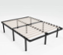
23-Feb-2023 | Air Fryer | Home Electrical Appliances | Fire Hazard, Burn Hazard | 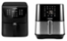  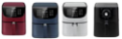
23-Feb-2023 | Replacement Lower Blade Guards for 12-Inch Chicago Electric Miter Saw | Tools and Hardware | Injury Hazard | 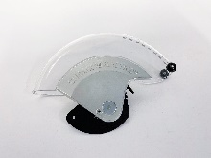
23-Feb-2023 | Timbersled Snow Bike Conversion Kit | Sporting Goods / Equipment | Crash Hazard | 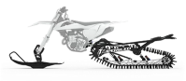  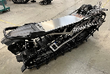
23-Feb-2023 | Bookcase | Furniture | Tip-Over Hazard, Entrapment Hazard, Injury Hazard, Death Hazard | 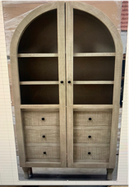
23-Feb-2023 | Lancaster Table & Seating Brand High Chair | Furniture | Fall Hazard | 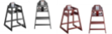  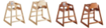
23-Feb-2023 | 1st Stage Scuba Regulator | Sporting Goods / Equipment | Injury Hazard, Drowning Hazard | 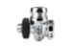  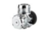
23-Feb-2023 | LumaRail Adult Portable Bed Rail | Tools and Hardware | Entrapment Hazard, Asphyxiation Hazard | 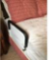
23-Feb-2023 | Mainstays Three-Wick Candle | Household Items | Fire Hazard, Laceration Hazard | 