Recall Cases Summary – Australia (Last Update Date: 31 March 2023)

Date | Product | Categories | Hazard | Image
1-Mar-2023 | DynaDrive DD60-10 and DynaDrive DD90-11 | Tools and Hardware | Electric Shock Hazard, Injury Hazard | 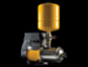
1-Mar-2023 | In-Shower Body Conditioner 400ml | Bodycare / Cosmetics | Microbiological Hazard
3-Mar-2023 | Wild Country Superlight Rock No 1-6 and Wild Country Superlight Rock Set 1-6 | Sporting Goods / Equipment | Fall Hazard, Injury Hazard | 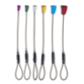
3-Mar-2023 | Enrich Timber Cleaner 2.2L | Chemicals | Burn Hazard, Damage to Sight
6-Mar-2023 | Beefeater Refrigerator | Home Electrical Appliances | Fire Hazard, Injury Hazard | 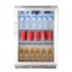  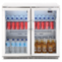
8-Mar-2023 | Nest Swing Egg Chair | Furniture | Injury Hazard | 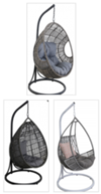
9-Mar-2023 | LED String Net Mesh Fairy Light | Electrical Appliances | Electric Shock Hazard, Injury Hazard, Fire Hazard | 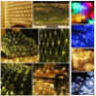
9-Mar-2023 | Black Ops Series Winch Models WN-6000, 60-WM-P-XPT-00, and WN-SOL-K | Electrical Appliances | Burn Hazard, Choking Hazard | 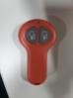
10-Mar-2023 | Skip Hop Silver Lining Cloud Activity Gym | Toys and Childcare Products | Choking Hazard, Suffocation Hazard, Injury Hazard, Death Hazard | 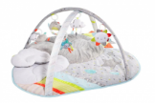  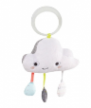
16-Mar-2023 | Heatray IRH-G 118 Overhead Radiant Heater | Home Electrical Appliances | Carbon Monoxide Poisoning Hazard, Health Risk Hazard, Injury Hazard, Death Hazard | 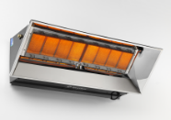  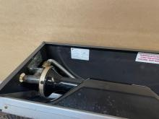
24-Mar-2023 | Nautica One Piece Swim Vest | Sporting Goods / Equipment | Drowning Hazard
24-Mar-2023 | Cooking Thermometer with Digital Display and Foldable Metal Prong | Electrical Appliances | Burn Hazard, Injury Hazard, Death Hazard, Choking Hazard | 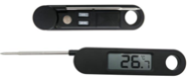
24-Mar-2023 | Adria 612PT Slider Gas Pipe | Car Components | Explosion Hazard, Fire Hazard, Injury Hazard, Burn Hazard, Death Hazard | 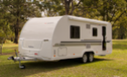
28-Mar-2023 | Bunny Cotton Rib Pyjama Set, Rib Heart Cotton Pyjama Set, Disney Bambi Cotton Rib Pyjama Set | Fabric / Textile / Garment / Home Textile | Fire Hazard | 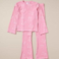
28-Mar-2023 | Toy Torch | Toys and Childcare Products | Burn Hazard, Injury Hazard, Death Hazard, Choking Hazard | 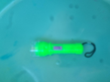
29-Mar-2023 | Kalu Cot | Furniture | Injury Hazard | 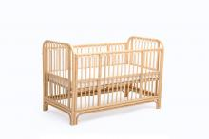
29-Mar-2023 | Boss Audio Bluetooth Soundbar BRT18A, BRT26A, BRT26RGB, BRT27A and SSL Audio Bluetooth Soundbar SB26 | Electrical Appliances | Burn Hazard, Death Hazard, Choking Hazard | 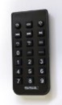  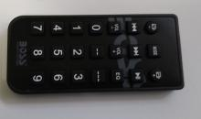
29-Mar-2023 | Fortis Shimano 7 Speed 26" Foldable Mountain Bike | Sporting Goods / Equipment | Injury Hazard, Death Hazard | 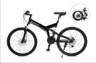
29-Mar-2023 | Bolzzen Commando 4822D | Sporting Goods / Equipment | Fall Hazard, Injury Hazard, Death Hazard | 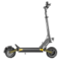
31-Mar-2023 | Cummins Marine Engine Throttle | Machinery | Injury Hazard | 