Recall Cases Summary – Canada (Last Update Date: 31 March 2023)

Date | Product | Categories | Hazard | Image
1-Mar-2023 | Falooda Drink Product | Food | Risk of Allergy | /
2-Mar-2023 | Patagonia Infant Capilene Midweight Base Layer Set | Fabric / Textile / Garment / Home Textile | Choking Hazard | 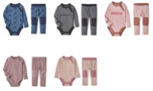
2-Mar-2023 | Anji Guotai Office Chair | Furniture | Fall Hazard | 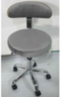
2-Mar-2023 | DR®Power PRO XL501 Chipper Shredder | Tools and Hardware | Laceration Hazard | 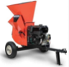
6-Mar-2023 | P. J. Salvage Children’s Pajama | Fabric / Textile / Garment / Home Textile | Burn Hazard | 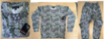  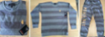
9-Mar-2023 | Pacifier and Bottle Accessory | Toys and Childcare Products | Choking Hazard | 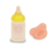
9-Mar-2023 | Hopper® M20 Soft Backpack Cooler, Hopper® M30 Soft Cooler, SideKick Dry® Gear Case | Fabric / Textile / Garment / Home Textile | Ingestion Hazard | 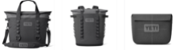
10-Mar-2023 | Fisherman's Wharf Dim Sum | Food | Risk of Allergy | 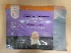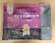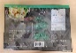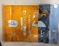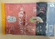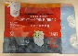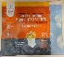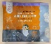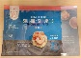
13-Mar-2023 | FRIGG Daisy Pacifier | Toys and Childcare Products | Choking hazard | 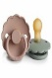  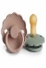  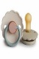  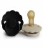  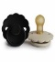  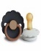  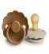  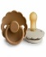  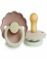  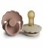  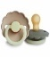  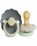
16-Mar-2023 | Sunbeam® Queen Size Heated Blanket | Home Electrical Appliances | Fire Hazard, Burn Hazard | 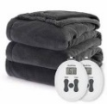
17-Mar-2023 | Bindle Bottle | Food Contact Material | Chemical Hazard | 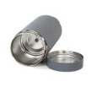  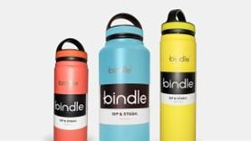
18-Mar-2023 | Nestlé Good Start - Soothe (Infant Formula) | Food | Microbiological Hazard | 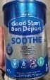
20-Mar-2023 | Chikitoe Plush Dinosaur with Rattle | Toys and Childcare Products | Choking Hazard | 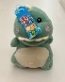  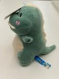
21-Mar-2023 | IKEA BLÅVINGAD Fishing Game Multicolour | Toys and Childcare Products | Choking Hazard | 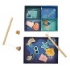
21-Mar-2023 | Frozen Pre-Fried Tempura Shrimp | Food | Risk of Allergy | /
22-Mar-2023 | Fried Fish Ball | Food | Risk of Allergy | 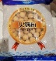
22-Mar-2023 | Carob (Drink) | Food | Microbiological Hazard
27-Mar-2023 | Jetson Electric Bikes - Nova and Star 3-Wheel Scooter | Toys and Childcare Products | Fall Hazard | 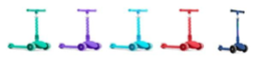
28-Mar-2023 | Wonton | Food | Risk of Allergy | 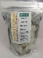  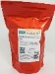
29-Mar-2023 | Bamboo Nursing Hoodie | Fabric / Textile / Garment / Home Textile | Choking Hazard | 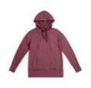  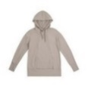
29-Mar-2023 | Various Change Table for Harmony Play & Go Playards | Furniture | Injury Hazard, Risk of Death, Entrapment Hazard | 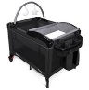  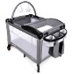  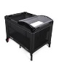  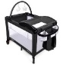
30-Mar-2023 | Battery Pack within Higdon Outdoors XS Series Motion Waterfowl Decoys and XS Replacement Battery | Electrical Appliances | Fire Hazard, Burn Hazard | 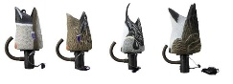  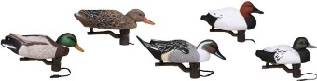  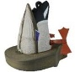  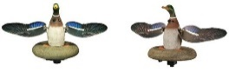
30-Mar-2023 | Seasoned Hot Pepper Sauce | Food | Microbiological Hazard | 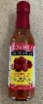
31-Mar-2023 | The Laundress Fabric Conditioner | Chemicals | Chemical Hazard | 