Recall Cases Summary – Europe (Last Update Date: 31 March 2023)

Date | Notifying Country | Product | Categories | Hazard | Image
1-Mar-2023 | Ireland | Travel Adaptor | Electrical Appliances | Electric Shock Hazard | 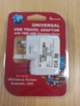
1-Mar-2023 | France | Candle | Household Items | Fire Hazard | 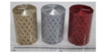
1-Mar-2023 | Germany | Sky Lantern | Outdoor Living Items | Fire Hazard
1-Mar-2023 | Poland | Plastic Toy | Toys and Childcare Products | Chemical Hazard | 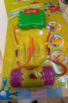
1-Mar-2023 | Germany | Baby Carrier | Toys and Childcare Products | Injury Hazard | 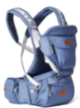
1-Mar-2023 | France | Toy Xylophone | Toys and Childcare Products | Choking Hazard | 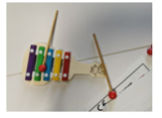
1-Mar-2023 | Estonia | Puzzle Play Mat | Toys and Childcare Products | Choking Hazard | 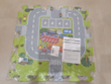
1-Mar-2023 | Austria | Children's Hooded Sweatshirt | Fabric / Textile / Garment / Home Textile | Injury Hazard, Strangulation Hazard | 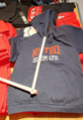
2-Mar-2023 | Poland | Pull-Along Toy | Toys and Childcare Products | Injury Hazard | 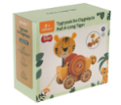
2-Mar-2023 | Ireland | Coffee Cup | Food Contact Material | Choking Hazard | 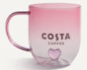
2-Mar-2023 | Hungary | Cosmetic Bag | Fabric / Textile / Garment / Home Textile | Chemical Hazard | 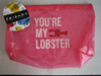
2-Mar-2023 | Hungary | Cosmetic Bag | Fabric / Textile / Garment / Home Textile | Chemical Hazard | 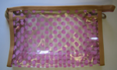
2-Mar-2023 | The Netherlands | Baby Toy | Toys and Childcare Products | Choking Hazard | 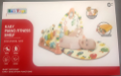
2-Mar-2023 | Ireland | Sofa/ Footstool | Furniture | Fire Hazard, Burn Hazard | 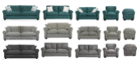
2-Mar-2023 | Hungary | Cosmetic Bag | Fabric / Textile / Garment / Home Textile | Chemical Hazard | 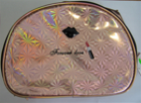
2-Mar-2023 | Hungary | Cosmetic Bag | Fabric / Textile / Garment / Home Textile | Chemical Hazard | 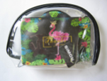
2-Mar-2023 | Sweden | Pendant | Jewelry | Chemical Hazard
2-Mar-2023 | Sweden | Pendant | Jewelry | Chemical Hazard
2-Mar-2023 | Sweden | Brooch | Jewelry | Chemical Hazard | 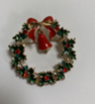
2-Mar-2023 | Germany | Circular Saw Blade | Machinery | Cut Hazard | 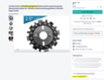
2-Mar-2023 | Germany | Circular Saw Blade | Machinery | Cut Hazard | 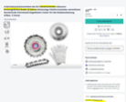
2-Mar-2023 | Germany | Circular Saw Blade | Machinery | Cut Hazard | 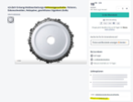
2-Mar-2023 | Germany | Circular Saw Blade | Machinery | Cut Hazard | 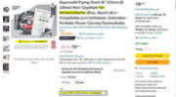
2-Mar-2023 | Germany | Circular Saw Blade | Machinery | Cut Hazard | 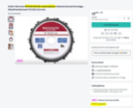
2-Mar-2023 | Germany | Circular Saw Blade | Machinery | Cut Hazard | 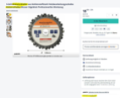
2-Mar-2023 | Germany | Circular Saw Blade | Machinery | Cut Hazard | 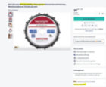
2-Mar-2023 | Germany | Circular Saw Blade | Machinery | Cut Hazard
2-Mar-2023 | Germany | Circular Saw Blade | Machinery | Cut Hazard | 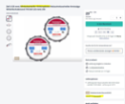
2-Mar-2023 | Germany | Circular Saw Blade | Machinery | Cut Hazard | 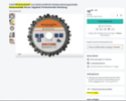
2-Mar-2023 | Germany | Circular Saw Blade | Machinery | Cut Hazard | 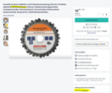
2-Mar-2023 | Germany | Circular Saw Blade | Machinery | Cut Hazard | 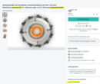
2-Mar-2023 | Germany | Circular Saw Blade | Machinery | Cut Hazard | 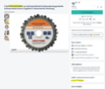
2-Mar-2023 | Germany | Circular Saw Blade | Machinery | Cut Hazard | 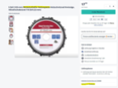
2-Mar-2023 | Germany | Circular Saw Blade | Machinery | Cut Hazard
2-Mar-2023 | Sweden | Light Sabre | Electrical Appliances | Environmental Hazard | 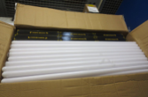
2-Mar-2023 | Sweden | Bracelet | Jewelry | Chemical Hazard | 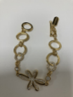
2-Mar-2023 | Italy | Hair Clip | Jewelry | Chemical Hazard | 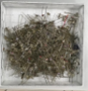
2-Mar-2023 | France | Bath Bomb | Bodycare / Cosmetics | Chemical Hazard
2-Mar-2023 | France | Finger Paint | Toys and Childcare Products | Chemical Hazard | 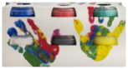
2-Mar-2023 | Romania | Perfume | Bodycare / Cosmetics | Chemical Hazard | 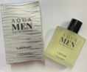
2-Mar-2023 | Romania | Perfume | Bodycare / Cosmetics | Chemical Hazard | 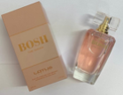
2-Mar-2023 | Germany | Sky Lantern | Outdoor Living Items | Fire Hazard | 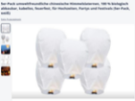
3-Mar-2023 | France | Soft Toy | Toys and Childcare Products | Strangulation Hazard
3-Mar-2023 | Germany | Circular Saw Blade | Machinery | Cut Hazard
3-Mar-2023 | Germany | Circular Saw Blade | Machinery | Cut Hazard | 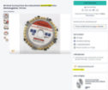
3-Mar-2023 | Sweden | Pendant | Jewelry | Chemical Hazard | 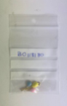
6-Mar-2023 | Romania | Perfume | Bodycare / Cosmetics | Chemical Hazard | 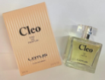
7-Mar-2023 | Italy | Hand and Nail Cream | Bodycare / Cosmetics | Chemical Hazard
7-Mar-2023 | Italy | Perfume | Bodycare / Cosmetics | Chemical Hazard | 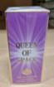
7-Mar-2023 | Hungary | Toy Telephone | Toys and Childcare Products | Damage to Hearing | 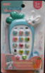
7-Mar-2023 | Hungary | Toy Rattle | Toys and Childcare Products | Choking Hazard | 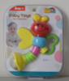
9-Mar-2023 | Sweden | Tattoo Ink | Chemicals | Chemical Hazard | 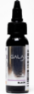
9-Mar-2023 | Germany | Particle Filter Mask | Protective Equipment | Health Risk Hazard | 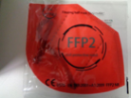
9-Mar-2023 | The Netherlands | Children's Cot | Furniture | Entrapment Hazard, Strangulation Hazard | 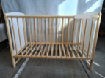
9-Mar-2023 | The Netherlands | Children's Cot | Furniture | Entrapment Hazard, Strangulation Hazard | 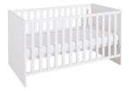
9-Mar-2023 | Poland | Toy Slime | Toys and Childcare Products | Chemical Hazard | 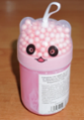
9-Mar-2023 | Poland | Toy Slime | Toys and Childcare Products | Chemical Hazard | 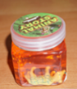
9-Mar-2023 | Bulgaria | Pushchair | Toys and Childcare Products | Injury Hazard | 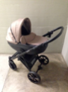
9-Mar-2023 | Bulgaria | Pushchair | Toys and Childcare Products | Injury Hazard | 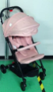
9-Mar-2023 | Sweden | Particle Filter Mask | Protective Equipment | Health Risk Hazard | 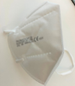
9-Mar-2023 | Denmark | Toy Gun | Toys and Childcare Products | Damage to Hearing
9-Mar-2023 | Germany | Particle Filter Mask | Protective Equipment | Health Risk Hazard | 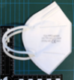
9-Mar-2023 | Poland | Toy Slime | Toys and Childcare Products | Chemical Hazard | 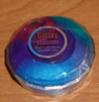
9-Mar-2023 | Poland | Toy Slime | Toys and Childcare Products | Chemical Hazard | 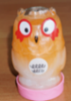
9-Mar-2023 | Poland | Toy Slime | Toys and Childcare Products | Chemical Hazard | 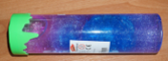
9-Mar-2023 | Poland | Toy Slime | Toys and Childcare Products | Chemical Hazard | 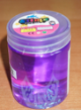
9-Mar-2023 | Germany | Necklace and Bracelet Set | Jewelry | Chemical Hazard
9-Mar-2023 | Germany | Brooch | Jewelry | Chemical Hazard | 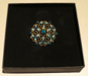
9-Mar-2023 | Belgium | Children's Dress | Fabric / Textile / Garment / Home Textile | Injury Hazard, Strangulation Hazard | 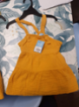
9-Mar-2023 | France | Toy Crossbow | Toys and Childcare Products | Injury Hazard, Suffocation Hazard | 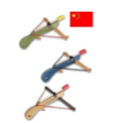
9-Mar-2023 | Germany | Travel Adaptor | Electrical Appliances | Electric Shock Hazard | 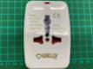
9-Mar-2023 | Malta | USB Charger | Electrical Appliances | Fire Hazard | 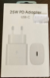
9-Mar-2023 | France | Rice Cooker | Home Electrical Appliances | Electric Shock Hazard, Burn Hazard | 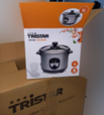
9-Mar-2023 | Romania | Puffer Toy | Toys and Childcare Products | Choking Hazard | 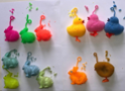
9-Mar-2023 | Ireland | Wooden Xylophone | Toys and Childcare Products | Choking Hazard | 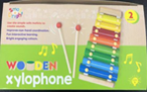
9-Mar-2023 | Czechia | Plastic Doll | Toys and Childcare Products | Chemical Hazard | 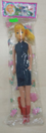
9-Mar-2023 | Bulgaria | Pushchair | Toys and Childcare Products | Injury Hazard | 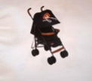
9-Mar-2023 | Poland | Plastic Rattle | Toys and Childcare Products | Choking Hazard | 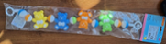
9-Mar-2023 | Poland | Plastic Rattle | Toys and Childcare Products | Choking Hazard | 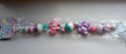
9-Mar-2023 | Italy | Children's Jacket | Fabric / Textile / Garment / Home Textile | Injury Hazard | 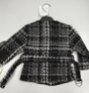
9-Mar-2023 | Italy | Hair Dryer | Home Electrical Appliances | Electric Shock Hazard, Burn Hazard, Fire Hazard | 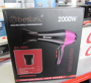
9-Mar-2023 | Bulgaria | Baby Pushchair | Toys and Childcare Products | Injury Hazard
9-Mar-2023 | Italy | Spray Deodorant | Bodycare / Cosmetics | Chemical Hazard | 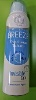
9-Mar-2023 | Italy | Spray Deodorant | Bodycare / Cosmetics | Chemical Hazard | 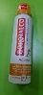  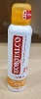
9-Mar-2023 | Italy | Deodorant | Bodycare / Cosmetics | Chemical Hazard | 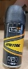
9-Mar-2023 | Italy | Deodorant Spray | Bodycare / Cosmetics | Chemical Hazard | 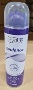
9-Mar-2023 | Italy | Shampoo | Bodycare / Cosmetics | Chemical Hazard | 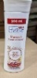
9-Mar-2023 | Italy | Liquid Soap | Bodycare / Cosmetics | Chemical Hazard | 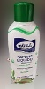
9-Mar-2023 | France | Toy Gun | Toys and Childcare Products | Injury Hazard | 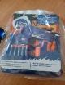
9-Mar-2023 | Romania | Baby Hat | Fabric / Textile / Garment / Home Textile | Strangulation Hazard | 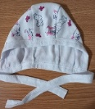
9-Mar-2023 | Lithuania | Eyebrow Epilator | Electrical Appliances | Environmental Hazard | 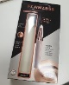
10-Mar-2023 | France | Paint for Miniature | Chemicals | Chemical Hazard | 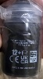  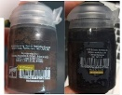
14-Mar-2023 | Ireland | Dental Bleaching System | Bodycare / Cosmetics | Chemical Hazard | 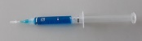  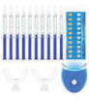
14-Mar-2023 | Germany | Slippers | Footwear | Chemical Hazard | 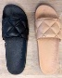  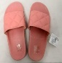  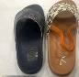
14-Mar-2023 | Sweden | Jewelry Pendant Balloon | Jewelry | Chemical Hazard | 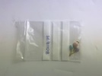
14-Mar-2023 | Belgium | Children's Hoodie | Fabric / Textile / Garment / Home Textile | Strangulation Hazard | 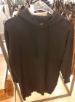
14-Mar-2023 | Poland | Toy Slime | Toys and Childcare Products | Chemical Hazard | 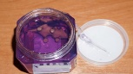  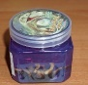
14-Mar-2023 | Belgium | Children's Hoodie | Fabric / Textile / Garment / Home Textile | Strangulation Hazard | 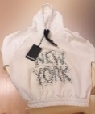
15-Mar-2023 | Italy | Liquid Soap | Bodycare / Cosmetics | Chemical Hazard | 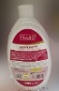
15-Mar-2023 | Germany | Earrings | Jewelry | Chemical Hazard | 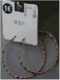
16-Mar-2023 | Ireland | Teeth Whitening Pen | Bodycare / Cosmetics | Chemical Hazard | 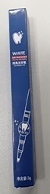
16-Mar-2023 | Italy | Children's Jumper | Fabric / Textile / Garment / Home Textile | Chemical Hazard | 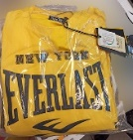  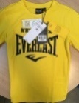
16-Mar-2023 | Germany | Necklace with Pendant | Jewelry | Chemical Hazard | 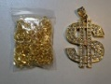
16-Mar-2023 | Germany | Necklace with Pendant | Jewelry | Chemical Hazard | 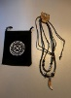
16-Mar-2023 | Germany | Concrete Screw | Tools and Hardware | Injury Hazard
16-Mar-2023 | Italy | Roll-On Deodorant | Bodycare / Cosmetics | Chemical Hazard | 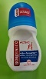
16-Mar-2023 | Ireland | Mirrored Bathroom Cabinet | Furniture | Cut Hazard, Injury Hazard | 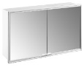
16-Mar-2023 | Germany | Baby Carrier | Toys and Childcare Products | Injury Hazard | 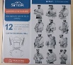
16-Mar-2023 | Austria | Children's Trousers | Fabric / Textile / Garment / Home Textile | Injury Hazard | 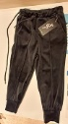
16-Mar-2023 | Austria | Children's Trousers | Fabric / Textile / Garment / Home Textile | Injury Hazard | 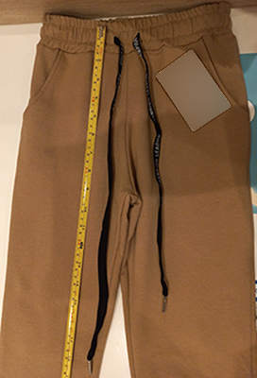
16-Mar-2023 | Cyprus | Universal Travel Adaptor | Electrical Appliances | Electric Shock Hazard | 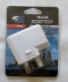
16-Mar-2023 | France | Wooden Toy | Toys and Childcare Products | Choking Hazard | 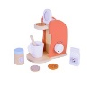
16-Mar-2023 | France | Activity Cube Toy | Toys and Childcare Products | Injury Hazard | 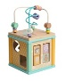
16-Mar-2023 | Cyprus | Travel Adaptor | Electrical Appliances | Electric Shock Hazard | 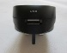  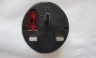  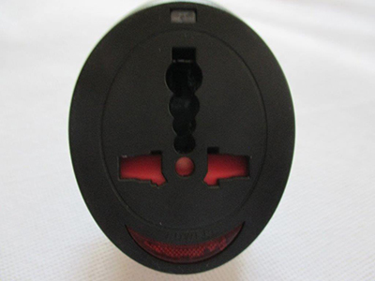
16-Mar-2023 | Hungary | Aroma Diffuser | Home Electrical Appliances | Electric Shock Hazard, Microbiological Hazard
16-Mar-2023 | Germany | Portable Gas Stove | Outdoor Living Items | Burn Hazard
16-Mar-2023 | Poland | Toy Slime | Toys and Childcare Products | Chemical Hazard | 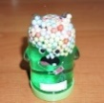
16-Mar-2023 | Poland | Toy Slime | Toys and Childcare Products | Chemical Hazard | 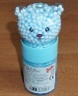
16-Mar-2023 | Belgium | Children's Hoodie | Fabric / Textile / Garment / Home Textile | Strangulation Hazard | 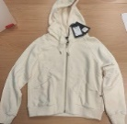
16-Mar-2023 | Belgium | Fireworks | Outdoor Living Items | Burn Hazard, Damage to Hearing | 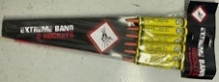
16-Mar-2023 | Romania | Children's Jacket | Fabric / Textile / Garment / Home Textile | Choking Hazard | 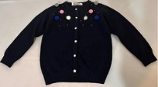
16-Mar-2023 | Sweden | Radio-Controlled Snake Toy | Toys and Childcare Products | Environmental Hazard | 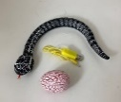
16-Mar-2023 | Cyprus | Plastic Doll | Toys and Childcare Products | Chemical Hazard
16-Mar-2023 | Poland | Toy Slime | Toys and Childcare Products | Chemical Hazard | 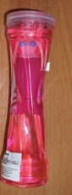
16-Mar-2023 | Poland | Toy Slime | Toys and Childcare Products | Chemical Hazard | 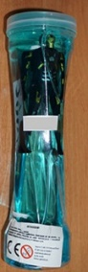
16-Mar-2023 | Poland | Toy Slime | Toys and Childcare Products | Chemical Hazard | 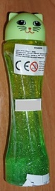
16-Mar-2023 | Poland | Toy Slime | Toys and Childcare Products | Chemical Hazard | 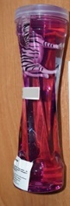
16-Mar-2023 | Poland | Toy Slime | Toys and Childcare Products | Chemical Hazard | 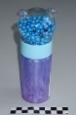
16-Mar-2023 | Poland | Toy Slime | Toys and Childcare Products | Chemical Hazard | 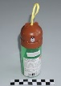
16-Mar-2023 | Cyprus | Doll Set | Toys and Childcare Products | Chemical Hazard | 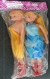
16-Mar-2023 | Germany | Earrings | Jewelry | Chemical Hazard | 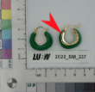
16-Mar-2023 | Cyprus | Children's Dress | Fabric / Textile / Garment / Home Textile | Injury Hazard | 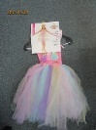
16-Mar-2023 | Estonia | Set of Earrings | Jewelry | Chemical Hazard | 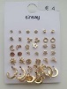
20-Mar-2023 | Greece | Lighting Chain | Electrical Appliances | Electric Shock Hazard, Fire Hazard | 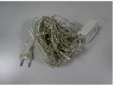  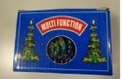
20-Mar-2023 | Bulgaria | Girls Leggings | Fabric / Textile / Garment / Home Textile | Choking Hazard | 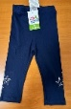  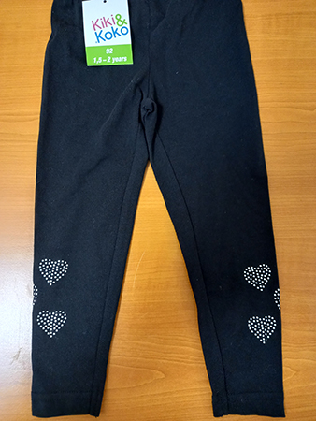
20-Mar-2023 | Germany | Chain with Pendant | Jewelry | Chemical Hazard | 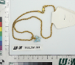  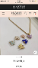  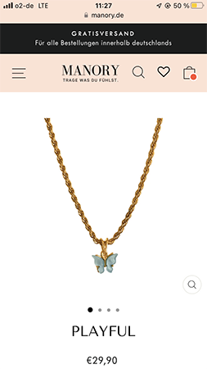
21-Mar-2023 | Germany | Leather Belt | Fabric / Textile / Garment / Home Textile | Chemical Hazard | 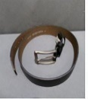
21-Mar-2023 | Sweden | Breath Alcohol Tester AT6000 | Electrical Appliances | Environmental Hazard | 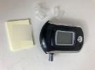
22-Mar-2023 | Latvia | Stroller | Toys and Childcare Products | Injury Hazard | 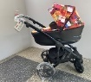
22-Mar-2023 | Ireland | Skin Lightening Lotion | Bodycare / Cosmetics | Chemical Hazard | 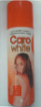
22-Mar-2023 | Ireland | Skin Lightening Oil | Bodycare / Cosmetics | Chemical Hazard | 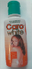
22-Mar-2023 | Cyprus | Jewelry Set | Jewelry | Chemical Hazard | 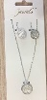
22-Mar-2023 | Czechia | Aftershave | Bodycare / Cosmetics | Chemical Hazard | 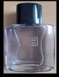
22-Mar-2023 | Czechia | Plastic Doll | Toys and Childcare Products | Chemical Hazard | 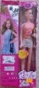
22-Mar-2023 | Czechia | Disposable Electronic Cigarette | Chemicals | Chemical Hazard | 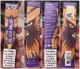  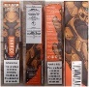
22-Mar-2023 | Belgium | Children's Shorts | Fabric / Textile / Garment / Home Textile | Injury Hazard | 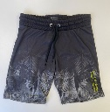
22-Mar-2023 | Romania | Children's Hat | Fabric / Textile / Garment / Home Textile | Strangulation Hazard | 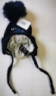  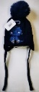
23-Mar-2023 | Germany | Car Wheel | Car Components | Injury Hazard | 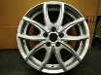  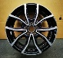  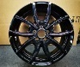
23-Mar-2023 | Germany | Pest Control Product | Chemicals | Chemical Hazard | 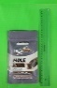
23-Mar-2023 | Italy | Hair Shampoo | Bodycare / Cosmetics | Chemical Hazard | 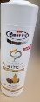
23-Mar-2023 | France | Safety Footwear | Footwear | Injury Hazard | 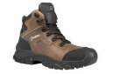
23-Mar-2023 | Norway | Electric Scooter for Children | Toys and Childcare Products | Injury Hazard | 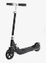  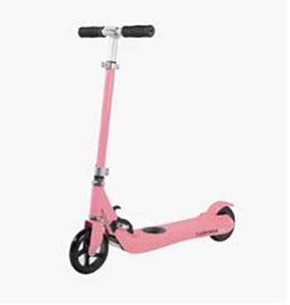
23-Mar-2023 | Cyprus | LED Light | Electrical Appliances | Electric Shock Hazard | 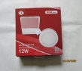  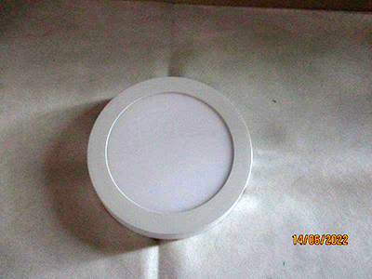
23-Mar-2023 | Denmark | Magnetic Toy Set | Toys and Childcare Products | Injury Hazard | 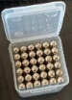  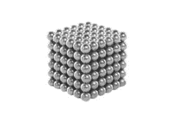
23-Mar-2023 | Greece | Lighting Chain | Electrical Appliances | Electric Shock Hazard, Fire Hazard | 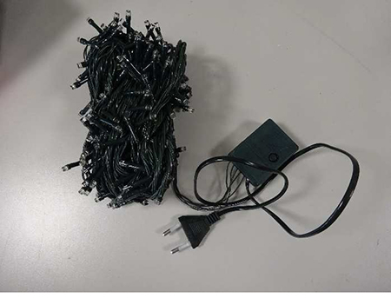
23-Mar-2023 | Greece | Lighting Chain | Electrical Appliances | Electric Shock Hazard, Fire Hazard | 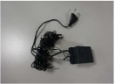
23-Mar-2023 | Sweden | Plastic Toy | Toys and Childcare Products | Chemical Hazard | 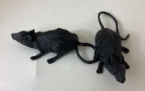
23-Mar-2023 | Austria | Portable Fan | Electrical Appliances | Burn Hazard | 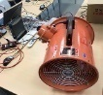
23-Mar-2023 | France | Children's Jacket | Fabric / Textile / Garment / Home Textile | Injury Hazard, Strangulation Hazard | 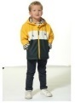
23-Mar-2023 | Bulgaria | Pushchair | Toys and Childcare Products | Injury Hazard | 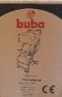
23-Mar-2023 | Bulgaria | Baby Pushchair | Toys and Childcare Products | Injury Hazard
23-Mar-2023 | Poland | Plastic Toy | Toys and Childcare Products | Cut Hazard | 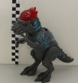
23-Mar-2023 | Czechia | T-Shirt | Fabric / Textile / Garment / Home Textile | Chemical Hazard | 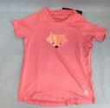
23-Mar-2023 | Bulgaria | Combination Pushchair | Toys and Childcare Products | Injury Hazard | 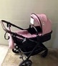
23-Mar-2023 | Belgium | Children's Shorts | Fabric / Textile / Garment / Home Textile | Injury Hazard | 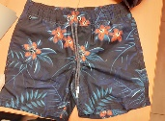
23-Mar-2023 | Belgium | Children's Shorts | Fabric / Textile / Garment / Home Textile | Injury Hazard | 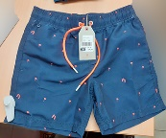
23-Mar-2023 | Poland | Climbing Chock | Sporting Goods / Equipment | Injury Hazard | 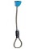  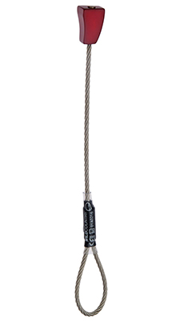
23-Mar-2023 | Germany | Necklace with Pendant | Jewelry | Chemical Hazard | 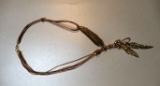
24-Mar-2023 | France | Glue | Chemicals | Chemical Hazard | 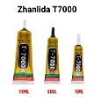  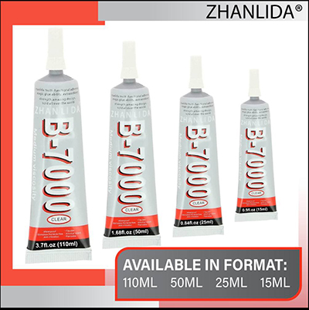
24-Mar-2023 | Luxembourg | Magnetic Toy Set | Toys and Childcare Products | Choking Hazard, Injury Hazard | 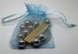
24-Mar-2023 | Czechia | Plastic Doll | Toys and Childcare Products | Chemical Hazard | 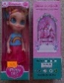
24-Mar-2023 | Sweden | Tattoo Ink | Chemicals | Chemical Hazard | 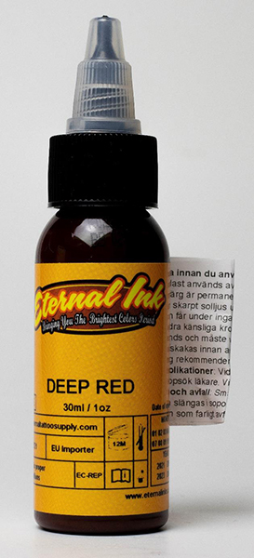
27-Mar-2023 | Austria | Electric Shoe Dryer | Electrical Appliances | Electric Shock Hazard | 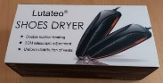
28-Mar-2023 | Germany | Earrings | Jewelry | Chemical Hazard | 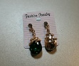
28-Mar-2023 | Sweden | Humidifier | Electrical Appliances | Environmental Hazard | 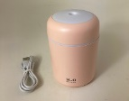
28-Mar-2023 | Sweden | Plastic Doll | Toys and Childcare Products | Chemical Hazard, Environmental Hazard | 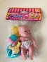
28-Mar-2023 | Sweden | LED Projector | Electrical Appliances | Chemical Hazard, Environmental Hazard | 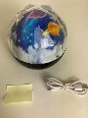
28-Mar-2023 | Sweden | Plastic Doll | Toys and Childcare Products | Chemical Hazard, Environmental Hazard | 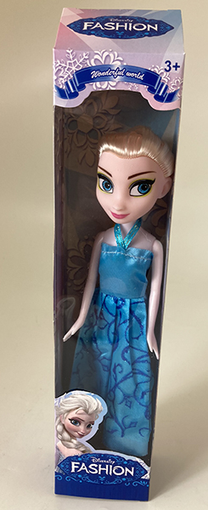
30-Mar-2023 | Finland | Wedge Splitter Machine | Machinery | Electric Shock Hazard | 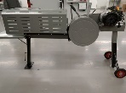
30-Mar-2023 | France | Motorcycle Jack | Machinery | Injury Hazard | 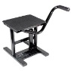
30-Mar-2023 | France | Wedge Splitter Machine | Machinery | Injury Hazard | 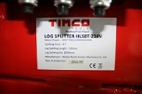
30-Mar-2023 | France | Ride-On Toy for Babies | Toys and Childcare Products | Entrapment Hazard, Injury Hazard | 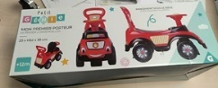
30-Mar-2023 | Germany | Lighting Chain | Electrical Appliances | Electric Shock Hazard | 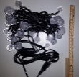
30-Mar-2023 | Ireland | Sofa | Furniture | Fire Hazard | 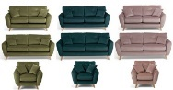
30-Mar-2023 | Ireland | Sofa/Footstool | Furniture | Fire Hazard | 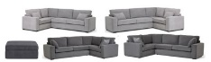
30-Mar-2023 | Ireland | Sofa | Furniture | Fire Hazard | 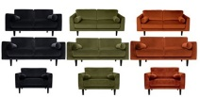
30-Mar-2023 | Cyprus | Children's Dress | Fabric / Textile / Garment / Home Textile | Injury Hazard | 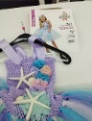
30-Mar-2023 | Cyprus | USB Charger | Electrical Appliances | Electric Shock Hazard | 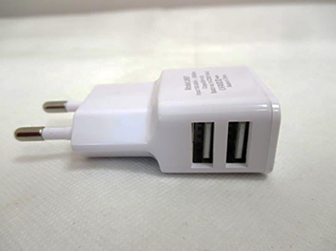
30-Mar-2023 | Slovenia | Bathing Seat for Children | Furniture | Injury Hazard | 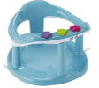
30-Mar-2023 | Germany | Jewelry Set | Jewelry | Chemical Hazard | 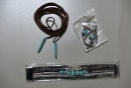
30-Mar-2023 | Lithuania | Plastic Doll | Toys and Childcare Products | Chemical Hazard | 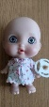
30-Mar-2023 | France | Air Freshener | Chemicals | Chemical Hazard | 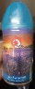
30-Mar-2023 | Estonia | Jewelry Set | Jewelry | Chemical Hazard | 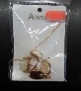
30-Mar-2023 | Estonia | Earrings | Jewelry | Chemical Hazard | 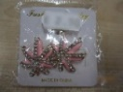
30-Mar-2023 | Sweden | Plastic Duck | Toys and Childcare Products | Chemical Hazard | 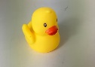
30-Mar-2023 | Finland | Lighting Chain | Electrical Appliances | Electric Shock Hazard | 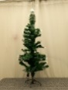
30-Mar-2023 | Sweden | Plastic Toy | Toys and Childcare Products | Chemical Hazard | 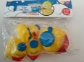
30-Mar-2023 | Sweden | Toy Camera | Toys and Childcare Products | Environmental Hazard | 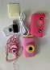
30-Mar-2023 | Sweden | Toy Phone | Toys and Childcare Products | Environmental Hazard | 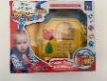
30-Mar-2023 | Sweden | Slime | Toys and Childcare Products | Chemical Hazard | 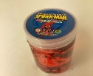
30-Mar-2023 | Sweden | Toy Bus | Toys and Childcare Products | Chemical Hazard | 