Recall Cases Summary – US (Last Update Date: 31 March 2023)

Date | Product | Categories | Hazard | Image
2-Mar-2023 | Office Chair | Furniture | Fall Hazard | 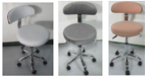
2-Mar-2023 | Infant Capilene Midweight Base Layer Set | Fabric / Textile / Garment / Home Textile | Choking Hazard | 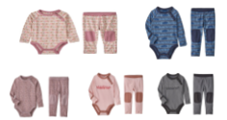
2-Mar-2023 | Children’s Bamboo Plate | Food Contact Material | Health Risk Hazard | 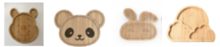
2-Mar-2023 | RELiON InSight Series® Lithium Battery | Electrical Appliances | Burn Hazard, Fire Hazard
2-Mar-2023 | Adult Workwear Sweatshirt and Hoodie | Fabric / Textile / Garment / Home Textile | Burn Hazard | 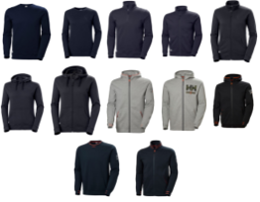
2-Mar-2023 | Classic Whimsy Children’s Pajama | Fabric / Textile / Garment / Home Textile | Burn Hazard | 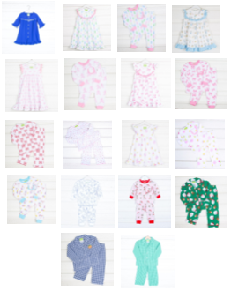
2-Mar-2023 | Multi-Purpose Kids Bike Helmet | Sporting Goods / Equipment | Injury Hazard | 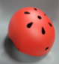
2-Mar-2023 | CTRL Imperial Wakeboard Binding | Footwear | Fall Hazard | 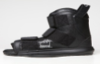
2-Mar-2023 | DR®Power PRO XL501 Chipper Shredder | Tools and Hardware | Laceration Hazard | 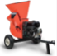
9-Mar-2023 | YETI Soft Cooler and Gear Case | Fabric / Textile / Garment / Home Textile | Ingestion Hazard | 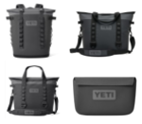
9-Mar-2023 | Aprepitant Capsule and Lidocaine and Prilocaine Cream | Pharmacy | Poisoning Hazard | 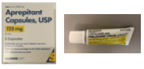
9-Mar-2023 | SRTH Small Room Tower Heater | Home Electrical Appliances | Fire Hazard | 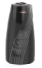
9-Mar-2023 | Kindred Bravely Bamboo Nursing Hoodie | Fabric / Textile / Garment / Home Textile | Choking Hazard | 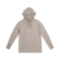
9-Mar-2023 | Calico Critters® Animal Figure and Set Sold with Bottle and Pacifier Accessory | Toys and Childcare Products | Choking Hazard
9-Mar-2023 | Bedsure Electric Heating Blanket and Pad | Home Electrical Appliances | Fire Hazard, Burn Hazard | 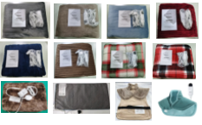
9-Mar-2023 | Pure Outdoor Cooking System | Outdoor Living Items | Fire Hazard | 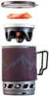
9-Mar-2023 | Baby Crib Bumper | Toys and Childcare Products | Suffocation Hazard | 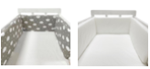
9-Mar-2023 | Anker 535 Power Bank (PowerCore 20k) | Electrical Appliances | Fire Hazard
9-Mar-2023 | Vaunn Medical Bed Assist Rail Adult Bed Rail | Tools and Hardware | Entrapment Hazard, Asphyxiation Hazard
16-Mar-2023 | Nurtec® ODT (Rimegepant) Orally Disintegrating Tablet, 75mg 8-Unit Dose Blister Pack | Pharmacy | Poisoning Hazard | 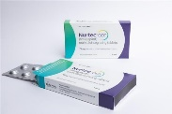  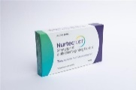
16-Mar-2023 | Ecoxall Sodium and Potassium Hydroxide | Chemicals | Burn Hazard, Skin Irritation Risk, Eye Irritation Risk | 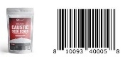  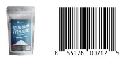
16-Mar-2023 | Fredericksburg Farms 10 Ounce Scented Candle with Glass Lid | Household Items | Laceration Hazard
16-Mar-2023 | Sunbeam® Queen Size Heated Blanket | Home Electrical Appliances | Burn Hazard, Fire Hazard | 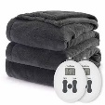
16-Mar-2023 | STIHL Docking Station Sold with STIHL iMOW® Robotic Lawn Mower | Electrical Appliances | Fire Hazard | 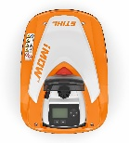  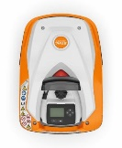
16-Mar-2023 | IKEA LETTAN Mirror | Household Items | Laceration Hazard
17-Mar-2023 | Mockingbird Single Stroller | Toys and Childcare Products | Fall Hazard | 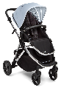
23-Mar-2023 | Kawasaki FT730V-EFI Lawn Mower Engine | Tools and Hardware | Burn Hazard, Fire Hazard | 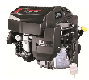  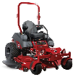  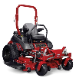  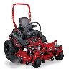  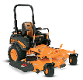  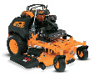
23-Mar-2023 | Burnham Commercial Natural Gas Boiler | Machinery | Burn Hazard | 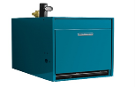  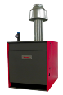
30-Mar-2023 | Battery Pack and Replacement Battery on XS Series Pulsators, Swimmers, Crazy Kicker, and Flasher Motion Decoy Used for Waterfowl Hunting | Outdoor Living Items | Fire Hazard, Burn Hazard | 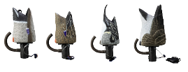  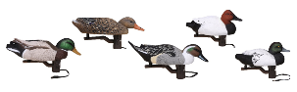  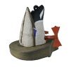  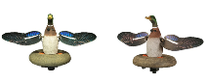
30-Mar-2023 | STYLR Hair Styler | Electrical Appliances | Electric Shock Hazard | 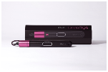  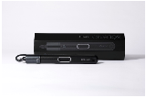
30-Mar-2023 | Carhartt Men’s Force Relaxed 5 Pocket Work Pants | Fabric / Textile / Garment / Home Textile | Fall Hazard | 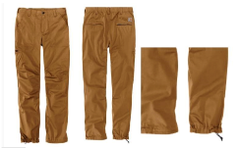
30-Mar-2023 | Open Cycle UP Ekar, UPPER Ekar, WIDE Ekar and MIND Ekar Bicycle | Sporting Goods / Equipment | Crash Hazard | 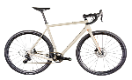  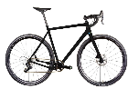  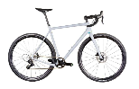
30-Mar-2023 | Cannondale Tesoro Neo X Speed Electric Bicycle | Sporting Goods / Equipment | Fall Hazard, Injury Hazard | 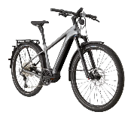
30-Mar-2023 | Adult Bike Helmet | Protective Equipment | Injury Hazard | 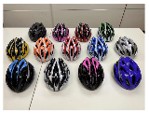
30-Mar-2023 | 2-In-1 Outdoor Kids Swing | Toys and Childcare Products | Fall Hazard | 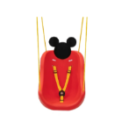  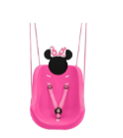  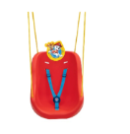
30-Mar-2023 | 42-Volt Rogue Self-Balancing Scooter/  Hoverboard | Sporting Goods / Equipment | Fire Hazard | 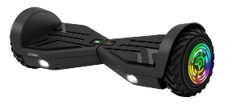
31-Mar-2023 | The Laundress Fabric Conditioner | Chemicals | Chemical Hazard | 