Recall Cases Summary – Australia (Last Update Date: 30 April 2023)

Date | Product | Categories | Hazard | Image
5-Apr-2023 | Jacuzzi Hot Tub — Jacuzzi J-200, J-300, J-400 and J-500 Collection Hot Tub | Home Electrical Appliances | Burn Hazard, Health Risk Hazard | 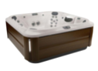
5-Apr-2023 | Battery Operated Flameless Tea Light | Electrical Appliances | Burn Hazard, Health Risk Hazard, Risk of Death, Choking Hazard | 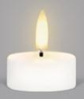
19-Apr-2023 | Cordless Wet Dry Vacuum Floor Cleaner | Home Electrical Appliances | Fire Hazard, Burn Hazard, Injury Hazard | 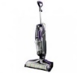
19-Apr-2023 | LED Tealight Candle - Multiple Pack Size | Electrical Appliances | Burn Hazard, Injury Hazard, Risk of Death, Choking Hazard | 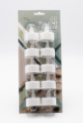  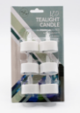  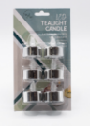  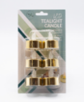
19-Apr-2023 | UEBE Domotherm Rapid REF0830 | Electrical Appliances | Burn Hazard, Injury Hazard, Risk of Death | 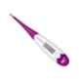
20-Apr-2023 | Ducati DesesrtX Side Luggage | Travel Items | Fire Hazard | 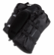
20-Apr-2023 | 50A Quad-Connect for 12V Batteries | Electrical Appliances | Burn Hazard, Fire Hazard, Injury Hazard | 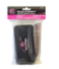  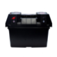
20-Apr-2023 | Mon Chateau Comfort Gel Mat | Fabric / Textile / Garment / Home Textile | Injury Hazard
21-Apr-2023 | 500ml Essential Oil Distillation Kit | Tools and Hardware | Health Risk Hazard | 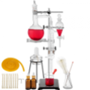
21-Apr-2023 | 360 Degree Camera Remote Control | Electrical Appliances | Choking Hazard, Burn Hazard, Risk of Death | 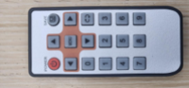
21-Apr-2023 | Furrion Entertainment System DV5700 & DV3300S Remote Control | Electrical Appliances | Choking Hazard, Burn Hazard, Risk of Death | 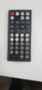  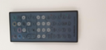
21-Apr-2023 | Bayer B15A20 Heavy Duty 240V 15A 20m Extension Lead | Electrical Appliances | Injury Hazard | 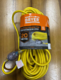
24-Apr-2023 | ANKO Kids Digital Watch | Computer / Audio / Video / Other Electronics & Accessories | Choking Hazard, Burn Hazard, Risk of Death | 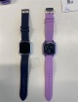
28-Apr-2023 | Wooden Baby Rattle | Toys and Childcare Products | Choking Hazard, Suffocation Hazard, Injury Hazard, Risk of Death | 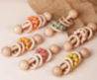
28-Apr-2023 | GS Optimus 3 Ton and 6 Ton Car Stand | Tools and Hardware | Injury Hazard, Risk of Death | 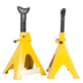
28-Apr-2023 | Michigan 25L/min Flowmeter Argon Single Gauge | Tools and Hardware | Injury Hazard | 