Recall Cases Summary – Canada (Last Update Date: 30 April 2023)

Date | Product | Categories | Hazard | Image
1-Apr-2023 | 60% Dark Chocolate with Hazelnut | Food | Risk of Allergy | 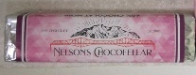
1-Apr-2023 | Chopped Sesame Wonton Salad Kit | Food | Risk of Allergy | /
3-Apr-2023 | Great Pretenders Easter Bunny Necklace | Jewelry | Chemical Hazard | 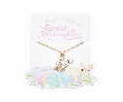
3-Apr-2023 | Sunter Rechargeable LED Vanity Mirror | Home Electrical Appliances | Fire Hazard | 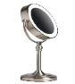  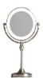
3-Apr-2023 | MAG-N-5-SPHERE | Toys and Childcare Products | Swallowing Risk, Injury Hazard
4-Apr-2023 | Hot Focus Petite Boutique Tie-Dye Butterfly, Rainbow and Glow In The Dark Children’s Jewelry Set | Jewelry | Chemical Hazard | 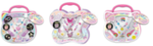
4-Apr-2023 | Kool Charmz Colors Strawberry, Heart & Arrow, and Apple Interchangeable Charm | Jewelry | Chemical Hazard | 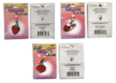
6-Apr-2023 | Dark Chocolate Product | Food | Risk of Allergy | 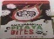  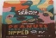  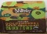  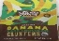
6-Apr-2023 | Orange Dark Chocolate | Food | Risk of Allergy | /
7-Apr-2023 | Dark Chocolate Bar | Food | Risk of Allergy | 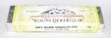  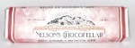
7-Apr-2023 | Plant-Based Schnitzel | Food | Risk of Allergy | 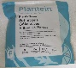
7-Apr-2023 | Bed Rail | Tools and Hardware | Entrapment Hazard, Asphyxiation Hazard | 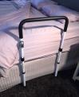
13-Apr-2023 | Audiovisual Cart | Tools and Hardware | Tip-Over Hazard | 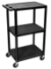  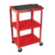
13-Apr-2023 | Flo Smart Water Lithium Ion Battery Backup | Electrical Appliances | Fire Hazard | 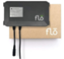
13-Apr-2023 | Great Pretenders Boutique Butterfly Jewel Necklace | Jewelry | Chemical Hazard
14-Apr-2023 | Dark Chocolate Product | Food | Risk of Allergy | 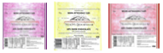
18-Apr-2023 | Angus Beef Burger | Food | Risk of Allergy | /
20-Apr-2023 | Stanley FATMAX and DEWALT Fiberglass Sledgehammer | Tools and Hardware | Injury Hazard | 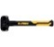  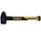  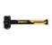  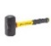  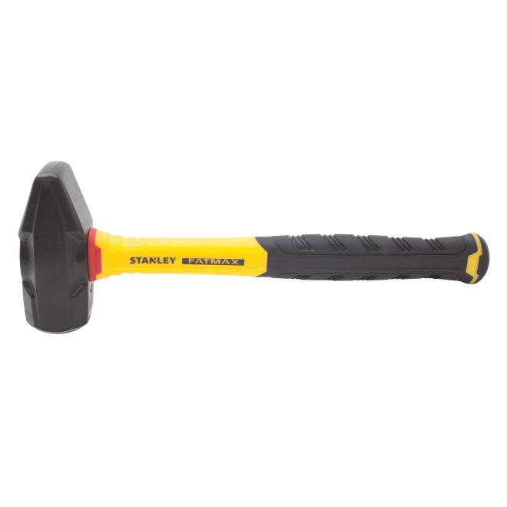  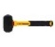  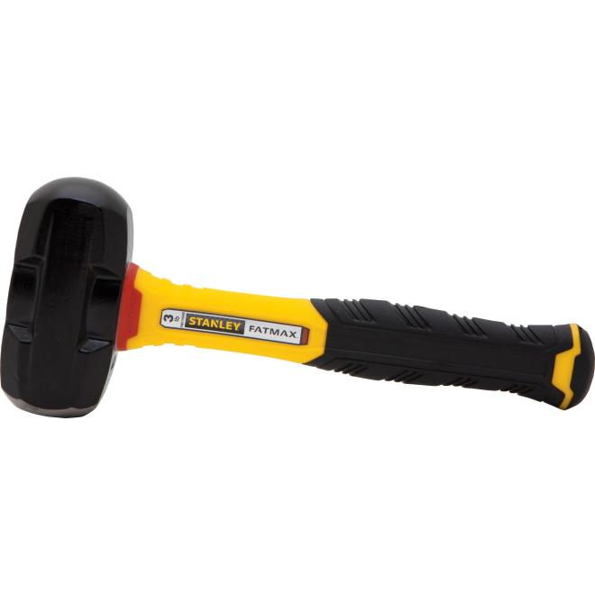  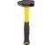  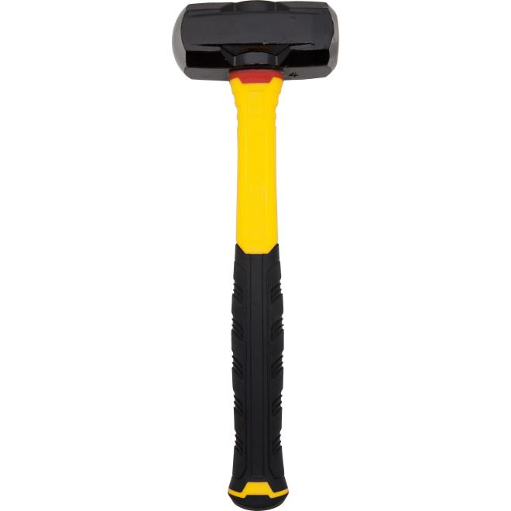  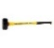  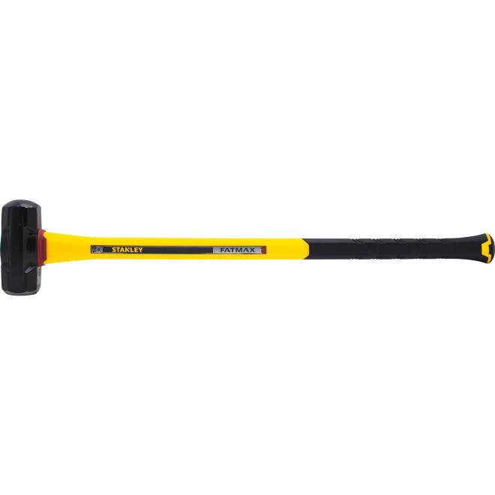
20-Apr-2023 | Kid Casters Children’s Fishing Rod | Tools and Hardware | Chemical Hazard | 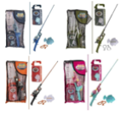
21-Apr-2023 | Boosh Brand Coconut Curry Cauli Bowl | Food | Risk of Allergy | 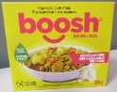
26-Apr-2023 | White and Natural Crib | Furniture | Entrapment Hazard, Injury Hazard | 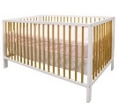
26-Apr-2023 | Kalon Studios Caravan Crib | Furniture | Entrapment Hazard, Injury Hazard
27-Apr-2023 | Certain Steamfast Brand Lightweight Handheld Home and Away Travel Steam Iron Model | Electrical Appliances | Fire Hazard, Burn Hazard, Electric Shock Hazard | 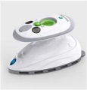
27-Apr-2023 | Black Diamond Equipment Recon LT Avalanche Transceiver | Electrical Appliances | Safety Risk Hazard | 