Recall Cases Summary – Europe (Last Update Date: 30 April 2023)

Date | Notifying Country | Product | Categories | Hazard | Image
3-Apr-2023 | Germany | Children’s Ring | Jewelry | Chemical Hazard | 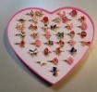
3-Apr-2023 | Germany | Earrings | Jewelry | Chemical Hazard | 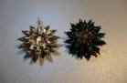
3-Apr-2023 | Germany | Jewelry Set | Jewelry | Chemical Hazard | /
3-Apr-2023 | Germany | Anklet | Jewelry | Chemical Hazard | 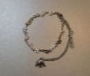
3-Apr-2023 | Germany | Bracelet | Jewelry | Chemical Hazard | 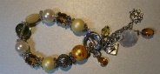
3-Apr-2023 | Germany | Advent Calendar | Jewelry | Chemical Hazard | 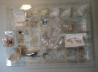
4-Apr-2023 | Ireland | Travel Adaptor | Electrical Appliances | Electric Shock Hazard | 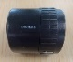
4-Apr-2023 | France | Glue | Chemicals | Chemical Hazard | 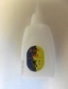
4-Apr-2023 | Sweden | Toy Pony | Toys and Childcare Products | Chemical Hazard | 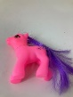
4-Apr-2023 | Romania | Children's Hoodie | Fabric / Textile / Garment / Home Textile | Injury Hazard, Strangulation Hazard | 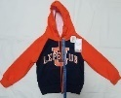  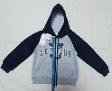
4-Apr-2023 | Romania | Children's Sports Outfit | Fabric / Textile / Garment / Home Textile | Injury Hazard, Strangulation Hazard | 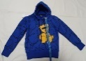  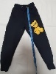
4-Apr-2023 | Romania | Face Cream | Bodycare / Cosmetics | Chemical Hazard | 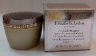
4-Apr-2023 | Romania | Soap | Bodycare / Cosmetics | Chemical Hazard | 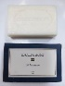
4-Apr-2023 | Italy | Cream Soap | Bodycare / Cosmetics | Chemical Hazard | 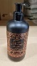
4-Apr-2023 | France | Plastic Doll | Toys and Childcare Products | Chemical Hazard | 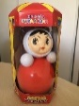
4-Apr-2023 | Romania | Immersion Heater | Electrical Appliances | Burn Hazard, Electric Shock Hazard | 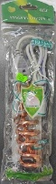
5-Apr-2023 | France | Folding Playpen | Toys and Childcare Products | Entrapment Hazard, Strangulation Hazard | 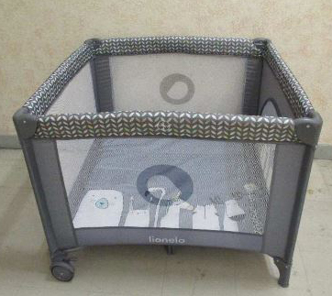
5-Apr-2023 | France | Wreath with Candle | Household Items | Fire Hazard | 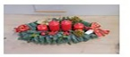
5-Apr-2023 | Austria | Exhaust Fan | Electrical Appliances | Electric Shock Hazard | 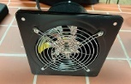
5-Apr-2023 | Germany | Advent Calendar | Jewelry | Chemical Hazard | 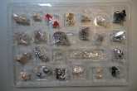
5-Apr-2023 | Malta | Pushchair | Toys and Childcare Products | Cut Hazard, Injury Hazard | 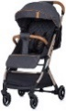
5-Apr-2023 | Germany | Jewelry Set | Jewelry | Chemical Hazard | 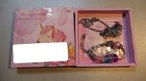
5-Apr-2023 | Germany | Pendant | Jewelry | Chemical Hazard | 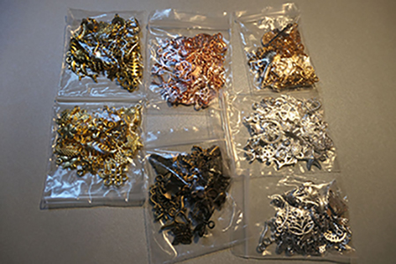
5-Apr-2023 | Slovenia | Children's Bathing Seat | Toys and Childcare Products | Choking Hazard, Injury Hazard | 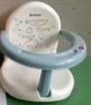
5-Apr-2023 | Slovenia | Mini Chainsaw | Machinery | Cut Hazard, Injury Hazard | 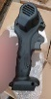  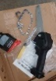
5-Apr-2023 | Bulgaria | Electrical Plug Cover | Electrical Appliances | Burn Hazard, Electric Shock Hazard, Fire Hazard | 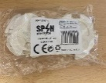
5-Apr-2023 | Finland | Plastic Toy | Toys and Childcare Products | Chemical Hazard
5-Apr-2023 | Sweden | Bluetooth Speaker | Computer / Audio / Video / Other Electronics & Accessories | Chemical Hazard, Environmental Hazard | 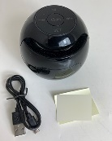
5-Apr-2023 | Sweden | Flexible LED Light | Electrical Appliances | Environmental Hazard | 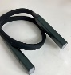
5-Apr-2023 | Sweden | Kids Piano | Toys and Childcare Products | Chemical Hazard, Environmental Hazard | 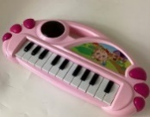
5-Apr-2023 | Poland | Plastic Ball | Toys and Childcare Products | Choking Hazard | 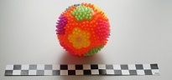
5-Apr-2023 | Hungary | Glass-Ceramic Cook Top | Home Electrical Appliances | Burn Hazard | 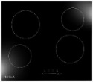
5-Apr-2023 | Sweden | Toy Bow | Toys and Childcare Products | Chemical Hazard | 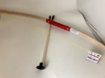
5-Apr-2023 | Slovakia | Plastic Doll | Toys and Childcare Products | Chemical Hazard | 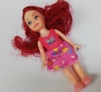
5-Apr-2023 | Romania | Soft Toy | Toys and Childcare Products | Choking Hazard | 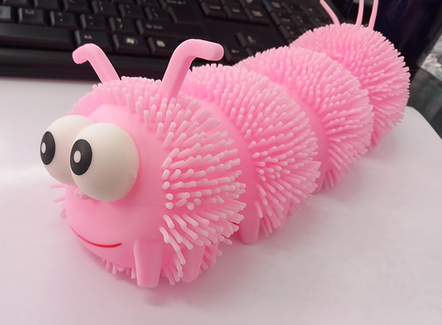
5-Apr-2023 | Croatia | Pushchair | Toys and Childcare Products | Injury Hazard | 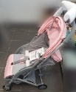
5-Apr-2023 | Belgium | Magnetic Toy Set | Toys and Childcare Products | Choking Hazard, Injury Hazard | 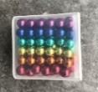
5-Apr-2023 | Romania | Babies' Dress | Fabric / Textile / Garment / Home Textile | Choking Hazard, Injury Hazard | 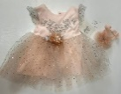
5-Apr-2023 | Romania | Children's Bonnet | Fabric / Textile / Garment / Home Textile | Strangulation Hazard | 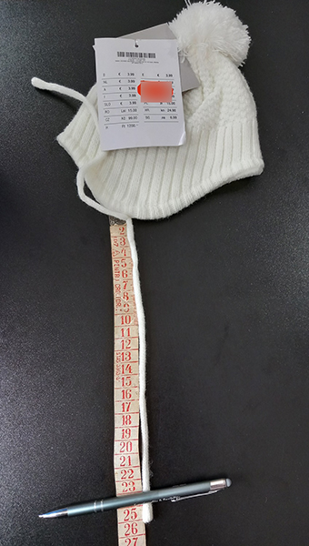  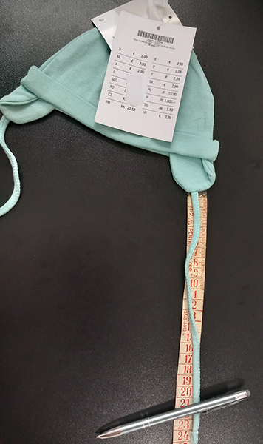
5-Apr-2023 | Sweden | Toy Dinosaur | Toys and Childcare Products | Chemical Hazard, Environmental Hazard | 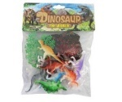
5-Apr-2023 | Romania | Perfume | Bodycare / Cosmetics | Chemical Hazard | 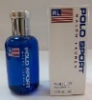
5-Apr-2023 | Hungary | Electric Scooter | Sporting Goods / Equipment | Burn Hazard, Fire Hazard, Injury Hazard | 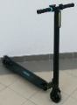
5-Apr-2023 | Hungary | Extension Lead | Electrical Appliances | Burn Hazard, Fire Hazard | 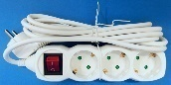
5-Apr-2023 | Hungary | Extension Lead | Electrical Appliances | Burn Hazard, Fire Hazard | 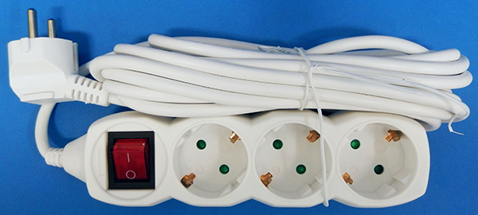
5-Apr-2023 | Sweden | Inflatable Floating Ring | Sporting Goods / Equipment | Chemical Hazard | 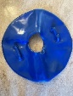
5-Apr-2023 | Germany | Necklace | Jewelry | Chemical Hazard
5-Apr-2023 | Germany | Necklace | Jewelry | Chemical Hazard | 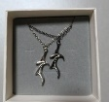
5-Apr-2023 | Germany | Necklace | Jewelry | Chemical Hazard | 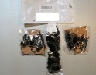
5-Apr-2023 | Czechia | USB Charger | Electrical Appliances | Electric Shock Hazard | 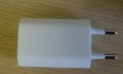
5-Apr-2023 | Romania | Children's Clothing | Fabric / Textile / Garment / Home Textile | Injury Hazard, Strangulation Hazard | 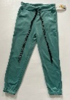  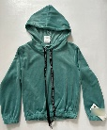
5-Apr-2023 | Romania | Perfume | Bodycare / Cosmetics | Chemical Hazard | 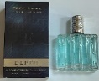
5-Apr-2023 | Romania | Perfume | Bodycare / Cosmetics | Chemical Hazard | 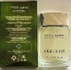
5-Apr-2023 | Romania | Face Serum | Bodycare / Cosmetics | Chemical Hazard | 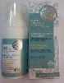
5-Apr-2023 | Romania | Face Serum | Bodycare / Cosmetics | Chemical Hazard | 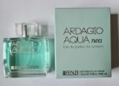
11-Apr-2023 | Italy | Liquid Hand Soap | Bodycare / Cosmetics | Chemical Hazard | 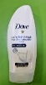
11-Apr-2023 | Italy | Eau De Toilette | Bodycare / Cosmetics | Chemical Hazard
11-Apr-2023 | Italy | Eau De Toilette | Bodycare / Cosmetics | Chemical Hazard | 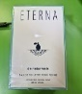
11-Apr-2023 | Italy | Eau De Toilette | Bodycare / Cosmetics | Chemical Hazard | 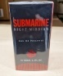
11-Apr-2023 | Italy | Face Cream | Bodycare / Cosmetics | Chemical Hazard | 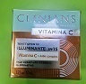
11-Apr-2023 | Italy | Hand Soap | Bodycare / Cosmetics | Chemical Hazard | 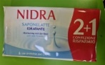
11-Apr-2023 | Italy | Children's Trousers | Fabric / Textile / Garment / Home Textile | Injury Hazard | 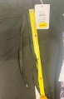
11-Apr-2023 | Italy | Spray Deodorant | Bodycare / Cosmetics | Chemical Hazard | 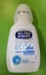
11-Apr-2023 | Italy | Sweatshirt | Fabric / Textile / Garment / Home Textile | Strangulation Hazard | 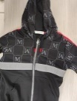
11-Apr-2023 | Italy | Children's Sweatshirt | Fabric / Textile / Garment / Home Textile | Strangulation Hazard | 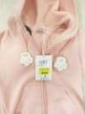
11-Apr-2023 | Italy | Hooded Sweatshirt | Fabric / Textile / Garment / Home Textile | Injury Hazard, Strangulation Hazard | 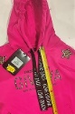
11-Apr-2023 | Italy | Shoes | Footwear | Chemical Hazard | 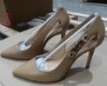
11-Apr-2023 | Italy | Summer Shoes | Footwear | Chemical Hazard
11-Apr-2023 | Italy | Shoes | Footwear | Chemical Hazard | 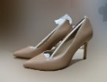
11-Apr-2023 | Italy | Children's Sweatshirt | Fabric / Textile / Garment / Home Textile | Injury Hazard, Strangulation Hazard | 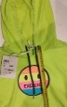
11-Apr-2023 | Italy | Children's Trousers | Fabric / Textile / Garment / Home Textile | Injury Hazard | 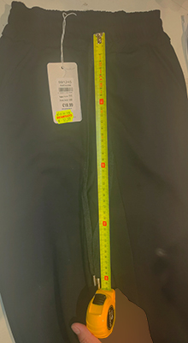
11-Apr-2023 | Italy | Hand Soap | Bodycare / Cosmetics | Chemical Hazard
11-Apr-2023 | Italy | Shampoo | Bodycare / Cosmetics | Chemical Hazard | 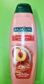
11-Apr-2023 | Italy | Fortifying Cream Conditioner | Bodycare / Cosmetics | Chemical Hazard | 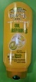
11-Apr-2023 | Italy | Shower Gel | Bodycare / Cosmetics | Chemical Hazard | 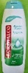
11-Apr-2023 | Italy | Liquid Soap | Bodycare / Cosmetics | Chemical Hazard | 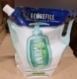
11-Apr-2023 | Italy | Eau De Toilette | Bodycare / Cosmetics | Chemical Hazard | 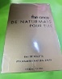
11-Apr-2023 | Italy | Deodorant Spray | Bodycare / Cosmetics | Chemical Hazard | 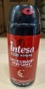
11-Apr-2023 | Italy | Hair Spray | Bodycare / Cosmetics | Chemical Hazard | 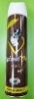
11-Apr-2023 | Italy | Deodorant Spray | Bodycare / Cosmetics | Chemical Hazard | 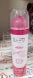
11-Apr-2023 | Italy | Skin Lightening Cream | Bodycare / Cosmetics | Chemical Hazard | 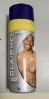
11-Apr-2023 | Italy | Deodorant Spray | Bodycare / Cosmetics | Chemical Hazard | 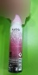
11-Apr-2023 | Italy | Skin Lightening Cream | Bodycare / Cosmetics | Chemical Hazard | 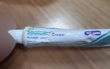
11-Apr-2023 | Italy | Children's Sweatshirt | Fabric / Textile / Garment / Home Textile | Injury Hazard, Strangulation Hazard | 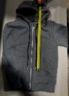
11-Apr-2023 | Ireland | Travel Adaptor | Electrical Appliances | Electric Shock Hazard | 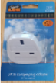
11-Apr-2023 | Poland | Soft Toy | Toys and Childcare Products | Damage to Hearing | 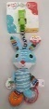
11-Apr-2023 | Germany | Hair Dye | Bodycare / Cosmetics | Chemical Hazard | 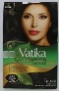
11-Apr-2023 | Romania | Eau De Toilette | Bodycare / Cosmetics | Chemical Hazard | 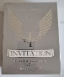
11-Apr-2023 | Romania | Perfume | Bodycare / Cosmetics | Chemical Hazard | 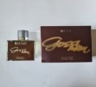
11-Apr-2023 | Czechia | Lighting Chain | Electrical Appliances | Electric Shock Hazard | 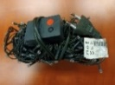
11-Apr-2023 | France | Eau De Parfum | Bodycare / Cosmetics | Chemical Hazard | 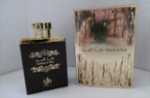
11-Apr-2023 | Italy | Aftershave | Bodycare / Cosmetics | Chemical Hazard | 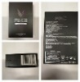
11-Apr-2023 | Italy | Aftershave | Bodycare / Cosmetics | Chemical Hazard | 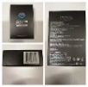
11-Apr-2023 | Italy | Anti-Age Cream | Bodycare / Cosmetics | Chemical Hazard | 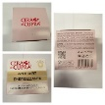
11-Apr-2023 | Italy | Anti-Age Cream | Bodycare / Cosmetics | Chemical Hazard | 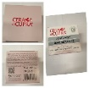
11-Apr-2023 | Italy | Deodorant | Bodycare / Cosmetics | Chemical Hazard | 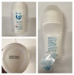
11-Apr-2023 | Romania | After Shave | Bodycare / Cosmetics | Chemical Hazard | 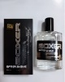
11-Apr-2023 | Romania | Hand Cream | Bodycare / Cosmetics | Chemical Hazard | 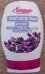
11-Apr-2023 | Romania | Hand Cream | Bodycare / Cosmetics | Chemical Hazard
11-Apr-2023 | Romania | Soap | Bodycare / Cosmetics | Chemical Hazard | 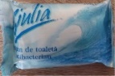
11-Apr-2023 | Romania | Children's Bonnet | Fabric / Textile / Garment / Home Textile | Strangulation Hazard | 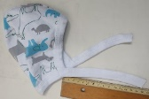
11-Apr-2023 | Sweden | Tattoo Ink | Chemicals | Chemical Hazard | 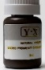
11-Apr-2023 | Romania | Children's Hat | Fabric / Textile / Garment / Home Textile | Choking Hazard | 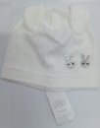
11-Apr-2023 | Czechia | Eau De Toilette | Bodycare / Cosmetics | Chemical Hazard | 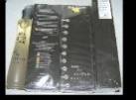
11-Apr-2023 | Romania | Children's Hat | Fabric / Textile / Garment / Home Textile | Choking Hazard, Strangulation Hazard | 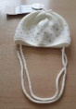
12-Apr-2023 | Italy | Pushchair | Toys and Childcare Products | Choking Hazard, Injury Hazard, Suffocation Hazard | 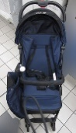
12-Apr-2023 | Italy | Hooded Sweatshirt | Fabric / Textile / Garment / Home Textile | Injury Hazard, Strangulation Hazard | 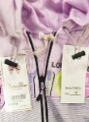
12-Apr-2023 | Italy | Children's Tracksuit | Fabric / Textile / Garment / Home Textile | Injury Hazard | 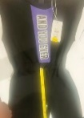
12-Apr-2023 | Italy | Shampoo | Bodycare / Cosmetics | Chemical Hazard | 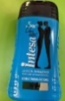
12-Apr-2023 | Italy | Bath and Shower Cream | Bodycare / Cosmetics | Chemical Hazard | 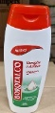
12-Apr-2023 | Germany | Halloween Mask | Toys and Childcare Products | Chemical Hazard | 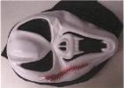
13-Apr-2023 | Italy | Skin Cream | Bodycare / Cosmetics | Chemical Hazard | 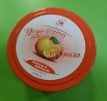
13-Apr-2023 | Italy | Shampoo | Bodycare / Cosmetics | Chemical Hazard | 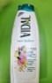
13-Apr-2023 | Italy | Tracksuit | Fabric / Textile / Garment / Home Textile | Injury Hazard, Strangulation Hazard | 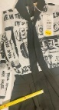
13-Apr-2023 | Italy | Children's Sweatshirt | Fabric / Textile / Garment / Home Textile | Injury Hazard, Strangulation Hazard | 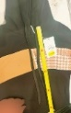
13-Apr-2023 | Italy | Hooded Sweatshirt | Fabric / Textile / Garment / Home Textile | Injury Hazard, Strangulation Hazard | 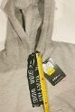
13-Apr-2023 | Italy | Children's Trousers | Fabric / Textile / Garment / Home Textile | Injury Hazard | 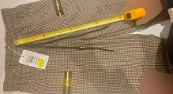
13-Apr-2023 | Italy | Children's Trousers | Fabric / Textile / Garment / Home Textile | Injury Hazard | 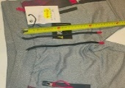
13-Apr-2023 | Italy | Children's Trousers | Fabric / Textile / Garment / Home Textile | Injury Hazard | 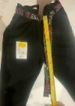
13-Apr-2023 | Italy | Children's Trousers | Fabric / Textile / Garment / Home Textile | Injury Hazard | 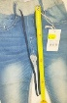
13-Apr-2023 | Italy | Children's Trousers | Fabric / Textile / Garment / Home Textile | Injury Hazard | 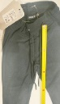
13-Apr-2023 | Italy | Children's Trousers | Fabric / Textile / Garment / Home Textile | Injury Hazard | 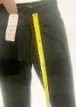
13-Apr-2023 | Italy | Glasses Case | Accessories | Chemical Hazard | 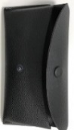
13-Apr-2023 | Italy | Children’s Jacket | Fabric / Textile / Garment / Home Textile | Injury Hazard, Strangulation Hazard | 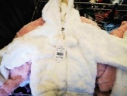
13-Apr-2023 | Germany | Wooden Toy | Toys and Childcare Products | Choking Hazard | 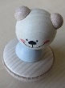
13-Apr-2023 | Italy | Children's Sweatshirt | Fabric / Textile / Garment / Home Textile | Strangulation Hazard | 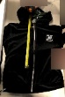
13-Apr-2023 | Romania | Perfume | Bodycare / Cosmetics | Chemical Hazard | 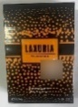
13-Apr-2023 | Germany | Compressed Air Breather | Protective Equipment | Suffocation Hazard | 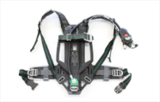
13-Apr-2023 | Finland | Children´s Shoes | Footwear | Chemical Hazard | 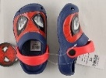
13-Apr-2023 | Croatia | Baby Pushchair | Toys and Childcare Products | Injury Hazard | 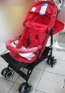
13-Apr-2023 | Czechia | Lighting Chain | Electrical Appliances | Electric Shock Hazard | 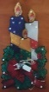
13-Apr-2023 | Romania | Hair Fixing Spray | Bodycare / Cosmetics | Chemical Hazard | 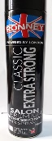
13-Apr-2023 | Czechia | Plastic Doll | Toys and Childcare Products | Chemical Hazard | 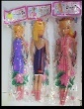
13-Apr-2023 | Germany | Vehicle Part / Replacement Wheel | Car Components | Injury Hazard | 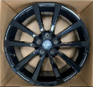
13-Apr-2023 | Romania | Perfume | Bodycare / Cosmetics | Chemical Hazard | 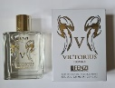
13-Apr-2023 | Romania | Perfume | Bodycare / Cosmetics | Chemical Hazard | 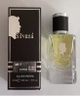
13-Apr-2023 | Romania | Deodorant Spray | Bodycare / Cosmetics | Chemical Hazard | 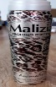
13-Apr-2023 | Romania | Beauty Set | Bodycare / Cosmetics | Chemical Hazard | 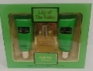  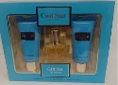
13-Apr-2023 | Romania | Beauty Set | Bodycare / Cosmetics | Chemical Hazard | 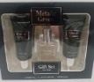  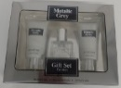
13-Apr-2023 | Romania | Perfume | Bodycare / Cosmetics | Chemical Hazard | 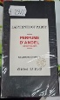
13-Apr-2023 | Romania | Children's Shoes | Footwear | Choking Hazard | 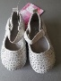
13-Apr-2023 | Romania | Children's Sweater | Fabric / Textile / Garment / Home Textile | Choking Hazard | 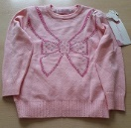
13-Apr-2023 | Romania | Liquid Hand Wash | Bodycare / Cosmetics | Chemical Hazard | 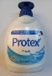
13-Apr-2023 | Sweden | LED Headlamp | Electrical Appliances | Chemical Hazard, Environmental Hazard | 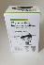
14-Apr-2023 | Italy | Children's Sweater | Fabric / Textile / Garment / Home Textile | Injury Hazard, Strangulation Hazard | 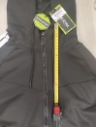
14-Apr-2023 | Italy | Children's Sweatshirt | Fabric / Textile / Garment / Home Textile | Injury Hazard, Strangulation Hazard | 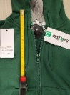
14-Apr-2023 | Italy | Children's Sweatpants | Fabric / Textile / Garment / Home Textile | Injury Hazard | 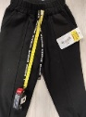
14-Apr-2023 | Italy | Children's Sweatpants | Fabric / Textile / Garment / Home Textile | Injury Hazard | 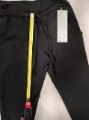
14-Apr-2023 | Germany | Bracelet | Jewelry | Chemical Hazard | 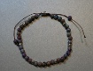
14-Apr-2023 | Italy | Shampoo | Bodycare / Cosmetics | Chemical Hazard | 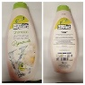
14-Apr-2023 | Poland | Luminaire | Electrical Appliances | Electric Shock Hazard | 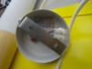
14-Apr-2023 | Romania | Perfume | Bodycare / Cosmetics | Chemical Hazard | 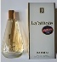
14-Apr-2023 | Romania | Perfume | Bodycare / Cosmetics | Chemical Hazard | 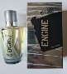
14-Apr-2023 | Sweden | Rubber Duck | Toys and Childcare Products | Environmental Hazard | 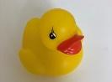
17-Apr-2023 | Italy | Sweatsuit | Fabric / Textile / Garment / Home Textile | Injury Hazard, Strangulation Hazard | 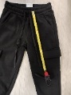
17-Apr-2023 | Italy | Sweatpants | Fabric / Textile / Garment / Home Textile | Injury Hazard | 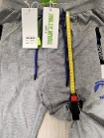
17-Apr-2023 | Italy | Sweatshirt | Fabric / Textile / Garment / Home Textile | Injury Hazard, Strangulation Hazard | 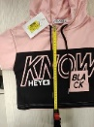
17-Apr-2023 | Italy | Trousers | Fabric / Textile / Garment / Home Textile | Injury Hazard | 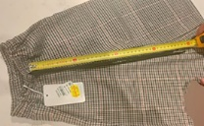
17-Apr-2023 | Italy | Hooded Sweatshirt | Fabric / Textile / Garment / Home Textile | Injury Hazard, Strangulation Hazard | 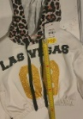
17-Apr-2023 | Italy | Trousers | Fabric / Textile / Garment / Home Textile | Injury Hazard | 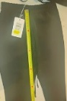
17-Apr-2023 | Italy | Sweatshirt | Fabric / Textile / Garment / Home Textile | Injury Hazard, Strangulation Hazard | 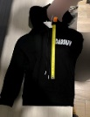
17-Apr-2023 | Italy | Sweatshirt | Fabric / Textile / Garment / Home Textile | Injury Hazard, Strangulation Hazard | 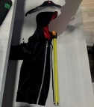
17-Apr-2023 | Italy | Sweatpants | Fabric / Textile / Garment / Home Textile | Injury Hazard | 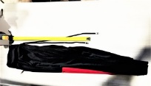
17-Apr-2023 | France | Children’s Hoodie | Fabric / Textile / Garment / Home Textile | Injury Hazard, Strangulation Hazard | 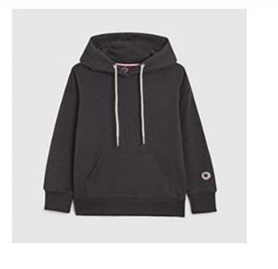  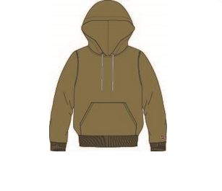  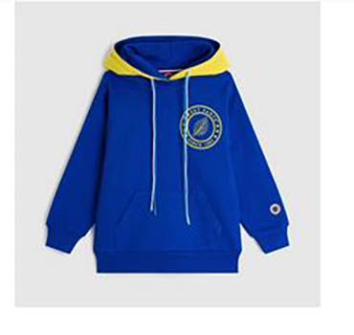  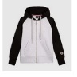  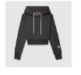
18-Apr-2023 | Italy | Paint | Chemicals | Chemical Hazard | 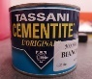
18-Apr-2023 | Germany | Jewelry Set | Jewelry | Chemical Hazard | 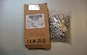
18-Apr-2023 | Germany | Brooches Set | Jewelry | Chemical Hazard | 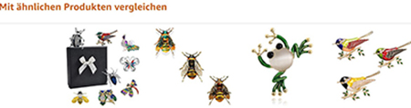  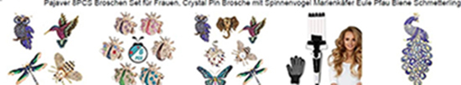  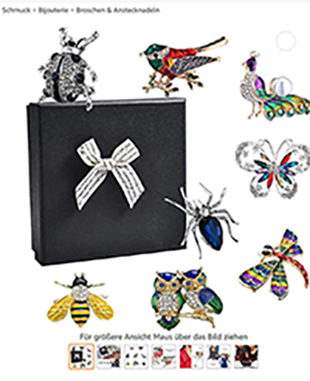  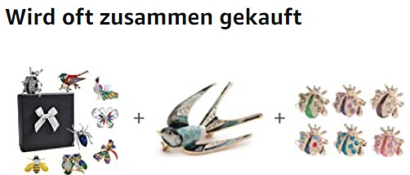
18-Apr-2023 | France | Naphthalene Mothball | Chemicals | Chemical Hazard | 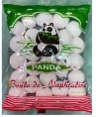
18-Apr-2023 | Sweden | Toy Robot Building Set | Toys and Childcare Products | Environmental Hazard | 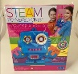
18-Apr-2023 | Finland | Gloves | Protective Equipment | Chemical Hazard | 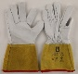
18-Apr-2023 | Sweden | Tattoo Ink | Chemicals | Chemical Hazard | 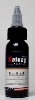
18-Apr-2023 | Sweden | Tattoo Ink | Chemicals | Chemical Hazard | 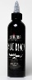
18-Apr-2023 | Sweden | Tattoo Ink | Chemicals | Chemical Hazard | 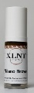
18-Apr-2023 | Sweden | Children's Headphones | Computer / Audio / Video / Other Electronics & Accessories | Chemical Hazard, Environmental Hazard | 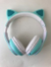
20-Apr-2023 | Germany | Laser Engraving Machine | Machinery | Damage to Sight | 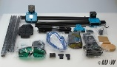
20-Apr-2023 | Germany | Bookend | Accessories | Chemical Hazard | 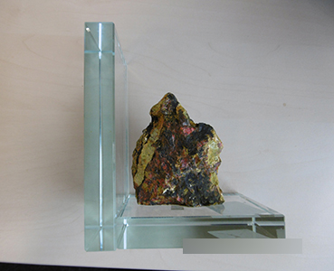  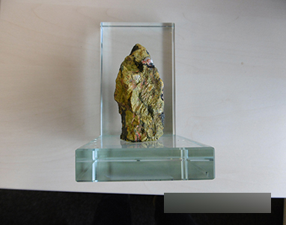  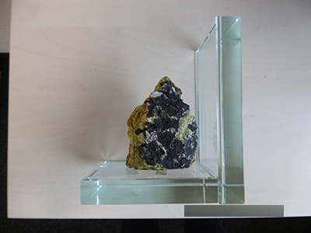  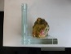
20-Apr-2023 | Italy | Sweatshirt | Fabric / Textile / Garment / Home Textile | Injury Hazard, Strangulation Hazard | 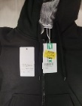
20-Apr-2023 | Italy | Sweatpants | Fabric / Textile / Garment / Home Textile | Injury Hazard | 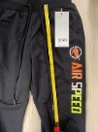
20-Apr-2023 | Ireland | Skin Lightening Cream | Bodycare / Cosmetics | Chemical Hazard | 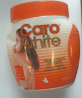
20-Apr-2023 | Italy | Trousers | Fabric / Textile / Garment / Home Textile | Injury Hazard | 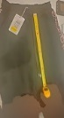
20-Apr-2023 | Germany | Jewelry Set | Jewelry | Chemical Hazard
20-Apr-2023 | Germany | Jewelry Set | Jewelry | Chemical Hazard | 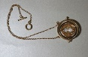  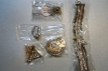
20-Apr-2023 | Czechia | Plastic Doll | Toys and Childcare Products | Chemical Hazard | 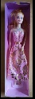  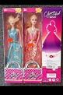
20-Apr-2023 | Germany | Wrap Bracelet | Jewelry | Chemical Hazard | /
20-Apr-2023 | Germany | Jewelry Set | Jewelry | Chemical Hazard | /
20-Apr-2023 | Germany | Necklace with Pendant | Jewelry | Chemical Hazard | 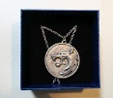
20-Apr-2023 | Germany | Jewelry Kit | Jewelry | Chemical Hazard | 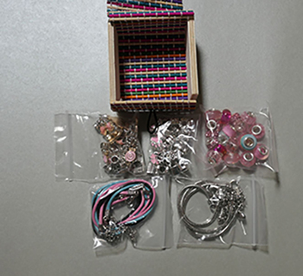
20-Apr-2023 | Czechia | Hair Gel | Bodycare / Cosmetics | Chemical Hazard | 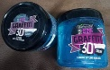
20-Apr-2023 | France | Scooter | Sporting Goods / Equipment | Injury Hazard | /
20-Apr-2023 | France | Paint Remover Spray | Chemicals | Chemical Hazard | 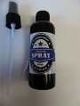
20-Apr-2023 | Cyprus | Plastic Doll | Toys and Childcare Products | Chemical Hazard | 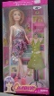
20-Apr-2023 | Germany | Tires | Car Components | Injury Hazard | 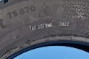
20-Apr-2023 | Germany | Tires | Car Components | Injury Hazard | 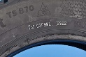
20-Apr-2023 | Spain | Parachute Rocket Flare | Chemicals | Injury Hazard, Explosion Hazard | 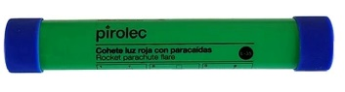
20-Apr-2023 | France | Soft Toy | Toys and Childcare Products | Burn Hazard, Choking Hazard, Fire Hazard | /
20-Apr-2023 | Cyprus | Plastic Doll | Toys and Childcare Products | Chemical Hazard | 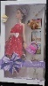
20-Apr-2023 | Cyprus | Plastic Doll | Toys and Childcare Products | Chemical Hazard | 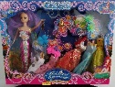
20-Apr-2023 | Sweden | Plastic Doll | Toys and Childcare Products | Chemical Hazard, Environmental Hazard | 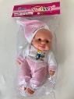
20-Apr-2023 | Czechia | Lighting Chain | Electrical Appliances | Electric Shock Hazard | 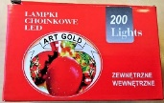
20-Apr-2023 | Germany | Tires | Car Components | Injury Hazard | /
20-Apr-2023 | Germany | Aftershave | Bodycare / Cosmetics | Chemical Hazard
20-Apr-2023 | Romania | Perfume | Bodycare / Cosmetics | Chemical Hazard | 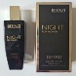
20-Apr-2023 | The Netherlands | Children's Cot | Furniture | Injury Hazard | /
20-Apr-2023 | Romania | Body Spray | Bodycare / Cosmetics | Chemical Hazard | 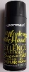
20-Apr-2023 | Romania | Eyebrows Dye | Bodycare / Cosmetics | Chemical Hazard | 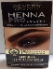
20-Apr-2023 | Romania | Baby’s Hat | Fabric / Textile / Garment / Home Textile | Choking Hazard, Strangulation Hazard | 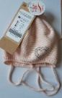
20-Apr-2023 | Sweden | Toy Slime | Toys and Childcare Products | Chemical Hazard | 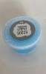
20-Apr-2023 | Sweden | Toy Car | Toys and Childcare Products | Chemical Hazard, Environmental Hazard | 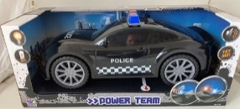
20-Apr-2023 | Sweden | Inflatable Pool | Toys and Childcare Products | Chemical Hazard | 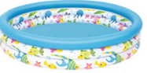
24-Apr-2023 | Germany | Particle Filter Mask | Protective Equipment | Health Risk Hazard | 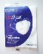
24-Apr-2023 | Poland | Magnetic Toy Set | Toys and Childcare Products | Swallowing Risk | 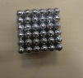
25-Apr-2023 | Austria | Plastic Duck Toy | Toys and Childcare Products | Choking Hazard | 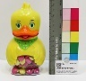
25-Apr-2023 | Sweden | Tattoo Ink | Chemicals | Chemical Hazard
25-Apr-2023 | France | Sandals | Footwear | Chemical Hazard | 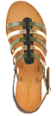
25-Apr-2023 | Sweden | Halloween Necklace | Jewelry | Environmental Hazard | 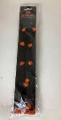
25-Apr-2023 | Sweden | Ring | Jewelry | Chemical Hazard | 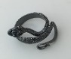
25-Apr-2023 | Sweden | Electric Flying Toy | Toys and Childcare Products | Environmental Hazard | 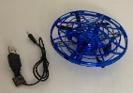
25-Apr-2023 | Sweden | Radio-Controlled Car | Toys and Childcare Products | Environmental Hazard | 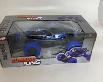
25-Apr-2023 | Sweden | Selfie Light | Electrical Appliances | Environmental Hazard | 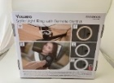
25-Apr-2023 | Sweden | Pendant | Jewelry | Chemical Hazard | 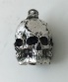
25-Apr-2023 | Sweden | Walking Dog Toy | Toys and Childcare Products | Environmental Hazard | 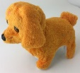
25-Apr-2023 | Sweden | Camping Shower | Tools and Hardware | Environmental Hazard | 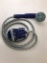
25-Apr-2023 | Czechia | Teeth Whitening Strip | Bodycare / Cosmetics | Chemical Hazard | 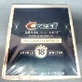
25-Apr-2023 | Hungary | Soft Toy Set | Toys and Childcare Products | Chemical Hazard, Choking Hazard | 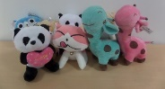
25-Apr-2023 | Sweden | Unicorn Children Lamp | Electrical Appliances | Environmental Hazard | 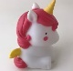
25-Apr-2023 | Sweden | LED Torch | Electrical Appliances | Environmental Hazard | 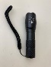
25-Apr-2023 | Sweden | Epilator | Electrical Appliances | Chemical Hazard, Environmental Hazard | 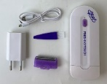
25-Apr-2023 | Finland | Finger Paint | Toys and Childcare Products | Chemical Hazard | 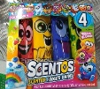
25-Apr-2023 | Sweden | Selfie Stick | Electrical Appliances | Environmental Hazard | 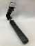
25-Apr-2023 | Sweden | Bluetooth Speaker | Computer / Audio / Video / Other Electronics & Accessories | Environmental Hazard | 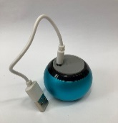
26-Apr-2023 | Latvia | USB Charger | Electrical Appliances | Electric Shock Hazard, Fire Hazard | 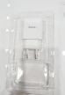
26-Apr-2023 | France | Plastic Toy Set | Toys and Childcare Products | Choking Hazard | 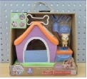
26-Apr-2023 | Sweden | Tattoo Ink | Chemicals | Chemical Hazard | 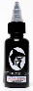
26-Apr-2023 | Sweden | Tattoo Ink | Chemicals | Chemical Hazard | 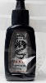
26-Apr-2023 | Sweden | Tattoo Ink | Chemicals | Chemical Hazard
26-Apr-2023 | Romania | Perfume | Bodycare / Cosmetics | Chemical Hazard | 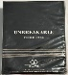
26-Apr-2023 | Romania | Eau De Toilette | Bodycare / Cosmetics | Chemical Hazard | 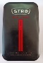
26-Apr-2023 | Sweden | Portable Gas Heater | Electrical Appliances | Burn Hazard | 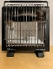
26-Apr-2023 | Finland | Plastic Ball | Sporting Goods / Equipment | Chemical Hazard | 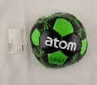
27-Apr-2023 | Latvia | USB Charger | Electrical Appliances | Electric Shock Hazard | /
27-Apr-2023 | Latvia | USB Charger | Electrical Appliances | Electric Shock Hazard, Fire Hazard | 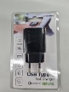
27-Apr-2023 | Germany | Pendant | Jewelry | Chemical Hazard | /
27-Apr-2023 | Germany | Earrings | Jewelry | Chemical Hazard | 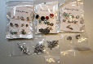
27-Apr-2023 | Germany | Ear Stud | Jewelry | Chemical Hazard | 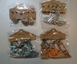
27-Apr-2023 | Germany | Brooch Set | Jewelry | Chemical Hazard | 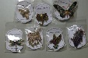
27-Apr-2023 | Germany | Jewelry Kit | Jewelry | Chemical Hazard | 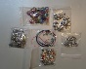  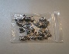
27-Apr-2023 | Germany | Wristband | Jewelry | Chemical Hazard | 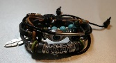
27-Apr-2023 | Germany | Chain with Pendant | Jewelry | Chemical Hazard | 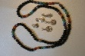
27-Apr-2023 | Germany | Beard Bead | Jewelry | Chemical Hazard | 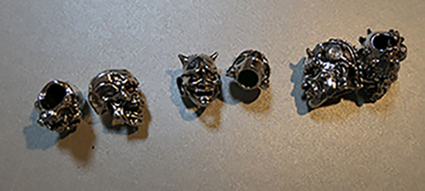  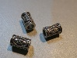
27-Apr-2023 | Germany | Ring Set | Jewelry | Chemical Hazard | 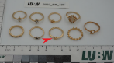
27-Apr-2023 | Germany | Necklace and Earring Set | Jewelry | Chemical Hazard | 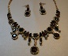
27-Apr-2023 | Cyprus | Plastic Doll | Toys and Childcare Products | Chemical Hazard | 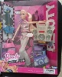
27-Apr-2023 | Sweden | USB Charger | Electrical Appliances | Environmental Hazard | 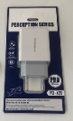
27-Apr-2023 | Sweden | Car Charger | Electrical Appliances | Environmental Hazard | 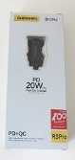
27-Apr-2023 | Sweden | Wireless Charger | Electrical Appliances | Environmental Hazard | 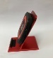
27-Apr-2023 | Sweden | USB Charger | Electrical Appliances | Environmental Hazard | 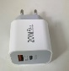
27-Apr-2023 | Sweden | Hair Dryer | Home Electrical Appliances | Environmental Hazard | 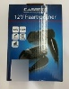
27-Apr-2023 | France | Wooden Toy with Key Ring | Toys and Childcare Products | Choking Hazard, Injury Hazard | 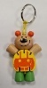
27-Apr-2023 | Cyprus | Plastic Doll | Toys and Childcare Products | Chemical Hazard | 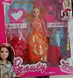
27-Apr-2023 | Cyprus | Plastic Doll | Toys and Childcare Products | Chemical Hazard | 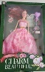
27-Apr-2023 | Cyprus | Ceiling Light | Electrical Appliances | Electric Shock Hazard | 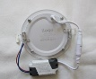
27-Apr-2023 | Romania | Eau De Toilette | Bodycare / Cosmetics | Chemical Hazard | 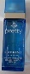
27-Apr-2023 | France | Laundry Hygiene and Fragrance Liquid | Chemicals | Chemical Hazard | 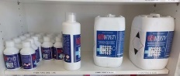
27-Apr-2023 | France | Self-Feeding Aid for Baby | Toys and Childcare Products | Choking Hazard, Suffocation Hazard | 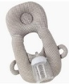  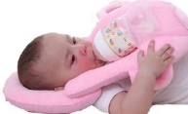
27-Apr-2023 | Romania | Eau De Toilette | Bodycare / Cosmetics | Chemical Hazard | 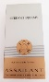
27-Apr-2023 | Sweden | Tattoo Ink | Chemicals | Chemical Hazard | 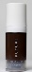
27-Apr-2023 | Sweden | Earrings | Jewelry | Chemical Hazard | 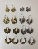
27-Apr-2023 | Sweden | Inflatable Ball | Toys and Childcare Products | Chemical Hazard | 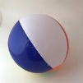
27-Apr-2023 | Sweden | Necklace | Jewelry | Chemical Hazard | 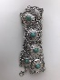
27-Apr-2023 | Sweden | Earrings | Jewelry | Chemical Hazard | 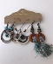
27-Apr-2023 | Sweden | Bracelet | Jewelry | Chemical Hazard | 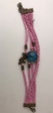
27-Apr-2023 | Sweden | Bag | Fabric / Textile / Garment / Home Textile | Chemical Hazard | 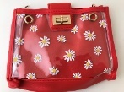
27-Apr-2023 | Sweden | Fancy-Dress Mask | Toys and Childcare Products | Chemical Hazard | 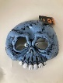
27-Apr-2023 | Sweden | Plastic Bag | Fabric / Textile / Garment / Home Textile | Chemical Hazard | 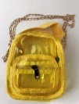
27-Apr-2023 | Czechia | Plastic Doll | Toys and Childcare Products | Chemical Hazard | 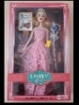
27-Apr-2023 | Czechia | Eau De Toilette | Bodycare / Cosmetics | Chemical Hazard | 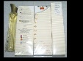
27-Apr-2023 | Sweden | Toy Spider | Toys and Childcare Products | Chemical Hazard | 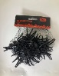
27-Apr-2023 | Sweden | LED Face Mask | Toys and Childcare Products | Environmental Hazard | 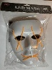
27-Apr-2023 | Sweden | USB Charger | Electrical Appliances | Chemical Hazard, Environmental Hazard | 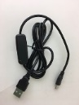
27-Apr-2023 | France | Puzzle Glue | Chemicals | Chemical Hazard | 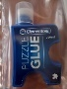
27-Apr-2023 | Poland | Plastic Toy | Toys and Childcare Products | Chemical Hazard, Choking Hazard | 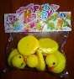
27-Apr-2023 | Sweden | Robot Vacuum Cleaner | Home Electrical Appliances | Environmental Hazard | 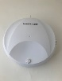
27-Apr-2023 | Sweden | Projector Pot | Electrical Appliances | Chemical Hazard, Environmental Hazard | 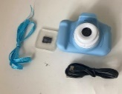
27-Apr-2023 | Sweden | Children's Camera | Electrical Appliances | Chemical Hazard, Environmental Hazard | 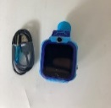
27-Apr-2023 | Poland | Activity Toy | Toys and Childcare Products | Choking Hazard | 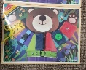
27-Apr-2023 | Sweden | Music LED Lamp | Electrical Appliances | Chemical Hazard, Environmental Hazard | 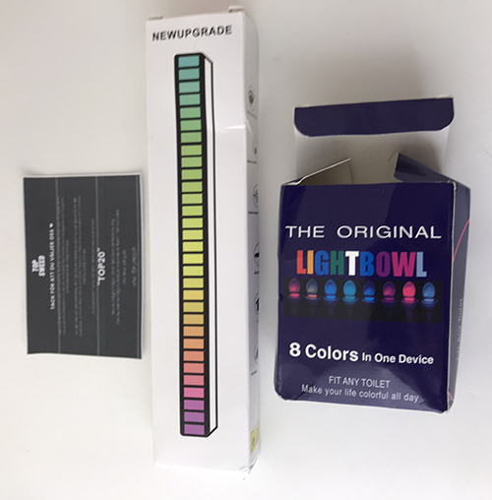
27-Apr-2023 | Sweden | Toilet Lamp | Electrical Appliances | Environmental Hazard | 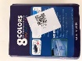
27-Apr-2023 | Sweden | Night Lamp | Electrical Appliances | Chemical Hazard, Environmental Hazard | 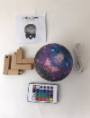
27-Apr-2023 | Malta | Pushchair | Toys and Childcare Products | Injury Hazard | 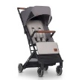
27-Apr-2023 | Sweden | USB Earphone | Computer / Audio / Video / Other Electronics & Accessories | Environmental Hazard | 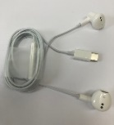
27-Apr-2023 | Germany | Hair Straightening Gel | Bodycare / Cosmetics | Chemical Hazard | 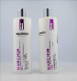  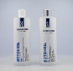
27-Apr-2023 | Sweden | Electric Scrub | Electrical Appliances | Chemical Hazard, Environmental Hazard | 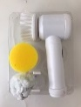
27-Apr-2023 | Sweden | Charger | Electrical Appliances | Environmental Hazard | 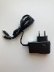
28-Apr-2023 | Romania | Eau De Parfum | Bodycare / Cosmetics | Chemical Hazard | 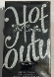
28-Apr-2023 | Romania | Eau De Parfum | Bodycare / Cosmetics | Chemical Hazard | 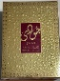
28-Apr-2023 | Lithuania | USB Charger | Electrical Appliances | Electric Shock Hazard | 