Recall Cases Summary – US (Last Update Date: 30 April 2023)

Date | Product | Categories | Hazard | Image
6-Apr-2023 | Alugator Ride 3.0 Hoe and Alugator Ride SE Avalanche Shovel | Tools and Hardware | Injury Hazard, Risk of Death | 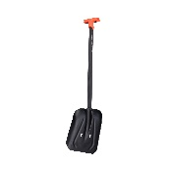  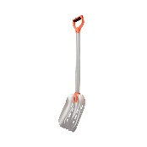
6-Apr-2023 | Cordless Multi-Surface Wet Dry Vacuum | Home Electrical Appliances | Fire Hazard | 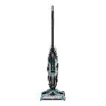
6-Apr-2023 | Basket with Ball Toy | Toys and Childcare Products | Choking Hazard | 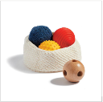
6-Apr-2023 | Fishing Game | Toys and Childcare Products | Choking Hazard | 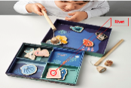
13-Apr-2023 | Luxor A/V Cart | Tools and Hardware | Injury Hazard, Risk of Death, Tip-Over Hazard | 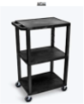  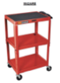
13-Apr-2023 | Flo Smart Water Monitor Lithium-Ion Battery Back-Up | Electrical Appliances | Fire Hazard | 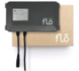
13-Apr-2023 | Children’s Robe | Fabric / Textile / Garment / Home Textile | Burn Hazard | 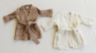
13-Apr-2023 | Arshiner Children’s Nightgown | Fabric / Textile / Garment / Home Textile | Burn Hazard
13-Apr-2023 | FunnyPaja Children’s Bathrobe | Fabric / Textile / Garment / Home Textile | Burn Hazard
20-Apr-2023 | Fiberglass Sledgehammer | Tools and Hardware | Impact Hazard | 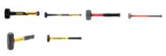
20-Apr-2023 | NewCosplay Children’s Sleepwear | Fabric / Textile / Garment / Home Textile | Burn Hazard | 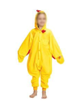
20-Apr-2023 | NewCosplay Children’s Sleepwear | Fabric / Textile / Garment / Home Textile | Burn Hazard
20-Apr-2023 | Children’s Robe | Fabric / Textile / Garment / Home Textile | Burn Hazard
20-Apr-2023 | Children's Fishing Rod | Toys and Childcare Products | Chemical Hazard | 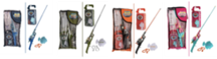
20-Apr-2023 | Lelinta Multi-Purpose Kids Helmet | Protective Equipment | Injury Hazard | 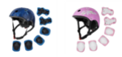
20-Apr-2023 | Youth In-Line Skates | Sporting Goods / Equipment | Fall Hazard | 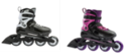
20-Apr-2023 | DynaDrive Fresh Water Well Pump | Electrical Appliances | Electric Shock Hazard | 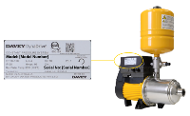
27-Apr-2023 | Screaming Plush Monkey Toy | Toys and Childcare Products | Choking Hazard | 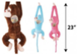
27-Apr-2023 | Pool and Spa Drain Cover | Tools and Hardware | Entrapment Hazard | 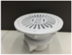
27-Apr-2023 | Steamfast Home & Away Travel Steam Iron and Brookstone Steam Bug Travel Steam Iron | Electrical Appliances | Fire Hazard, Burn Hazard, Electric Shock Hazard
27-Apr-2023 | Ejoyous Pool Drain Cover | Tools and Hardware | Entrapment Hazard | 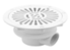
27-Apr-2023 | Pool Drain Cover | Tools and Hardware | Entrapment Hazard | 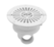
27-Apr-2023 | Recon LT Avalanche Transceiver | Electrical Appliances | Safety Risk Hazard, Risk of Death | 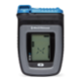
27-Apr-2023 | Easter Bunny Necklace and Boutique Butterfly Jewel Necklace | Jewelry | Chemical Hazard

