Recall Cases Summary – Australia (Last Update Date: 31 May 2023)

Date | Product | Categories | Hazard | Image
1-May-2023 | YETI Hopper M20 (Backpack), YETI Hopper M30 1.0 (Tote), Hopper M30 2.0 (Tote), YETI Sidekick Dry (Gear Case) | Fabric / Textile / Garment / Home Textile | Injury Hazard, Choking Hazard, Risk of Death | 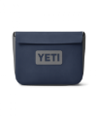  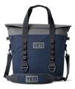  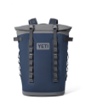
2-May-2023 | Newborn Self-Feeding Pillow | Toys and Childcare Products | Choking Hazard, Suffocation Hazard , Risk of Death | 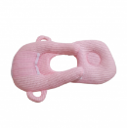
2-May-2023 | LG 65” and 77” Smart TV | Home Electrical Appliances | Injury Hazard, Electric Shock Hazard | 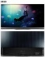  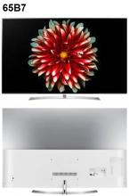  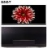  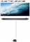  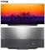  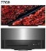
4-May-2023 | BLAVINGAD Fishing Game Multicolour | Toys and Childcare Products | Choking Hazard, Suffocation Hazard | 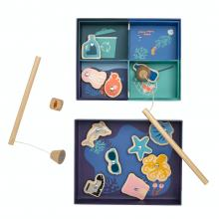
9-May-2023 | AM-510 Digital Multimeter | Electrical Appliances | Burn Hazard, Injury Hazard, Risk of Death | 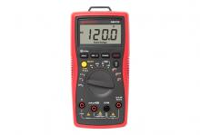
10-May-2023 | Baby Wooden Rattle | Toys and Childcare Products | Choking Hazard, Suffocation Hazard, Risk of Death | 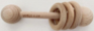  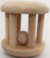
12-May-2023 | Baby Wooden Stick Rattle | Toys and Childcare Products | Choking Hazard, Suffocation Hazard, Risk of Death | 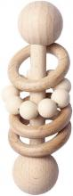  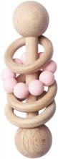
17-May-2023 | Telescopic Magnetic Pick-Up Tool with LED | Tools and Hardware | Choking Hazard, Burn Hazard, Risk of Death | 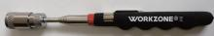
17-May-2023 | KickAss Portable Camping Hot Water System | Outdoor Living Items | Injury Hazard, Risk of Death | 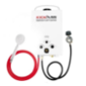
17-May-2023 | ZARA Boy Shirt, Long Sleeved with Button | Fabric / Textile / Garment / Home Textile | Choking Hazard, Suffocation Hazard, Injury Hazard, Risk of Death | 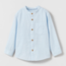
18-May-2023 | GiGwi Pet Droid Motion Active Mouse Cat Toy | Pet Items | Choking Hazard, Burn Hazard, Risk of Death | 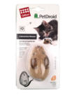
19-May-2023 | Panasonic CR2016 Lithium Coin Battery 3V | Electrical Appliances | Choking Hazard, Burn Hazard, Risk of Death | 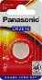
23-May-2023 | Texas Instruments BA II Plus Financial Calculator | Stationery | Choking Hazard, Burn Hazard, Risk of Death | 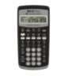
23-May-2023 | HP 10bII+ Financial Calculator | Stationery | Choking Hazard, Burn Hazard, Risk of Death | 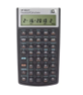
23-May-2023 | Texas Instruments TI-30X Plus Scientific Calculator | Stationery | Choking Hazard, Burn Hazard, Risk of Death | 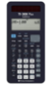
23-May-2023 | MI159506SL Nata by Milan Calculator | Stationery | Choking Hazard, Burn Hazard, Risk of Death | 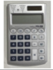
23-May-2023 | Children’s Wooden Jigsaw Puzzle | Toys and Childcare Products | Choking Hazard, Suffocation Hazard | 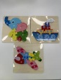
24-May-2023 | Dometic Marine Steering Cable for Malibu Response, Malibu Wakesetter and Axis Boat | Tools and Hardware | Injury Hazard, Risk of Death | 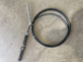
26-May-2023 | Energizer A76 4 pack Miniature Alkaline/Watch button batteries 1.5 Volt | Electrical Appliances | Injury Hazard | 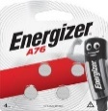
26-May-2023 | Eyecandy Round Ottoman | Furniture | Injury Hazard, Laceration Hazard | 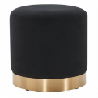
26-May-2023 | Hands Free Reading Book Light - Black | Electrical Appliances | Choking Hazard, Burn Hazard, Risk of Death | 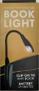
26-May-2023 | PRO Vibe Stem (Alloy) | Sporting Goods / Equipment | Injury Hazard | 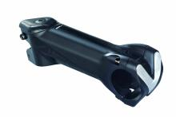
26-May-2023 | My First Music Book Guitar | Toys and Childcare Products | Choking Hazard, Burn Hazard, Risk of Death | 