Recall Cases Summary – Canada (Last Update Date: 31 May 2023)

Date | Product | Categories | Hazard | Image
2-May-2023 | Souris Mini Teether and Pacifier Clip | Toys and Childcare Products | Choking Hazard | 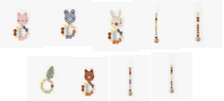
3-May-2023 | Souris Mini Necklace Set with Cat Pendant | Jewelry | Chemical Hazard | 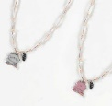  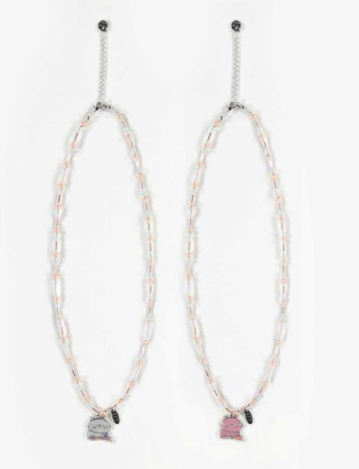
3-May-2023 | Curly Parsley | Food | Microbiological Hazard | 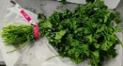
4-May-2023 | Sahara Folding Food Dehydrator | Electrical Appliances | Fire Hazard | 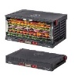
4-May-2023 | INSTYLE Modena and Vienna Rectangular Mirror | Household Items | Fire Hazard
5-May-2023 | Thermosphere and Mastercraft Ceiling-Mounted 7500W/240V Electric Utility Workshop/Garage Heater, Model EH-4604BY with Remote Control & Thermostat | Electrical Appliances | Fire Hazard, Burn Hazard | 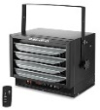  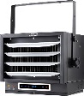  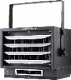
5-May-2023 | Red Chilli Powder | Food | Microbiological Hazard | /
10-May-2023 | Various Top Down Bottom Up Corded Window Covering | Household Items | Strangulation Hazard | 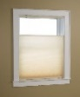  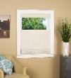  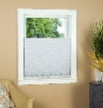
11-May-2023 | LIVINGbasics®️ Indoor Safety Gate | Household Items | Injury Hazard | 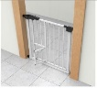
12-May-2023 | Peloton Bike Model PL01 Seat Post | Sporting Goods / Equipment | Fall Hazard, Injury Hazard | 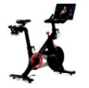
12-May-2023 | Boosh Brand Coconut Curry Cauli Bowl | Food | Risk of Allergy | 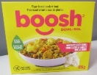
15-May-2023 | SmartBase® Euro Slats Metal Platform Bed Frame | Furniture | Injury Hazard
16-May-2023 | Mortadella | Food | Risk of Allergy | /
16-May-2023 | The Original Ranch Homestyle Topping & Dressing | Food | Risk of Allergy | /
17-May-2023 | Enoki Mushroom | Food | Microbiological Hazard | 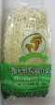
18-May-2023 | Shimano PRO Vibe Bicycle Stem | Sporting Goods / Equipment | Injury Hazard | 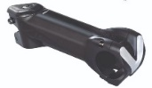
18-May-2023 | PowerXL Stuffed Wafflizer Waffle Maker | Home Electrical Appliances | Burn Hazard | 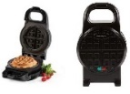
20-May-2023 | Vegan Cheddar Pierogies | Food | Risk of Allergy | 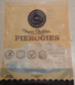
23-May-2023 | Alex Baby Crib, Convertible 4 in 1 Design | Furniture | Entrapment Hazard, Injury Hazard | 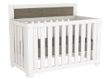  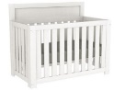
24-May-2023 | Thai Green Pepper | Food | Microbiological Hazard | 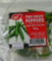
25-May-2023 | Eccles Step Stool | Tools and Hardware | Fall Hazard | 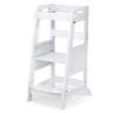
25-May-2023 | The Good and the Beautiful Math 1 and Math 3 Boxes | Accessories | Laceration Hazard | 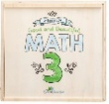  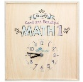
27-May-2023 | Nostrala Firm Surface-Ripened Organic Cheese | Food | Microbiological Hazard | /
30-May-2023 | Arora Cookwares Clay Cooking Pot with Lid | Household Items | Burn Hazard, Injury Hazard | 