Recall Cases Summary – Europe (Last Update Date: 31 May 2023)

Date | Notifying Country | Product | Categories | Hazard | Image
2-May-2023 | Romania | Cream Soap | Bodycare / Cosmetics | Chemical Hazard | 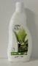
2-May-2023 | Romania | Cosmetic Set | Bodycare / Cosmetics | Chemical Hazard | 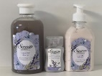
2-May-2023 | Sweden | Fish Shaped Pet Toy | Toys and Childcare Products | Chemical Hazard, Environmental Hazard | 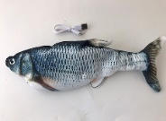
2-May-2023 | Romania | Shower Cream | Bodycare / Cosmetics | Chemical Hazard | 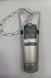
2-May-2023 | Romania | Shower Gel | Bodycare / Cosmetics | Chemical Hazard | 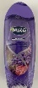  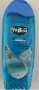
3-May-2023 | Malta | Baby Stroller | Toys and Childcare Products | Choking Hazard | 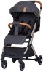
3-May-2023 | Sweden | Rain Boots | Footwear | Chemical Hazard | 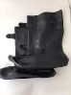
3-May-2023 | Romania | Babies' Dress | Fabric / Textile / Garment / Home Textile | Choking Hazard | 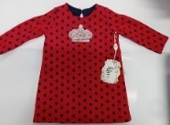
3-May-2023 | Romania | Eau De Toilette | Bodycare / Cosmetics | Chemical Hazard | 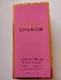
3-May-2023 | Romania | Eau De Toilette | Bodycare / Cosmetics | Chemical Hazard | 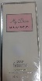
3-May-2023 | Romania | Eau De Toilette | Bodycare / Cosmetics | Chemical Hazard | 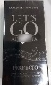
3-May-2023 | Sweden | Hover Football | Sporting Goods / Equipment | Environmental Hazard | 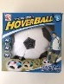
3-May-2023 | Sweden | Electric Scooter | Sporting Goods / Equipment | Environmental Hazard | 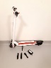
3-May-2023 | Sweden | Electric Scooter | Sporting Goods / Equipment | Environmental Hazard | 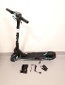
3-May-2023 | Sweden | Electric Scooter | Sporting Goods / Equipment | Environmental Hazard | 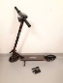
4-May-2023 | France | Electric Barbecue Grill | Electrical Appliances | Electric Shock Hazard | 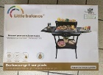
4-May-2023 | Italy | Soft Toy | Toys and Childcare Products | Choking Hazard | 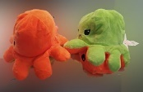
4-May-2023 | Germany | Balaclava | Fabric / Textile / Garment / Home Textile | Chemical Hazard | 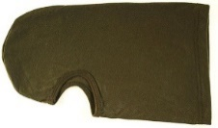
4-May-2023 | Germany | Earring Set | Jewelry | Chemical Hazard | 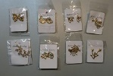
4-May-2023 | Germany | Necklace | Jewelry | Chemical Hazard | 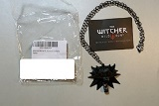
4-May-2023 | Cyprus | Plastic Doll | Toys and Childcare Products | Chemical Hazard | 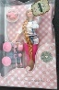
4-May-2023 | Cyprus | Plastic Doll | Toys and Childcare Products | Chemical Hazard | 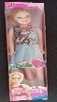
4-May-2023 | Cyprus | Plastic Doll | Toys and Childcare Products | Chemical Hazard
4-May-2023 | Czechia | Lighting Chain | Electrical Appliances | Electric Shock Hazard | 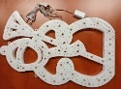
4-May-2023 | Finland | Volleyball | Sporting Goods / Equipment | Chemical Hazard | 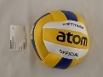  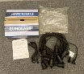
4-May-2023 | Czechia | Lighting Chain | Electrical Appliances | Electric Shock Hazard | 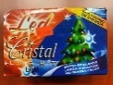
4-May-2023 | Czechia | Lighting Chain | Electrical Appliances | Electric Shock Hazard | 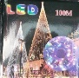  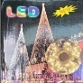
4-May-2023 | Finland | Lighting Chain | Electrical Appliances | Electric Shock Hazard | 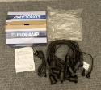
4-May-2023 | Sweden | Ring | Jewelry | Chemical Hazard | 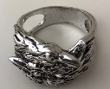
4-May-2023 | Austria | Cosmetics Kit | Bodycare / Cosmetics | Chemical Hazard | 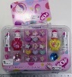
4-May-2023 | Lithuania | USB Charger | Electrical Appliances | Electric Shock Hazard | 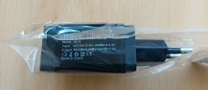
4-May-2023 | Lithuania | USB Charger | Electrical Appliances | Electric Shock Hazard | 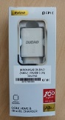
4-May-2023 | Sweden | Electrical Heated Lunch Box | Electrical Appliances | Chemical Hazard, Environmental Hazard | 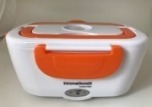
4-May-2023 | Sweden | Electric Fan | Home Electrical Appliances | Environmental Hazard | 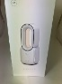
4-May-2023 | Sweden | Black Camping Light | Electrical Appliances | Chemical Hazard, Environmental Hazard | 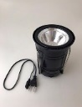
4-May-2023 | Lithuania | Lighting Chain | Electrical Appliances | Electric Shock Hazard | 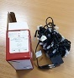
4-May-2023 | Sweden | Electrical Mosquito Killer | Home Electrical Appliances | Chemical Hazard, Environmental Hazard | 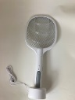
4-May-2023 | Malta | Pushchair | Toys and Childcare Products | Injury Hazard | 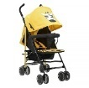
4-May-2023 | Czechia | Lighting Chain | Electrical Appliances | Electric Shock Hazard | 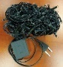
4-May-2023 | Czechia | Lighting Chain | Electrical Appliances | Electric Shock Hazard | 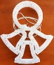
4-May-2023 | Malta | Pushchair | Toys and Childcare Products | Injury Hazard | 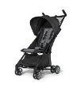
4-May-2023 | Sweden | Light String | Electrical Appliances | Chemical Hazard | 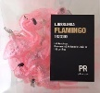
4-May-2023 | The Netherlands | Sensory Swing | Toys and Childcare Products | Strangulation Hazard | 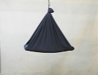
4-May-2023 | The Netherlands | Sensory Swing | Toys and Childcare Products | Strangulation Hazard | 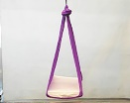
4-May-2023 | The Netherlands | Sensory Swing | Toys and Childcare Products | Strangulation Hazard | 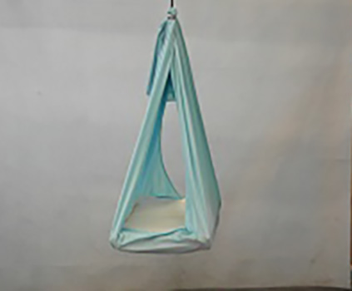
4-May-2023 | The Netherlands | Sensory Swing | Toys and Childcare Products | Strangulation Hazard | 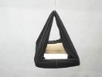
4-May-2023 | Czechia | Tattoo Ink | Chemicals | Chemical Hazard | 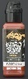
4-May-2023 | Sweden | Inflatable Ball | Sporting Goods / Equipment | Chemical Hazard | 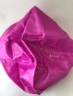
4-May-2023 | Sweden | Gymnastics Ball | Sporting Goods / Equipment | Chemical Hazard | 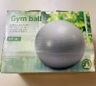
4-May-2023 | Sweden | Straightening Comb | Home Electrical Appliances | Chemical Hazard, Environmental Hazard | 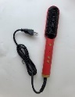
4-May-2023 | Sweden | Pilates Ball | Sporting Goods / Equipment | Chemical Hazard | 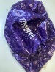
4-May-2023 | Malta | Pushchair | Toys and Childcare Products | Injury Hazard | 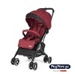
4-May-2023 | Germany | Fan Heater | Home Electrical Appliances | Electric Shock Hazard | 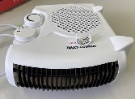
4-May-2023 | France | Toy Cushion | Toys and Childcare Products | Chemical Hazard | 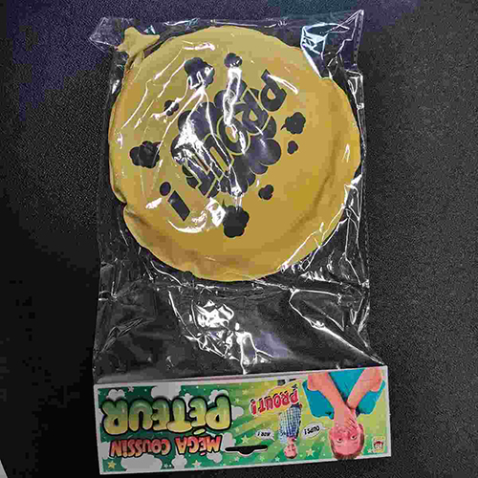
4-May-2023 | Poland | Lighting Chain | Electrical Appliances | Electric Shock Hazard, Fire Hazard | 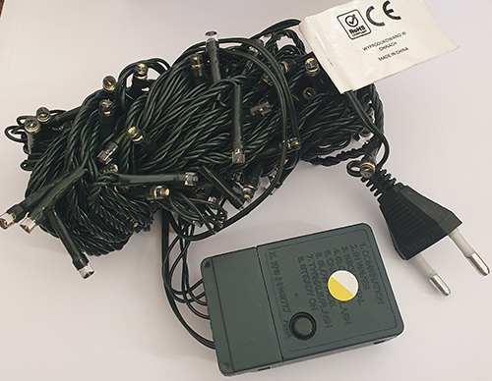
4-May-2023 | Romania | Hair Styling Product | Bodycare / Cosmetics | Chemical Hazard | 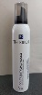
4-May-2023 | Poland | Lighting Chain | Electrical Appliances | Electric Shock Hazard, Fire Hazard | 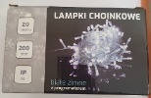
4-May-2023 | Poland | Lighting Chain | Electrical Appliances | Electric Shock Hazard, Fire Hazard | 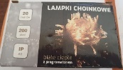
4-May-2023 | Poland | Lighting Chain | Electrical Appliances | Electric Shock Hazard, Fire Hazard | 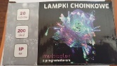
4-May-2023 | Sweden | Electric Scooter | Sporting Goods / Equipment | Environmental Hazard | 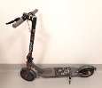
4-May-2023 | Finland | Toy Bow and Arrow Set | Toys and Childcare Products | Chemical Hazard | 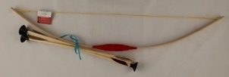
4-May-2023 | Lithuania | USB Charger | Electrical Appliances | Electric Shock Hazard | 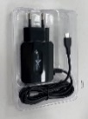
4-May-2023 | Sweden | Soap Bubble Toy | Toys and Childcare Products | Chemical Hazard, Environmental Hazard | 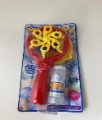
4-May-2023 | Sweden | Toy Excavator | Toys and Childcare Products | Environmental Hazard | 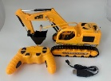
4-May-2023 | Hungary | Cosmetic Bag | Fabric / Textile / Garment / Home Textile | Chemical Hazard | 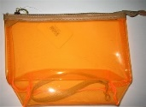
4-May-2023 | Hungary | Plastic Doll | Toys and Childcare Products | Chemical Hazard | 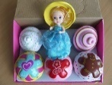
4-May-2023 | Sweden | Electric Scooter | Sporting Goods / Equipment | Environmental Hazard | 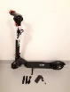
4-May-2023 | Sweden | Portable Vacuum Cleaner | Home Electrical Appliances | Chemical Hazard, Environmental Hazard | 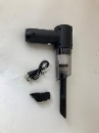
4-May-2023 | Sweden | Radio Controlled Car | Toys and Childcare Products | Chemical Hazard, Environmental Hazard | 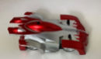
4-May-2023 | Sweden | Necklace | Jewelry | Chemical Hazard | 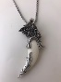
4-May-2023 | Belgium | Fishing Game | Toys and Childcare Products | Choking Hazard | 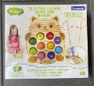
4-May-2023 | Sweden | Ring | Jewelry | Chemical Hazard | 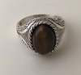
4-May-2023 | Sweden | Solar Powered Figurine | Toys and Childcare Products | Environmental Hazard | 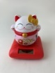
4-May-2023 | France | Leather Slippers | Footwear | Chemical Hazard | 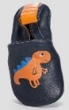
4-May-2023 | Finland | USB Charger | Electrical Appliances | Electric Shock Hazard | 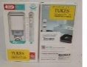
4-May-2023 | Sweden | Jewelry Kit | Jewelry | Chemical Hazard | 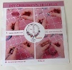
4-May-2023 | Poland | Soft Toy | Toys and Childcare Products | Choking Hazard | 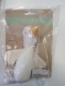
5-May-2023 | Denmark | Firework | Outdoor Living Items | Burn Hazard | 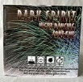
5-May-2023 | Denmark | Firework | Outdoor Living Items | Burn Hazard, Damage to Sight | 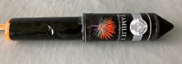
5-May-2023 | Denmark | Firework | Outdoor Living Items | Fire Hazard | 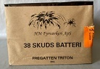
8-May-2023 | Italy | Eau De Parfum | Bodycare / Cosmetics | Chemical Hazard | 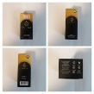
8-May-2023 | Italy | Eau De Parfum | Bodycare / Cosmetics | Chemical Hazard | 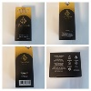
8-May-2023 | Italy | Deodorant Spray | Bodycare / Cosmetics | Chemical Hazard | 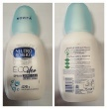
8-May-2023 | Sweden | Electric Scooter | Sporting Goods / Equipment | Chemical Hazard, Environmental Hazard | 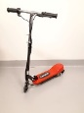
8-May-2023 | Romania | Eau De Toilette | Bodycare / Cosmetics | Chemical Hazard | 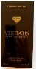
8-May-2023 | Romania | Eau De Toilette | Bodycare / Cosmetics | Chemical Hazard | 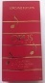
8-May-2023 | Sweden | Sticker | Toys and Childcare Products | Chemical Hazard | 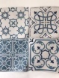
8-May-2023 | Romania | Eau De Toilette | Bodycare / Cosmetics | Chemical Hazard | 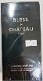
8-May-2023 | Romania | Eau De Toilette | Bodycare / Cosmetics | Chemical Hazard | 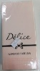
8-May-2023 | France | Soft Toy | Toys and Childcare Products | Choking Hazard | 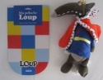
8-May-2023 | Romania | Eau De Toilette | Bodycare / Cosmetics | Chemical Hazard | 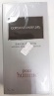
8-May-2023 | Romania | Perfume | Bodycare / Cosmetics | Chemical Hazard | 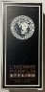
8-May-2023 | Sweden | Necklace | Jewelry | Chemical Hazard | 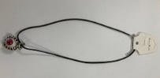
8-May-2023 | Sweden | Wristband | Jewelry | Chemical Hazard | 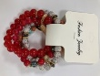
10-May-2023 | Italy | Shower Cream | Bodycare / Cosmetics | Chemical Hazard | 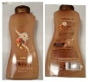
10-May-2023 | Germany | Laser Pointer | Electrical Appliances | Damage to Sight | 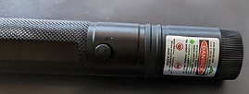
10-May-2023 | Finland | Hammer | Tools and Hardware | Chemical Hazard | 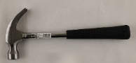
11-May-2023 | Denmark | Firework | Outdoor Living Items | Burn Hazard | 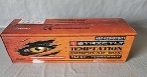
11-May-2023 | Denmark | Firework | Outdoor Living Items | Burn Hazard | 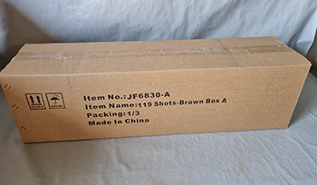
11-May-2023 | Denmark | Firework | Outdoor Living Items | Burn Hazard | 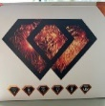
11-May-2023 | Denmark | Firework | Outdoor Living Items | Burn Hazard, Damage to Hearing, Damage to Sight, Injury Hazard | 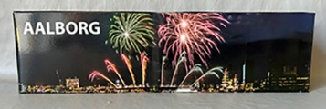
11-May-2023 | Denmark | Firework | Outdoor Living Items | Burn Hazard, Damage to Sight | 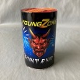
11-May-2023 | Denmark | Firework | Outdoor Living Items | Burn Hazard, Damage to Sight | 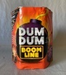
11-May-2023 | Italy | Perfume | Bodycare / Cosmetics | Chemical Hazard | 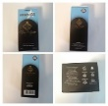
11-May-2023 | Austria | Heatable Ski-Boot-Bag | Fabric / Textile / Garment / Home Textile | Burn Hazard, Fire Hazard | 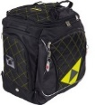
11-May-2023 | Romania | Extension Lead | Electrical Appliances | Electric Shock Hazard | 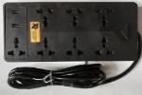
11-May-2023 | Slovakia | Bicycle Helmet | Protective Equipment | Injury Hazard | 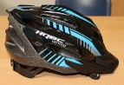
11-May-2023 | France | Key Ring | Toys and Childcare Products | Chemical Hazard | 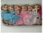  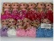  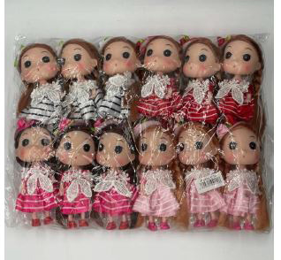  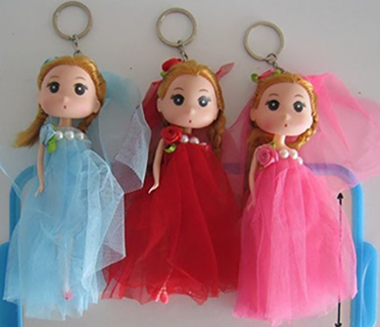
11-May-2023 | Sweden | Necklace | Jewelry | Chemical Hazard | 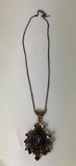
11-May-2023 | France | Soft Toy | Toys and Childcare Products | Choking Hazard | 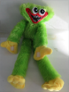
11-May-2023 | Sweden | Electric Scooter | Sporting Goods / Equipment | Chemical Hazard, Environmental Hazard | 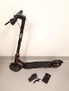
11-May-2023 | France | Toy Telephone | Toys and Childcare Products | Chemical Hazard, Choking Hazard | 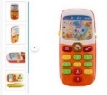
11-May-2023 | Finland | USB Charger | Electrical Appliances | Electric Shock Hazard | 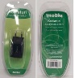
11-May-2023 | Cyprus | Travel Adaptor | Electrical Appliances | Electric Shock Hazard | 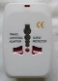
11-May-2023 | Czechia | Tattoo Ink | Chemicals | Chemical Hazard | 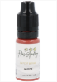
11-May-2023 | Finland | Active Speaker | Electrical Appliances | Electric Shock Hazard | 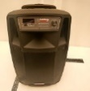
11-May-2023 | Czechia | Plastic Doll | Toys and Childcare Products | Chemical Hazard | 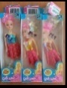
11-May-2023 | Czechia | Eau De Parfum | Bodycare / Cosmetics | Chemical Hazard | 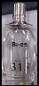
11-May-2023 | Hungary | Plastic Doll with Accessories | Toys and Childcare Products | Chemical Hazard | 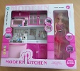
11-May-2023 | Sweden | Ring | Jewelry | Chemical Hazard | 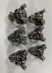  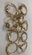  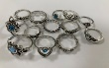  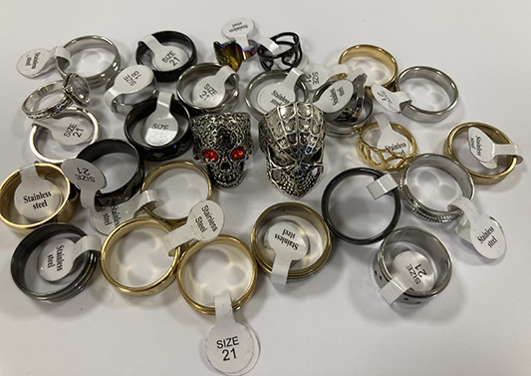  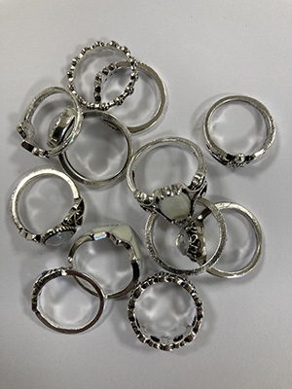
11-May-2023 | Italy | Hairspray | Bodycare / Cosmetics | Chemical Hazard | 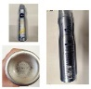
11-May-2023 | Cyprus | Circular Saw Disk | Machinery | Cut Hazard | 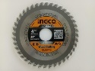
11-May-2023 | Sweden | Wristwatch | Accessories | Environmental Hazard | 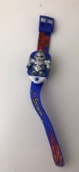
11-May-2023 | Sweden | Tamagotchi | Toys and Childcare Products | Environmental Hazard | 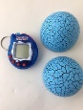
11-May-2023 | Poland | Plastic Swing | Toys and Childcare Products | Entrapment Hazard, Injury Hazard | 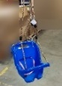
11-May-2023 | Czechia | Lighting Chain | Electrical Appliances | Electric Shock Hazard | 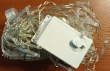
11-May-2023 | Czechia | Lighting Chain | Electrical Appliances | Electric Shock Hazard | 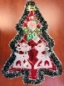
11-May-2023 | Czechia | Lighting Chain | Electrical Appliances | Electric Shock Hazard | 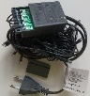
12-May-2023 | Romania | Children's Hoodie | Fabric / Textile / Garment / Home Textile | Injury Hazard, Strangulation Hazard | 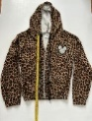
12-May-2023 | Italy | Hair Mousse | Bodycare / Cosmetics | Chemical Hazard | 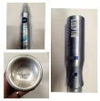
12-May-2023 | Italy | Shower Cream | Bodycare / Cosmetics | Chemical Hazard | 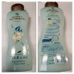
12-May-2023 | Italy | Aftershave Cream | Bodycare / Cosmetics | Chemical Hazard | 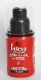
12-May-2023 | Italy | Deodorant Spray | Bodycare / Cosmetics | Chemical Hazard | 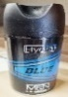
12-May-2023 | Italy | Deodorant Stick | Bodycare / Cosmetics | Chemical Hazard | 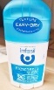
12-May-2023 | Italy | Deodorant Spray | Bodycare / Cosmetics | Chemical Hazard | 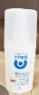
12-May-2023 | Italy | Deodorant Spray | Bodycare / Cosmetics | Chemical Hazard | 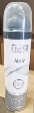
12-May-2023 | Italy | Deodorant Spray | Bodycare / Cosmetics | Chemical Hazard | 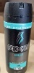
12-May-2023 | Italy | Face Cream | Bodycare / Cosmetics | Chemical Hazard | 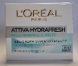
12-May-2023 | Italy | Deodorant Spray | Bodycare / Cosmetics | Chemical Hazard | 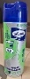
12-May-2023 | Italy | Hair Mask | Bodycare / Cosmetics | Chemical Hazard | 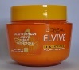
12-May-2023 | Italy | Shaving Foam | Bodycare / Cosmetics | Chemical Hazard | 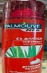
12-May-2023 | Italy | Perfume | Bodycare / Cosmetics | Chemical Hazard
12-May-2023 | Italy | Face Cream | Bodycare / Cosmetics | Chemical Hazard | 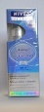
12-May-2023 | Italy | Shampoo | Bodycare / Cosmetics | Chemical Hazard | 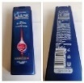
12-May-2023 | Italy | Shaving Cream | Bodycare / Cosmetics | Chemical Hazard | 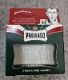
12-May-2023 | Romania | Eau De Toilette | Bodycare / Cosmetics | Chemical Hazard | 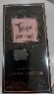
12-May-2023 | Denmark | Firework | Outdoor Living Items | Damage to Hearing, Damage to Sight, Injury Hazard | 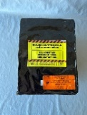
12-May-2023 | Romania | Eau De Toilette | Bodycare / Cosmetics | Chemical Hazard | 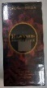
12-May-2023 | Romania | Eau De Toilette | Bodycare / Cosmetics | Chemical Hazard | 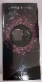
12-May-2023 | Romania | Eau De Toilette | Bodycare / Cosmetics | Chemical Hazard | 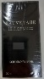
12-May-2023 | Czechia | Plastic Doll | Toys and Childcare Products | Chemical Hazard | 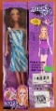
12-May-2023 | Czechia | Plastic Doll | Toys and Childcare Products | Chemical Hazard | 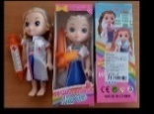
12-May-2023 | Romania | Eau De Toilette | Bodycare / Cosmetics | Chemical Hazard | 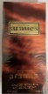
12-May-2023 | Italy | Hairspray | Bodycare / Cosmetics | Chemical Hazard | 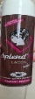
12-May-2023 | Sweden | Necklace | Jewelry | Chemical Hazard | 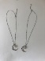
12-May-2023 | Romania | Children's Sports Outfit | Fabric / Textile / Garment / Home Textile | Injury Hazard, Strangulation Hazard | 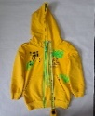  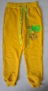
12-May-2023 | Romania | Children's Hoodie | Fabric / Textile / Garment / Home Textile | Injury Hazard, Strangulation Hazard | 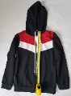
12-May-2023 | Romania | Children's Hoodie | Fabric / Textile / Garment / Home Textile | Injury Hazard, Strangulation Hazard | 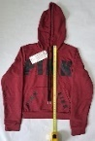
15-May-2023 | Denmark | Firework | Outdoor Living Items | Burn Hazard, Injury Hazard | 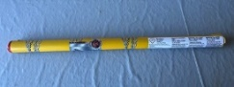
16-May-2023 | Italy | Hair Mousse | Bodycare / Cosmetics | Chemical Hazard | 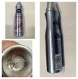  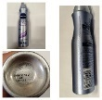
16-May-2023 | Italy | Perfume | Bodycare / Cosmetics | Chemical Hazard | 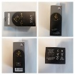
16-May-2023 | Italy | Eau De Toilette | Bodycare / Cosmetics | Chemical Hazard | 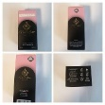
16-May-2023 | Italy | Face Tonic | Bodycare / Cosmetics | Chemical Hazard | 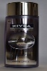
16-May-2023 | Italy | Children's Hoodie | Fabric / Textile / Garment / Home Textile | Injury Hazard, Strangulation Hazard | 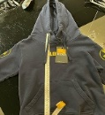
16-May-2023 | Italy | Children's Hoodie | Fabric / Textile / Garment / Home Textile | Injury Hazard, Strangulation Hazard | 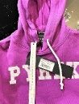
16-May-2023 | Italy | Hydrating Cream | Bodycare / Cosmetics | Chemical Hazard | 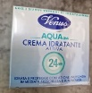
16-May-2023 | Italy | Eau De Toilette | Bodycare / Cosmetics | Chemical Hazard | 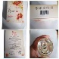
16-May-2023 | Italy | Body Cream | Bodycare / Cosmetics | Chemical Hazard | 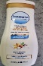
16-May-2023 | Italy | Eau De Toilette | Bodycare / Cosmetics | Chemical Hazard | 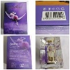
16-May-2023 | Italy | Eau De Toilette | Bodycare / Cosmetics | Chemical Hazard | 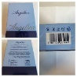
16-May-2023 | Italy | Liquid Detergent | Chemicals | Chemical Hazard | 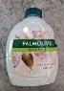
16-May-2023 | Italy | Eau De Toilette | Bodycare / Cosmetics | Chemical Hazard | 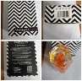
16-May-2023 | Italy | Eau De Toilette | Bodycare / Cosmetics | Chemical Hazard | 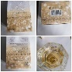
16-May-2023 | Italy | Bath Cream | Bodycare / Cosmetics | Chemical Hazard | 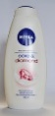
16-May-2023 | Italy | Eau De Toilette | Bodycare / Cosmetics | Chemical Hazard | 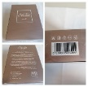
16-May-2023 | Italy | Eau De Toilette | Bodycare / Cosmetics | Chemical Hazard | 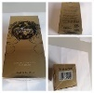
16-May-2023 | Italy | Bath Cream | Bodycare / Cosmetics | Chemical Hazard | 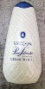
16-May-2023 | Italy | Eau De Toilette | Bodycare / Cosmetics | Chemical Hazard | 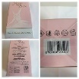
16-May-2023 | Italy | Eau De Toilette | Bodycare / Cosmetics | Chemical Hazard | 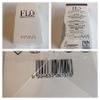
16-May-2023 | Italy | Eau De Toilette | Bodycare / Cosmetics | Chemical Hazard | 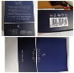
16-May-2023 | Italy | Shaving Soap | Bodycare / Cosmetics | Chemical Hazard | 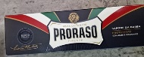
16-May-2023 | Italy | Face Cream | Bodycare / Cosmetics | Chemical Hazard | 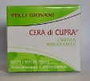
16-May-2023 | Italy | Eau De Toilette | Bodycare / Cosmetics | Chemical Hazard | 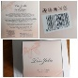
16-May-2023 | Italy | Gilet with Hood | Fabric / Textile / Garment / Home Textile | Injury Hazard, Strangulation Hazard | 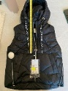
16-May-2023 | Italy | Hair Conditioner | Bodycare / Cosmetics | Chemical Hazard | 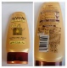
16-May-2023 | France | Soft Toy | Toys and Childcare Products | Choking Hazard | 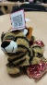
16-May-2023 | Romania | Perfume | Bodycare / Cosmetics | Chemical Hazard | 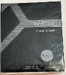
16-May-2023 | Romania | Perfume | Bodycare / Cosmetics | Chemical Hazard | 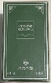
16-May-2023 | Romania | Perfume | Bodycare / Cosmetics | Chemical Hazard | 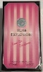
16-May-2023 | Romania | Perfume | Bodycare / Cosmetics | Chemical Hazard | 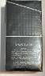
16-May-2023 | France | Soft Toy | Toys and Childcare Products | Chemical Hazard | 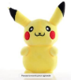
16-May-2023 | Germany | Camping Stove | Outdoor Living Items | Chemical Hazard | 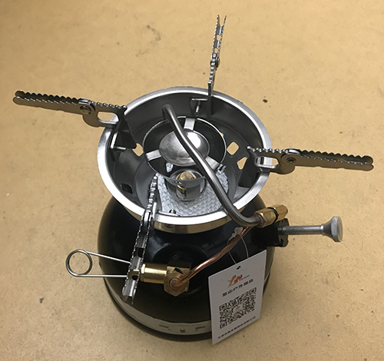
16-May-2023 | Germany | Particle Filter Mask | Protective Equipment | Health Risk Hazard | 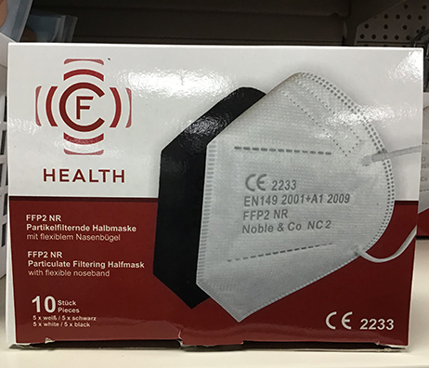  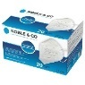
16-May-2023 | Romania | Cosmetic Gift Set | Bodycare / Cosmetics | Chemical Hazard | 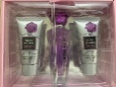
16-May-2023 | Italy | Children's Hoodie | Fabric / Textile / Garment / Home Textile | Injury Hazard, Strangulation Hazard | 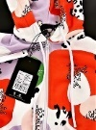
16-May-2023 | Italy | Hair Conditioner | Bodycare / Cosmetics | Chemical Hazard | 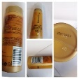
17-May-2023 | Latvia | USB Charger | Electrical Appliances | Electric Shock Hazard | 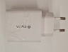
17-May-2023 | Italy | Perfume | Bodycare / Cosmetics | Chemical Hazard | 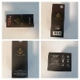
17-May-2023 | Italy | Children’s Hoodie | Fabric / Textile / Garment / Home Textile | Injury Hazard, Strangulation Hazard
17-May-2023 | Italy | Shaving Foam | Bodycare / Cosmetics | Chemical Hazard | 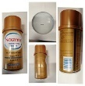
17-May-2023 | Italy | Children’s Hoodie | Fabric / Textile / Garment / Home Textile | Injury Hazard, Strangulation Hazard | 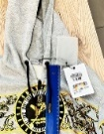
17-May-2023 | Italy | Children’s Hoodie | Fabric / Textile / Garment / Home Textile | Injury Hazard, Strangulation Hazard | 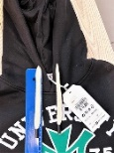
17-May-2023 | Italy | Hoodie | Fabric / Textile / Garment / Home Textile | Injury Hazard, Strangulation Hazard | 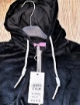
17-May-2023 | Italy | Children’s Hoodie | Fabric / Textile / Garment / Home Textile | Injury Hazard, Strangulation Hazard | 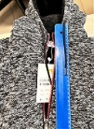
17-May-2023 | Italy | Deodorant Spray | Bodycare / Cosmetics | Chemical Hazard | 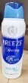
17-May-2023 | Italy | Deodorant Spray | Bodycare / Cosmetics | Chemical Hazard | 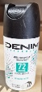
17-May-2023 | Italy | Deodorant Stick | Bodycare / Cosmetics | Chemical Hazard | 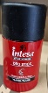
17-May-2023 | Italy | Deodorant Spray | Bodycare / Cosmetics | Chemical Hazard | 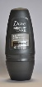
17-May-2023 | Italy | Perfume | Bodycare / Cosmetics | Chemical Hazard | 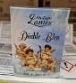
17-May-2023 | Italy | Tonic Lotion | Bodycare / Cosmetics | Chemical Hazard | 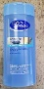
17-May-2023 | Italy | Skin Cream | Bodycare / Cosmetics | Chemical Hazard | 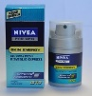
17-May-2023 | Italy | Children's Jacket | Fabric / Textile / Garment / Home Textile | Injury Hazard, Strangulation Hazard | 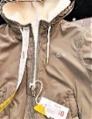
17-May-2023 | Italy | Night Cream | Bodycare / Cosmetics | Chemical Hazard | 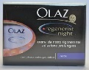
17-May-2023 | Italy | Hair Gel | Bodycare / Cosmetics | Chemical Hazard | 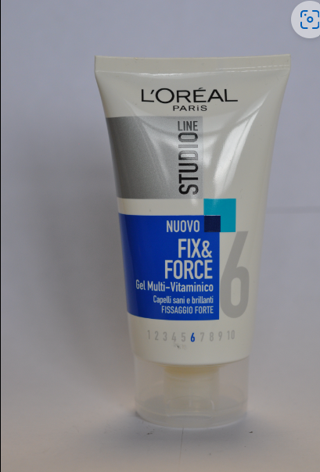
17-May-2023 | Italy | Deodorant Spray | Bodycare / Cosmetics | Chemical Hazard | 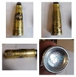
17-May-2023 | Czechia | Particle Filter Mask | Protective Equipment | Health Risk Hazard | 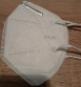
17-May-2023 | Romania | Perfume | Bodycare / Cosmetics | Chemical Hazard | 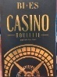  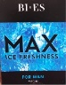
17-May-2023 | Romania | Perfume | Bodycare / Cosmetics | Chemical Hazard | 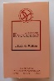
17-May-2023 | Sweden | Waterproof Bag | Fabric / Textile / Garment / Home Textile | Chemical Hazard | 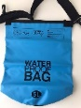
17-May-2023 | Denmark | Firework | Outdoor Living Items | Burn Hazard, Damage to Hearing | 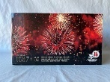
17-May-2023 | Romania | Perfume | Bodycare / Cosmetics | Chemical Hazard | 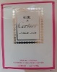
17-May-2023 | Germany | Particle Filter Mask | Protective Equipment | Health Risk Hazard | 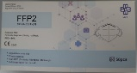
17-May-2023 | Cyprus | USB Charger | Electrical Appliances | Electric Shock Hazard | 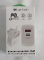
17-May-2023 | Romania | Perfume | Bodycare / Cosmetics | Chemical Hazard | 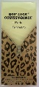
17-May-2023 | Sweden | Plastic Ball | Sporting Goods / Equipment | Chemical Hazard | 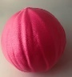
17-May-2023 | Czechia | Electronic Toy | Toys and Childcare Products | Environmental Hazard | 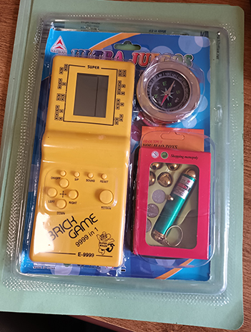
17-May-2023 | Poland | Pushchair Toy | Toys and Childcare Products | Strangulation Hazard | 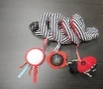
17-May-2023 | Italy | Perfume | Bodycare / Cosmetics | Chemical Hazard | 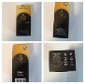
17-May-2023 | Italy | Face Cream | Bodycare / Cosmetics | Chemical Hazard | 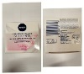
17-May-2023 | Italy | Children's Sweatpants | Fabric / Textile / Garment / Home Textile | Injury Hazard | 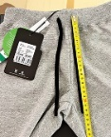
17-May-2023 | Italy | Eye Make-Up Remover | Bodycare / Cosmetics | Chemical Hazard | 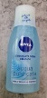
17-May-2023 | Italy | Skin Tonic | Bodycare / Cosmetics | Chemical Hazard | 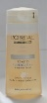
17-May-2023 | Italy | Shoes | Footwear | Chemical Hazard | 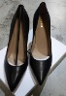
17-May-2023 | Italy | Deodorant Stick | Bodycare / Cosmetics | Chemical Hazard | 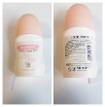
17-May-2023 | Italy | Eau De Toilette | Bodycare / Cosmetics | Chemical Hazard | 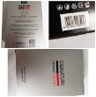
17-May-2023 | Italy | Eau De Toilette | Bodycare / Cosmetics | Chemical Hazard | 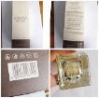
17-May-2023 | Italy | Face Tonic | Bodycare / Cosmetics | Chemical Hazard | 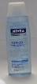
17-May-2023 | Italy | Liquid Soap | Bodycare / Cosmetics | Chemical Hazard | 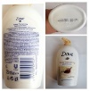
22-May-2023 | Cyprus | Eau De Toilette | Bodycare / Cosmetics | Chemical Hazard | 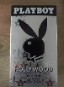
23-May-2023 | Italy | Deodorant | Bodycare / Cosmetics | Chemical Hazard | 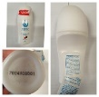
23-May-2023 | Italy | Deodorant | Bodycare / Cosmetics | Chemical Hazard | 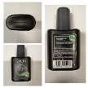
23-May-2023 | Italy | Perfume | Bodycare / Cosmetics | Chemical Hazard | 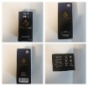
23-May-2023 | Italy | Deodorant | Bodycare / Cosmetics | Chemical Hazard | 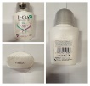
23-May-2023 | Italy | Deodorant | Bodycare / Cosmetics | Chemical Hazard | 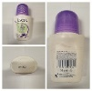
23-May-2023 | Italy | Perfume | Bodycare / Cosmetics | Chemical Hazard | 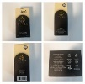
23-May-2023 | Italy | Perfume | Bodycare / Cosmetics | Chemical Hazard | 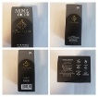
23-May-2023 | Italy | Hairspray | Bodycare / Cosmetics | Chemical Hazard | 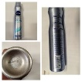
23-May-2023 | Italy | Cream Soap | Bodycare / Cosmetics | Chemical Hazard | 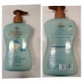
23-May-2023 | Italy | Shower Cream | Bodycare / Cosmetics | Chemical Hazard | 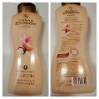
23-May-2023 | Italy | Cream Soap | Bodycare / Cosmetics | Chemical Hazard | 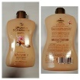
23-May-2023 | Italy | Children’s Hoodie | Fabric / Textile / Garment / Home Textile | Injury Hazard, Strangulation Hazard | 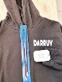
23-May-2023 | Italy | Children’s Hoodie | Fabric / Textile / Garment / Home Textile | Injury Hazard, Strangulation Hazard | 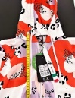
23-May-2023 | Italy | Perfume | Bodycare / Cosmetics | Chemical Hazard | 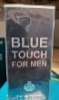
23-May-2023 | Italy | Perfume | Bodycare / Cosmetics | Chemical Hazard | 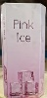
23-May-2023 | Italy | Perfume | Bodycare / Cosmetics | Chemical Hazard | 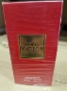
23-May-2023 | Italy | Perfume | Bodycare / Cosmetics | Chemical Hazard | 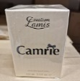
23-May-2023 | Italy | Cream Gel | Bodycare / Cosmetics | Chemical Hazard | 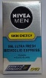
23-May-2023 | Italy | Aftershave Balm | Bodycare / Cosmetics | Chemical Hazard | 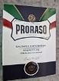
23-May-2023 | Italy | Face Cream | Bodycare / Cosmetics | Chemical Hazard | 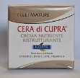
23-May-2023 | Italy | Aftershave | Bodycare / Cosmetics | Chemical Hazard | 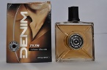
23-May-2023 | Italy | Deodorant Spray | Bodycare / Cosmetics | Chemical Hazard | 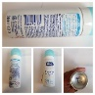
23-May-2023 | Italy | Hairspray | Bodycare / Cosmetics | Chemical Hazard | 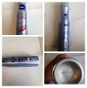
23-May-2023 | Italy | Cleansing Milk | Bodycare / Cosmetics | Chemical Hazard | 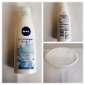
23-May-2023 | Italy | Cleansing Milk | Bodycare / Cosmetics | Chemical Hazard | 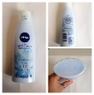
23-May-2023 | Italy | Hair Mousse | Bodycare / Cosmetics | Chemical Hazard | 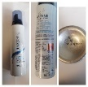
23-May-2023 | Slovakia | Travel Adaptor | Electrical Appliances | Electric Shock Hazard | 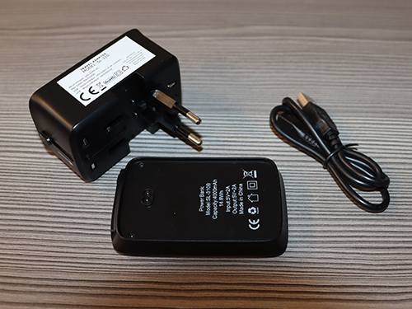
23-May-2023 | Croatia | USB Charger | Electrical Appliances | Electric Shock Hazard | 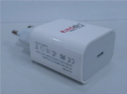
24-May-2023 | Italy | Children's Hoodie | Fabric / Textile / Garment / Home Textile | Injury Hazard, Strangulation Hazard | 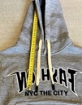
24-May-2023 | Italy | Children's Trousers | Fabric / Textile / Garment / Home Textile | Injury Hazard, Strangulation Hazard | 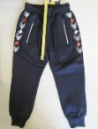
24-May-2023 | Ireland | Baby Self-Feeding Pillow | Toys and Childcare Products | Choking Hazard | 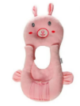
24-May-2023 | Ireland | Baby Self-Feeding Pillow | Toys and Childcare Products | Choking Hazard | 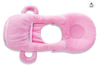
24-May-2023 | Ireland | Baby Self-Feeding Pillow | Toys and Childcare Products | Choking Hazard | 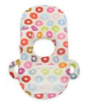
24-May-2023 | Ireland | Baby Self-Feeding Pillow | Toys and Childcare Products | Choking Hazard | 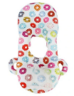
24-May-2023 | Ireland | Baby Self-Feeding Pillow | Toys and Childcare Products | Choking Hazard | 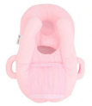
24-May-2023 | Ireland | Baby Self-Feeding Pillow | Toys and Childcare Products | Choking Hazard | 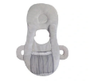
24-May-2023 | Ireland | Baby Self-Feeding Pillow | Toys and Childcare Products | Choking Hazard | 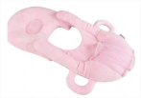
24-May-2023 | Ireland | Baby Self-Feeding Pillow | Toys and Childcare Products | Choking Hazard | 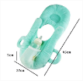
25-May-2023 | Czechia | Lighting Chain | Electrical Appliances | Electric Shock Hazard | 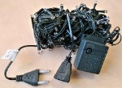
25-May-2023 | Italy | Children's Hoodie | Fabric / Textile / Garment / Home Textile | Injury Hazard, Strangulation Hazard
25-May-2023 | Italy | Children's Hoodie | Fabric / Textile / Garment / Home Textile | Injury Hazard, Strangulation Hazard | 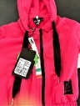
25-May-2023 | Italy | Shower Gel | Bodycare / Cosmetics | Chemical Hazard | 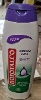
25-May-2023 | Italy | Children's Hoodie | Fabric / Textile / Garment / Home Textile | Injury Hazard, Strangulation Hazard | 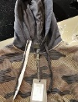
25-May-2023 | Italy | Children's Hoodie | Fabric / Textile / Garment / Home Textile | Injury Hazard, Strangulation Hazard | 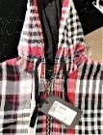
25-May-2023 | Italy | Children's Hoodie | Fabric / Textile / Garment / Home Textile | Injury Hazard, Strangulation Hazard | 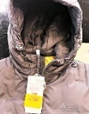
25-May-2023 | Italy | Children's Hoodie | Fabric / Textile / Garment / Home Textile | Injury Hazard, Strangulation Hazard
25-May-2023 | Italy | Shoes | Footwear | Chemical Hazard | 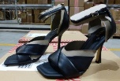
25-May-2023 | Italy | Children's Jacket | Fabric / Textile / Garment / Home Textile | Injury Hazard, Strangulation Hazard | 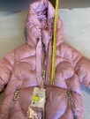
25-May-2023 | Germany | Hairdryer | Home Electrical Appliances | Electric Shock Hazard | 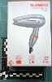
25-May-2023 | Greece | Gloves | Protective Equipment | Chemical Hazard | 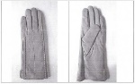
25-May-2023 | Sweden | Electric Scooter | Sporting Goods / Equipment | Environmental Hazard | 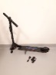
25-May-2023 | Sweden | Plastic Doll | Toys and Childcare Products | Chemical Hazard, Environmental Hazard | 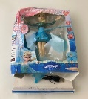
25-May-2023 | Sweden | Outdoor Solar LED | Electrical Appliances | Environmental Hazard | 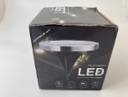
25-May-2023 | Sweden | Massager | Home Electrical Appliances | Environmental Hazard | 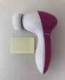
25-May-2023 | Sweden | Radio | Electrical Appliances | Chemical Hazard, Environmental Hazard | 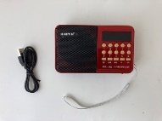
25-May-2023 | Sweden | Toy with Light Projector | Toys and Childcare Products | Environmental Hazard | 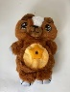
25-May-2023 | Sweden | Air Pump | Electrical Appliances | Chemical Hazard, Environmental Hazard | 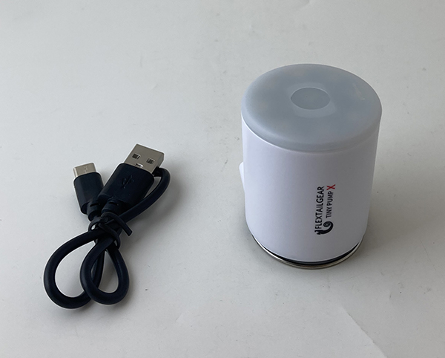
25-May-2023 | Hungary | Air Humidifier | Home Electrical Appliances | Microbiological Hazard | 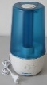
25-May-2023 | Hungary | Aroma Humidifier | Home Electrical Appliances | Microbiological Hazard | 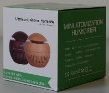
25-May-2023 | France | Finger Paint | Toys and Childcare Products | Chemical Hazard | 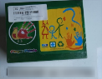
25-May-2023 | Hungary | Fancy Dress | Fabric / Textile / Garment / Home Textile | Burn Hazard | 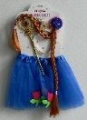
25-May-2023 | Poland | Plastic Doll | Toys and Childcare Products | Chemical Hazard | 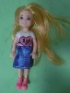
25-May-2023 | Germany | Motorcycle Spare Part | Car Components | Injury Hazard | 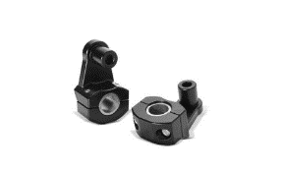
25-May-2023 | Italy | Children's Hoodie | Fabric / Textile / Garment / Home Textile | Injury Hazard, Strangulation Hazard | 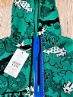
25-May-2023 | Italy | Face Cream | Bodycare / Cosmetics | Chemical Hazard | 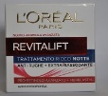
25-May-2023 | Italy | Eau De Toilette | Bodycare / Cosmetics | Chemical Hazard | 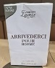
25-May-2023 | Italy | Eau De Toilette | Bodycare / Cosmetics | Chemical Hazard | 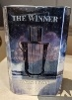
25-May-2023 | Italy | Eau De Toilette | Bodycare / Cosmetics | Chemical Hazard | 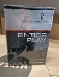
25-May-2023 | Italy | Deodorant | Bodycare / Cosmetics | Chemical Hazard | 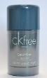
25-May-2023 | Italy | Moisturising Cream | Bodycare / Cosmetics | Chemical Hazard | 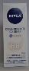
25-May-2023 | Italy | Perfume | Bodycare / Cosmetics | Chemical Hazard
25-May-2023 | Italy | Perfume | Bodycare / Cosmetics | Chemical Hazard | 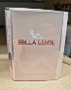
25-May-2023 | Italy | Children's Hoodie | Fabric / Textile / Garment / Home Textile | Injury Hazard, Strangulation Hazard | 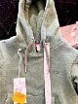
25-May-2023 | Italy | Liquid hand Soap | Bodycare / Cosmetics | Chemical Hazard | 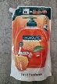
25-May-2023 | Italy | Liquid Soap | Bodycare / Cosmetics | Chemical Hazard | 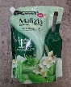
25-May-2023 | Italy | Children's Hoodie | Fabric / Textile / Garment / Home Textile | Injury Hazard, Strangulation Hazard | 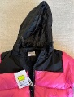
25-May-2023 | Luxembourg | Magnetic Pen | Stationery | Choking Hazard, Injury Hazard | 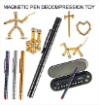
25-May-2023 | France | Spray Glue | Chemicals | Chemical Hazard | 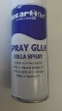
25-May-2023 | Czechia | Plastic Doll | Toys and Childcare Products | Chemical Hazard
25-May-2023 | Czechia | Lighting Chain | Electrical Appliances | Electric Shock Hazard | 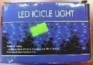
26-May-2023 | Italy | Children's Hoodie | Fabric / Textile / Garment / Home Textile | Injury Hazard, Strangulation Hazard | 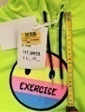
26-May-2023 | Italy | Shoes | Footwear | Chemical Hazard | 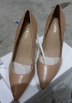
26-May-2023 | Italy | Shoes | Footwear | Chemical Hazard | 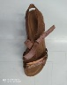
26-May-2023 | Estonia | Children's Dress | Fabric / Textile / Garment / Home Textile | Injury Hazard, Strangulation Hazard | 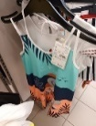
26-May-2023 | The Netherlands | Children's Cot | Furniture | Entrapment Hazard | 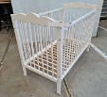
29-May-2023 | Italy | Shaving Foam | Bodycare / Cosmetics | Chemical Hazard | 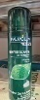
29-May-2023 | Sweden | Perfume | Bodycare / Cosmetics | Chemical Hazard | 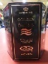
30-May-2023 | Romania | Perfume | Bodycare / Cosmetics | Chemical Hazard
30-May-2023 | Sweden | Perfume | Bodycare / Cosmetics | Chemical Hazard | 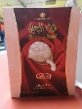
30-May-2023 | Poland | Plastic Doll | Toys and Childcare Products | Chemical Hazard
30-May-2023 | Lithuania | USB Charger | Electrical Appliances | Electric Shock Hazard | 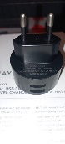
31-May-2023 | Poland | Roof Window | Construction Products | Electric Shock Hazard | 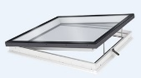
31-May-2023 | Hungary | Air Humidifier | Home Electrical Appliances | Microbiological Hazard | 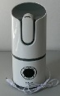
31-May-2023 | Sweden | Skin Lightening Cream | Bodycare / Cosmetics | Chemical Hazard | 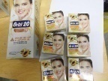
31-May-2023 | Hungary | Aroma Diffuser | Home Electrical Appliances | Microbiological Hazard | 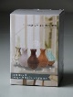
31-May-2023 | Italy | Perfume | Bodycare / Cosmetics | Chemical Hazard | 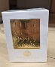
31-May-2023 | Czechia | Disposable Electronic Cigarette | Chemicals | Chemical Hazard | 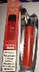
31-May-2023 | Sweden | Skin Lightening Cream | Bodycare / Cosmetics | Chemical Hazard | 