Recall Cases Summary – US (Last Update Date: 31 May 2023)

Date | Product | Categories | Hazard | Image
4-May-2023 | Twin Over Twin Bunk Bed | Furniture | Fall Hazard, Impact Hazard | 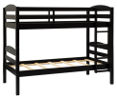  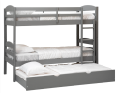
4-May-2023 | Severe Weather Doorglass Insert | Household Items | Injury Hazard | 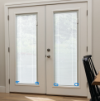  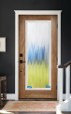
4-May-2023 | L.O.L. Surprise! Trick or Treat Subscription Box Sold with Metal Doll Pin | Toys and Childcare Products | Lead Poisoning Hazard | 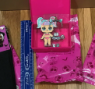
4-May-2023 | Sahara Folding Food Dehydrator | Electrical Appliances | Fire Hazard | 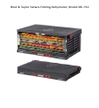
4-May-2023 | Children’s White Robe | Fabric / Textile / Garment / Home Textile | Burn Hazard | 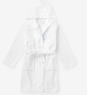
11-May-2023 | Blue Ridge Utility Knife | Tools and Hardware | Laceration Hazard | 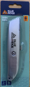
11-May-2023 | Cocktail Shaker | Food Contact Material | Laceration Hazard | 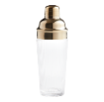
11-May-2023 | Repair Continental Cabinet and Hampton Bay Kitchen Wall Cabinet | Furniture | Impact Hazard | 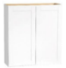  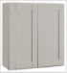  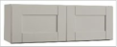  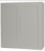  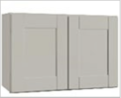
11-May-2023 | Two Million Exercise Bike | Sporting Goods / Equipment | Fall Hazard, Injury Hazard | 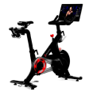
18-May-2023 | PhysiciansCare Allergy, Allergy Plus and Cold and Cough | Pharmacy | Poisoning Hazard | 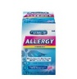  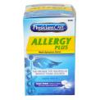  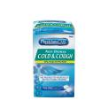  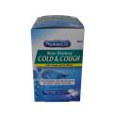
18-May-2023 | Shimano PRO Vibe Alloy Stem for Road Bicycle | Sporting Goods / Equipment | Injury Hazard | 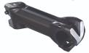
18-May-2023 | Cole & Mason 505WEG Pepper Mill | Food Contact Material | Laceration Hazard | 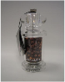
18-May-2023 | Adult Bike Helmet | Protective Equipment | Injury Hazard | 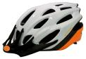  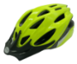  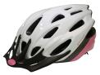  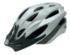
18-May-2023 | Personal Chiller Mini Fridge Gamer Beverage Refrigerator with LED Light | Home Electrical Appliances | Burn Hazard | 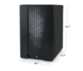  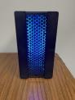  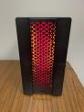
18-May-2023 | Threshold Glass Jar Candle | Household Items | Laceration Hazard, Burn Hazard | 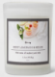  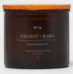  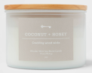  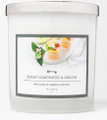
18-May-2023 | PowerXL Stuffed Wafflizer Waffle Maker | Home Electrical Appliances | Burn Hazard | 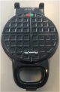
25-May-2023 | Janod Sweet Cocoon Activity Table | Toys and Childcare Products | Choking Hazard | 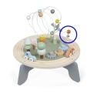  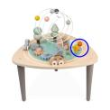
25-May-2023 | The Preschool Electric Bicycle | Sporting Goods / Equipment | Lead Poisoning Hazard | 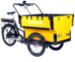
25-May-2023 | The Good and the Beautiful Math 1 and Math 3 Boxes with Metallic Whiteboard | Accessories | Laceration Hazard | 