Recall Cases Summary – Australia (Last Update Date: 30 June 2023)

Date | Product | Categories | Hazard | Image
8-Jun-2023 | RELiON InSight 48V Lithium-ion Batteries | Car Components | Fire Hazard | 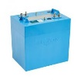
8-Jun-2023 | The Laundress Fabric Conditioners | Chemicals | Chemical Hazard, Health Risk Hazard | 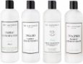
8-Jun-2023 | Hydraulic Lifting Vehicle Trolley Jacks | Tools and Hardware | Injury Hazard, Risk of Death | 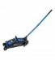  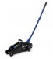  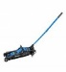  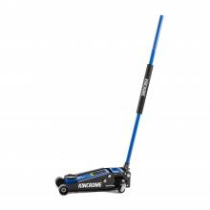
8-Jun-2023 | Hydraulic Lifting Vehicle Trolley Jack 2250kg | Tools and Hardware | Injury Hazard, Risk of Death | 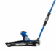  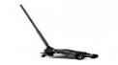
16-Jun-2023 | Kids Bunk Bed Sets in Various Colours | Furniture | Entrapment Hazard, Fall Hazard | 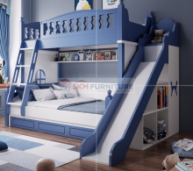  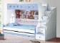  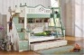  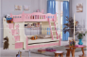
19-Jun-2023 | Serpentine Rough Gemstones Containing Asbestos | Construction Products | Health Risk Hazard | 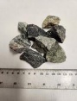
20-Jun-2023 | Various Novelty Items Containing Button Batteries | Electrical Appliances | Choking Hazard, Burn Hazard, Ingestion Hazard, Risk of Death | 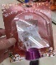  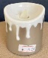  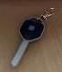  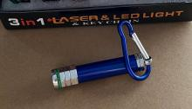  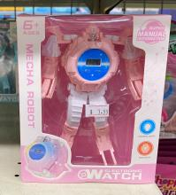  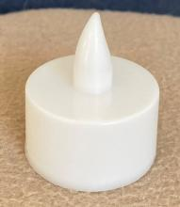  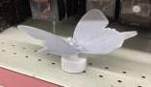
23-Jun-2023 | Automotive Remotes and Shells | Car Components | Burn Hazard, Risk of Death, Ingestion Hazard | 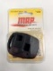  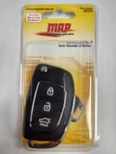  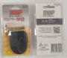  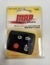  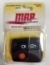
23-Jun-2023 | Lithium Battery Systems (LBS) Lithium Iron Phosphate Batteries | Electrical Appliances | Injury Hazard, Risk of Death, Fire Hazard | 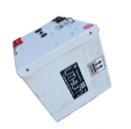  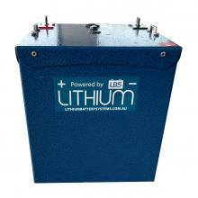
23-Jun-2023 | Car Booster Seat Safety Chair Cushion Pad for Toddler Children Child Kids Sturdy | Car Components | Injury Hazard, Risk of Death | 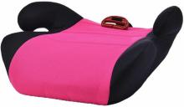
23-Jun-2023 | Musical Candle | Electrical Appliances | Choking Hazard, Burn Hazard, Ingestion Hazard, Risk of Death | 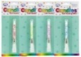  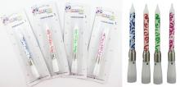
26-Jun-2023 | Marmo Table Lamp | Home Electrical Appliances | Injury Hazard, Electric Shock Hazard | 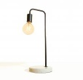
29-Jun-2023 | Click Telescopic LED Torch | Electrical Appliances | Choking Hazard, Burn Hazard, Ingestion Hazard, Risk of Death | 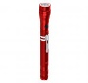  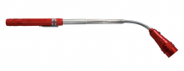
29-Jun-2023 | Toddler Girls Micro Corduroy Dungarees, Kids Overalls | Fabric / Textile / Garment / Home Textile | Choking Hazard, Suffocation Hazard, Injury Hazard, Ingestion Hazard, Risk of Death | 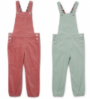
30-Jun-2023 | Hydraulic Disc Brakes Fitted on Certain Model of Trek Bicycles | Sporting Goods / Equipment | Injury Hazard | 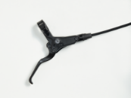
30-Jun-2023 | The Cambio Spoon Self-Feeding Baby Spoon and Teething Toy in Navy, Dusty Pink, and Stone Colours | Food Contact Material | Choking Hazard, Suffocation Hazard, Injury Hazard, Ingestion Hazard, Risk of Death | 