Recall Cases Summary – Canada (Last Update Date: 30 June 2023)

Date | Product | Categories | Hazard | Image
1-Jun-2023 | EGO Power+ Cordless Brushless Hedge Trimmers | Tools and Hardware | Laceration Hazard | 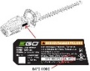  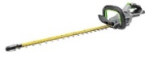
1-Jun-2023 | PowerXL Model SHL96 and SHL90-SC Self-Cleaning Juicers | Home Electrical Appliances | Laceration Hazard, Ingestion Hazard | 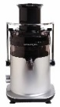  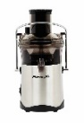
2-Jun-2023 | Nature’s Pick Brand Fresh Cut Cubed Butternut Squash | Food | Microbiological Hazard | 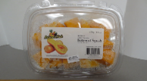
5-Jun-2023 | White Jasmine Facial Skin Tonic | Bodycare / Cosmetics | Risk of Allergy, Skin Irritation Risk | 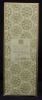
5-Jun-2023 | Mood Rings with Painted Flowers | Jewelry | Lead Poisoning Hazard , Chemical Hazard, Risk of Death | 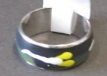  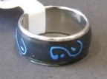
8-Jun-2023 | Giro Merit Bicycle Helmet | Protective Equipment | Injury Hazard | 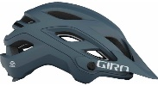
8-Jun-2023 | Little Cotton Clothes Sleepwear | Fabric / Textile / Garment / Home Textile | Burn Hazard | 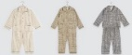  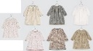  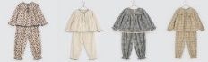
8-Jun-2023 | Kate and Laurel Astora and Valenti Mirrors | Household Items | Laceration Hazard | 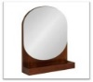  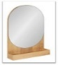  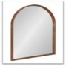
8-Jun-2023 | Signature Design by Ashley Furniture Industries, LLC Party Time Power Loveseats, Sofas and Recliners | Furniture | Fire Hazard | 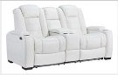  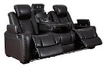  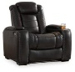
9-Jun-2023 | CultureFly’s L.O.L. Surprise! Trick or Treat Themed Boxes | Fabric / Textile / Garment / Home Textile | Strangulation Hazard, Lead Poisoning Hazard | 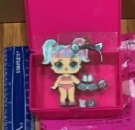  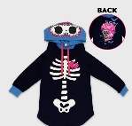
9-Jun-2023 | Saladitos Brand Lupini Beans | Food | Microbiological Hazard | 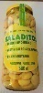
13-Jun-2023 | Tahini | Food | Microbiological Hazard | 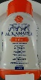
13-Jun-2023 | Frozen Raspberries | Food | Microbiological Hazard | 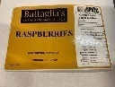
14-Jun-2023 | IQF Whole Raspberries and IQF Antioxidant Blend | Food | Microbiological Hazard | 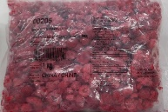
15-Jun-2023 | BKIND Brightening Face Serum | Bodycare / Cosmetics | Microbiological Hazard | 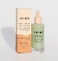
15-Jun-2023 | Oceanic Excursion, Hera, and OceanPro QLR4 Weight Pockets | Sporting Goods / Equipment | Drowning Hazard | 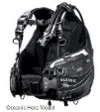  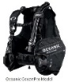  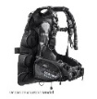
15-Jun-2023 | Promax Solve Hydraulic Disc Brakes | Tools and Hardware | Injury Hazard, Fall Hazard | 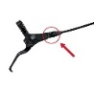
15-Jun-2023 | Sélection du Pâtissier Brand Framboisier Cake and WOW! Factor Desserts Brand Berry Burst Slab Cake | Food | Microbiological Hazard | /
16-Jun-2023 | Lupini Beans | Food | Microbiological Hazard | 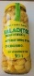
17-Jun-2023 | Mango Frozen Dessert Bar | Food | Risk of Allergy | 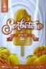
17-Jun-2023 | IQF Antioxidant Blend | Food | Microbiological Hazard | /
19-Jun-2023 | CHICOLOGY Faux Wood Blind | Household Items | Strangulation Hazard, Entanglement Hazard, Risk of Death | 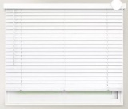
19-Jun-2023 | Sheba Top-Down Bottom-Up Blackout Cellular Shade | Household Items | Strangulation Hazard, Entanglement Hazard, Risk of Death | 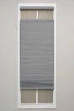  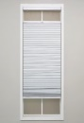
20-Jun-2023 | Outdoor Home Collection Daybed | Furniture | Fall Hazard
21-Jun-2023 | Steam Humidifiers | Home Electrical Appliances | Fire Hazard | 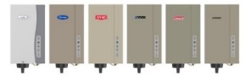
22-Jun-2023 | Zuru Robo Alive Junior Baby Shark Bath Toy | Toys and Childcare Products | Laceration Hazard | 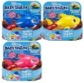
22-Jun-2023 | Organic Blackberries (Frozen) | Food | Microbiological Hazard | 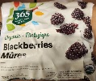
26-Jun-2023 | Child Car Seat | Car Components | Injury Hazard | 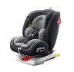
27-Jun-2023 | Portable Children’s Car Seat | Car Components | Injury Hazard | 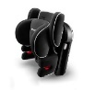  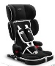
27-Jun-2023 | Various Kool Charmz Dangling Links and Kool Charmz Colours Interchangeable Charm | Jewelry | Chemical Hazard | 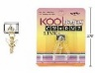  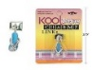  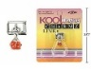  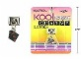  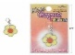  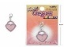  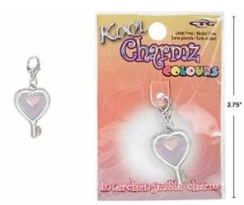
27-Jun-2023 | TONGXINLE Universal Two-Way Car Seat for Child & Baby | Car Components | Injury Hazard | 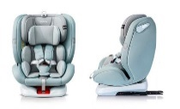
29-Jun-2023 | Bass Modules | Computer / Audio / Video / Other Electronics & Accessories | Fire Hazard | 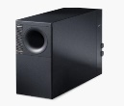  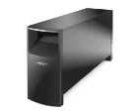
30-Jun-2023 | Super Momz Baby 4 in 1 Car Seat for 0-15 Months Baby | Toys and Childcare Products | Injury Hazard | 