Recall Cases Summary – China (Last Update Date: 30 June 2023)

Date | Province | Product | Categories | Hazard | Image
5-Jun-2023 | Inner Mongolia | Student Uniforms | Fabric / Textile / Garment / Home Textile | Strangulation Hazard, Injury Hazard, Entanglement Hazard | /
5-Jun-2023 | Shanghai | U-shaped Toothbrushes for Children | Bodycare / Cosmetics | Swallowing Risk, Suffocation Hazard | 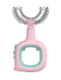
6-Jun-2023 | Beijing | Paper Straws and Spiral Pattern Heat-insulated Paper Cups | Food Contact Material | Health Risk Hazard | 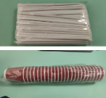
7-Jun-2023 | Fujian | Girls' Hooded Sweaters | Fabric / Textile / Garment / Home Textile | Strangulation Hazard | 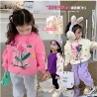
7-Jun-2023 | Shandong | Red Double-Layer Round Bellyband | Fabric / Textile / Garment / Home Textile | Suffocation Hazard | /
7-Jun-2023 | Shandong | Toy Supplied with Floor Mats | Toys and Childcare Products | Swallowing Risk, Choking Hazard | /
7-Jun-2023 | Shandong | Electric Bicycle | Sporting Goods / Equipment | Safety Risk Hazard | /
7-Jun-2023 | Shandong | Puzzle Floor Mats | Toys and Childcare Products | Safety Risk Hazard | /
8-Jun-2023 | Shanghai | Fixed LED Lamps | Electrical Appliances | Electric Shock Hazard | 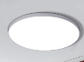  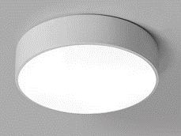
9-Jun-2023 | Shanghai | Recessed Lamps | Electrical Appliances | Electric Shock Hazard | 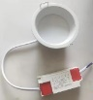
9-Jun-2023 | Beijing | Smart Treadmills | Sporting Goods / Equipment | Electric Shock Hazard | 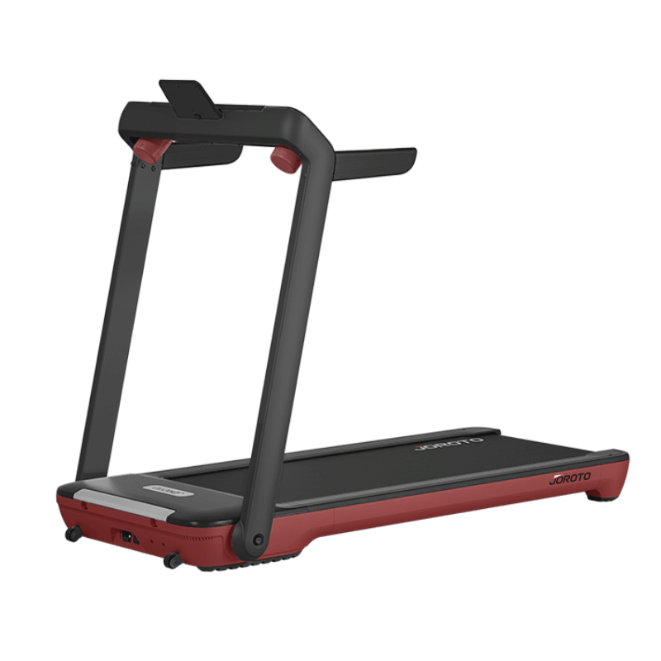
9-Jun-2023 | Beijing | Jackets | Fabric / Textile / Garment / Home Textile | Entanglement Hazard, Fall Hazard | 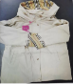
12-Jun-2023 | Shanghai | Drawing Erasers | Stationery | Health Risk Hazard | 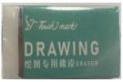
12-Jun-2023 | Beijing | Anti-mildew Sealant | Chemicals | Chemical Hazard | 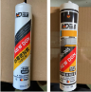
12-Jun-2023 | Beijing | Plush Toys | Toys and Childcare Products | Chemical Hazard, Health Risk Hazard | 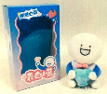
13-Jun-2023 | Inner Mongolia | Student Clothing | Fabric / Textile / Garment / Home Textile | Strangulation Hazard, Entanglement Hazard, Safety Risk Hazard | /
16-Jun-2023 | Anhui | Energy-saving Heaters | Home Electrical Appliances | Electric Shock Hazard, Fire Hazard | /
16-Jun-2023 | Anhui | Power Lithium Batteries | Electrical Appliances | Fire Hazard, Explosion Hazard Safety Risk Hazard | /
19-Jun-2023 | Hunan | Schoolbooks (Mathematics Books for Middle Schools) | Stationery | Cut Hazard | 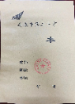
19-Jun-2023 | Hunan | Energy-saving Foot Warmers | Home Electrical Appliances | Electric Shock Hazard, Fire Hazard | 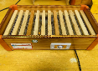
19-Jun-2023 | Beijing | Schoolbags | Fabric / Textile / Garment / Home Textile | Chemical Hazard | 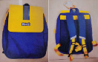
19-Jun-2023 | Anhui | Children's High Chair | Toys and Childcare Products | Injury Hazard, Safety Risk Hazard | /
19-Jun-2023 | Anhui | MFZ/ABC4 Portable Dry Powder Fire Extinguishers | Tools and Hardware | Safety Risk Hazard | /
19-Jun-2023 | Anhui | MFZ/ABC3 Portable Dry Powder Fire Extinguishers | Tools and Hardware | Safety Risk Hazard | /
19-Jun-2023 | Anhui | Household Bunk Beds | Furniture | Fall Hazard | /
19-Jun-2023 | Anhui | Bunk Beds (Child-mother Beds) | Furniture | Injury Hazard, Safety Risk Hazard | /
19-Jun-2023 | Anhui | Notebooks | Stationery | Cut Hazard, Safety Risk Hazard | /
19-Jun-2023 | Anhui | Bunk Beds (Child-mother Beds) | Furniture | Injury Hazard, Safety Risk Hazard | /
19-Jun-2023 | Anhui | Submersible Pumps | Sporting Goods / Equipment | Electric Shock Hazard | /
19-Jun-2023 | Anhui | Submersible Pumps | Sporting Goods / Equipment | Electric Shock Hazard, Health Risk Hazard | /
19-Jun-2023 | Anhui | Portable Dry Powder Fire Extinguishers | Tools and Hardware | Safety Risk Hazard | /
20-Jun-2023 | Anhui | Multifunctional Hair Clipper | Electrical Appliances | Electric Shock Hazard, Injury Hazard | /
20-Jun-2023 | Anhui | Indoor Heaters | Home Electrical Appliances | Electric Shock Hazard, Fire Hazard, Safety Risk Hazard | /
20-Jun-2023 | Jilin | Student Uniforms (Autumn) | Fabric / Textile / Garment / Home Textile | Chemical Hazard | /
20-Jun-2023 | Anhui | Disposable Bamboo Chopsticks | Food Contact Material | Cut Hazard, Safety Risk Hazard | /
20-Jun-2023 | Anhui | Writing Paper | Stationery | Health Risk Hazard | /
20-Jun-2023 | Anhui | Disposable Chopsticks | Food Contact Material | Cut Hazard, Safety Risk Hazard | /
20-Jun-2023 | Anhui | Daily Paper | Stationery | Eye Irritation Risk | /
20-Jun-2023 | Shanghai | Children's Bicycles | Sporting Goods / Equipment | Crushing Hazard, Health Risk Hazard | 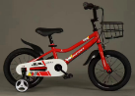
21-Jun-2023 | Jiangsu | Children's Bed Guardrail | Toys and Childcare Products | Fall Hazard, Strangulation Hazard, Suffocation Hazard | 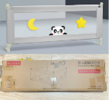
25-Jun-2023 | Inner Mongolia | Student Winter and Spring and Autumn Clothing | Fabric / Textile / Garment / Home Textile | Strangulation Hazard, Entanglement Hazard, Safety Risk Hazard | /
26-Jun-2023 | Shanghai | Children's Leather Shoes | Footwear | Lead Poisoning Hazard | 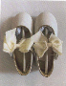
26-Jun-2023 | Shanghai | High-grade Drawing Erasers | Stationery | Chemical Hazard | 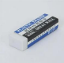
26-Jun-2023 | Jiangsu | Electric Vehicle Charger | Electrical Appliances | Electric Shock Hazard | 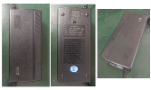
27-Jun-2023 | Xinjiang | Bed Boards | Furniture | Chemical Hazard, Risk of Allergy | /
28-Jun-2023 | Hunan | Solid Wood box-type Foot Warmers | Home Electrical Appliances | Electric Shock Hazard | 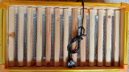
28-Jun-2023 | Hunan | Fruit Bowls | Food Contact Material | Safety Risk Hazard, Injury Hazard | 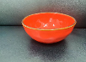
28-Jun-2023 | Hunan | Workbooks | Stationery | Eye Irritation Risk | 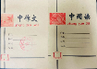
28-Jun-2023 | Jilin | Wet Wipes | Bodycare / Cosmetics | Risk of Allergy, Health Risk Hazard | /
28-Jun-2023 | Fujian | Ceramic Sealing Faucets | Household Items | Lead Poisoning Hazard | 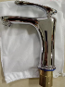
28-Jun-2023 | Fujian | Ceramic Sealing Faucets | Household Items | Lead Poisoning Hazard | 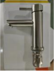
28-Jun-2023 | Fujian | Melamine Bowls | Food Contact Material | Chemical Hazard | 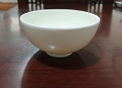
28-Jun-2023 | Fujian | Children's Windbreaker Jacket, Suspender Shorts and Woven Cropped Pants | Fabric / Textile / Garment / Home Textile | Strangulation Hazard, Safety Risk Hazard | 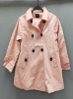  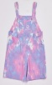  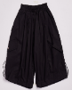
28-Jun-2023 | Fujian | Baby Jumpsuits | Fabric / Textile / Garment / Home Textile | Strangulation Hazard, Safety Risk Hazard | 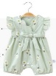
28-Jun-2023 | Fujian | Girls' Hanfu Skirts | Fabric / Textile / Garment / Home Textile | Strangulation Hazard, Safety Risk Hazard | 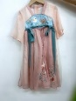
29-Jun-2023 | Shanghai | Student Book Bags | Fabric / Textile / Garment / Home Textile | Chemical Hazard, Health Risk Hazard | 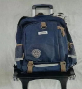
29-Jun-2023 | Shanghai | Student Trolley Bags | Fabric / Textile / Garment / Home Textile | Chemical Hazard, Health Risk Hazard | 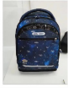
29-Jun-2023 | Shanghai | Unisex Backpacks | Fabric / Textile / Garment / Home Textile | Chemical Hazard, Health Risk Hazard | 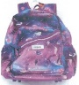
29-Jun-2023 | Shanghai | Hot Drink Cups | Food Contact Material | Safety Risk Hazard | 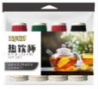
29-Jun-2023 | Shandong | Girls' Half-sleeve Open-crotch One-piece Clothing Made of Pure Cotton Icy Jersey | Fabric / Textile / Garment / Home Textile | Fall Hazard, Suffocation Hazard, Safety Risk Hazard, Ingestion Hazard | /
29-Jun-2023 | Shandong | Bamboo Fiber Nightdresses for Girls Under the Brand of Bidi Baby | Fabric / Textile / Garment / Home Textile | Suffocation Hazard | /
29-Jun-2023 | Shandong | Wallaby & Siri Summer Beach Girl Skirts | Fabric / Textile / Garment / Home Textile | Suffocation Hazard, Safety Risk Hazard | /
29-Jun-2023 | Shandong | Legged Apron | Fabric / Textile / Garment / Home Textile | Suffocation Hazard, Safety Risk Hazard | /
29-Jun-2023 | Shandong | Gauze Apron—Double Layer | Fabric / Textile / Garment / Home Textile | Suffocation Hazard, Safety Risk Hazard | /
29-Jun-2023 | Shandong | Luxury Strollers | Toys and Childcare Products | Crushing Hazard, Entanglement Hazard | /

